**Assignment 2**

**Screen Shots**

**Suzie**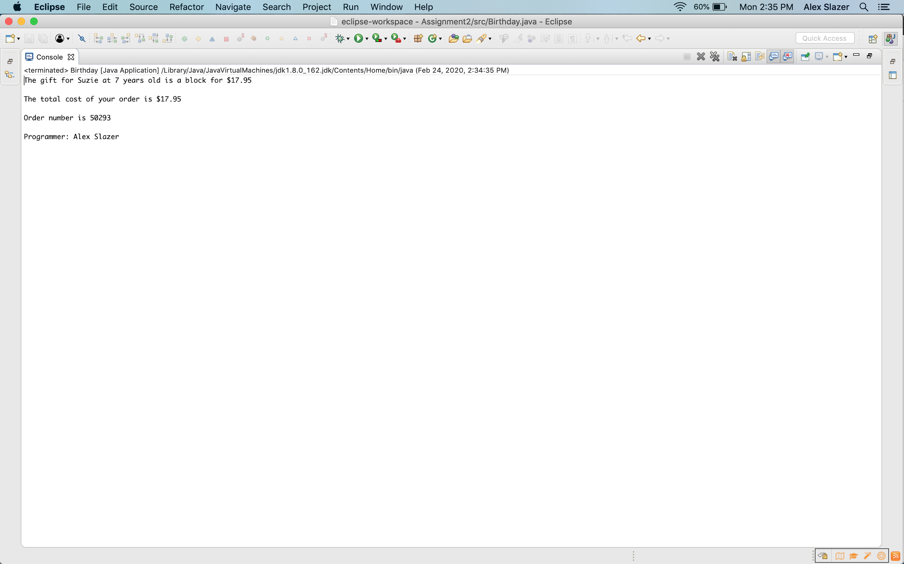

**All 3 Children**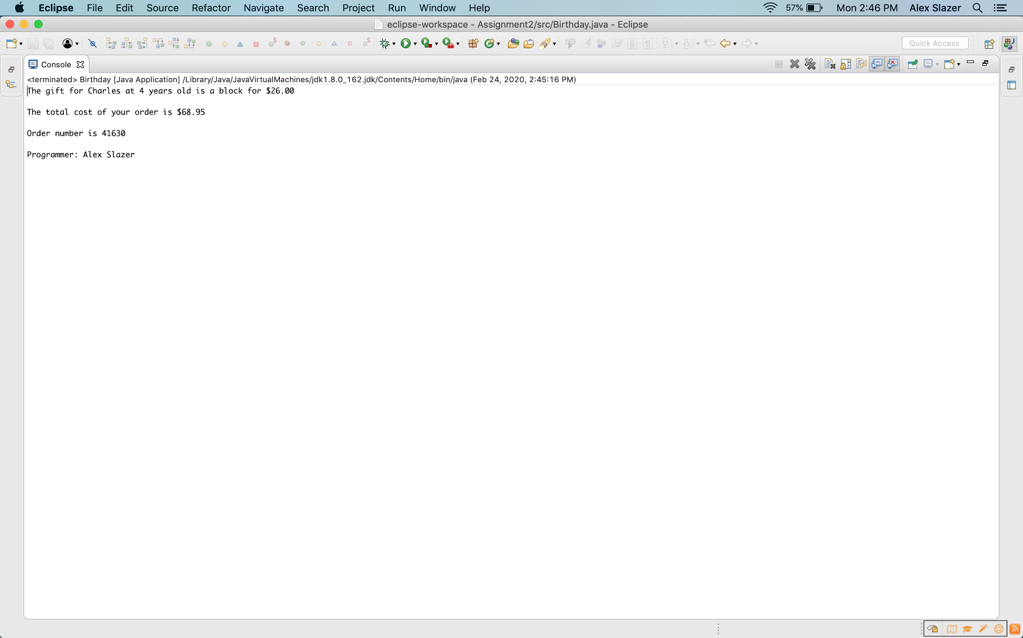

**Test Cases (3 of correct, 3 of incorrect)**

**With Correct Input**

|  |  |  |  |  |  |  |  |  |
| --- | --- | --- | --- | --- | --- | --- | --- | --- |
| **Name** | **Age** | **Toy** | **Card** | **Balloon** | **ExpectedCost of Gift** | **Actual Cost of Gift** | **ExpectedTotal Cost** | **Actual Total Cost** |
| Suzie | 7 | Book | Yes | No | $17.95 | $17.95 |  |  |
| Donnie | 1 | Plushie | No | No | $25.00 | $25.00 |  |  |
| Charles | 4 | Blocks | No | Yes | $26.00 | $26.00 |  |  |
|  |  |  |  |  |  |  | $68.95 | $68.95 |

**With Incorrect Input**

|  |  |  |  |  |  |  |
| --- | --- | --- | --- | --- | --- | --- |
| **Name** | **Age** | **Toy** | **Card** | **Balloon** | **Expected Message** | **Actual Message** |
| Chris | 3 | Book | No | No | Toy is not age-appropriate  Do you want to buy another toy? Yes or No | Toy is not age-appropriate  Do you want to buy another toy? Yes or No |
| Bent | 3 | Blocks | Blah blah blah | No | Invalid choice  Please choose again  Do you want a card with the gift? Yes or No | Invalid choice  Please choose again  Do you want a card with the gift? Yes or No |
| Chetler | 7 | Toyota | No | No | Invalid choice  Please choose again  Choose a toy: a plushie, blocks, or a book | Invalid choice  Please choose again  Choose a toy: a plushie, blocks, or a book |