

**BICOL UNIVERSITY COLLEGE OF SCIENCE**

**LEGAZPI CITY, ALBAY**

**IT Elect 1 – WEB DEVELOPMENT**

**DOCUMENTATION**

**(LABORATORY 1)**

**SUBMITTED BY:**

JERALD JAY G. BUBAN

BSIT – 3C

1. 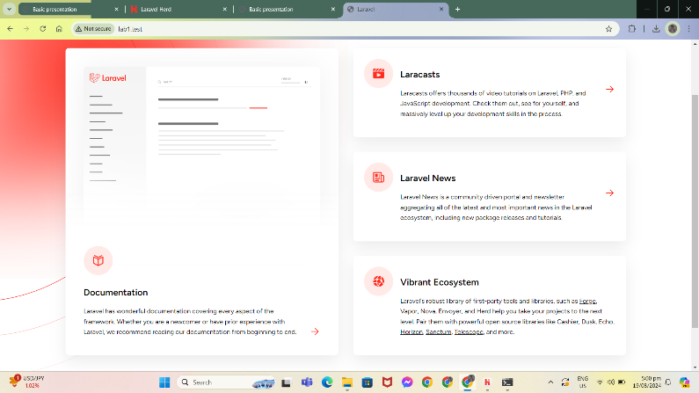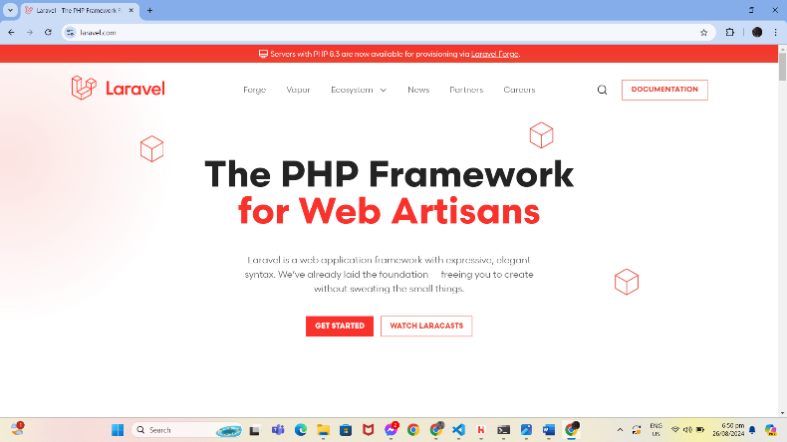Install Laravel along with its dependencies.

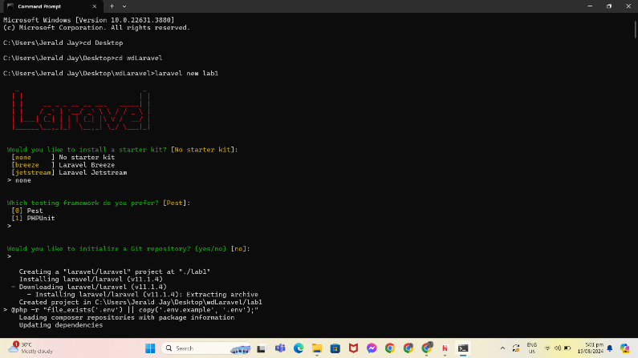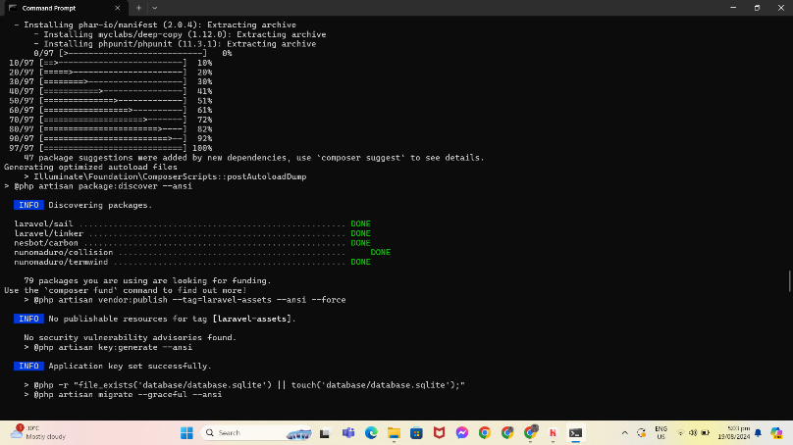

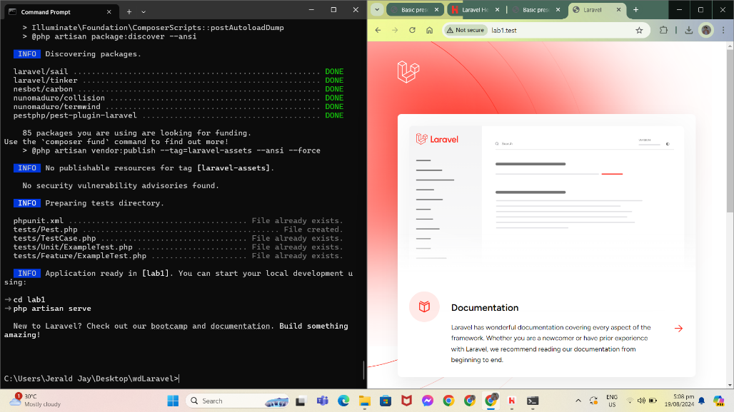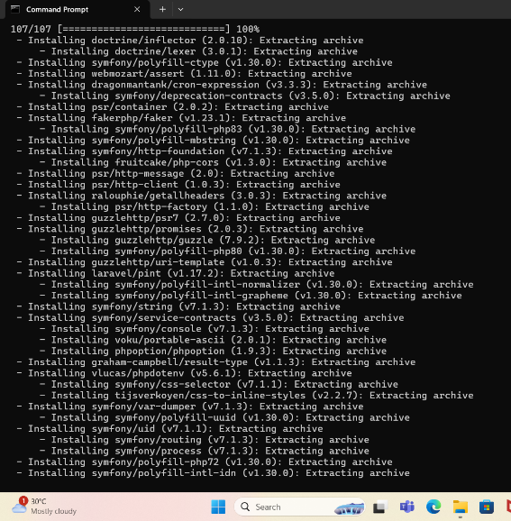

1. Create a Laravel project and put it in a Git repository

3. Set up the .env file to include database connection details



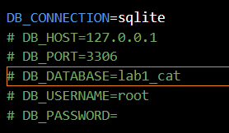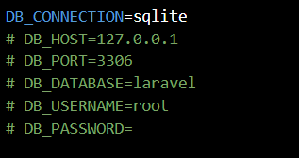

4. Create at least 3 views (homepage, about, content)

3 Views

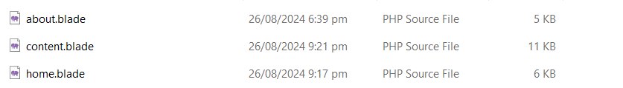

* 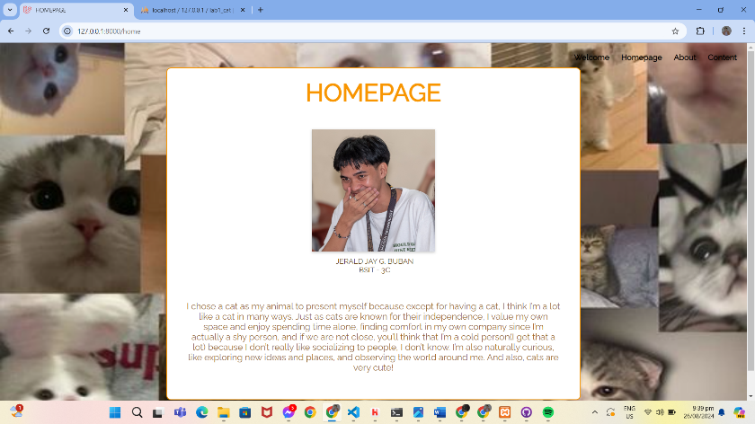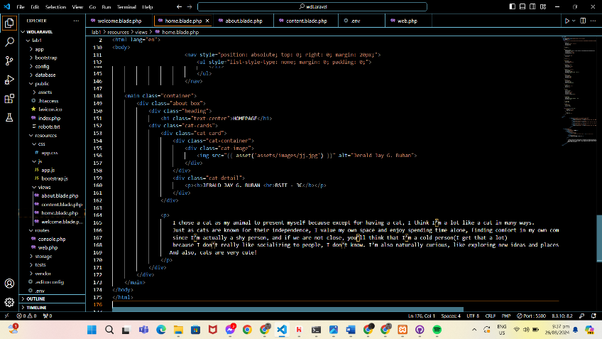**HOMEPAGE**
* 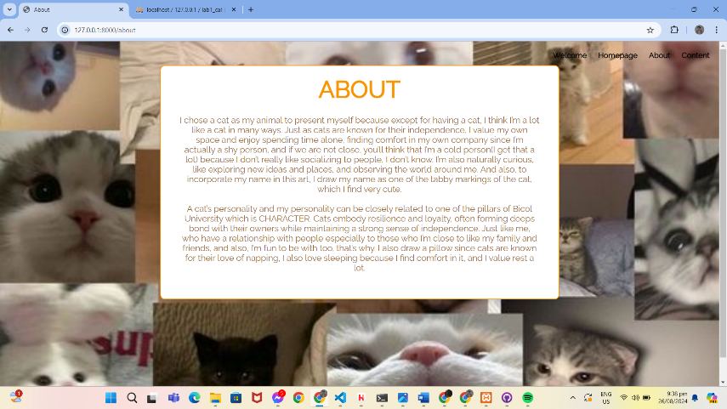**ABOUT**

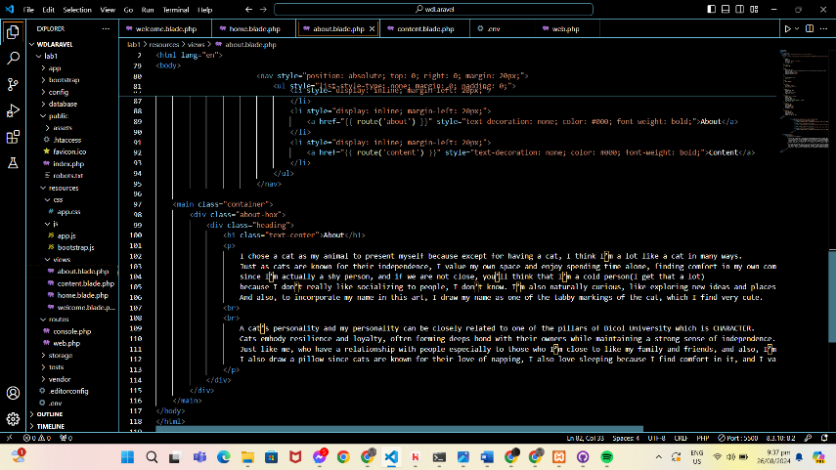

* 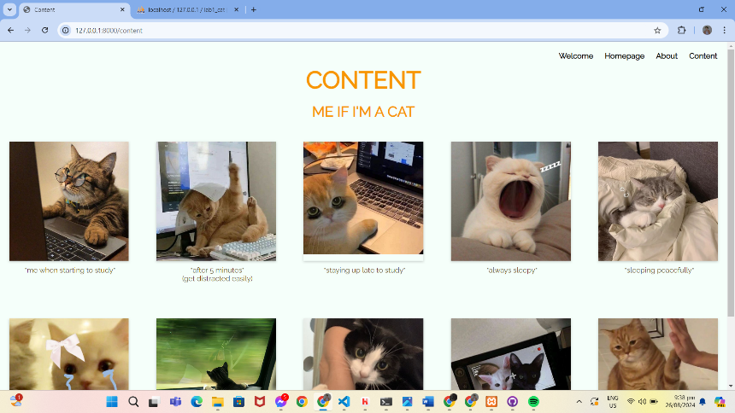**CONTENT**

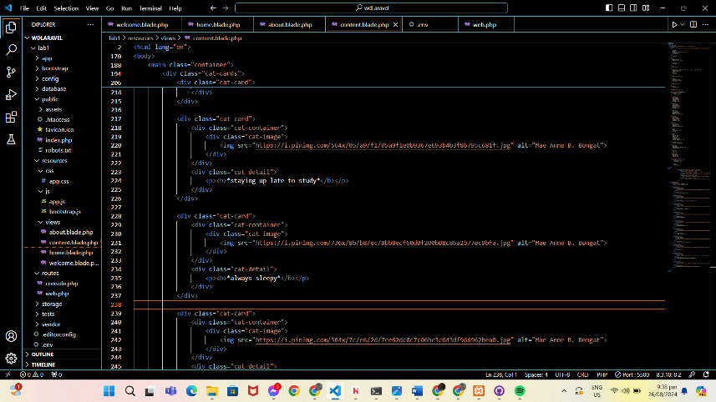

5. Create and run routes

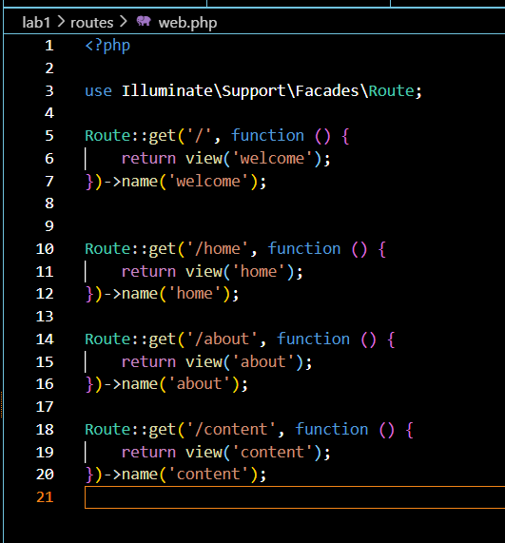

6. Identify and document the purpose of key directories and files in the Laravel project.

**KEY DIRECTORIES:**