Analysis of how Auto Sale records correlate with World’s economic factors



FIRST MIDTERM PROJECT REPORT SUBMITTED
IN FULFILMENT OF THE REQUIREMENTS FOR THE COURSE
STAT 112
INTRODUCTION TO DATA PROCESSING AND VISUALIZATION
DEPARTMENT OF STATISTICS OF
MIDDLE EAST TECHNICAL UNIVERSITY

BY

Aslı Ceren Aksu

December 2024

1.ABSTRACT:

This study examines how auto sale performance vary across world’s socio-economic factors using combined datasets of Auto Sale records and World metrics. The data that given to us required cleaning and tidying in a surface level in order to interpret and expound in an accurate way. Cleaning and tidying process included addressing missing values, checking and changing data types as a correct version and creating calculated fields to achieve accurate analysis using descriptive statistics and exploratory data analysis (EDA) techniques.

2.INTRODUCTION:
This analysis mainly delves into the sale records, which contain the selling amount and customer’s purchase preferences according to the country’s socioeconomic conditions. In these datasets when we combined two of them to evaluate there were 19 Countries to examine. The auto sale data set contained 19 different variables, while word data from 2023 contained 14 variables, which makes 33 variables in total to consider.
Data Description:
33 Variables that mentioned earlier are:
Automobile Sales Dataset:
ORDERNUMBER: | This column represents the unique identification number assigned to each order.
QUANTITYORDERED: | It indicates the number of items ordered in each order.
PRICEEACH: | This column specifies the price of each item in the order.
ORDERLINENUMBER: | It represents the line number of each item within an order.
SALES: | This column denotes the total sales amount for each order, which is calculated by multiplying the quantity ordered by the price of each item.
ORDERDATE: | It denotes the date on which the order was placed.
DAYS_SINCE_LASTORDER: | This column represents the number of days that have passed since the last order for each customer. It can be used to analyze customer purchasing patterns.
STATUS: | It indicates the status of the order, such as "Shipped," "In Process," "Cancelled," "Disputed," "On Hold," or "Resolved."
PRODUCTLINE: | This column specifies the product line categories to which each item belongs.
MSRP: | It stands for Manufacturer's Suggested Retail Price and represents the suggested selling price for each item.
PRODUCTCODE: | This column represents the unique code assigned to each product.
CUSTOMERNAME: | It denotes the name of the customer who placed the order.
PHONE: | This column contains the contact phone number for the customer.
ADDRESSLINE1: | It represents the first line of the customer's address.
CITY: | This column specifies the city where the customer is located.
POSTALCODE: | It denotes the postal code or ZIP code associated with the customer's address.
COUNTRY: | This column indicates the country where the customer is located.
CONTACTLASTNAME: | It represents the last name of the contact person associated with the customer.
CONTACTFIRSTNAME: | This column denotes the first name of the contact person associated with the customer.
DEALSIZE: | It indicates the size of the deal or order, which are the categories "Small," "Medium," or "Large."

Global Country Information:
Country: | Name of the country.
Latitude: | Latitude coordinate of the country's location
Longitude: | Longitude coordinate of the country's location
Birth Rate: | Number of births per 1,000 population per year
CO2-Emission: | Carbon dioxide emissions in tons
CPI: | Consumer Price Index, a measure of inflation and purchasing power.
Gasoline Price: | Price of gasoline per liter in local currency
GDP: | Gross Domestic Product, the total value of goods and services produced in the country
Life expectancy: | Average number of years a newborn is expected to live
Population: | Total population of the country
Tax Revenue(%): | Tax revenue as a percentage of GDP
Total tax rate: | Overall tax burden as a percentage of commercial profits.
Unemployment rate: | Percentage of the labor force that is unemployed
Urban_population: | Percentage of the population living in urban areas
Research questions:
In the below, there are 5 research questions that I cover with visualizations. These questions were generated according to 2 datasets that promoted to us.
- What are the total sales across different product lines and their corresponding shipping statuses?
- How do CO2 emissions differ across countries based on sales and MSRP?
- Does selling at a price more that MSRP correlate with sales?
- How do GDP per capita vary across product lines and urbanization ratio categories?
- How do GDP per Capita vary across MSRP?

3.DATA TIDYING AND CLEANING STEPS:

Joining the data together
To use both data sets in our visualization we need to combine them in a way. After examining the data, I noticed that the only common variable between given data sets is country. Therefore I decided to use inner join or left join to combine them. Since two of it does not make any difference in my scenario I use inner join. First I dragged Autosales to the blank space and by clicking the right corner I opened it. Then I drag the world data into the join table and select inner join.
Cleaning the data
After we receive the data first we need to get to know the data. First, I checked the names of the variables and what they meant. All data names were clear about what they were presenting. Before trying to visualize data we need to look for any missing, miswritten, wrongly formatted or, categorized and duplicated values. Luckily, we did not have any missing or duplicated values through the variables that we need. The ‘we need’ part is important because in this data set phone numbers are given in a different format, but we don’t need to change it since we’re not gonna use it. When I first received datasets, missing values on order date confused me, but after I got familiar with the data I figured out that while the autosale dataset contains years 2018, 2019, and 2020, world data contained only 2023 variables. Because of this reason, I realized that I can’t make any assumptions about yearly changes in an intersection of the 2 datasets. However, if we do have any missing values or duplicates in our datasets we should have removed or fulfilled them with the right operation.
After cleaning and tidying the data I checked for variable types or scales that were promoted automatically by Tableau right after entering the datasets. Because GDP values and Gasoline Prices in the World data set contain dollar signs, tableau recognized it as a string measure. Nevertheless, these variables should have been numeric if we wanted to have clear and accurate results. Therefore, since I use Mac I changed them easily in the Tableau’s data source page without needing to use excel.
Calculated Fields
Urbanization ratio category:
- To get this calculated field, first I make an another calculated field called “urban ratio” in this calculated field I divide urban population to the over all population to get unbiased opinion about urbanization. After that in order to answer my first question “How does do sales vary across product lines and urbanization ratio categories?” I needed to make this ratio categorized. To make. A proper categorization between countries’ urban ratio’s I put “urban ratio” on an empty sheet with countries to see the results. Then minding the range, I separate them in 3 groups as low, medium and high. And the last part was creating an another calculated field for categorized version. I named the field as “urban ratio category” and write the code below:
IF [urban ratio] < 0.815 THEN "Low"
ELSEIF [urban ratio] < 0.827 THEN "Medium"
ELSE "High"
END
With this code I separated these countries in three groups.
Profit-loss for each country:
In the question “Does selling at a price more that MSRP correlate with sales?” I needed to create a calculated field that tells me if they sell it on a price more than MSRP or less than MSRP. In this scenario I named selling more than MSRP as “profit” and less as “loss”. But the hard part was making it for every country. In order to do this I created another calculated with the help of internet sources since I didn’t know how to do it. This calculated field contained the code:
{ FIXED [Country] : AVG([Priceeach] - [Msrp]) }
and I named this field as price-msrp for each country. After that I found my self in a position that can be easily create my actual calculated field: Finally I wrote a code like:
IF [price-msrp for each country] >0 THEN "profit"
ELSE "loss”
END
With the use of this code I named each country as profit or loss.
GDP per Capita
Lastly I create a simple calculated field for my last question “How do GDP per Capita vary across MSRP?” In order to interpret GDP as an unbiased element from population I divide GDP to the population with this code:
[GDP]/[Population]
And I named this field as GDP per capita to use in my treemap chart.

4. EXPLORATORY DATA ANALYSIS:
In this Project, I conducted 5 research questions.
1-) What are the total sales across different product lines and their corresponding shipping statuses?
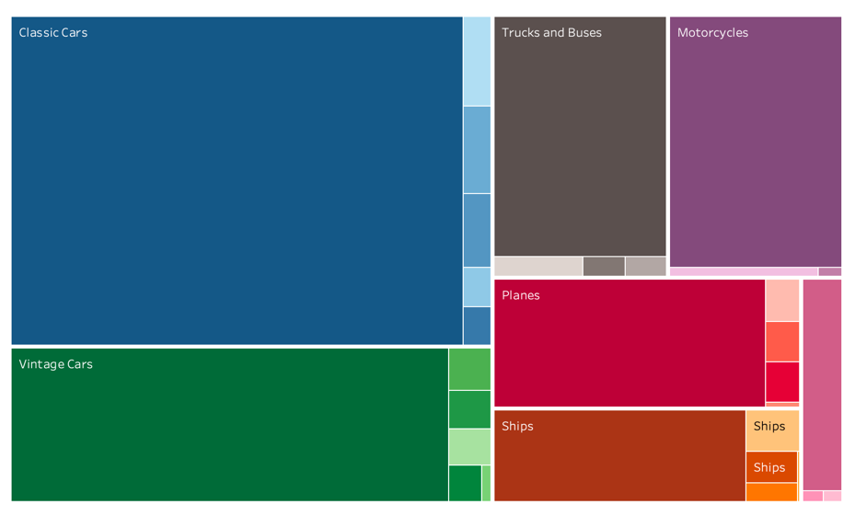
Since sales are numerical while product lines and shipping status are categorical, in my belief best visualization was the mosaic plot. In this chart the purpose was to see how sales are distributed across automobile types and if it impacts shipping level. The main colors represented the automobile types and the color spread represented the shipping status. As can be seen on the mosaic plot, classic cars carry the popularity among automobiles with 5 different shipping levels. In addition, to the sale diffusion. How many of these sales are shipped cancelled and so on can be seen in the chart as well. It is clear that no matter the type of product line, most of them are delivered in each category. However, as the sale distribution among automobile types decreases, the diversity of shipping status also reduces. For example, while Classic cars have 5 shipping levels, Trains have just 3. In conclusion, our data show that Classic cars are the most preferred product line with the most variety of shipping levels.
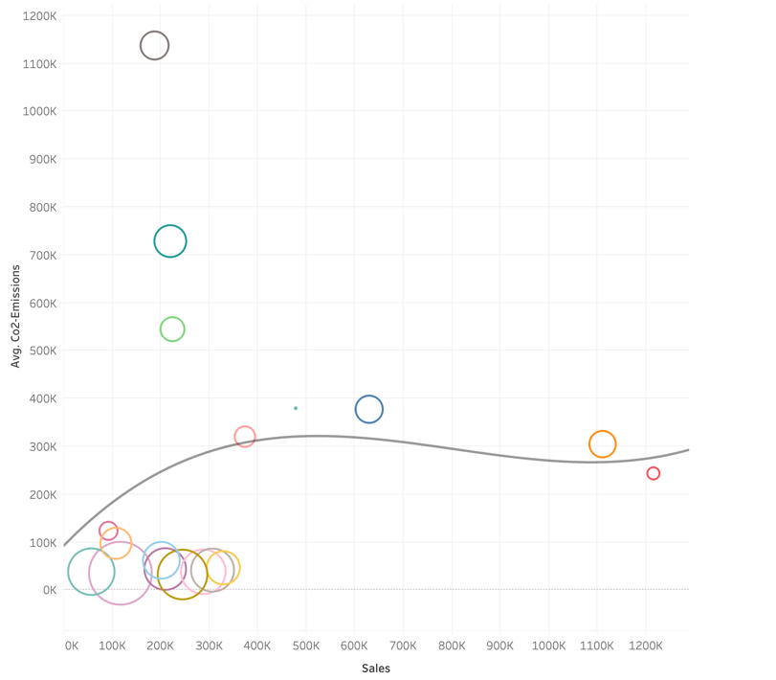
2-) How do CO2 emissions differ across countries based on sales and MSRP?
To determine the relationship between 3 numerical variables, a bubble plot is one of the best options. In this graph, USA hardened to see other values because it was on a very different scale than other countries. I used box plots to determine if it is an outlier or not, and USA was out of the minimum and maximum range. Because of this, I detected it as an outlier and removed it from my graph for clarity. To see the relationship better I added a polynominal trend line. According to the graph, most countries are cumulated in the bottom left corner. As the sales and average CO2 emissions go higher we can see that MSRP increases which is represented as the bubble size. So, we can say that MSRP has a negative relationship with both co2 emissions and sales.
3-) Does selling at a price more that MSRP correlate with sales?

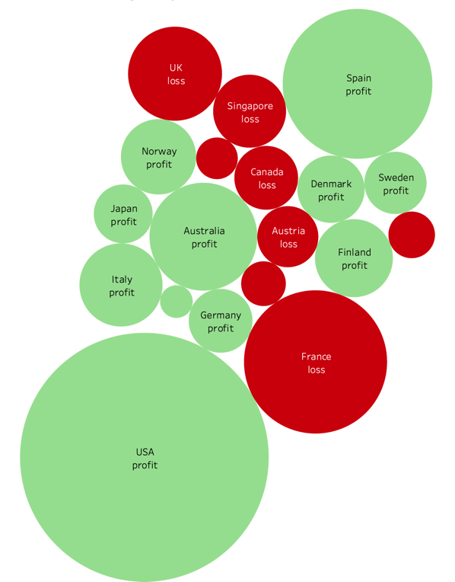
The packed bubble plot helped to see the sale distribution across countries with the impact of MSRP. With the calculated field, profit or loss, we can see that countries that sell more or less than MSRP do not strongly affect sales directly. On the other hand countries with the most sales, the USA and Spain, are categorized as a profit which means they have sold at a price more than MSRP. To conclude, even though the relationship is not strong sales tend to be higher in the countries with ‘profit’ countries

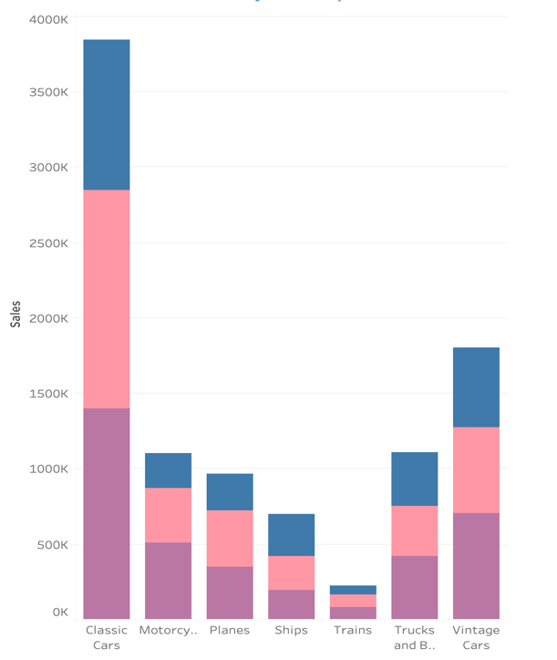
4-) How does do sales vary across product lines and urbanization ratio categories?
Since I had two categorical and one numerical variable, I chose to use stacked bar charts. In this visualization, we can see the analysis of how the urbanization ratio impacts the sale of product categories. With the help of the calculated field ‘urbanization ratio category’ we can comment that each urbanization level affects sales in categories differently. Medium urbanization results in the most sales in overall sales, and low urbanization results in medium sales. In addition, it is clear to see that high urbanization in particular of each product category results in higher sales than other urbanization categories. Hence, we can say that medium urbanization causes more sales.
5-) How do GDP per Capita vary across MSRP?
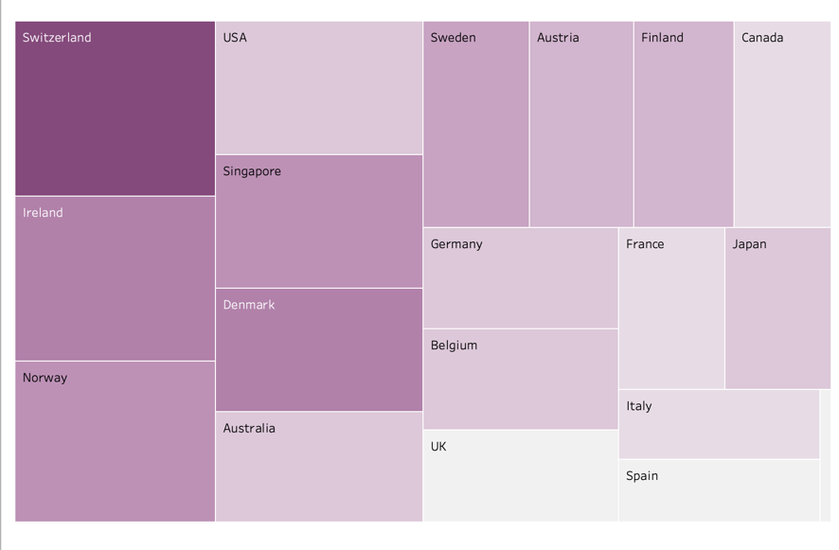
I used a Treemap chart to visualize how GDP per capita and MSRP impact each other in all countries. In this visualization, I used a calculated field called GDP per capita in order to make a more accurate comment on the GDP’s effect without the impact on the Country’s population. Because when I didn’t create a calculated field and use GDP as it is, there were a huge range between worldwide countries and small countries. The darkness of the colors in this chart represents the average MSRP, while the areas speak for GDP per capita. Through this chart, we can easily say that, even though it is not so strong, there is a weak relationship between GDP per capita and MSRP. Switzerland has the winner place for both MSRP and GDP per capita.

5-) CONCLUSION:
To conclude, in this report I analyzed how do countrys’ socio- economic and demographic structure such as CO2 emission, urbanization, total population, GDP and so on vary across the affect of customer’s automobile purchase preferences. With the help of calculated fields I was able to answer my 5 questions. From these questions I observe that Classic Car sales are very ahead of the other product types in every kind of urbanization and on the high ratio category preferences differed from the low and medium. While they prefer motorcycles over trucks and buses, high ratio category preferred trucks and busses which completely makes sense to me. Same between motorcycles and planes. High urbanization countries preferred planes over motorcycles, opposite of low and medium urbanization. After that I examine the MSRP in detail and how it correlates with world data. The reason behind this was finding MSRP’s affect on both sales and world’s demographic structure. First I look at how it correlates with CO2 emisson and sales. In addition, I found in general as the MSRP decreases average CO2 emission and sales increases. Which also means CO2 emission and sales has a positive relationship between them. Hovewer, after that I wanted to investigate MSRP and sales in a different format because MSRP as it’s own does not feel enough to me. The important part was the relationship between price each and MSRP. I wanted to learn When the product sold at a price that would make a profit to them did it increased or decreased sales? An I saw that selling at a price less than MSRP did not end up as huge selling records, which was surprising. Lastly, I observe MSRP with GDP per capita. In general as the GDP increases, level of development of the countries increases too since the revenue increases. With this visualization I figured that MSRP and GDP per capita have a positive relationship. Which means that In more developed countries the money that you will need to buy the same product will be much higher than a less developed country.

