# GIT HW

## Definition

                In this exercise you will use git.

**Scenario:**

Our product’s r2.5.4 version is being used in production and we have r2.5.5 that will be released in the future. Also there is r3.0 version which is in the development process. Suddenly an error occured in r2.5.4 and we are creating a branch called r2.5.4.1 Bugfix in order to solve this. Then we add those changes to our future branch and development branch.

                Now, carry out this scenario in your git environment.

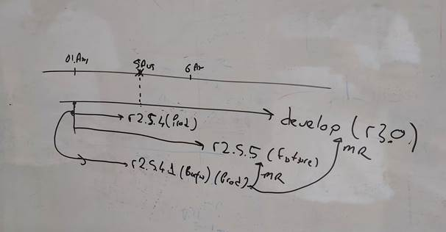

**Objectives** :

* To learn how to use git.
* To understand importance of version control.
* To carry out a real world scenario

**Exercise Keywords:** git, version control, merge, branch.

**SOLUTION:**

git checkout r2.5.5

git merge r2.5.4.1_Bugfix

git checkout r3.0

git merge r2.5.4.1_Bugfix

git add .

git commit -m "Merged bugfix from r2.5.4.1_Bugfix"