Cost Analysis
This project has been developed in an academic setting, so priority was given to zero-cost solutions, free platforms, and open-source tools. The resulting cost analysis covers the entire infrastructure, AI usage, design tools, and human resources, enabling a comprehensive financial assessment.

1. Domain & Hosting Costs

1.1 Domain Costs
The project will use free subdomains offered by hosting providers.
- Domain Cost: 0 USD
- Reason: Fully compatible with academic and budget-limited constraints.

1.2 Hosting Infrastructure Costs
The hosting strategy relies entirely on free-tier technologies.

Frontend Hosting
Platforms:
- Vercel
- Netlify
- GitHub Pages
These provide:
- Free SSL certificates
- Automatic deployments
- Sufficient bandwidth and storage

Backend & AI Hosting
Platforms:
- Firebase (Free Tier)
- Supabase (Free Tier)
These services cover:
- Database operations
- Authentication
- File storage
- Basic API hosting

Computational Limitations
Free tiers limit:
- AI processing power
- Concurrency
- Storage capacity
These constraints are acceptable for academic usage.
- Total Hosting Cost: 0 USD

2. Data & AI Costs

2.1 API Token Costs
If commercial models (GPT-4, Claude 3.5, Gemini) were used:
- Cost = token usage × price per token
Given academic limitations, paid APIs are avoided.

2.2 GPU & Training Infrastructure Costs
Training or fine-tuning open-source models (Llama, Mistral) would require:
- Paid GPU instances (AWS, Azure, GCP)
Since the project uses pre-built lightweight models on free tiers, training cost is eliminated.

2.3 Vector Database Costs
Free-tier plans of Pinecone, Weaviate, or Milvus can store limited data with:
- No charge for basic vector storage
- Free monthly query limits

2.4 Data Labeling Costs
Manual data annotation could introduce external labor costs.
In this project, automated parsing and academic datasets are used.
- Total AI & Data Cost: 0 USD

3. Design Tool Costs

UI/UX Design
Tools evaluated:
- Figma: Free plan selected
- Adobe XD: Paid monthly, avoided
- Sketch: Annual license, avoided
Optional tools such as Miro, Maze, and InVision may add costs, but free alternatives will be used.
- Total Design Tool Cost: 0 USD

4. Testing & Quality Assurance Costs
Testing needs include:
- Interface testing
- Cross-browser compatibility checks
- Performance checks
- Basic user feedback
The following free tools will be used:
- Chrome DevTools
- Postman
- Lighthouse
- GitHub Issues for bug tracking
Paid tools (Sentry, BrowserStack, Hotjar) were evaluated but not required.
- Total Testing & QA Cost: 0 USD

5. Human Resources / Labor Costs
Although the project requires substantial effort in:
- Frontend development
- Backend development
- AI integration
- UX design
- Project management
- Testing & documentation
Because the project is academic, contributors are students.
- Total Labor Cost: 0 USD

6. Storage, Bandwidth & Monitoring Costs

6.1 Storage
Firebase & Supabase free tiers cover:
- File storage
- Database storage
- Basic backups

6.2 Bandwidth
Frontend hosting providers offer ample free bandwidth for academic use.

6.3 Monitoring & Logging
Platforms like Firebase Console or GitHub Insights provide free basic monitoring.
- Total Storage/Bandwidth/Monitoring Cost: 0 USD

7. Maintenance & Update Costs
Long-term software maintenance often includes:
- Updating dependencies
- Maintaining repository
- Fixing bugs
- Version control
Tools used:
- GitHub Free Plan
- Open-source packages
Since no paid services are required, maintenance cost remains zero.
- Total Maintenance Cost: 0 USD

8. Legal & Compliance Costs
The system handles personal data (CVs, job descriptions).
Potential costs might include:
- GDPR/KVKK consultancy
- External privacy audits
For academic usage, compliance will be ensured through:
- Minimal data storage
- Anonymization
- Free built-in security mechanisms from Firebase/Supabase
- Total Compliance Cost: 0 USD

Total Estimated Project Cost: 0 USD
All core components—including hosting, domain, AI usage (in free tier), design tools, testing, storage, and maintenance—operate on free-tier or open-source solutions.
Therefore, the total financial cost remains 0 USD, making the project fully feasible within academic constraints.
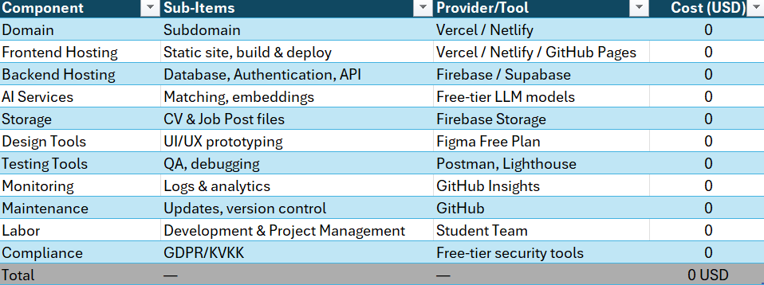

9.Feasibility Analysis
This project is feasible within the framework of an academic course from a technical, financial, and operational standpoint. From a technical standpoint, the platform can be developed using existing web technologies, open source libraries, and free cloud services, which are sufficient for creating a functional prototype and demonstration. From a financial standpoint, the project is viable because all major components—hosting, domain, artificial intelligence tools, design, and testing—are planned to be launched on free plans, resulting in zero direct costs. From an operational standpoint, the project is within the capabilities of the team members because roles and responsibilities are clearly defined and aligned with the project requirements. Overall, given the limited scope, clear goals, and available resources, the project can be successfully completed within the academic schedule.

