MOCKUPS
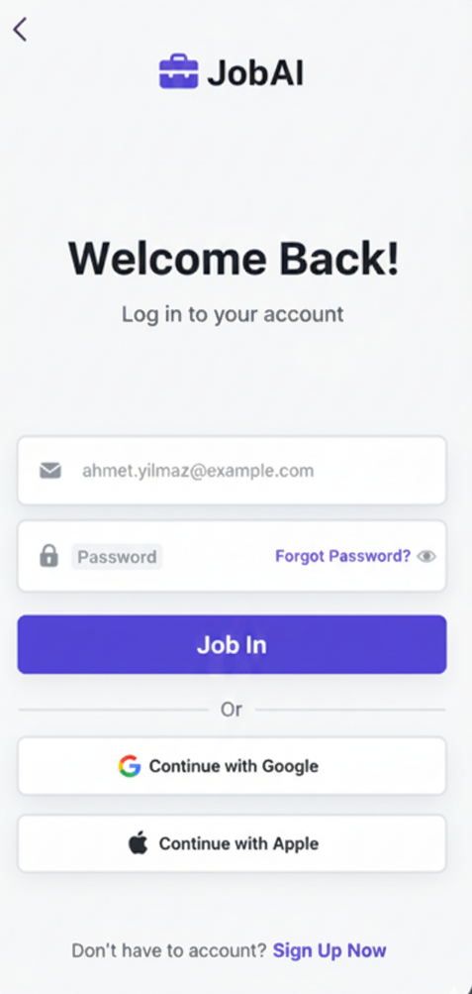
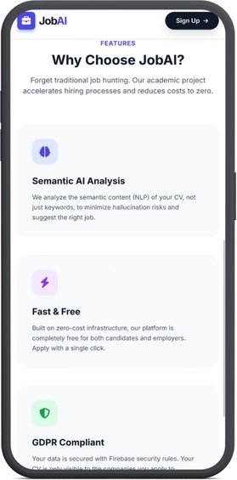

Figure 2: Login Page
Figure 1: Featutes Page

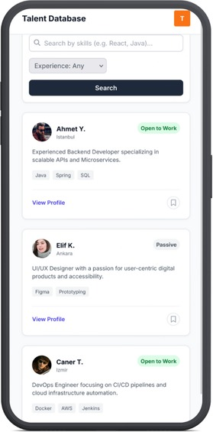
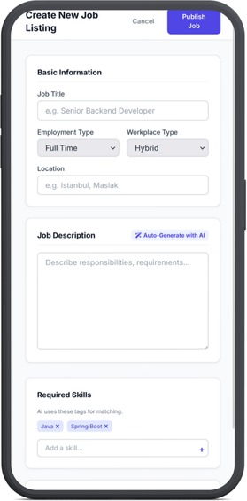

Figure 4: Candidate List Page
Figure 3: Create New Job Listing
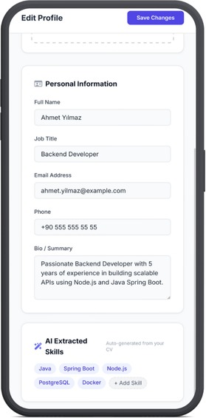
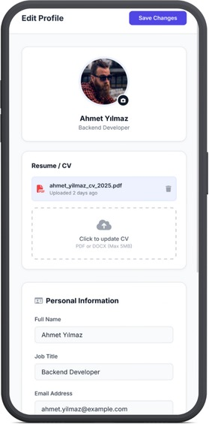
Figure 6: Edit Profile Page (Continiue)
Figure 5: Edit Profile Page

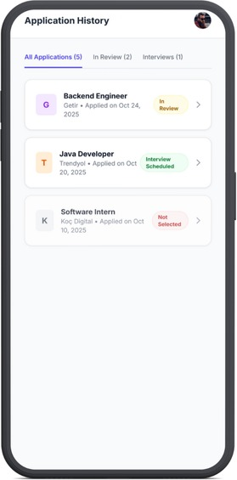
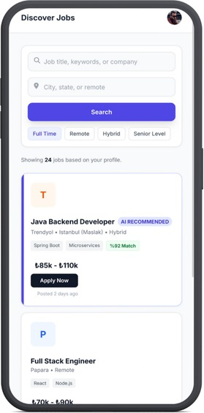
Figure 8: Aplication History
Figure 7: Discover Jobs Page

Figure 10
Figure 9

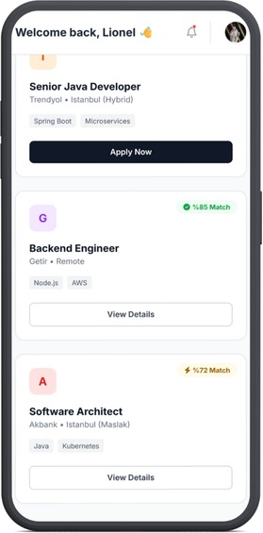
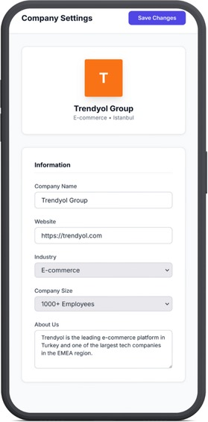
Figure 9: Candidate Home Page
Figure 10: Company Settings Page

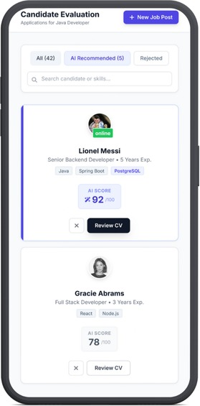
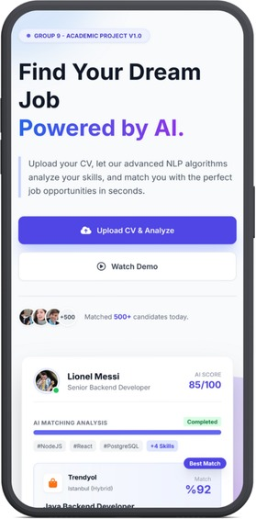

Figure 14
Figure 13
Figure 11: Landing Page
Figure 12: Candidate Evaluation Page
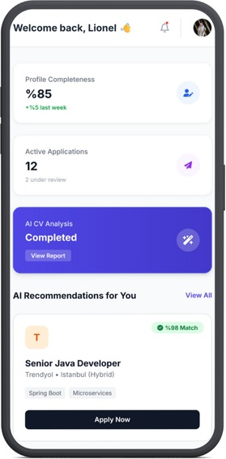
Figure 13: Job Recommendations Page

JobAI Interface Visuals and Descriptions

1. Features Page (Figure 1)
- Purpose: To explain the unique value proposition and core technical advantages of the JobAI platform to both candidates and employers.
- Function: Highlights key platform features such as Semantic AI Analysis (for advanced matching), Fast & Free service (for accessibility), and GDPR Compliance (for data security and privacy).

2. Login Page (Figure 2)
- Purpose: To provide a secure gateway for existing users to access the platform.
- Function: Serves as the initial entry point, allowing users to authenticate using standard email/password fields or through quick sign-in options like Google and Apple ("Welcome Back!").

3. Initial Landing/Onboarding Page (Figure 11)
- Purpose: To introduce the platform's central promise and guide new users into the process.
- Function: Promotes the main goal: "Find Your Dream Job Powered by AI." It clearly displays the call-to-action buttons to "Upload CV & Analyze" to start the AI matching process and a link to "Watch Demo."

4. Candidate Home / Dashboard (Figure 9)
- Purpose: To present a personalized, at-a-glance overview of the candidate's activity and status.
- Function: Shows key metrics like profile completeness, the number of active job applications, and the status of the AI CV Analysis report. This page also initiates the display of personalized job postings recommended by the AI (e.g., Senior Java Developer - 98% Match).

5. Edit Profile Page (Figure 5 & 6)
- Purpose: To allow candidates to manage and update their professional and personal data.
- Function: Enables the user to upload or replace their CV (PDF or DOCX), edit personal information (full name, email, current job title), and verify the AI Extracted Skills automatically parsed from their résumé.

6. Discover Jobs Page (Figure 7)
- Purpose: To allow candidates to actively search and explore new career opportunities.
- Function: Provides a search interface with filters based on job title, keywords, location/remote options, and employment type. Job listings are displayed along with the AI match percentage (e.g., %92 Match) and estimated salary ranges (e.g., ₺85k - ₺110k).

7. Application History Page (Figure 8)
- Purpose: To track the status and history of all submitted job applications efficiently.
- Function: Lists all applications made by the candidate and clearly indicates their current status, such as "In Review," "Interview Scheduled," or "Not Selected."

8. Employer: Create New Job Listing (Figure 3)
- Purpose: To provide employers with a structured form to publish new job openings quickly.
- Function: Allows the definition of the job title, employment type, location, and necessary skills (e.g., Java, Spring Boot). A key feature is the option to "Auto-Generate with AI" to create a detailed job description instantly.

9. Employer: Candidate Evaluation Page (Figure 12)
- Purpose: To facilitate rapid and data-driven evaluation of applicants for a specific job posting.
- Function: Lists all applicants (e.g., Lionel Messi, Gracie Abrams) and assigns an AI SCORE (e.g., 92/100) indicating compatibility. Employers can filter the list to show only "AI Recommended" candidates before proceeding to "Review CV."

10. Employer: Company Settings (Figure 10)
- Purpose: To manage and update the corporate identity and information associated with the employer account.
- Function: Allows editing essential corporate details, including the Company Name (e.g., Trendyol Group), website, industry, employee count, and the company's "About Us" statement.

11. Employer: Talent Database (Figure 4)
- Purpose: To enable proactive sourcing by allowing employers to search for potential candidates who have registered on the platform.
- Function: Provides a search and filter mechanism based on specific skills (e.g., React, Java) and experience level. It lists relevant candidates (e.g., Ahmet Y., Elif K.) along with their skills and their "Open to Work" status.

