Projet Timeline
The project schedule is structured over an 8-week academic timeline using a hybrid approach combining WBS (Work Breakdown Structure) for task decomposition and PERT (Program Evaluation and Review Technique) and Gantt Charts for time management and dependency visualization. This ensures that resource allocation is optimized and the Critical Path is closely monitored to meet the submission deadline.

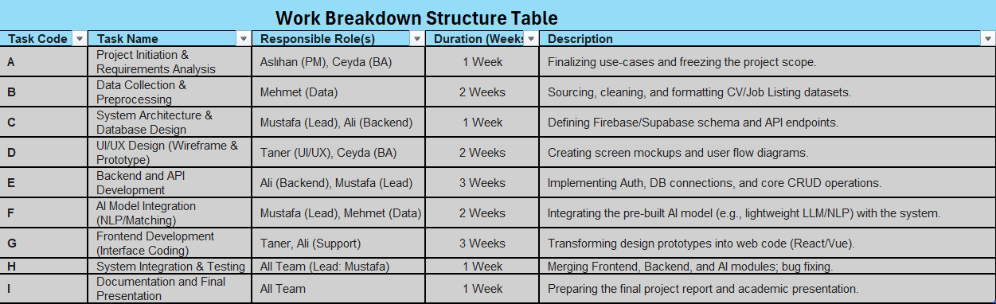

1-Work Breakdown Structure
The project scope for the Job Matching Platform is broken down into 9 major tasks (A to I) spanning an 8-week academic period. This Work Breakdown Structure (WBS) serves as the foundational tool for project management by defining every deliverable and assigning clear responsibilities and time estimates. The tasks are designed to be sequential where necessary, while allowing for parallel work streams to maximize efficiency, particularly across the development teams (Backend, Frontend, and AI).

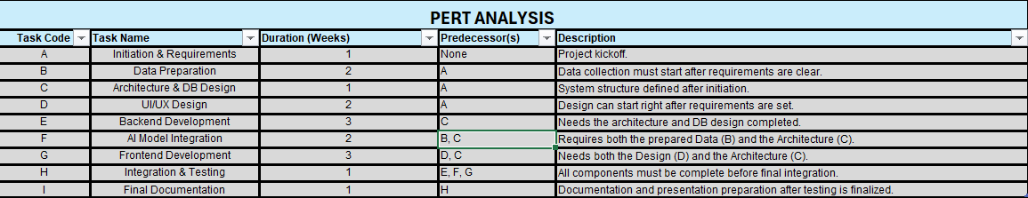

2-Pert Analysıs
Initial duration estimates were derived using the PERT (Program Evaluation and Review Technique) method, which employs Optimistic (O), Most Likely (M), and Pessimistic (P) estimates to calculate a statistically realistic Expected Time (TE) for each task. The calculated TE values (as seen in the subsequent PERT Analysis table) guide the allocation of resources and form the basis of the final project schedule.These estimates reduce uncertainty and improve schedule reliability.

3-Critical Path Analysis (CPA)
The CPA determines the minimum time required to complete the project by identifying the longest sequence of dependent tasks. The total duration of all possible paths was calculated using the TE values:
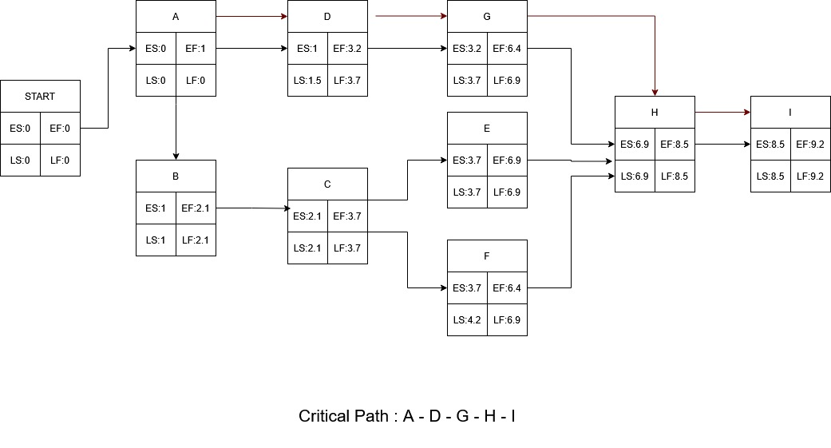

Conclusion and Implications:
The critical path of the project has been identified as:
A → D → G → H → I
(Initiation → UI/UX Design → Frontend Development → Integration → Documentation).
- Based on critical path analysis, the total estimated project duration is approximately 9.2 weeks, as indicated by the earliest completion date of the last activity (I). This exceeds the strict 8-week academic deadline by approximately 1.2 weeks, which represents a significant risk to the schedule.
- Fast-tracking: Starting Frontend Development (G) before UI/UX Design (D) is fully complete.
- Crashing: Allocating additional resources or time to critical tasks (D and G) to shorten their duration.
These strategies aim to ensure that the project is completed within the defined timeframe while maintaining quality.
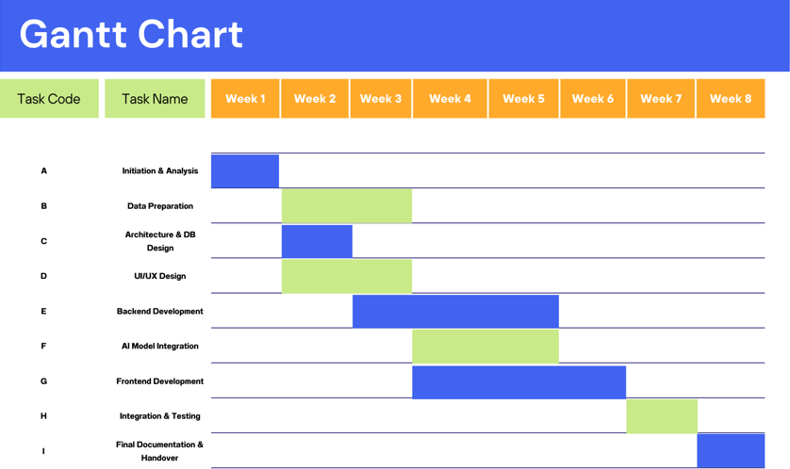

4-Gantt Chart
The Gantt Chart below visually translates the PERT analysis into a week-by-week timeline. It clearly illustrates task durations, dependencies, and concurrent work, with the Critical Path tasks highlighted to guide project monitoring. This timeline provides a realistic and controllable roadmap for the successful completion of the project.

