**ÇIKTI – 1**

[INFO] loading CIFAR-10 data...

170500096/170498071 [==============================] - 11s 0us/step

[INFO] compiling model...

[INFO] training network for 30 epochs...

Train on 50000 samples, validate on 10000 samples

Epoch 1/30

50000/50000 [==============================] - 331s 7ms/step - loss: 1.5303 - accuracy: 0.4788 - val_loss: 1.2373 - val_accuracy: 0.5700

Epoch 2/30

50000/50000 [==============================] - 327s 7ms/step - loss: 1.0410 - accuracy: 0.6337 - val_loss: 0.8672 - val_accuracy: 0.6875

Epoch 3/30

50000/50000 [==============================] - 322s 6ms/step - loss: 0.8962 - accuracy: 0.6858 - val_loss: 0.8127 - val_accuracy: 0.7140

Epoch 4/30

50000/50000 [==============================] - 320s 6ms/step - loss: 0.8130 - accuracy: 0.7157 - val_loss: 0.7470 - val_accuracy: 0.7334

Epoch 5/30

50000/50000 [==============================] - 312s 6ms/step - loss: 0.7404 - accuracy: 0.7401 - val_loss: 0.7043 - val_accuracy: 0.7550

Epoch 6/30

50000/50000 [==============================] - 314s 6ms/step - loss: 0.6859 - accuracy: 0.7597 - val_loss: 0.6296 - val_accuracy: 0.7754

Epoch 7/30

50000/50000 [==============================] - 309s 6ms/step - loss: 0.6349 - accuracy: 0.7769 - val_loss: 0.5986 - val_accuracy: 0.7905

Epoch 8/30

50000/50000 [==============================] - 306s 6ms/step - loss: 0.5961 - accuracy: 0.7914 - val_loss: 0.5872 - val_accuracy: 0.7940

Epoch 9/30

50000/50000 [==============================] - 304s 6ms/step - loss: 0.5581 - accuracy: 0.8042 - val_loss: 0.5610 - val_accuracy: 0.8062

Epoch 10/30

50000/50000 [==============================] - 306s 6ms/step - loss: 0.5278 - accuracy: 0.8137 - val_loss: 0.5975 - val_accuracy: 0.8015

Epoch 11/30

50000/50000 [==============================] - 302s 6ms/step - loss: 0.5005 - accuracy: 0.8245 - val_loss: 0.5451 - val_accuracy: 0.8102

Epoch 12/30

50000/50000 [==============================] - 298s 6ms/step - loss: 0.4844 - accuracy: 0.8289 - val_loss: 0.5460 - val_accuracy: 0.8120

Epoch 13/30

50000/50000 [==============================] - 299s 6ms/step - loss: 0.4633 - accuracy: 0.8359 - val_loss: 0.5312 - val_accuracy: 0.8208

Epoch 14/30

50000/50000 [==============================] - 300s 6ms/step - loss: 0.4497 - accuracy: 0.8389 - val_loss: 0.5276 - val_accuracy: 0.8183

Epoch 15/30

50000/50000 [==============================] - 299s 6ms/step - loss: 0.4287 - accuracy: 0.8485 - val_loss: 0.5279 - val_accuracy: 0.8196

Epoch 16/30

50000/50000 [==============================] - 303s 6ms/step - loss: 0.4083 - accuracy: 0.8546 - val_loss: 0.5480 - val_accuracy: 0.8209

Epoch 17/30

50000/50000 [==============================] - 301s 6ms/step - loss: 0.3969 - accuracy: 0.8599 - val_loss: 0.5311 - val_accuracy: 0.8229

Epoch 18/30

50000/50000 [==============================] - 305s 6ms/step - loss: 0.3941 - accuracy: 0.8609 - val_loss: 0.5374 - val_accuracy: 0.8217

Epoch 19/30

50000/50000 [==============================] - 306s 6ms/step - loss: 0.3751 - accuracy: 0.8670 - val_loss: 0.5611 - val_accuracy: 0.8148

Epoch 20/30

50000/50000 [==============================] - 307s 6ms/step - loss: 0.3675 - accuracy: 0.8699 - val_loss: 0.5287 - val_accuracy: 0.8232

Epoch 21/30

50000/50000 [==============================] - 301s 6ms/step - loss: 0.3547 - accuracy: 0.8752 - val_loss: 0.5276 - val_accuracy: 0.8247

Epoch 22/30

50000/50000 [==============================] - 305s 6ms/step - loss: 0.3435 - accuracy: 0.8795 - val_loss: 0.5378 - val_accuracy: 0.8270

Epoch 23/30

50000/50000 [==============================] - 300s 6ms/step - loss: 0.3373 - accuracy: 0.8813 - val_loss: 0.5452 - val_accuracy: 0.8206

Epoch 24/30

50000/50000 [==============================] - 303s 6ms/step - loss: 0.3268 - accuracy: 0.8839 - val_loss: 0.5244 - val_accuracy: 0.8240

Epoch 25/30

50000/50000 [==============================] - 300s 6ms/step - loss: 0.3156 - accuracy: 0.8881 - val_loss: 0.5324 - val_accuracy: 0.8275

Epoch 26/30

50000/50000 [==============================] - 305s 6ms/step - loss: 0.3179 - accuracy: 0.8867 - val_loss: 0.5211 - val_accuracy: 0.8288

Epoch 27/30

50000/50000 [==============================] - 301s 6ms/step - loss: 0.3086 - accuracy: 0.8897 - val_loss: 0.5409 - val_accuracy: 0.8269

Epoch 28/30

50000/50000 [==============================] - 304s 6ms/step - loss: 0.3079 - accuracy: 0.8899 - val_loss: 0.5158 - val_accuracy: 0.8325

Epoch 29/30

50000/50000 [==============================] - 299s 6ms/step - loss: 0.2982 - accuracy: 0.8947 - val_loss: 0.5232 - val_accuracy: 0.8307

Epoch 30/30

50000/50000 [==============================] - 298s 6ms/step - loss: 0.2941 - accuracy: 0.8952 - val_loss: 0.5300 - val_accuracy: 0.8314

Time taken: 9189.5 seconds

[INFO] evaluating network...

precision recall f1-score support

airplane 0.90 0.81 0.85 1000

car 0.92 0.91 0.92 1000

bird 0.78 0.74 0.76 1000

cat 0.69 0.68 0.68 1000

deer 0.77 0.85 0.81 1000

dog 0.75 0.76 0.76 1000

frog 0.85 0.88 0.86 1000

horse 0.89 0.86 0.88 1000

ship 0.90 0.91 0.91 1000

truck 0.88 0.91 0.90 1000

accuracy 0.83 10000

macro avg 0.83 0.83 0.83 10000

weighted avg 0.83 0.83 0.83 10000

**ÇIKTI – 2**

<matplotlib.legend.Legend at 0x7fc535f33588>

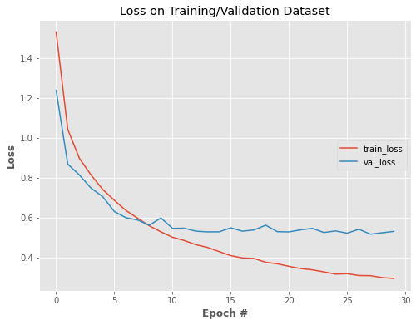

**ÇIKTI – 3**

<matplotlib.legend.Legend at 0x7fc535edac50>

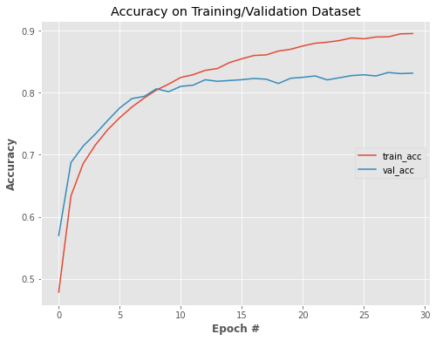

**ÇIKTI – 4**

Saved model to disk

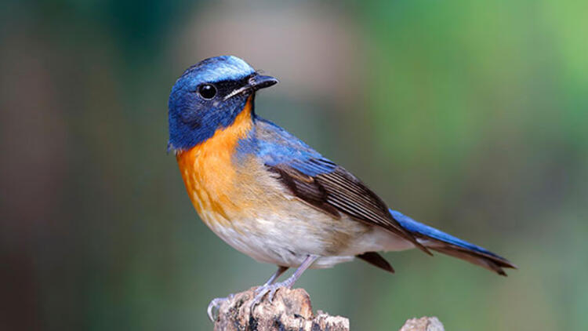

Text(0, 0.5, 'Category')

