EEE 313 INTRODUCTION TO EMBEDDED SYSTEMS
INTERM APPLICATION HOMEWORKS

(25P) Q2. Perform an application by using two buttons and one 7-segment display with your Rpi, STM32, Nano 33, or other board. The type of 7-segment will be assigned to the students as Common Anode or Common Cathode after assigning the boards to the students.
Purpose of Application: Implement a counter that counts forward from 0 to F when one button is pressed, and from F to 0 when the other button is pressed. Clearly state the intended purpose (i.e, what you are trying to do for each situation) in your video capture and in this document.
Circuit Diagram: You are free to build your circuit for application. Draw your circuit in Fritzing.
Restriction: Neither the Arduino IDE nor the Arduino programming language will be used when performing this application. Use only Thonny IDE with MicroPhython/CircuitPython or STM32CubeIDE with C/C++.
Homework Submission: Record a video with all the team members for your application. In your video content; explain your program codes, show your program to be compiled successfully, show your program to be uploaded to your board, show your circuit to be run successfully for each case. Note that no simulation study is requested.
The following files need to be uploaded to Teams.
- This word document by completing the ANSWERS section (do not upload as pdf)
- Your video file (Will be talked in English). Do NOT speak in Turkish! Show your face!)
- Fritzing circuit file
- Application project folder created by IDE software. Include your source file
Deadline for submission: 22nd December, 2024. Note that 5 points from 25 will be deducted for each day of late uploading!. The system will be closed 4 days later than the deadline!
------------------------------------------------ANSWERS-----------------------------------------------
Project Team: Aslı İZCİ – Gözde Nur ATIL
Your Board: STM32F411RET6
Your 7-segment Display Type: Common Anode.
Your Software IDE: STM32CubeIDE.
Your Programming Language: C/C++.
Application Purpose: This application creates a counter that increments from 0 to F when one button is pressed and decrements from F to 0 when another button is pressed. The current value is displayed in hexadecimal format on a 7-segment display.
Fritzing Circuit Diagram:
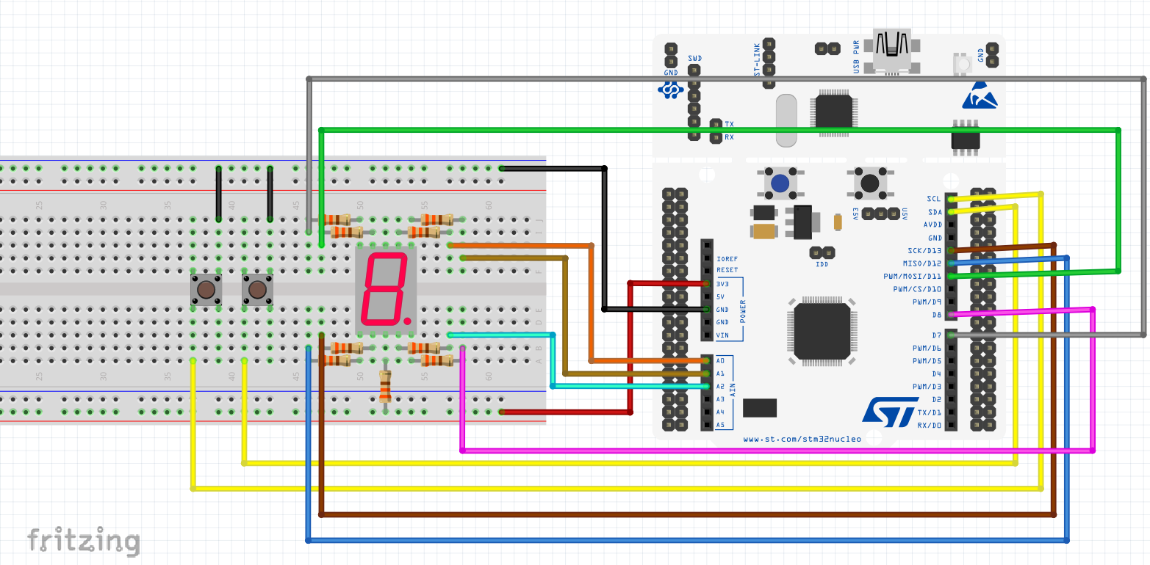
Program codes:
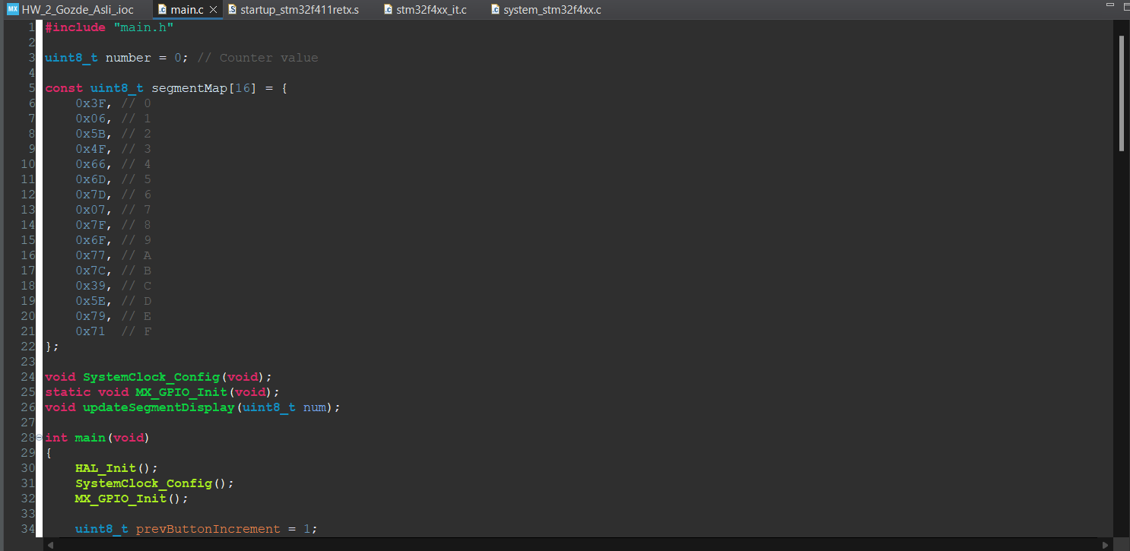
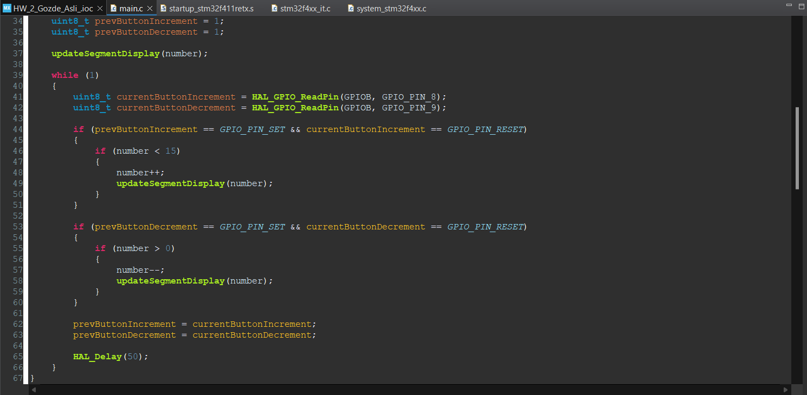
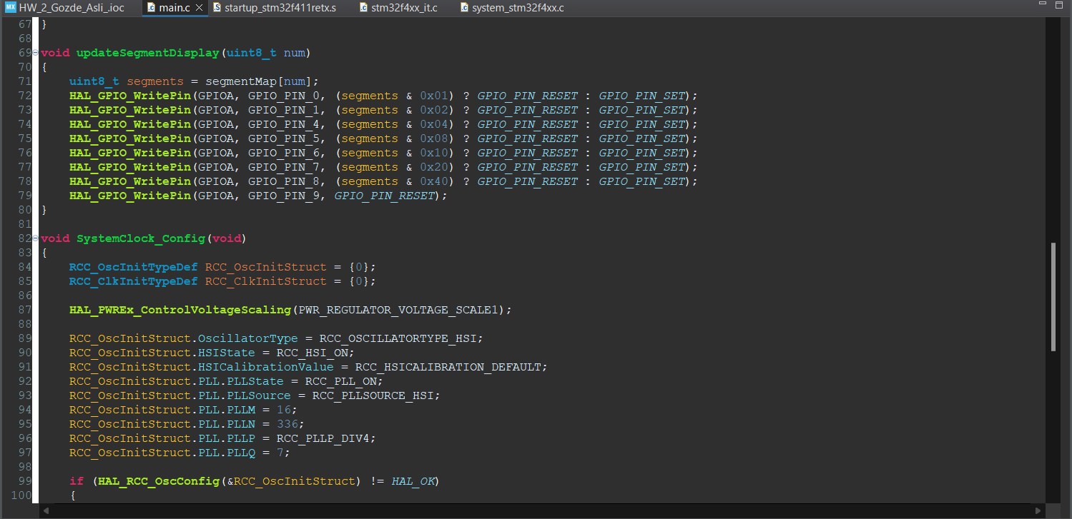
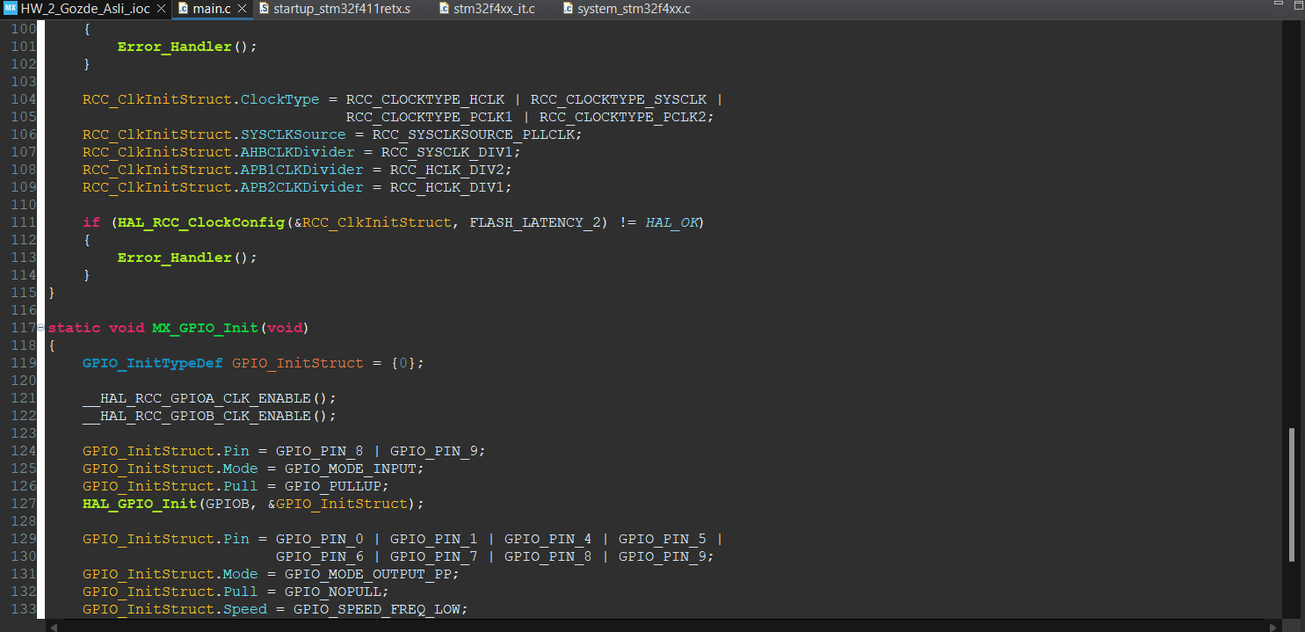
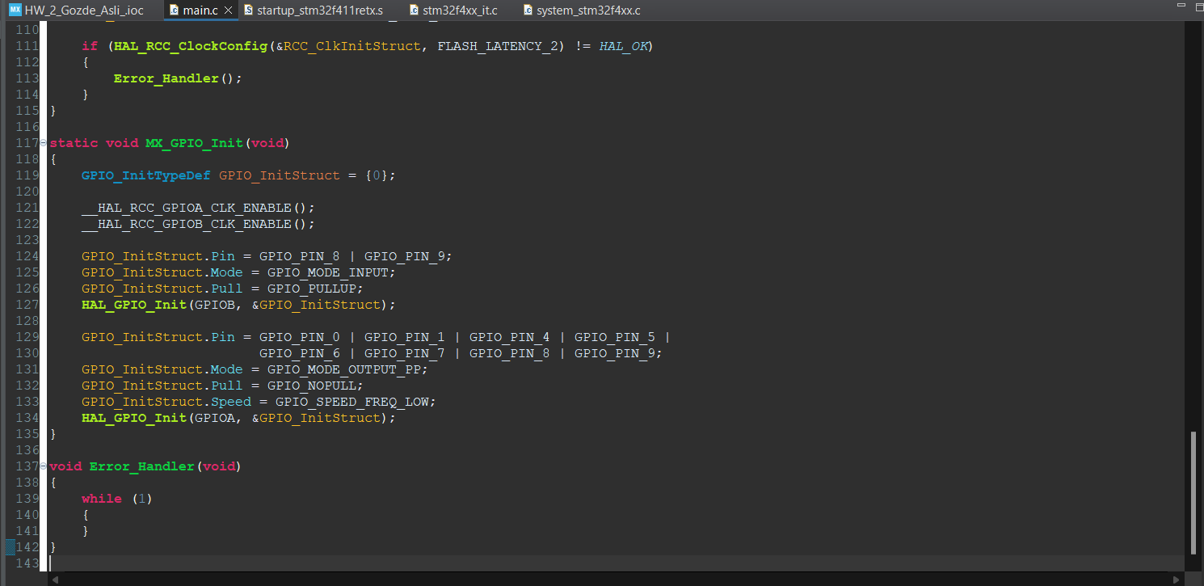
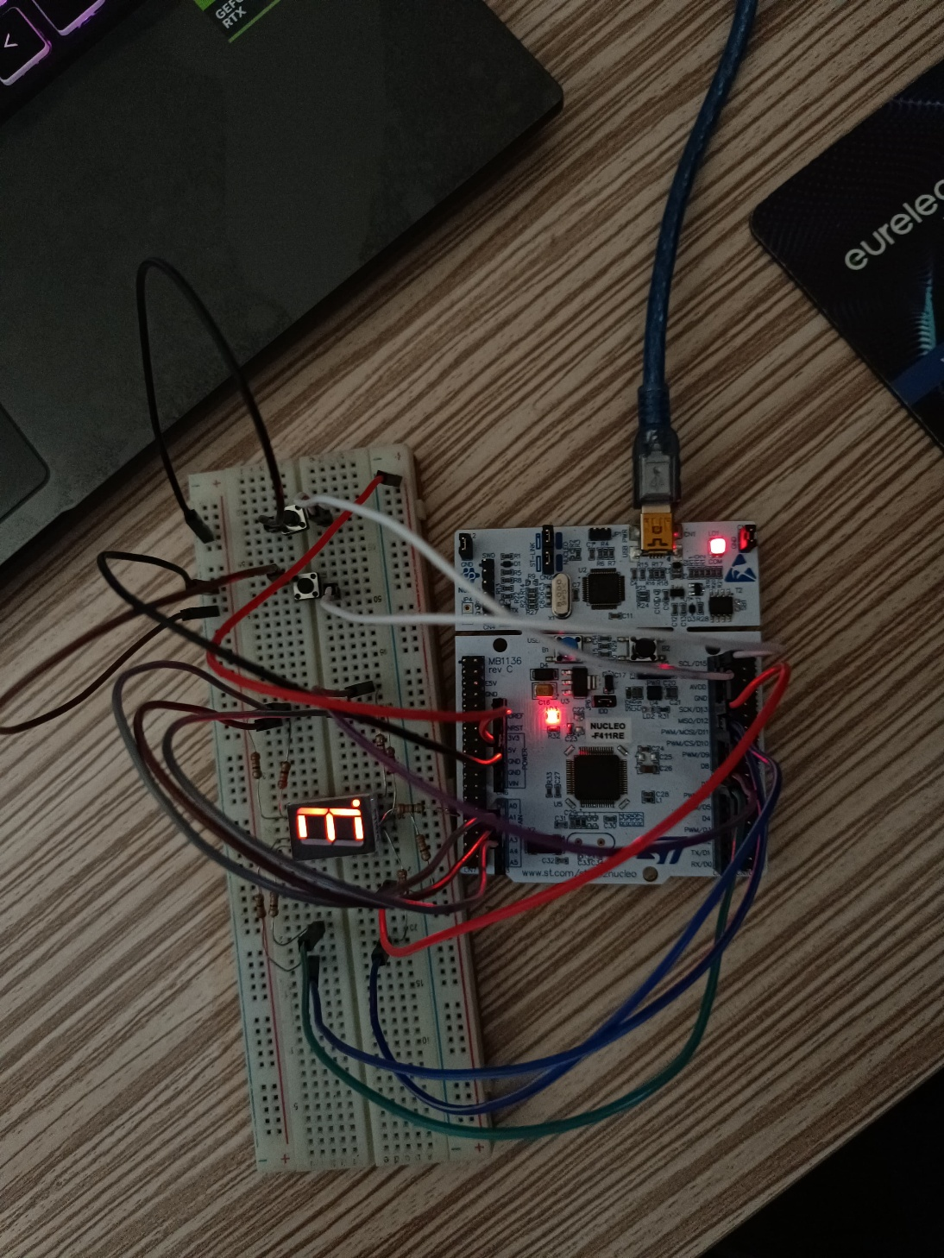
Photo for your circuit (only 1 photo):

