EEE 313 INTRODUCTION TO EMBEDDED SYSTEMS
INTERM APPLICATION HOMEWORKS

(25P) Q4. Perform an application by using one RGB (assigned for Q1), one buzzer, and one sensor (will be assigned later) with your Rpi, STM32, Nano 33, or other board. The type of sensor will be assigned to the students after assigning the boards to the students.

Purpose of Application: You are free about the purpose of application. Clearly state the intended purpose (i.e, what you are trying to do for each situation) in your video capture and in this document.
Circuit Diagram: You are free to build your circuit for application. Draw your circuit in Fritzing.
Restriction: Neither the Arduino IDE nor the Arduino programming language will be used when performing this application. Use only Thonny IDE with MicroPhython/CircuitPython or STM32CubeIDE with C/C++.
Homework Submission: Record a video with all the team members for your application. In your video content; explain your program codes, show your program to be compiled successfully, show your program to be uploaded to your board, show your circuit to be run successfully for each case. Note that no simulation study is requested.
The following files need to be uploaded to Teams.
- This word document by completing the ANSWERS section (do not upload as pdf)
- Your video file (Will be talked in English). Do NOT speak in Turkish! Show your face!)
- Fritzing circuit file
- Application project folder created by IDE software. Include your source file

Deadline for submission: 5th January, 2025. Note that 5 points from 25 will be deducted for each day of late uploading!. The system will be closed 4 days later than the deadline!

------------------------------------------------ANSWERS-----------------------------------------------
Project Team: Aslı İZCİ – Gözde Nur ATIL
Your Board: STM32F411RET6
Your Sensor Type: LDR Sensor
Your RGB Type: Common Anode
Your Software IDE: STM32CubeIDE.
Your Programming Language: C/C++.
Application Purpose: The purpose of this project is to develop a system that adjusts the buzzer's frequency based on ambient light intensity and changes the color of the RGB LED according to the light level. As the light intensity increases, the buzzer will beep more frequently, and the LED will turn red to alert the user.

Fritzing Circuit Diagram:
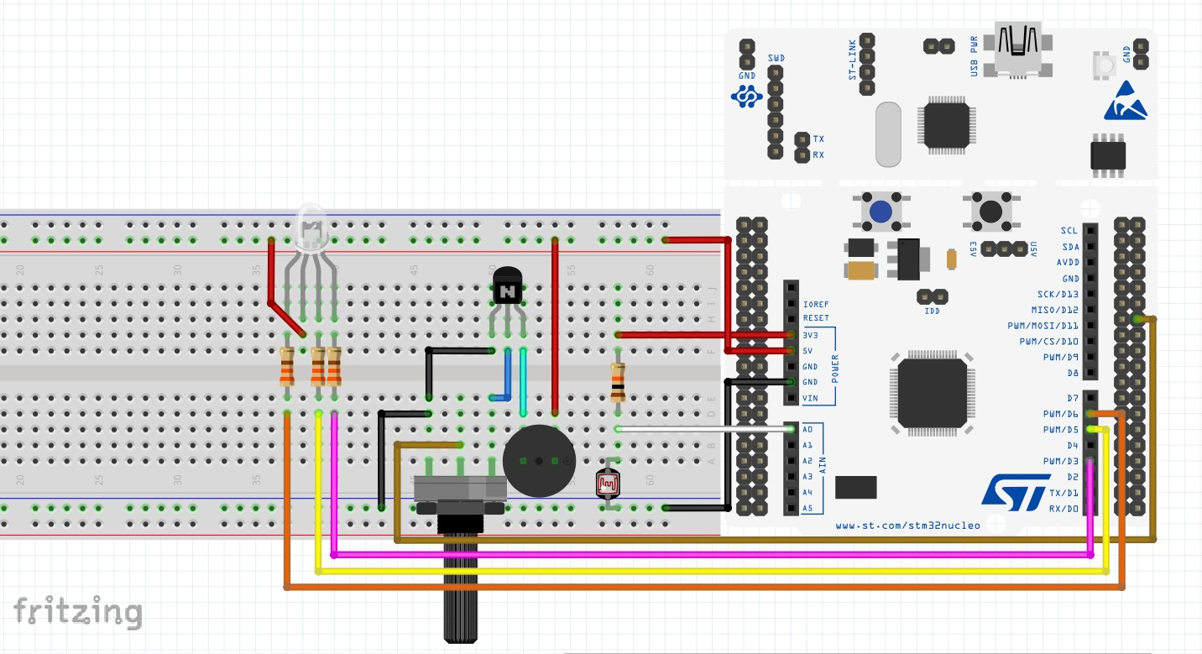
Program codes:
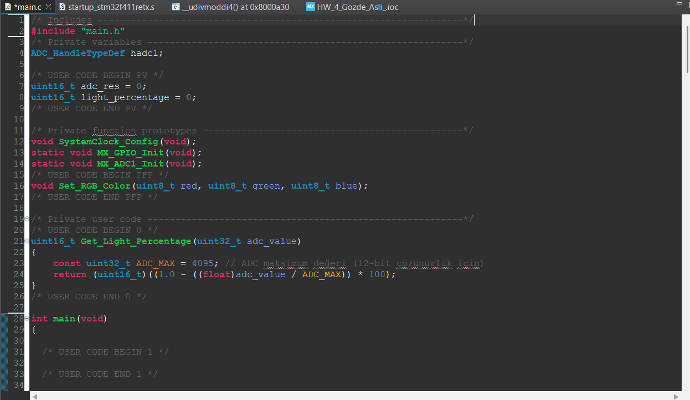
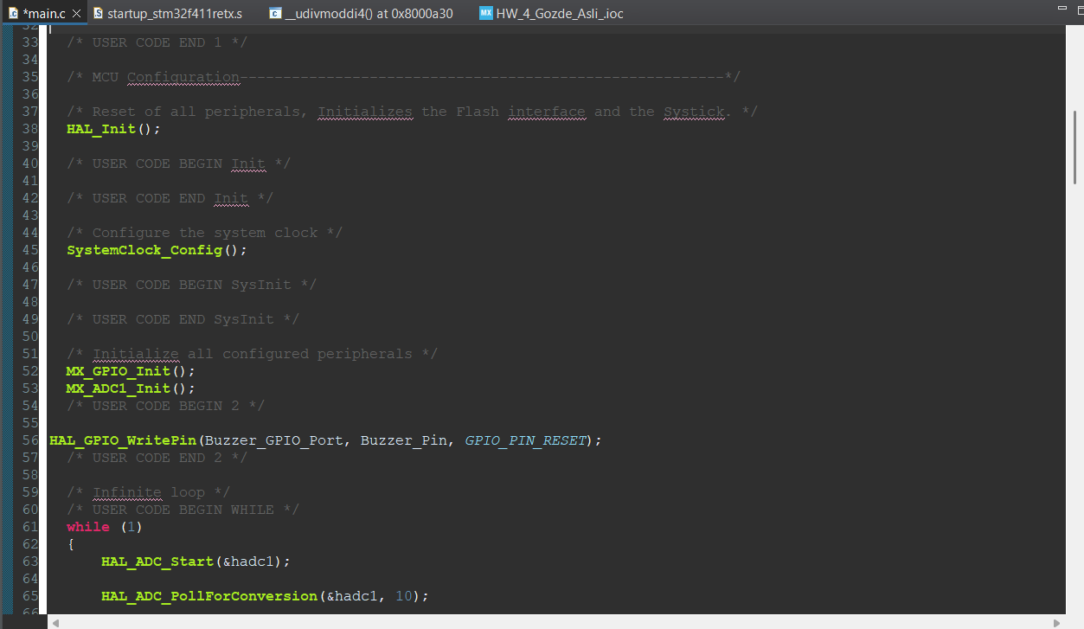
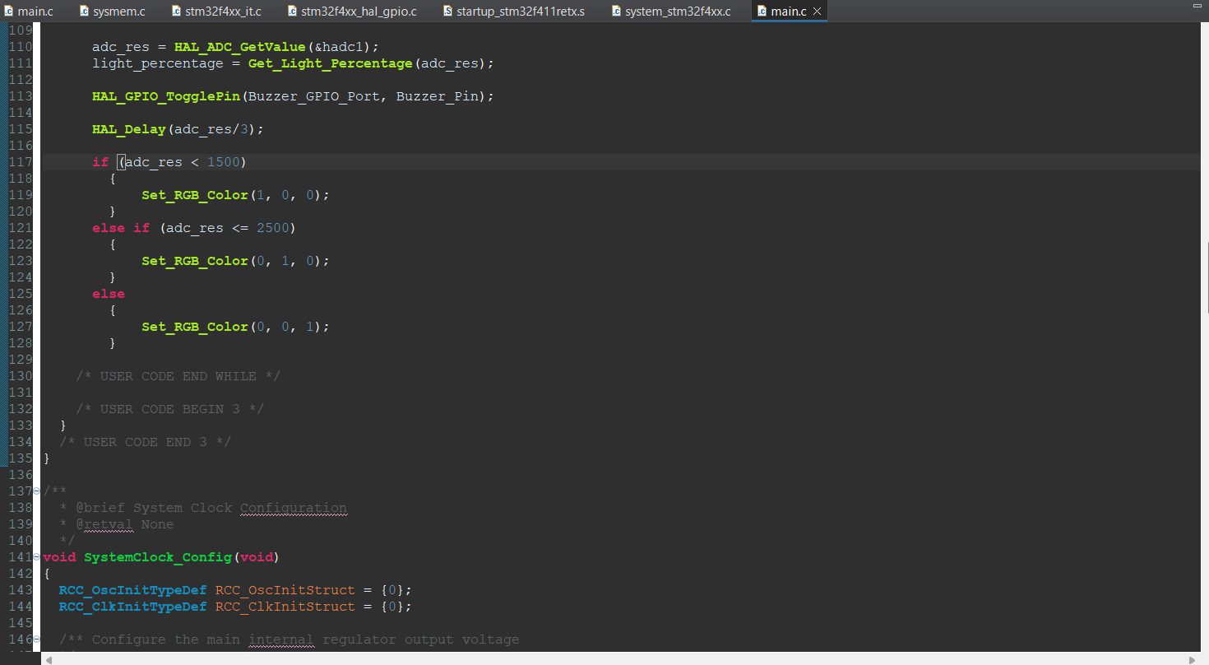
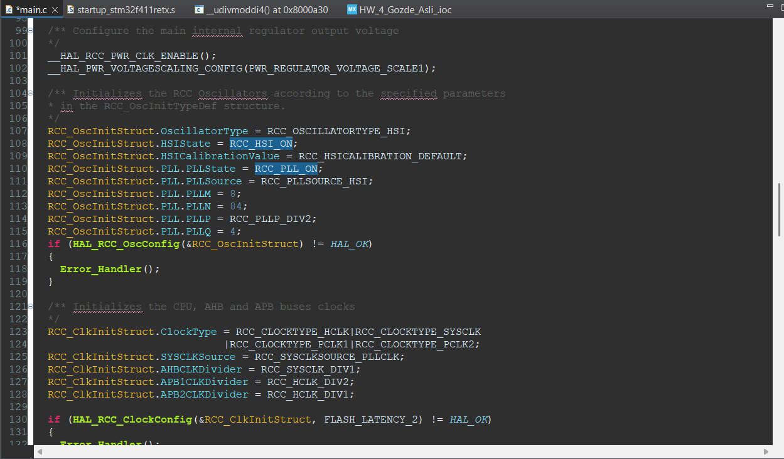
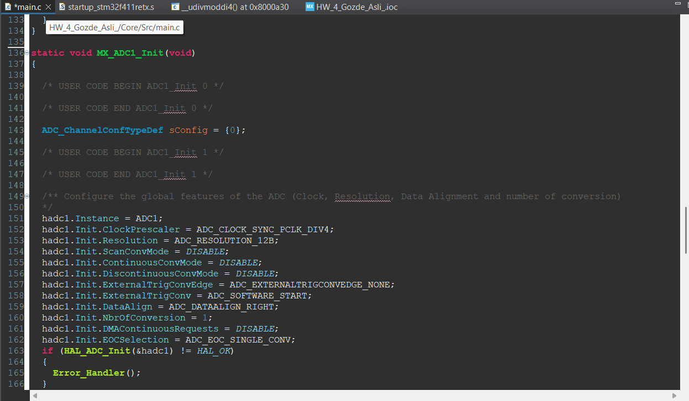
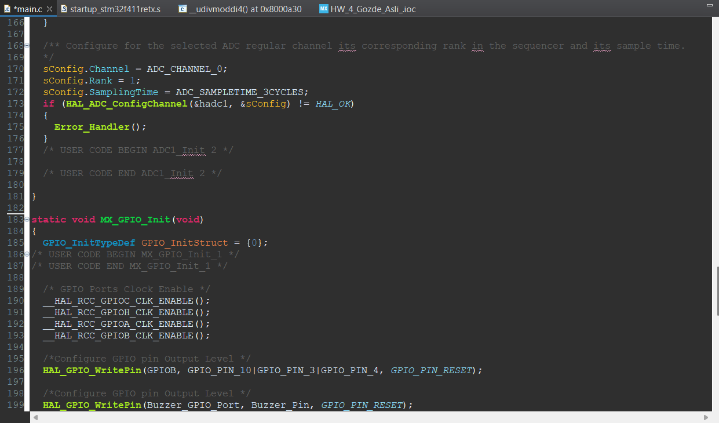
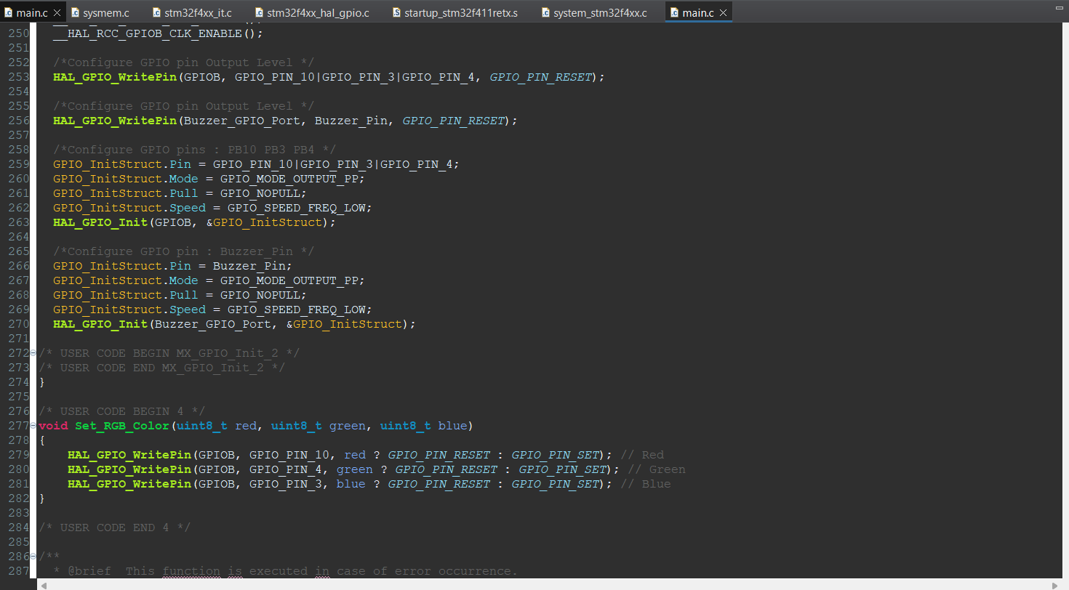
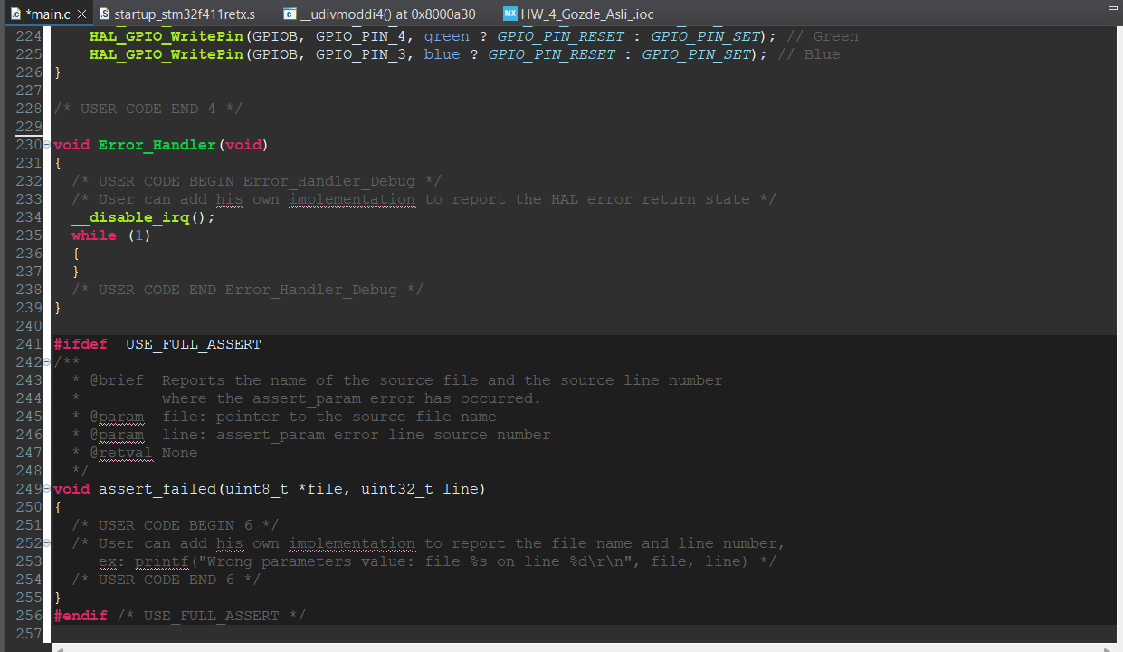

Photo for your circuit (only 1 photo):
