Part 2
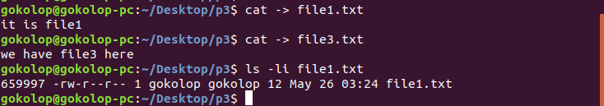

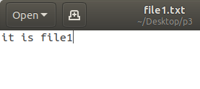
We created the files file1.txt and file3.txt with the content as seen above. Then, we access the file1.txt’s inode number with the command “ls -li <filename>”, which is 659997 in this case. Then we create a hard link to file1.txt and create file2.txt.

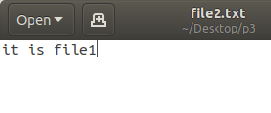
The hard linked file has the same content and the same inode number as the original file as seen in the screenshot below.
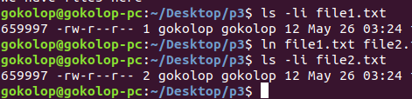
When you edit file2.txt, because of the hard link, file1.txt’s content also changes.
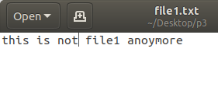
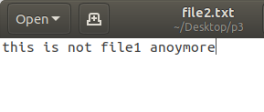
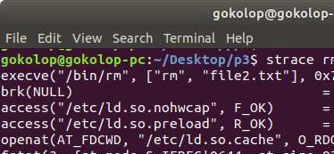
After removing file1.txt, file2.txt still exists with the same content written in it.
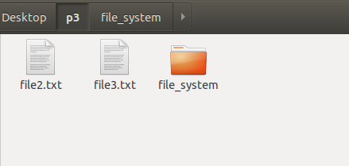

When we try to remove file2.txt, execve system call is used with the parameters rm and file2.txt.
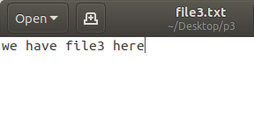
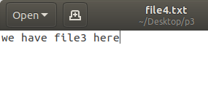

When we examing the remaining two files, we can see that their inode numbers are different, because of the soft link that we created.
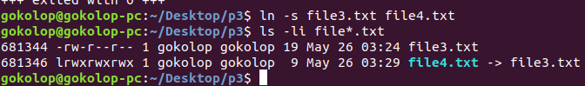
Then, after we edit file4.txt, file3.txt’s contents are altered aswell.
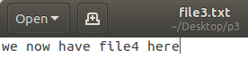
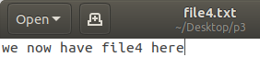

Lastly, after we remove file3.txt, when we try to edit file4.txt again, we come across with an error shown below.
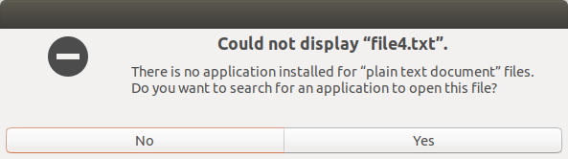
A short link acts like a shortcut file when it comes to open a removed file. While a hard link is an exact copy of a file with the same inode number, a short link creates a pointer to the original file. When you destroy the pointed object. You cannot open the short linked file.

Part 1- implementation
In our implementation, we changed the global variable PAGES from 256 to 64 as to make the memory smaller, requiring page replacement policies to effectively manage the memory. However we had to keep the MEMORY_SIZE global variable the same size, otherwise the rest of the implementation gave a segmentation fault error. For the Least Recently Used policy, we had to devise a way to keep the access times of the elements in the memory. This way we could get the information of the most recently used and the least recently used elements. The lru_tracker is initialized to be -1. In each access, whether it is from the TLB or the pagetable, we update the corresponding element’s access time. For the access time stamp, we used the already given total_addresses variable which starts from 0 and increases by one at each element access.
We also added a fifo_ptr which keeps track of the index of the oldest element in the page tabe to replace. Modifying the max function given, we wrote a min function. Since access times are ever increasing, it is the greatest for the recently accesses and smallest for the least recently accesses element. Thus we needed a min function.
However the most important addition we did was to write the search_table function. This looks through the page table to find the index(which corresponds to the physical address) of the given logical address. Since the virtual-physical memory sizes are no longer the same, we need a search function to look through the table. To increase efficiency, we used an “early return”, as soon as there is a logical address match, no need to keep looking and the function immediately returns the index. If no match is found, it returns 0.
In our implementation, the argument is -p and 0/1. We keep the replacement policy information in the dir variable. In the flow, if there is a tlb miss, we use the search_table function to look for the logical page. If it is a miss, it means page fault, then we look for an empty memory slot. If found we just occupy that part, otherwise we use the preferred page replacement method to choose the victim slot. For the fifo replacement we had to use modulo as it circularly keeps track of the “ages” of the elements. We looked at the TLB fifo implementation for this as an example.
For the LRU replacement, we find the min element in the lru_tracker array, which corresponds to the element that is least recently used, then choose it as the victim.
In all the access scenarios, we update the lru_tracker in the following way:
lru_tracker[physical_page]=total_addresses;
in which the total_address acts as a time stamp.

