**Project Report:** Development of a Neural Network-Based Chat-Bot

**Group Members:** Alper Sertbaş, Alper Turacı, Aslınur Tezcan

**1. Introduction**

**1.1 Project Objective**

The objective of this project is to develop a chat-bot that can recommend suitable laptops based on user preferences. The chat-bot aims to find the best laptop for the user according to specified criteria.

**1.2 Scope**

The project does not aim to develop a fully functional natural language processing (NLP) chat-bot. Instead, the goal is to create a system that can provide meaningful responses and recommendations for several rounds of conversation.

**1.3 Importance of the Project**

This project aims to assist users in making informed decisions when choosing a laptop, thus simplifying the process of selecting a technological product. It also serves as an opportunity to learn and practice basic neural network applications.

**2. Materials and Methods**

**2.1 Development Environment**

The project was developed using the Python programming language, which was chosen for its extensive library support and flexibility.

**2.2 Libraries**

Key libraries used in the project include:

Pandas: For data loading and preprocessing.

Scikit-learn: For data splitting, scaling, and similarity calculations.

TensorFlow/Keras: For building and training the neural network model.

Numpy: For numerical operations and data manipulation.

**2.3 Data Sources**

The dataset used for the project is a CSV file containing technical specifications of various laptops. This dataset includes features such as brand, model, screen size, weight, and price.

**2.4 Network Design**

The neural network architecture is as follows:

LSTM Layer: With 50 units, used to process the input as a time series.

Dense Layer: Output layer, used to reconstruct the input features.

The model was compiled with the 'adam' optimizer and 'mean_squared_error' loss function and trained using these settings.

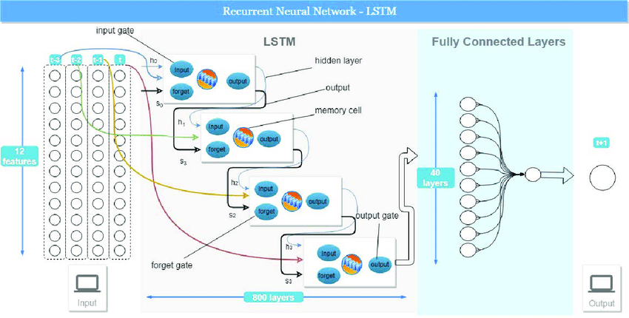

**2.5 Training and Testing Phases**

The dataset was split into training and testing sets (80% training, 20% testing). The data was scaled using StandardScaler and reshaped to fit the LSTM model.

**3. Implementation and Results**

**3.1 Chat-Bot Functions**

The chat-bot collects user preferences such as brand, model, screen size, resolution, CPU, RAM, storage, GPU, operating system, weight, and price to recommend the most suitable laptops.

**3.2 Example Usage Scenarios**

Example scenarios include:

A user looking for a laptop within a specific brand and price range.

A user looking for a laptop with a specific screen size and weight range.

**3.3 Performance Evaluation**

The model's performance was evaluated using the mean_squared_error metric on the test data. Additionally, cosine similarity was used to find the most similar laptops, ensuring they fall within the user's specified price range.

**4. Discussion**

**4.1 Strengths of the Project**

User-friendly and interactive system.

Capable of providing meaningful recommendations based on user preferences.

**4.2 Weaknesses and Limitations**

The dataset contains a limited number of laptops.

May not fully match user preferences in all cases.

**4.3 Improvement Suggestions**

Expanding the dataset with more laptop entries.

Incorporating NLP techniques for more natural interactions.

**5. Conclusion**

This project developed a basic chat-bot that can recommend laptops based on user preferences using neural networks. Future improvements could enhance the system's effectiveness and scope.

**6. Appendices**

<https://github.com/aslinurtezcan/Laptop-Recommendation-Chat-Bot>

**7. References**

<https://www.kaggle.com/datasets/ganeshmohane/laptop-datacsv>