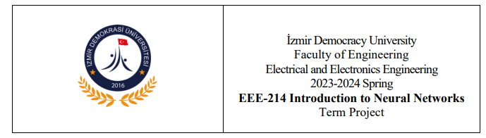

**Academic Staff:** Asst. Prf.Çağlar Cengizler

**Project Report:** Development of a Neural Network-Based Chat-Bot

**Group Members:** Alper Sertbaş (alpersertbas3@gmail.com), Alper Turacı (alperturaci298@gmail.com), Aslınur Tezcan ([aslinurtezcan@gmail.com](mailto:aslinurtezcan@gmail.com))

**Github Name And Link:** Laptop-Recommendation-Chat-Bot / [GitHub - aslinurtezcan/Laptop-Recommendation-Chat-Bot](https://github.com/aslinurtezcan/Laptop-Recommendation-Chat-Bot)

**1. Introduction**

**1.1 Project Objective**

The objective of this project is to develop a chat-bot that can recommend suitable laptops based on user preferences. The chat-bot aims to find the best laptop for the user according to specified criteria.

**1.2 Importance of the Project**

The goal was to create a system that can provide meaningful responses and recommendations for several rounds of conversation.

This project aims to assist users in making informed decisions when choosing a laptop, thus simplifying the process of selecting a technological product. It also serves as an opportunity to learn and practice basic neural network applications.

**2. Materials and Methods**

**2.1 Development Environment**

The project was developed using the Python programming language, which was chosen for its extensive library support and flexibility.

**2.2 Libraries**

Key libraries used in the project include:

Pandas: For data loading and preprocessing.

Scikit-learn: For data splitting, scaling, and similarity calculations.

TensorFlow/Keras: For building and training the neural network model.

Numpy: For numerical operations and data manipulation.

**2.3 Data Sources**

The dataset used for the project is a CSV file containing technical specifications of various laptops. This dataset includes features such as brand, model, screen size, weight, and price.

**2.4 Network Design**

The code creates a recommendation system that processes user preferences and offers laptop recommendations using an LSTM (Long Short-Term Memory) model. While the LSTM model is frequently preferred in such projects with its ability to process the data set as a time series, the most suitable laptops are determined by using sophisticated calculation methods such as cosine similarity for the recommendation system. The preferences received from the user are made suitable for the model with LabelEncoder and are made understandable by humans while offering suggestions. This approach is too complex and user-oriented to be solved with simple if-else constructs.

The neural network architecture is as follows:

LSTM Layer: With 64 units, used to process the input as a time series.

The model was compiled with the 'adam' optimizer and 'mean_squared_error' loss function and trained using these settings.

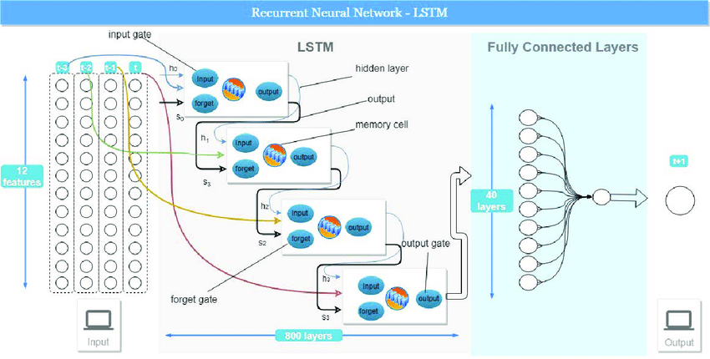

**2.5 Training and Testing Phases**

The dataset was split into training and testing sets (80% training, 20% testing). The data was scaled using StandardScaler and reshaped to fit the LSTM model.

**3. Implementation and Results**

**3.1 Chat-Bot Functions**

The chat-bot collects user preferences such as brand, model, screen size, resolution, CPU, RAM, storage, GPU, operating system, weight, and price and then these inputs that given by the user are filtering by the chat-bot we created and it recommend the most suitable laptops out of many options.

**3.2 Example Usage Scenarios**

There is a two photos, first one is the process of chat-bot helping us through chatting and collecting the informations at the same time. Second photo is the output ( one of the computers that recommended by the chat-bot according the informations we gave.)

**metin, ekran görüntüsü, yazı tipi, sayı, numara içeren bir resim

Açıklama otomatik olarak oluşturuldu**

**metin, ekran görüntüsü, yazı tipi, sayı, numara içeren bir resim

Açıklama otomatik olarak oluşturuldu**

**3.3 Performance Evaluation**

The model's performance was evaluated using the mean_squared_error metric on the test data. Additionally, cosine similarity was used to find the most similar laptops, ensuring they fall within the user's specified price range. The main difference in why the MSE metric is so high is based on this; When working with data containing large numbers, such as laptop prices, this type of error may be more tolerable. However, the data may need to be revisited to further reduce the model's error.

**4. Discussion**

**4.1 Strengths of the Project**

User-friendly and interactive system.

Capable of providing meaningful recommendations based on user preferences.

**4.2 Weaknesses and Limitations**

The dataset contains a limited number of laptops.

May not fully match user preferences in all cases.

**4.3 Improvement Suggestions**

Expanding the dataset with more laptop entries.

Incorporating NLP techniques for more natural interactions.

**5. Conclusion**

This project developed a basic chat-bot that can recommend laptops based on user preferences using neural networks. We did able to make a chat-bot that helps us to choose the best option out of many, thanks to this we will be able to save time and also we will not lose ourselves inside of the many computers but we will just go directly find what we exactly desire. We are aware that it can give more precise results so, by the future improvements could enhance the system's effectiveness and its scope.

**6. Appendices**

<https://github.com/aslinurtezcan/Laptop-Recommendation-Chat-Bot>

**7. References**

<https://www.kaggle.com/datasets/ganeshmohane/laptop-datacsv>