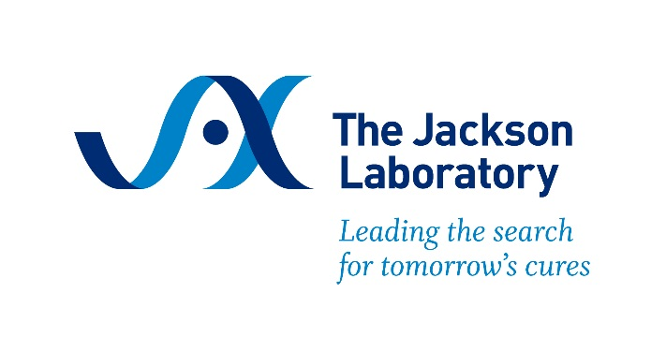

**Computational Techniques and Resources for Effective Translational Research in Alzheimer’s Disease**

**May 5-8, 2025**

**Schedule Subject to Change**

**Sunday, May 4th**

3:00 – 5:00 PM Arrivals (Highseas Conference Center)

5:00 – 6:00 PM Social Hour & Welcome (Highseas 1st floor)

6:00 – 7:00 PM Dinner

**Monday, May 5th**

7:00 – 8:00 AM Breakfast(Highseas 1st floor)

8:00 – 8:30 AM **Welcome and** **Course Overview** (Highseas 3rd floor)  
Asli Uyar, Ph.D., The Jackson Laboratory

8:30 – 9:15 AM **NIA Translational Programs**   
Suzana Petanceska, Ph.D., NIH, National Institute on Aging

9:15 – 10:05 AM **Clinical and Neuropathological Heterogeneity of Alzheimer’s Disease**

Nilüfer Ertekin-Taner, M.D., Ph.D., Mayo Clinic

10:05 – 10:15 AM Break

10:15 AM – 12:15 PM **Workshop: Introduction to Synapse and The AD Knowledge Portal**

Laura Heath, Ph.D., Sage Bionetworks

12:15 – 1:00 PM Lunch (Highseas 1st floor)

1:00 – 2:00 PM **Transcriptomic Landscape in Alzheimer’s Disease**  
Vilas Menon, Ph.D., Columbia University

2:00 – 4:30 PM **Workshop: Computational Workflows for Single Cell and Spatial Transcriptomics**

Robert Butler III, Ph.D., Stanford University

6:00 – 7:00 PM Dinner (Highseas 1st floor)

7:00 – 8:30 PM **Open Forum: Participants' Experience with Biomedical Data Repositories and Knowledgebases** (Highseas 1st floor)   
Laura Heath, Ph.D., Sage Bionetworks

**Tuesday, May 6th**

7:00 – 8:00 AM Breakfast(Highseas 1st floor)

8:00 – 9:00 AM **Mouse Models of AD & MODEL-AD Overview** (Highseas 3rd floor)  
Kim Green, Ph.D., University of California, Irvine

9:00 AM – 12:00 PM **Workshop:** **Cross-Species Functional Alignment**

Greg Cary, Ph.D., The Jackson Laboratory

12:00 – 1:00 PM Lunch (Highseas 1st floor)

1:00 – 2:00 PM **Drug Repurposing to Target the Aging Process and Biology Underlying ADRD**  
Chia-Ling Kuo, Ph.D., University of Connecticut

2:00 – 4:00 PM **Integrated Multi-omics Analysis**

Ravi Pandey, Ph.D., The Jackson Laboratory

4:00 – 6:30 PM Group Outdoor Activity

6:30 – 7:30 PM Dinner (Highseas 1st floor)

7:30 – 8:30 PM **Open Forum: Open and Inclusive Research in AD and Aging** (Highseas 1st floor)   
 Susan McClatchy, M.S., The Jackson Laboratory

**Wednesday, May 7th**

7:00 – 8:00 AM Breakfast(Highseas 1st floor)

8:00 – 9:00 AM **Computational Science in AD: Promises and Challenges** (Highseas 3rd floor)  
Greg Carter, Ph.D., The Jackson Laboratory

9:00 AM – 12:00 PM **Workshop: Reproducibility Case Study**

Susan McClatchy, M.S., The Jackson Laboratory

12:00 – 1:00 PM Lunch (Highseas 1st floor)

1:00 – 2:00 PM **Predictive Modeling in AD and Aging** (Highseas 3rd Floor)  
Asli Uyar, Ph.D., The Jackson Laboratory

2:00 – 4:30 PM **Workshop: Introduction to Deep Learning Applications in Multi-Omics Data Analysis for AD**

Rohit Tripathy, Ph.D., The Jackson Laboratory

6:00 – 7:00 PM Lobster Dinner (Highseas 1st floor)

7:00 – 8:00 PM **Open Forum: Artificial Intelligence Approaches to Prevent, Detect, and Manage Dementia** (Highseas 1st floor)   
Vilas Menon, Ph.D., Columbia University

**Thursday, May 8th**

7:00 – 8:00 AM Breakfast(Highseas 1st floor)

8:00 – 9:00 AM **Molecular Subtypes of AD** (Highseas 3rd floor)  
Ryan Neff, M.D., Ph.D, The Moun Sinai Hospital

9:00 AM – 12:00 PM **Workshop: Choosing the Right Animal Model**

Asli Uyar, Ph.D., The Jackson Laboratory

Ravi Pandey, Ph.D., The Jackson Laboratory

Greg Cary, Ph.D., The Jackson Laboratory

12:00 – 1:00 PM Lunch (Highseas 1st floor)

1:00 – 4:00 PM **Bring Your Own Research Question** (Highseas 3rd Floor)  
All Faculty

4:00-4:30 PM **Course Summary**

Asli Uyar, Ph.D., The Jackson Laboratory

6:00 – 7:00 PM Dinner (Highseas 1st floor)

7:00 – 8:30 PM **Open Forum: AD Drug Development and Clinical Trials** (Highseas 1st floor)   
 Greg Cary, Ph.D., The Jackson Laboratory

**Friday, May 9th**

7:00 AM Grab and Go Breakfast (Highseas Snack Room)

9:00 AM Departures (Room check-out is 9:00am, but participants may stay on the first floor of Highseas until noon)