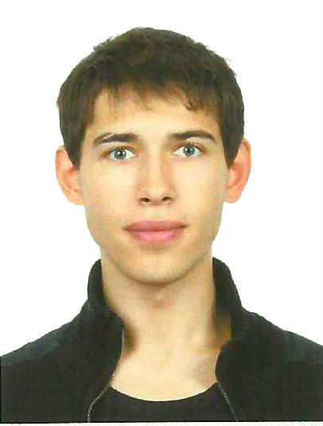
Andrey Lushnikov

Applying for
<..>

Personal
- location: Saint Petersburg, Russian Federation
- birthday: December 1, 1989
- e-mail: aslushnikov@gmail.com

Education
- Saint Petersburg State University
Department of Mathematics and Mechanics
2007-2012

Specialties
- Work experience with Android SDK, iOS, Java ME
- Aware of Java, Objective-C, web (ruby, node.js, HTML/Javascript/CSS), relational databases (MySQL, SQLite)
- Experienced in GIT; had times spent with Subversion as well
- Knowledge of algorithms and data structures

Projects
- iFree, freelance. December, 2011 – December, 2011 (link)
project: html5 chess game and checkers with offline AI
technologies: javascript
- Facebook inc, intern. August, 2011 – October, 2011 (link)
project: Facebook client for Android
technologies: Android SDK, javascript
- Saint-Petersburg Academic University, intern. April, 2011 – July, 2011 (link)
project: Web service for proteins morphing ( morph-pro.bioinf.spbau.ru)
technologies: ruby on rails, javascript, html/css, web GL
- SmartKupon, developer. July, 2010 – March, 2011 (link)
project: Java ME Client for mobile marketing startup
technologies: Java ME
- SmartKupon, developer. November, 2009 – June, 2010 (link)
project: iOS Client for mobile marketing startup
technologies: iPhone SDK 2.1, SQLite
- On-line testing system, developer. September, 2009 – October, 2009
project: system for powering test-based olympiads
technologies: PHP, javascript, html/css, MySQL
- Student project “Remote Viewer”. June, 2009 – August, 2009 (link)
project: client/server application for browsing any files on your mobile
technologies: Java ME

