For the third year in a row,**Python retains it's #1 dominance**followed by Java, C++, and Javascript.

This year's most noticeable changes were a **300% increase in Objective-C submissions**, a 100% surge in C#, as well as a 33% increase in Javascript submissions while PHP lost -55%, Perl dropped -16%, and Java shrank -14%.

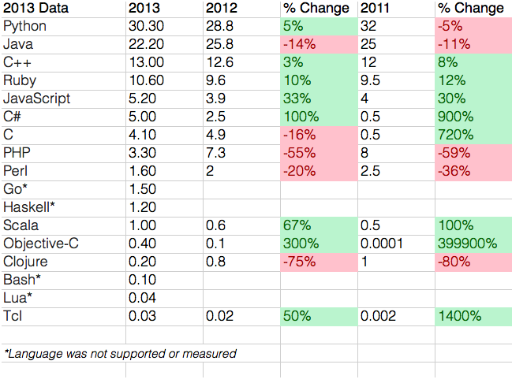

C# and Java are actually quite similar, from an application developer's perspective. The major similarities of these languages will be discussed here.

### All Objects are References

### C# and Java are Type-Safe Languages

### C# and Java Are "Pure" Object-Oriented Languages

### Single Inheritance

### Built-in Thread and Synchronization Support

### C - an older programming language that is described as Hands-on. As the programmer you must tell the program to do everything. Also this language will let you do almost anything. It does not support object orriented code. Thus no classes.  C++ - an extention language per se of C. In C code ++ means increment 1. Thus C++ is better than C. It allows for highly controlled object orriented code. Once again a very hands on language that goes into MUCH detail.  C# - Full object orriented code resembling the style of C/C++ code. This is really closer to JAVA. C# is the latest version of the C style languages and is very good for developing web applications.