cd /opt

unzip apache-activemq-5.14.0-bin.zip将下载好的activemq安装包解压

cp -r apache-activemq-5.14.0 /usr/local/software/activemq

cd /usr/local/software/activemq

ll

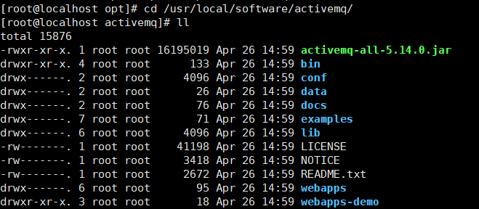

cd /etc/init.d

vim activemq 建立activemq脚本

#!/bin/bash

# chkconfig: 2345 19 81

# description: This is activemq

JAVA_HOME="/usr/local/software/jdk-8"

export JAVA_HOME

export CATALINA_HOME=/usr/local/software/activemq

case $1 in

start)

sh $CATALINA_HOME/bin/activemq start

;;

stop)

sh $CATALINA_HOME/bin/activemq stop

;;

restart)

sh $CATALINA_HOME/bin/activemq stop

sleep 1

sh $CATALINA_HOME/bin/activemq start

;;

esac

exit 0

/usr/local/software/activemq 是activemq路径 /usr/local/software/jdk-8 是jdk路径

chmod u+x activemq 添加执行权限

chkconfig activemq on 添加到系统服务当中去

firewall-cmd --zone=public --add-port=8161/tcp --permanent 开启8161端口 (web管理页面端口)

firewall-cmd --zone=public --add-port=61616/tcp --permanent 开启61616端口(activemq服务监控端口)

firewall-cmd --reload 重启防火墙

activemq.xml配置文件，启用延时投递

<broker xmlns="http://activemq.apache.org/schema/core" schedulerSupport="true" >

</broker>

service activeqmq start 开启服务

service activemq stop 停止服务

service activemq restart 重启服务

Web 管理页面默认密码是username:admin password:admin