将下载好的logstash 放到/opt目录

cd /opt

cp -r logstash-6.4.2 /usr/local/software/logstash

将mysql 的驱动加进来 mysql-connector-java

touch mysql.yml 新建数据和elasticsearch 映射配置

vim mysql.yml

input {

jdbc {

jdbc_driver_library => "/usr/local/software/logstash/bin/mysql-connector-java-5.1.44.jar"

jdbc_driver_class => "com.mysql.jdbc.Driver"

jdbc_connection_string => "jdbc:mysql://192.168.52.134:3306/zmw"

jdbc_user => "root"

jdbc_password => "123456"

schedule => "* * * * *"

statement => "select * from user_base_info where mw_id > :sql_last_value"

type => "user_base_info"

}

jdbc {

jdbc_driver_library => "/usr/local/software/logstash/bin/mysql-connector-java-5.1.44.jar"

jdbc_driver_class => "com.mysql.jdbc.Driver"

jdbc_connection_string => "jdbc:mysql://192.168.52.134:3306/zmw"

jdbc_user => "root"

jdbc_password => "123456"

schedule => "* * * * *"

statement => "select *,(select count(discuss_id)from discuss where discuss.article_id = article.article_id )as comment_number from article

left join article_content on article_content.content_id = article.content_id

left join article_attribute on article_attribute.attribute_id = article.attribute_id

left join custom_theme on article_attribute.custom_theme_id =custom_theme.id

left join user_base_info on user_base_info.mw_id = article.mw_id

where article.article_id > :sql_last_value"

type => "article"

}

}

output {

if[type]=="user_base_info"{

elasticsearch {

hosts => "192.168.52.134:9200"

# index名

index => "user_base_info"

# 需要关联的数据库中有有一个id字段，对应索引的id号

document_id => "%{mw_id}"

document_type => "%{type}"

doc_as_upsert => true

action => "update"

}

}

if[type]=="article"{

elasticsearch {

hosts => "192.168.52.134:9200"

# index名

index => "article"

# 需要关联的数据库中有有一个id字段，对应索引的id号

document_id => "%{article_id}"

document_type => "%{type}"

doc_as_upsert => true

action => "update"

}

}

stdout {

codec => json_lines

}

}

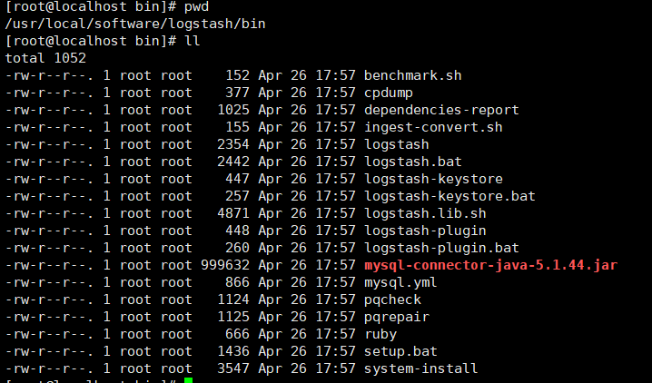

cd /etc/init.d

vim logstash 创建脚本

#!/bin/bash

export JAVA_HOME=/usr/local/software/jdk-8

LOGSTASH=/usr/local/software/logstash

CONFIG=$LOGSTASH/bin/mysql.yml

if [[ -f $CONFIG ]]

then

sh ${LOGSTASH}/bin/logstash -f $CONFIG

else

echo "file not exit"

fi

Service logstash 脚本启动