将下载好的elasticsearch传到 /opt目录

cd /opt

unzip elasticsearch-6.4.2.zip

groupadd esgroup 添加一个组

useradd -d /home/esuser -m esuser -g esgroup添加一个用户

cd /home/esuser

mkdir elasticsearch

cp -r/opt/ elasticsearch-6.4.2 /home/esuser/elasticsearch/es

chown -R esuser:esgroup /home/esuser/* 给esuser目录下的所有文件授权给esuser用户

cd /elasticsearch/es

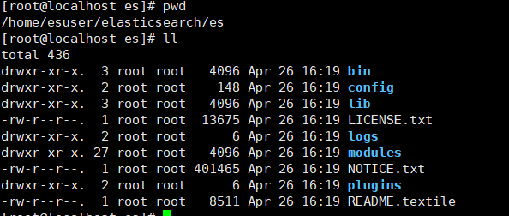

cd config

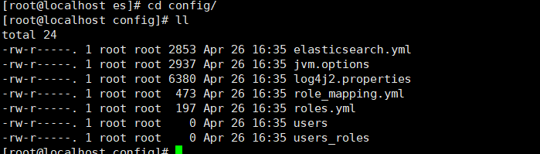

vim elasticsearch.yml 配置elasticsearch

#cluster名

cluster.name: zmw

#节点名称

node.name: "zmw"

#本机地址

network.host: 192.168.52.134

#tcp的端口号

transport.tcp.port: 9300

http.port: 9200

http.cors.enabled: true

http.cors.allow-origin: "*"

vim jvm.option

Jvm 内存大小

-Xms256m

-Xmx256m

firewall-cmd --zone=public --add-port=9300/tcp --permanent 开启9300端口

firewall-cmd --zone=public --add-port=9200/tcp --permanent 开启9200端口

firewall-cmd --reload 重启防火墙

启动:su esuser

cd /home/esuser/elasticsearch/es/bin

./elasticsearch

如果出现错误



1.max file descriptors [4096] for elasticsearch process is too low, increase to at least [65536]

每个进程最大同时打开文件数太小，可通过下面2个命令查看当前数量

ulimit -Hn

ulimit -Sn

Vim /etc/security/limits.conf文件，增加配置，用户退出后重新登录生效

* soft nofile 65536

* hard nofile 65536

2、max number of threads [3818] for user [es] is too low, increase to at least [4096]

问题同上，最大线程个数太低。Vim etc/security/limits.conf，增加配置

* soft nproc 4096

* hard nproc 4096

可通过命令查看

ulimit -Hu

ulimit -Su

3、max virtual memory areas vm.max_map_count [65530] is too low, increase to at least [262144]

vim vi /etc/sysctl.conf

vm.max_map_count=262144

sysctl -p 修改生效