将zookeeper 安装包上传到/opt 目录下

cd /opt

tar -zxvf zookeeper-3.4.13.tar.gz

cp -r zookeeper-3.4.13 /usr/local/software/zookeeper 复制

cd /usr/local/software/zookeeper/conf 进入Zookeeper 配置文件目录

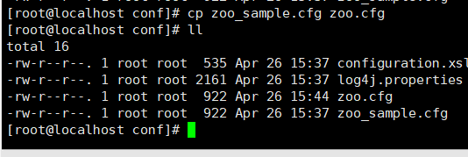

cp zoo_sample.cfg zoo.cfg

vim zoo.cfg 修改zookeeper的配置文件

dataDir=/usr/local/software/zookeeper/data zookeeper 数据目录

dataLogDir=/usr/local/software/zookeeper/data/log zookeeper 日志目录

cd /usr/local/software/zookeeper

mkdir data

cd data

mkdir log

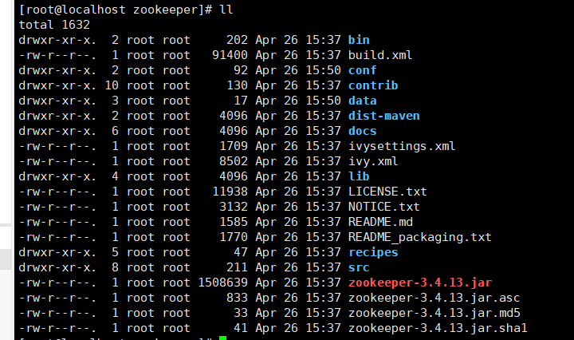

vim /etc/profile 配置环境变量

export ZOOKEEPER_HOME=/usr/local/software/zookeeper

export PATH=$PATH:$ZOOKEEPER_HOME/bin

source /etc/profile 执行刷新环境变量

创建开机启动脚本

cd /etc/init.d

vim zookeeper

#!/bin/bash

# chkconfig: 2345 33 90

# description: This is zookeeper

JAVA_HOME="/usr/local/software/jdk-8"

export ZOOKEEPER=/usr/local/software/zookeeper

export JAVA_HOME

case $1 in

start)

sh $ZOOKEEPER/bin/zkServer.sh start

;;

stop)

sh $ZOOKEEPER/bin/zkServer.sh stop

;;

restart)

sh $ZOOKEEPER/bin/zkServer.sh stop

sleep 1

sh $ZOOKEEPER/bin/zkServer.sh start

;;

esac

exit 0

chmod u+x zookeeper 添加执行权限

chkconfig zookeeper on 加入到系统启动目录当中

firewall-cmd --zone=public --add-port=2181/tcp --permanent 开启2181端口

firewall-cmd --reload 重启防火墙