

Artificial Intelligence Lab
Lab 5 Report

Submitted By:
Asma Zainab
SU92-BSSEM-S25-025
BSSE-4A
Submitted To:
Mr. Rasikh Ali

Contents
Task 1: Trace the supplied tree by hand using minimax 4
1.1. Tree 4
1.2. Calculation 4
Task 2: Leaf Evaluation Counter 4
Task 3: Reordering Branches 5
Reflection: 5

Task 1: Trace the supplied tree by hand using minimax

1.1. Tree
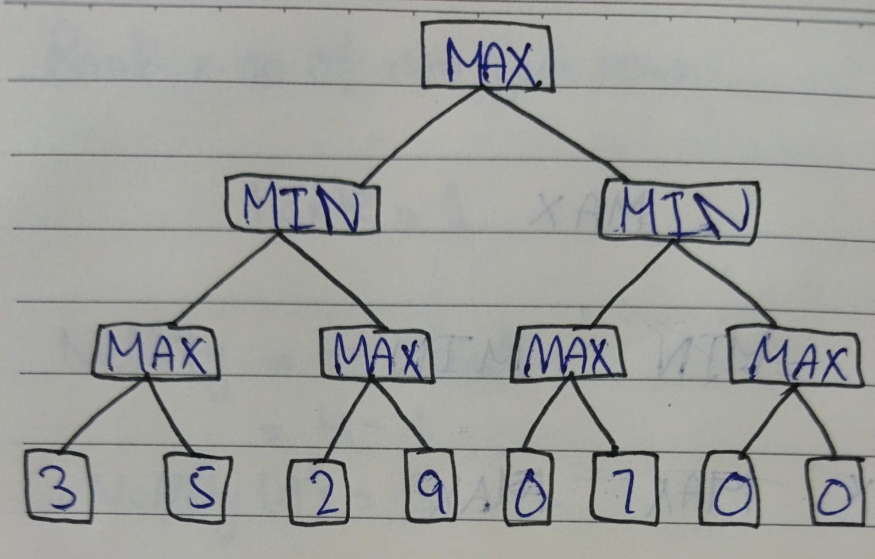
I traced the minimax tree using these leaf scores:
[3, 5, 2, 9, 0, 7]
The binary tree required 8 nodes so I added two more nodes.

1.2. Calculation
MAX nodes:
- max (3,5) = 5
- max (2,9) = 9
- max (0,7) = 7
- max (0,0) = 0
MIN nodes:
- min (5,9) = 5
- min (7,0) = 9
Root Max:
- max (5,0) = 5
Final Minimax value = 5

Task 2: Leaf Evaluation Counter
I added a leaf evaluation counter to both algorithms in this task. The scores I used:

[3, 5, 2, 9, 3, 5, 2, 9]
This tells how many leaves were evaluated for each algorithm.
Algorithm | Final Value | Leaves Evaluated
Minimax | 5 | 8
Alpha-Beta | 5 | 7

Both algorithms had returned the same final value. However, Alpha-Beta pruning evaluated fewer leaf nodes because it skipped a branch that could not change the final result.

Task 3: Reordering Branches
In this task I changed the order of the branches. I used the same leaf values.
Algorithm | Branch Order | Final Value | Leaves Evaluated
Minimax | Original | 5 | 8
Minimax | Reordered | 5 | 8
Alpha-Beta | Original | 5 | 7
Alpha-Beta | Reordered | 5 | 8

After reordering the branches, Alpha-Beta Pruning evaluated more leaf nodes. The final value remained 5 in both cases. Minimax evaluated all eight leaves regardless of their order.

Reflection:
From this lab I have learnt how the Minimax algorithm chooses the best value by using MAX and MIN levels. I also learnt how the Alpha Beta Pruning algorithm helps reduce unnecessary evaluations.

