Task Report – CoreTech Data Analytics Internship

Task 01: Setup and Introduction

Introduction
My name is Asma. I am excited to participate in the CoreTech Data Analytics Internship Program. I have completed the initial setup of the required tools, including Google Sheets, Power BI Desktop, and Google Drive. This task helped me understand the basic tools used in data analytics and their importance in business decision-making.

1. What is Data Analytics?
Data Analytics is the process of collecting, cleaning, organizing, and analyzing data to discover useful patterns, trends, and insights. These insights help organizations make better decisions, improve performance, and solve business problems.

2. What Does a Data Analyst Do?
A Data Analyst:
- Collects data from various sources.
- Cleans and organizes data.
- Analyzes data using analytical tools.
- Creates reports and dashboards.
- Identifies trends and patterns.
- Provides insights to support business decisions.
The main goal of a Data Analyst is to convert raw data into meaningful information that helps organizations achieve their objectives.

3. Difference Between Data, Information, and Insight

Data
Raw facts and figures without context.
Example:
- Sales records: 100, 150, 200

Information
Processed and organized data that provides meaning.
Example:
- Total sales this month are 450 units.

Insight
Actionable understanding gained from information.
Example:
- Sales increase significantly during promotional campaigns, suggesting that future promotions can boost revenue.

4. How Analytics Helps CoreTech Innovation
Analytics can help CoreTech Innovation by:
- Improving business decision-making.
- Identifying customer behavior and preferences.
- Monitoring company performance.
- Finding operational inefficiencies.
- Predicting future trends.
- Supporting strategic planning and growth.
By using analytics, CoreTech Innovation can make data-driven decisions that improve productivity and business success.

5. Tools Used in Data Analytics

Microsoft Excel / Google Sheets
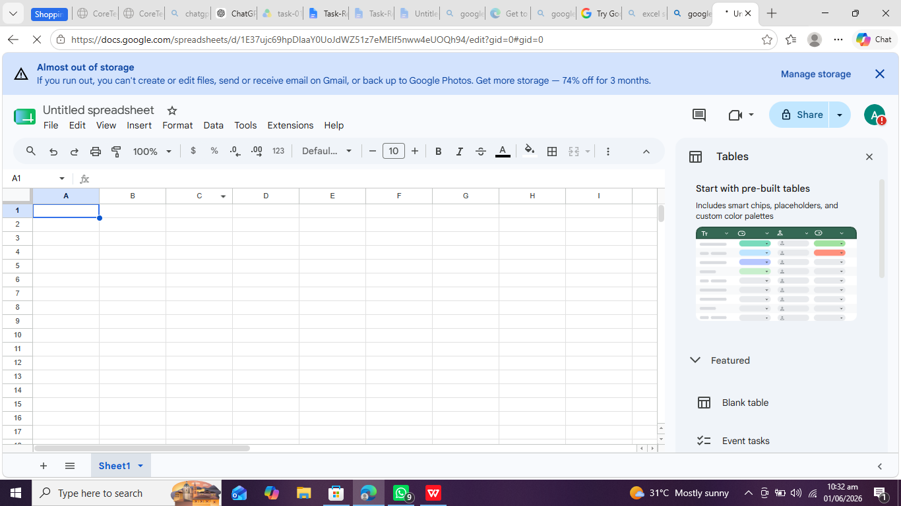
Used for:
- Data entry
- Data cleaning
- Calculations
- Basic analysis
- Charts and reports

Power BI
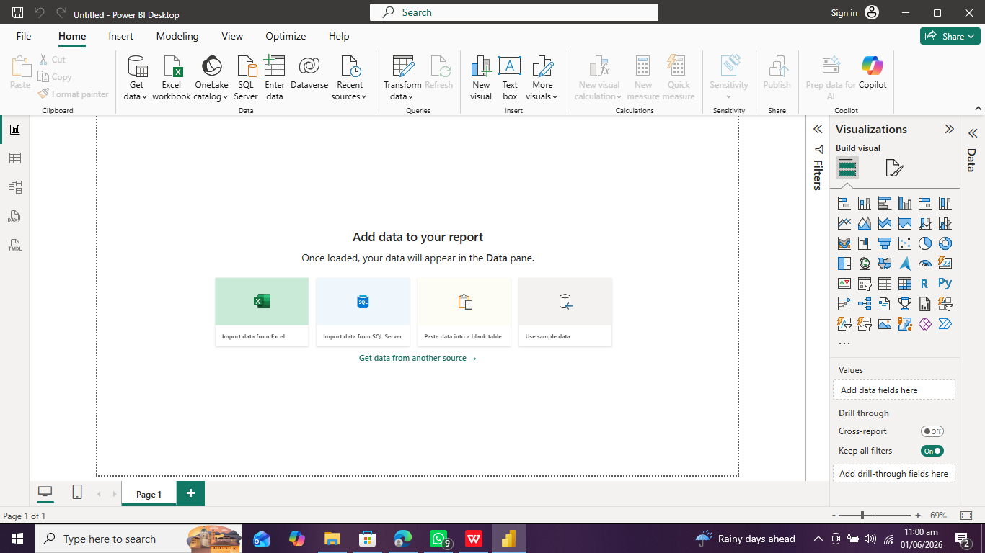

Power BI
Used for:
- Data visualization
- Interactive dashboards
- Business intelligence reporting

Google Drive
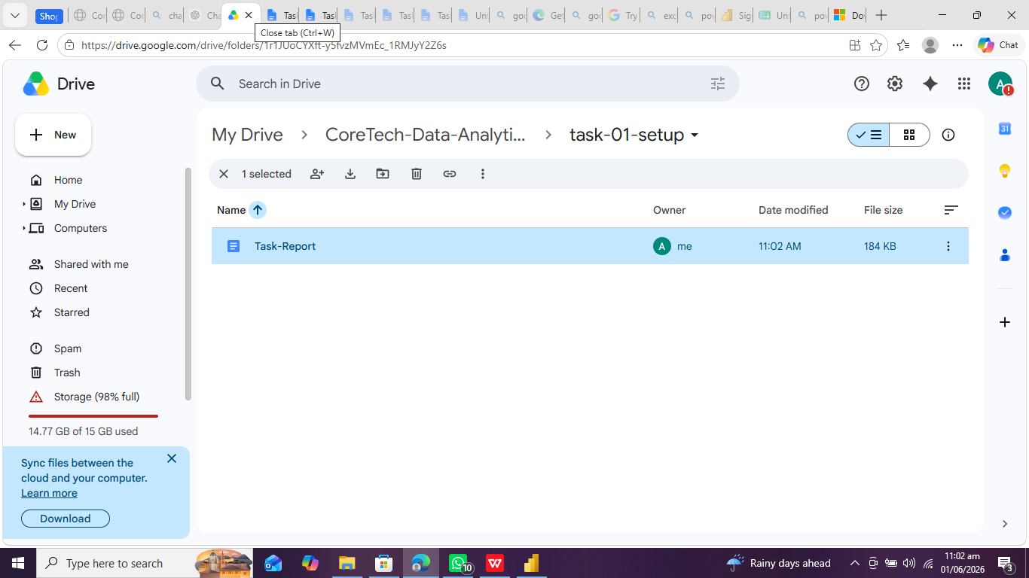
Used for:
- Cloud storage
- File sharing
- Collaboration
- Project organization

Setup Completion
The following tools have been successfully set up:
✓ Microsoft Excel / Google Sheets
✓ Power BI Desktop
✓ Google Drive Folder Structure
Screenshots are attached in the task folder as evidence of setup completion.

Conclusion
This task provided an introduction to the tools and concepts used in data analytics. I successfully completed the required setup and gained a basic understanding of data analytics, the role of a data analyst, and the importance of analytics in supporting business decisions.

