

Football Player Segmentation and Classification
  - Project Report

  - Asma Massad
  - Course Name: Computer Vision
FOOTBALL PLAYER SEGMENTATION AND CLASSIFICATION

Introduction
Semantic segmentation is a computer vision task that aims to assign a label to each pixel in an image. Unlike other image recognition tasks that classify the entire image or detect objects within it, semantic segmentation provides a detailed understanding of the image at a pixel level.
It involves training deep learning models, such as convolutional neural networks (CNNs), to learn and recognize complex patterns and features in images. There are many architectures that were built for the task semantic segmentation like U-Net, or DeepLab.
One application that we can utilize the outcomes of sematic segmentation is football match analysis, like players identification and exclusion from the background, also we could further use multiclass segmentation where we can identify the teams of the players.
In this project we used deep leaning based sematic segmentation algorithm (UNet) to detect the players at a pixel level. Also, we provided additional information about the players role and team and football field side in each image, based on traditional computer vision techniques. Finally, we used a pretrained deep learning for human pose estimation called MoveNet to show a skeletal key-point data on the players on each frame, which could be used in future work for further analysis.
The dataset we used provided 512 images from a football match and a json file contains annotations with pixel-level binary masks that indicate the player's location and segmentation boundaries.

2. Methodology
We divided the project into the following sub-tasks:
- Multiclass Mask Generation.
- Training A Multiclass Unet Algorithm.
- Player Role and Team Classification.
- Ball Possession Estimation.
- Player Pose Estimation.
We will discuss the details about our approach with each task in the following subsections.

2.1 Multiclass Mask Generation
We generated new masks using the binary masks provided by the dataset, where we colored the players according to their teams. For the blue team (Team A), we generated blue masks and set the rest of individuals and the background to black. As for the red team (Team B) we colored the mask with red. Finally, we combined both masks to create a multiclass mask.
We also generated mask for the referees, and goalkeepers from both teams, however we did not add these masks to the final mask, because they caused problems and affected the UNet performance. One of the problems is that the goalkeepers and the referees are not present in each image, so if we set the number of classed to 5 with UNet, the algorithm will try to assign all 5 classes to the pixels in the image. The Other problem is that team B goalkeeper’s outfit color is very close to the referee’s outfit.
We generated the multiclass masks as follows:
- Background Subtraction
The provided binary masks were used to remove the background from the images. This was done using ‘bitwise_and’ function from OpevCV.
- Extract Teams Colors
First, we assigned a center color for each team. Which is a color that we think the majority of outfit’s pixels are close to within a distance that we have provided. The center colors were decided manually after inspecting multiple images using photoshop.
The center colors were as follows (RGB color space):
- Team A = [129, 239, 252]
- Team B = [170, 25, 50]
- Referee = [30, 50, 90]
- Goalkeeper A = [110, 220, 150]
- Goalkeeper B = [75, 65, 90]
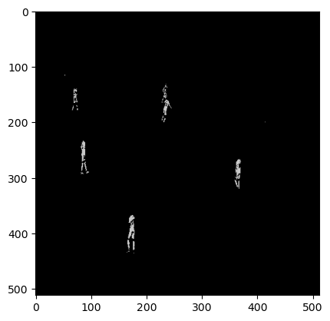
To extract the pixels within a certain distance from the center color, we used Euclidian distance, then the extracted pixels where recolored with a gray color. Each class has its own gray color. The output from this step in in figure 1.
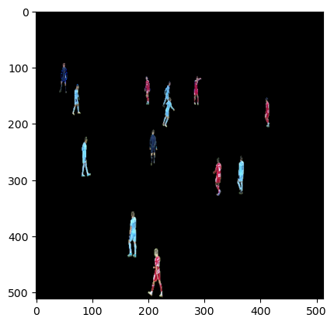
Figure 1: (a) The original masked image (b) The extrated
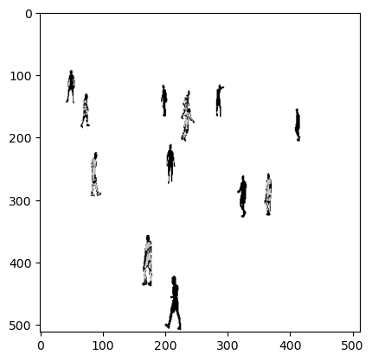
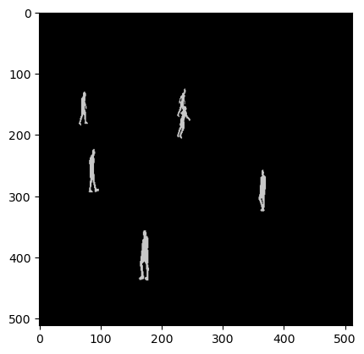
Then we combined the image in Figure 1-b with the inverted binary mask to get the shape outline of the players as seen in figure 2-a. The next step was to recolor the shape outline with the gray color of the class. To find the shape outline against the background we used the function ‘label’ from scipy library, each player region was stored in an array. Finally, each region was checked if it has gray pixels above a threshold and recolored the entire region with gray color. Figure 2-b present the final mask for team A.
Figure 2: (a) The extraceted pixels from team added with the Inverted mask (b) The final mask for team A
- Final Multiclass Mask
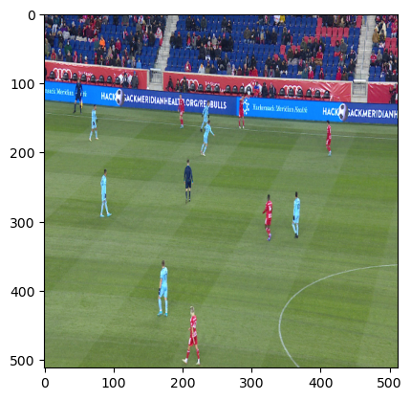
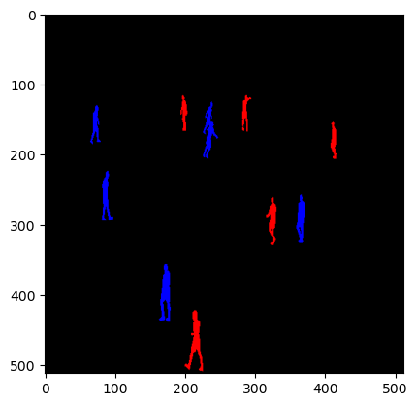
The final step was to re color each class with a more distinguishable color (blue for team A, and red for team B) then combining both masks into the final mask, figure 3 shows the final mask.
Figure 3: (a) The original Image (b) The final mask
The masks were used in two tasks, UNet multiclass segmentation, and player role and team classification.

2.2 UNet Multiclass Segmentation
In this task we used the multiclass masks that we have created in the previous step as an input to a multiclass UNet model. First, we encoded the masks using tensorflow ‘one_hot’ then built the model with four encoder blocks, a bridge (bottom) layer and four decoder layers. The output layer had 3 classes as output and the activation function was softmax. Earlier models that we experimented with had unstable loss output that became ‘nan’ during training, so we used gradient clipping.

2.3 Player Role Classification
Since we do not have enough information about the match or the teams playing, we had to make some assumptions and simplifications about the players roles. We noticed that the images from the match where either from the left side of the field (Team A side), right side (team B side) or from the center of the field.
In our approach, first the field side in the image is decided (left, center, or right), then the image is divided into 3 parts: part-1 where x< 170, part-2 where x is between 170 and 340 and part-3 where x is greater than 340. We chose these number because the image size we are using is (512 x 512). Then we assigned the roles according to the field side classification of the image as follows:
- Left side of the field: For team A, if the player is located before x=340 then he is Defender (D), else he is Midfielder (M). For team B if the player is located before x=340 then he is Forward (F), else he is Midfielder.
- Center of the field: For team A before x=170 the player is Midfielder; else he is Forward. For team B before x=340 he is Forward, else he is Midfielder.
- Right side of the field: For team A before x=170 the player is Midfielder; else he is Forward. For team B before x =170 the player is Midfielder, else he is Defender.
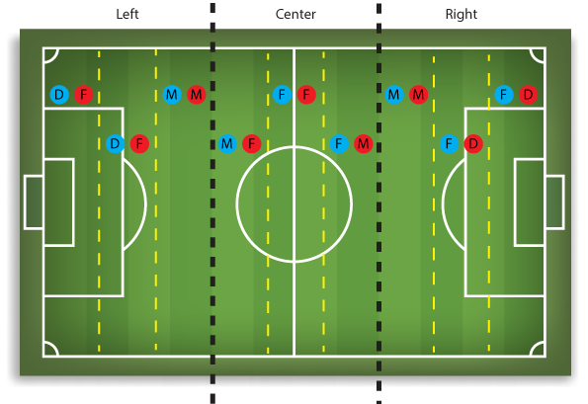
The assumption about player roles according to their position in the field is illustrated in figure 4.

Figure 4: Player Role According to their position in the field (Blue is team A, Red is team B).
To detect the side of the field in the image, first we used Hough transform to detect the lines in the field. To make the line detection more accurate and to exclude any lines outside the field we created a mask using color thresholding around two values for RGB green color representing the field grass.
Then according to the detected lines slopes we decided the field side. Usually, Hough transform produces multiple lines, so for each line we calculated the slope, if it is negative and between the value -3 to -100, then the field side is left, if the slope is positive between 3 and 100, then the side is right and if the slope between -0.5 and 0.5 (horizontal line) or above 100 or below -100 (vertical line) then the view is from the center of the field.
The classification for each line in the image is stored and the most frequent classification is considered the side of the field.

2.4 Ball Possession
We used a very simple approach, where we assumed that if the image shows the left side, then team B has the ball and if the image shows the right side, then team A has the ball. And we calculated the percentages accordingly.

2.5 Player Pose Estimation
For Player pose estimation we used a pretrained model called MoveNet. First, we converted the images into a video then we applied the algorithm to the video to show the skeletal key-points for the detected players by the algorithm.

rESULTS AND Discussion
In this section we will present the results of each task, and provide discussion for the results and some of the challenges we faced.
A. UNet Multiclass Segmentation
The UNet had the following results:
Model Accuracy on the Training Dataset: 99.71%
Model Accuracy on the Validation Dataset: 99.72%
Model Accuracy on the Test Dataset: 99.7%
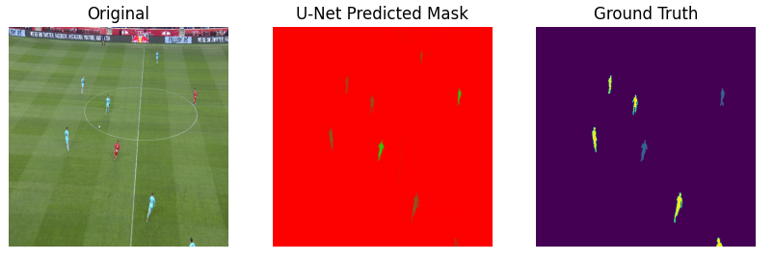
The output masks were able to detect players that were discarded during the generation of the original masks due to thresholding. Figure 5 shows a comparison between the original mask and the predicated one. We can see that it has mistaken parts of the field center line as players.
Figure 5: (a) Original Image (b) Predicted Mask (c) Ground Truth Mask.

B. Player Role and Team Classification
For the player role classification, when inspecting many images, we found the results were accurate most of the time, however when the image showed the goal of either sides at an angle around 45° the classification would give the opposite side. After some inspection we found that when the slope value was between -3 to 3 this problem occurred.
Also, we tried using ‘HoughCircles’ to detect the circles on the field which would help us further in the role classification task, but the results were not accurate and the function kept detecting false circle even when we performed parameters tuning. The detected line and the player role classification is show in figure 6, the first initial letter is the player role (F: Forward, M: Midfielder, D: Defender) and the second initial is for the team.
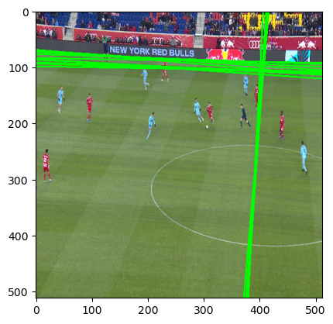
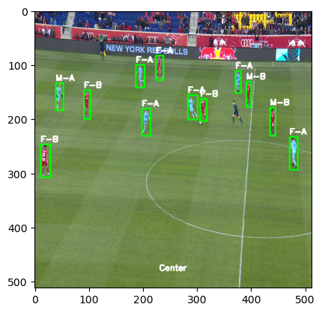
Figure 6: (a) Detected line from Hough transform (b) Player role classification
- Ball Possession
When the side of the field was calculated for all the images, The results show that team A had the ball 37.36% of the time and team B had the ball 62.64% of the time.
- Player Pose Estimation
We applied the MoveNet algorithm to a video we created from the images, we tried to tune the parameters, and the result is presented in figure 7. It shows that not all the players were detected by the algorithm one reason could be that the players are small in comparison with the image size, also there many players in the scene which could affect the algorithm’s performance.
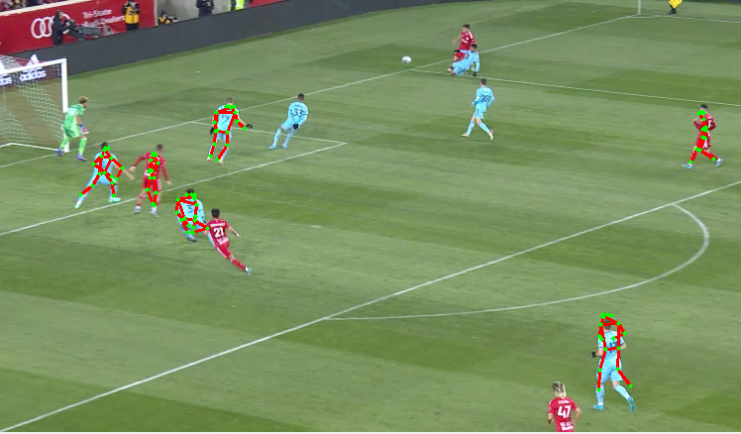
Figure 7: MoveNet Pose Estimation Results.

Conclusion
In this project we used a dataset that was intended for binary semantic segmentation of football players, and applied feature engineering techniques for image processing to generate multiclass masks for deep learning based semantic segmentation of the players based on their team. We also used the masks and the field lines information extracted from Hough transform to classify the player’s role. The filed lines information was also used to calculate a simplified ball possession statistics. Finally, we applied a pretrained deep learning pose estimation algorithm to estimate the skeletal key-points of the players.

