An AOP-Guided Toxicogenomics Framework for Mechanistic Interpretation of MXene Responses in Human Peripheral Blood Mononuclear Cells
Asmaa A. Abdelwahab¹, Angela Serra², Dario Greco^{2*}, Barry Hardy^{1*}
¹Edelweiss Connect GmbH, Technology Park Basel, Hochbergerstrasse 60C, 4057 Basel, Switzerland
²Finnish Hub for Development and Validation of Integrated Approaches(FHAIVE)Faculty of Medicine and Health TechnologyTampere UniversityTampere 33100, Finland

*Correspondence: barry.hardy@edelweissconnect.com & dario.greco@tuni.fi

Abstract
Transcriptomic evidence for MXene bioactivity is distributed across materials, exposure systems, and analytical conventions, which complicates mechanistic comparison. We developed an adverse outcome pathway (AOP)-guided workflow and applied it to a public RNA-sequencing study of human peripheral blood mononuclear cells exposed for 24 h to 50 micrograms per millilitre Ta4C3, Mo2Ti2C3, or Nb4C3, with lipopolysaccharide and concanavalin A as positive controls. At false discovery rate (FDR) < 0.05 and absolute log2 fold change >= 1, Ta4C3, Mo2Ti2C3, and Nb4C3 yielded 470, 320, and 262 differentially expressed genes, respectively, compared with 967 for lipopolysaccharide and 4731 for concanavalin A. Recurrent enrichment implicated leukocyte chemotaxis, cytokine-receptor activity, extracellular and vesicular compartments, Toll-like receptor signalling, and neutrophil degranulation. AOP fingerprinting identified 411, 289, and 244 enriched key events and 152, 107, and 90 represented AOPs for Ta4C3, Mo2Ti2C3, and Nb4C3. DoRothEA expansion increased two literature-derived signatures from 125 to 517/703 genes and from 24 to 339/339 genes using A/B and A/B/C confidence tiers; represented AOPs increased from 105 to 218 and from 28 to 186. This broader prior-knowledge coverage produced extensive AOP overlap and was therefore treated as hypothesis generation rather than evidence of material equivalence. A supplied AOPGraphExplorer export contained 278 biological events and 348 directed key-event relationships across 48 AOPs, highlighting mitochondrial dysfunction, oxidative stress, inflammatory mediator release, cell injury/death, and neuroinflammation as shared network hubs. Exploratory AOPxGeneNet analysis further linked Ta4C3-responsive coexpression modules to four FDR-significant module-AOP pairs and prioritized genes including NLRP3, CLEC7A, ALDH2, ACP5, and lysosomal genes. Together, these analyses support a graded immune-trafficking and cellular-stress response, strongest for Ta4C3 in this experiment, while defining testable hypotheses rather than causal or organ-level toxicity conclusions.
Keywords: MXenes; toxicogenomics; adverse outcome pathways; peripheral blood mononuclear cells; transcription-factor regulons; coexpression networks; nanosafety

Introduction
MXenes are two-dimensional transition-metal carbides, nitrides, and carbonitrides derived from layered precursors and commonly represented as Mn+1XnTx, where Tx denotes surface terminations.[1,2] Their aqueous processability, large surface area, and tunable chemistry have motivated applications in energy storage, sensing, environmental technologies, and biomedicine. The same physicochemical diversity complicates safety assessment: composition, flake dimensions, surface oxidation, terminal groups, dose, protein corona, and biological model may each change the observed response.
Human peripheral blood mononuclear cells (PBMCs) provide a relevant system for detecting immune perturbation. Fusco et al. profiled PBMC responses to Ta4C3, Mo2Ti2C3, and Nb4C3 and reported comparatively modest transcriptomic effects, with Ta4C3 producing the clearest response among the three materials.[3] Transcript-level changes alone, however, do not establish a mode of action: gene lists depend on statistical thresholds and may combine causal signals, compensatory responses, cell-composition effects, and nonspecific stress.
The AOP framework organizes evidence from molecular initiating events through measurable key events (KEs) to adverse outcomes (AOs), while explicitly separating mechanistic plausibility from hazard prediction.[4] AOP-aligned toxicogenomics can therefore provide a structured interpretation layer for transcriptomic data.[5] Transcription-factor (TF) regulons and coexpression networks add complementary prior knowledge, but they also expand the search space and can amplify shared annotations. Their outputs require transparent backgrounds, multiple-testing control, and cautious interpretation.
Here, we reanalyzed the GSE200036 PBMC dataset, projected two independent literature-derived MXene signatures onto the experimental contrasts, expanded those signatures with DoRothEA regulons, and integrated functional enrichment, KE/AOP fingerprints, an AOPGraphExplorer network export, and an AOPxGeneNet coexpression/AOPxLINK run. The objectives were to quantify material-specific response strength, identify recurrent mechanistic themes, distinguish measured transcriptional evidence from database-derived context, and generate experimentally testable hypotheses for MXene nanosafety assessment.

Results and Discussion

Study design, data validation, and transcriptional response
The analysis comprised 18 samples (three biological replicates per condition): untreated control, lipopolysaccharide (LPS), concanavalin A (ConA), Ta4C3, Mo2Ti2C3, and Nb4C3. The pipeline begins with an independent validation stage that verifies file structure, sample-metadata concordance, count integrity, identifier mapping, library depth, expression filtering, principal-component structure, and sample correlations before differential expression. All 18 supplied samples were retained. Figure 1 summarizes the reproducible computational workflow.
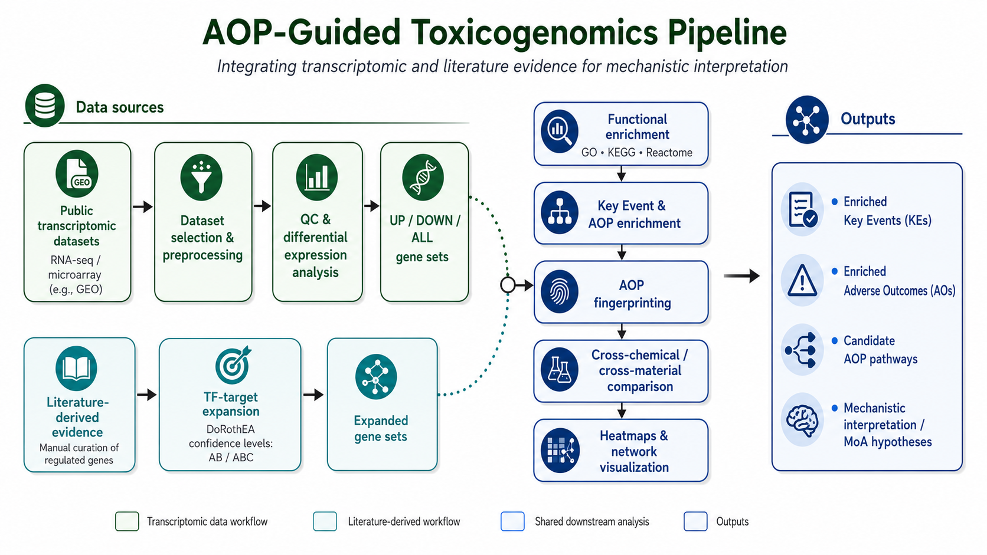
Figure 1. AOP-guided toxicogenomics workflow. The transcriptomic branch generates ALL, UP, and DOWN gene sets after validation and differential-expression analysis. The literature branch expands curated signatures through DoRothEA confidence tiers A/B and A/B/C. Both branches enter functional enrichment, KE/AOP enrichment, cross-material comparison, visualization, and mechanistic interpretation. AOPGraphExplorer and AOPxGeneNet analyses were evaluated as complementary network-context layers.
Using FDR < 0.05 and absolute log2 fold change >= 1, Ta4C3 produced 470 significant genes (243 up, 227 down), followed by Mo2Ti2C3 with 320 (160 up, 160 down) and Nb4C3 with 262 (151 up, 111 down). The positive controls yielded larger responses: LPS produced 967 significant genes and ConA produced 4731. The nearly balanced directions for the MXenes differ from the much broader ConA response and argue against reducing the response to a single activation axis (Table 1 and Figure 2).

Table 1. Differential-expression, key-event, and AOP coverage by condition. DEG thresholds were FDR < 0.05 and absolute log2 fold change >= 1. KE and AOP values are counts of distinct significant annotations for the ALL gene set.
Condition | Role | UP | DOWN | Total DEGs | Distinct KEs | Distinct AOPs
ConA | Positive control | 2183 | 2548 | 4731 | 702 | 221
LPS | Positive control | 462 | 505 | 967 | 566 | 198
Ta4C3 | MXene | 243 | 227 | 470 | 411 | 152
Mo2Ti2C3 | MXene | 160 | 160 | 320 | 289 | 107
Nb4C3 | MXene | 151 | 111 | 262 | 244 | 90
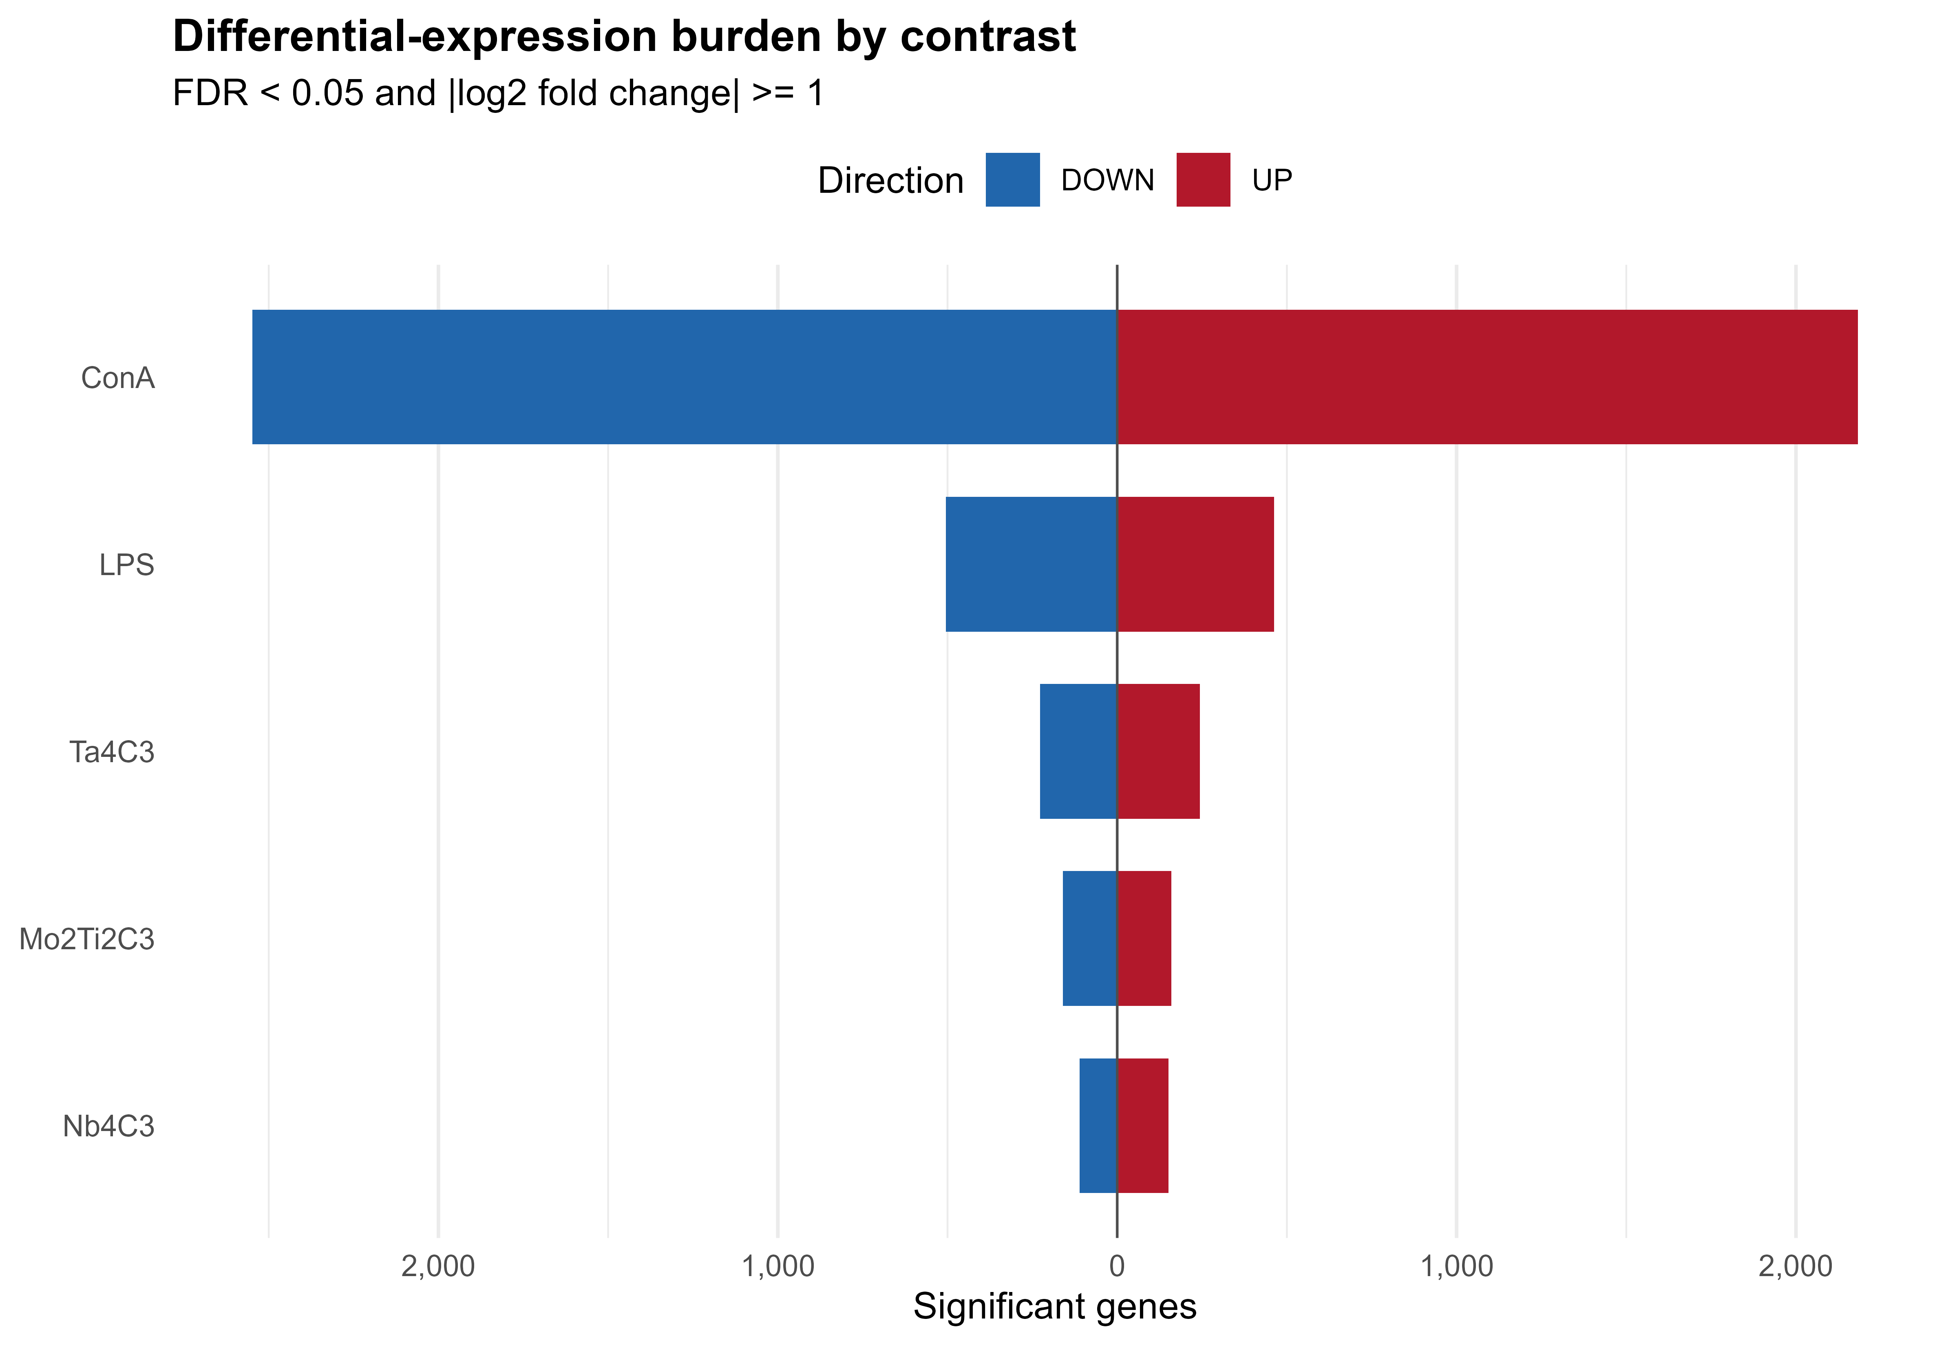
Figure 2. Differential-expression burden by contrast. Bars show significant up- and down-regulated genes at FDR < 0.05 and absolute log2 fold change >= 1. The positive controls establish the scale of broad immune stimulation; among the tested MXenes, Ta4C3 produced the largest response.
Pairwise overlap was substantially greater among MXene gene sets than between MXenes and the positive controls. Jaccard indices for ALL significant genes ranged from 0.36 to 0.47 among the three MXenes, compared with 0.04-0.18 for most MXene-control pairs. Direction-specific overlap was similar (UP, 0.33-0.52; DOWN, 0.35-0.42). Genome-wide log2 fold changes were most concordant between Ta4C3 and Nb4C3 (Spearman rho = 0.563), and 69 genes met the DEG threshold in all five contrasts. These results support a shared component of the PBMC response but also retain material- and stimulus-specific effects.
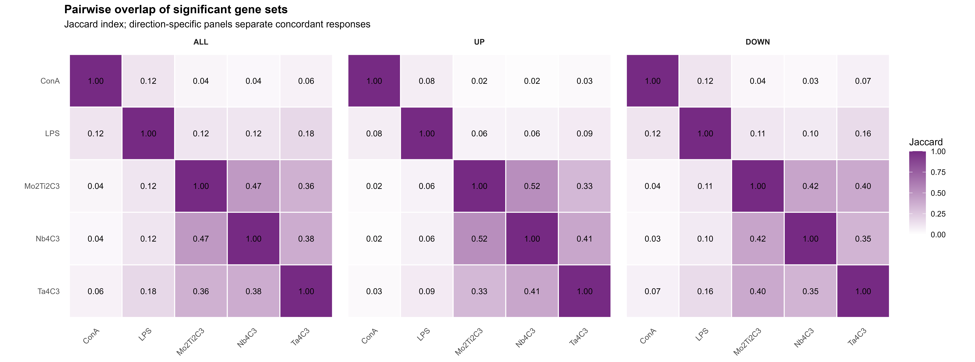
Figure 3. Pairwise overlap of significant gene sets. Jaccard indices are shown for ALL, UP, and DOWN sets. Greater within-MXene overlap is evident, but values below 0.6 also indicate non-identical responses.

Recurrent functional programs and literature-signature projection
Across the transcriptomic and literature-derived gene sets, recurrent Gene Ontology terms emphasized leukocyte trafficking and extracellular communication. Chemotaxis was significant in 13 gene sets, the external side of the plasma membrane in 16, and cytokine-receptor binding in 14. Cytokine-cytokine receptor interaction recurred in 11 gene sets, as did Reactome neutrophil degranulation. These annotations are consistent with immune-cell activation and trafficking, while extracellular-matrix, vesicular-lumen, receptor, and lysosomal terms suggest changes in cell-surface communication and intracellular processing (Figure 4).
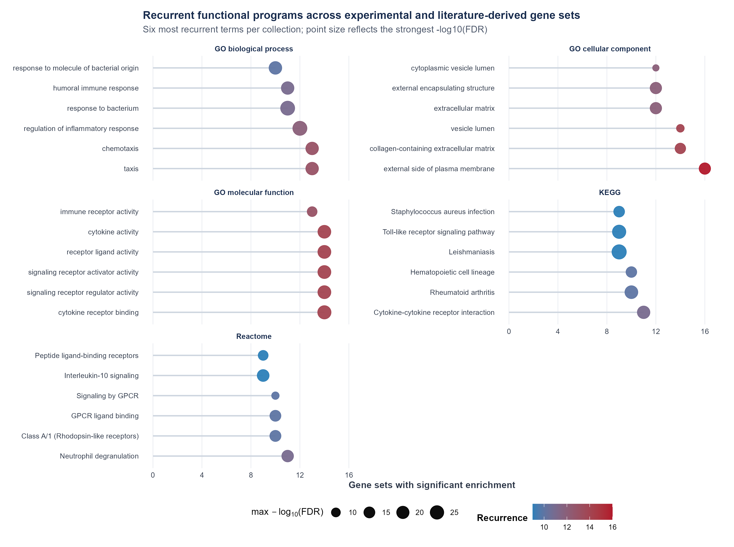
Figure 4. Recurrent functional programs across experimental and literature-derived gene sets. The six most recurrent terms per collection are shown. Position and colour encode the number of gene sets with significant enrichment; point size encodes the strongest observed -log10(FDR). Disease-named KEGG terms are interpreted as shared pathway-gene annotations, not diagnoses.
Rank-based projection offered a threshold-independent comparison with the literature signatures. The HN-Ti3C2 up-regulated signature was strongly enriched in ConA (normalized enrichment score [NES] = 2.46; FDR = 4.65 x 10^-9), whereas the Ti3C2Tx down-regulated signature showed negative enrichment in LPS (NES = -2.21; FDR = 1.31 x 10^-8), ConA (NES = -1.85; FDR = 5.56 x 10^-5), and Mo2Ti2C3 (NES = -1.77; FDR = 6.15 x 10^-4). The dominance of positive-control matches and the different source systems argue for context-dependent biological similarity rather than direct replication of the literature exposures.
A  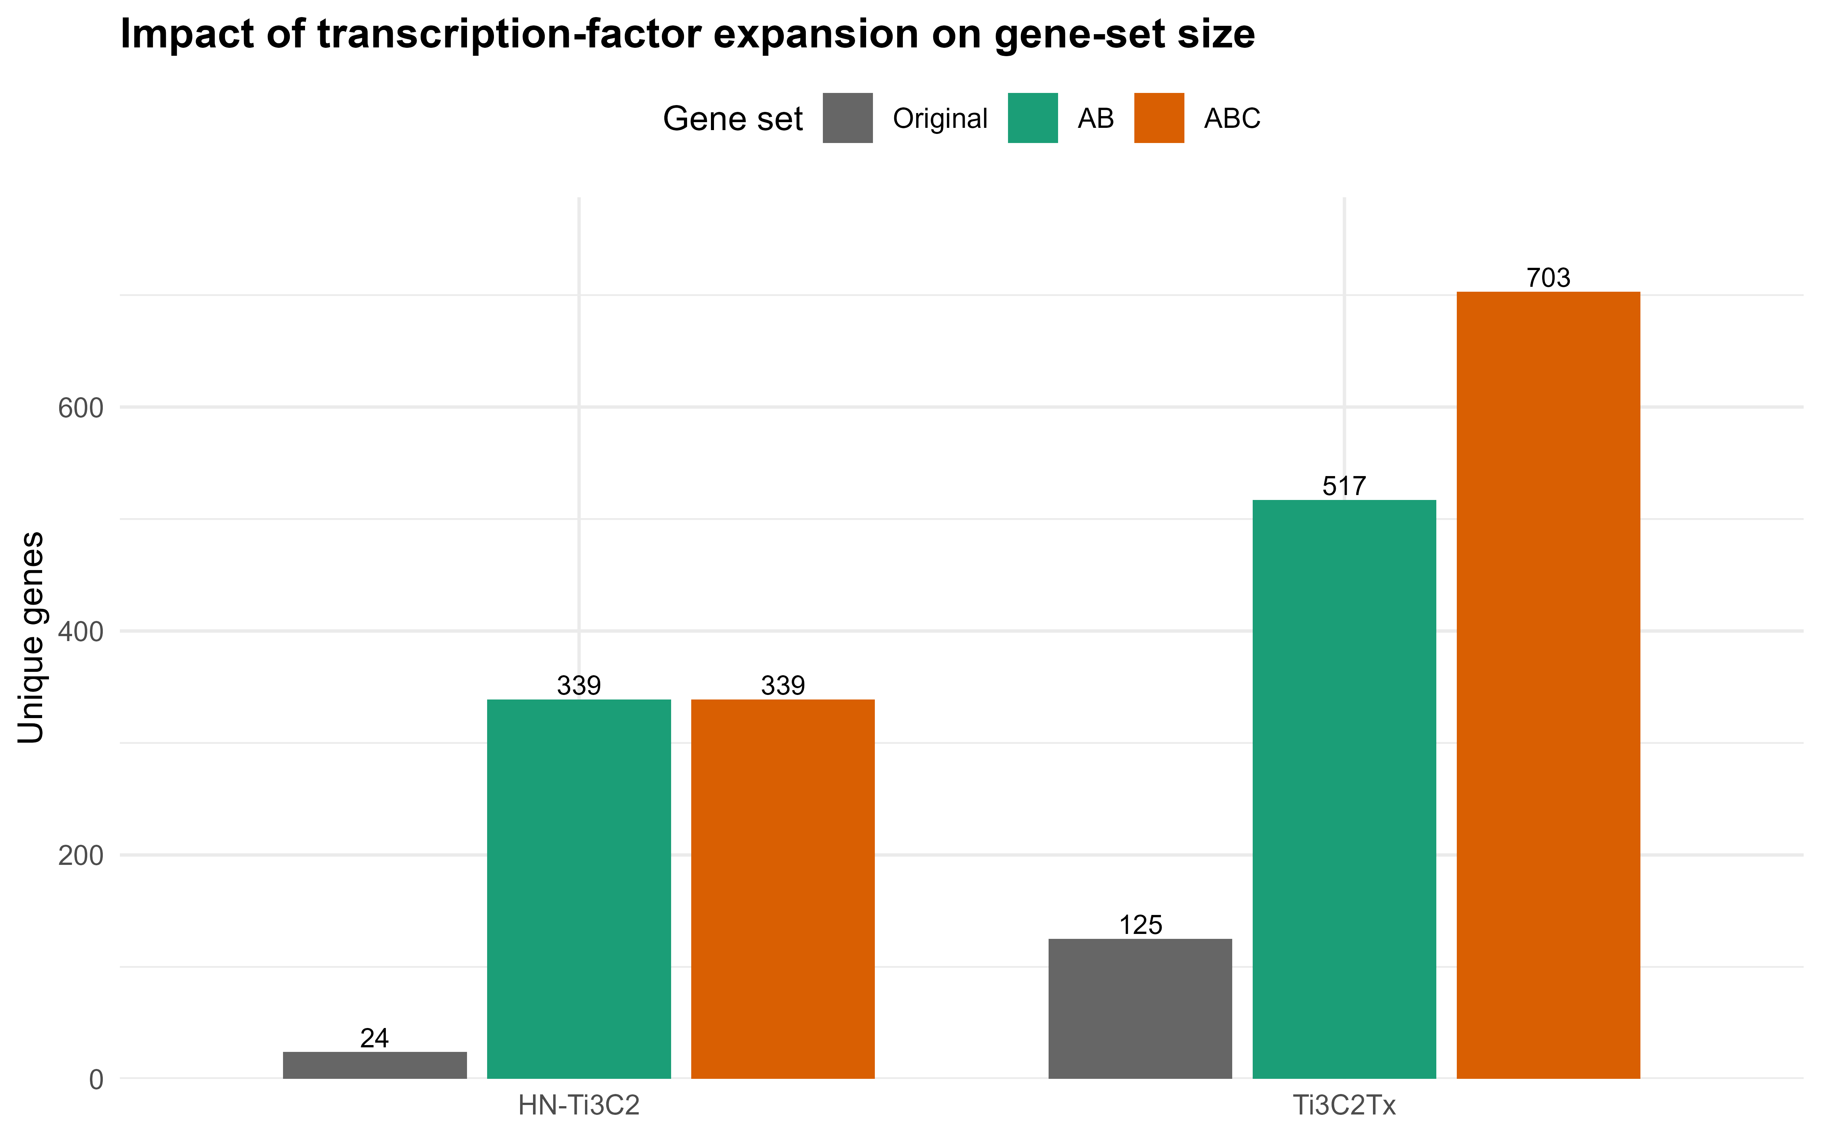 | B  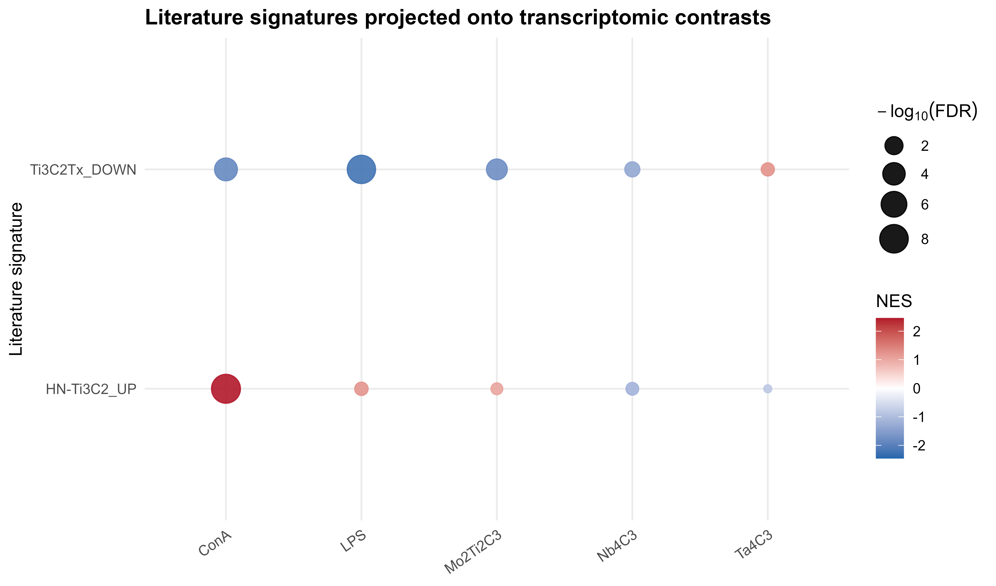
Figure 5. TF-regulon expansion and literature-signature projection. (A) DoRothEA expansion increased HN-Ti3C2 from 24 to 339 genes in both confidence modes and Ti3C2Tx from 125 to 517 (A/B) or 703 (A/B/C) genes. (B) Literature signatures were tested against ranked experimental contrasts with multilevel fgsea; colour encodes NES and point size encodes -log10(FDR).

Key-event and AOP fingerprints reveal broad but non-causal convergence
KE enrichment followed the overall response gradient: ConA (702 distinct KEs) and LPS (566) exceeded Ta4C3 (411), Mo2Ti2C3 (289), and Nb4C3 (244). Corresponding AOP coverage was 221, 198, 152, 107, and 90, respectively (Table 1). These values describe database coverage at the configured significance threshold; they are not measures of toxicity severity and do not imply that downstream AOs occurred in the PBMC culture.
TF-regulon expansion greatly increased the size and AOP coverage of both literature signatures (Table 2). For Ti3C2Tx, AOP coverage increased from 105 in the original signature to 218 in both expanded sets. For HN-Ti3C2, coverage increased from 28 to 186. This gain is useful for recovering mechanisms omitted by short source lists, but it also reflects the many-to-many structure of TF-target and AOP annotations. The A/B and A/B/C expansions should therefore be interpreted as sensitivity analyses over prior-knowledge breadth.
Table 2. Effect of DoRothEA regulon expansion on literature-derived gene-set and AOP coverage. Counts are unique valid genes or distinct represented AOPs.
Signature | Original genes | A/B genes | A/B/C genes | Original AOPs | A/B AOPs | A/B/C AOPs
Ti3C2Tx | 125 | 517 | 703 | 105 | 218 | 218
HN-Ti3C2 | 24 | 339 | 339 | 28 | 186 | 186
The A/B-expanded Ti3C2Tx profile contained 150 of 152 Ta4C3 AOPs (98.7%), all 107 Mo2Ti2C3 AOPs, and all 90 Nb4C3 AOPs. The A/B/C profile contained 149 of 152, 107 of 107, and 89 of 90, respectively. These high overlaps show that the expanded reference spans most AOP annotations reached by the PBMC datasets. They do not demonstrate identical mechanisms: the expanded reference itself is broad, AOPs share KEs and genes, and the source studies used different cell systems, doses, and intended applications.

AOPGraphExplorer identifies recurrent network hubs
The supplied AOPGraphExplorer export comprised 278 biological-event nodes (45 molecular initiating events, 188 KEs, and 45 AOs) and 348 directed key-event relationships representing 48 AOP identifiers. Degree-based context highlighted mitochondrial dysfunction, cell injury/death, oxidative stress, secretion of proinflammatory mediators, and neuroinflammation, alongside broad AOs such as neurodegeneration (Figure 6). The network also contained endocrine and organ-specific branches. Because it combines curated relationships across biological contexts, node centrality indicates reuse within the selected knowledge graph, not causal importance in MXene-exposed PBMCs.
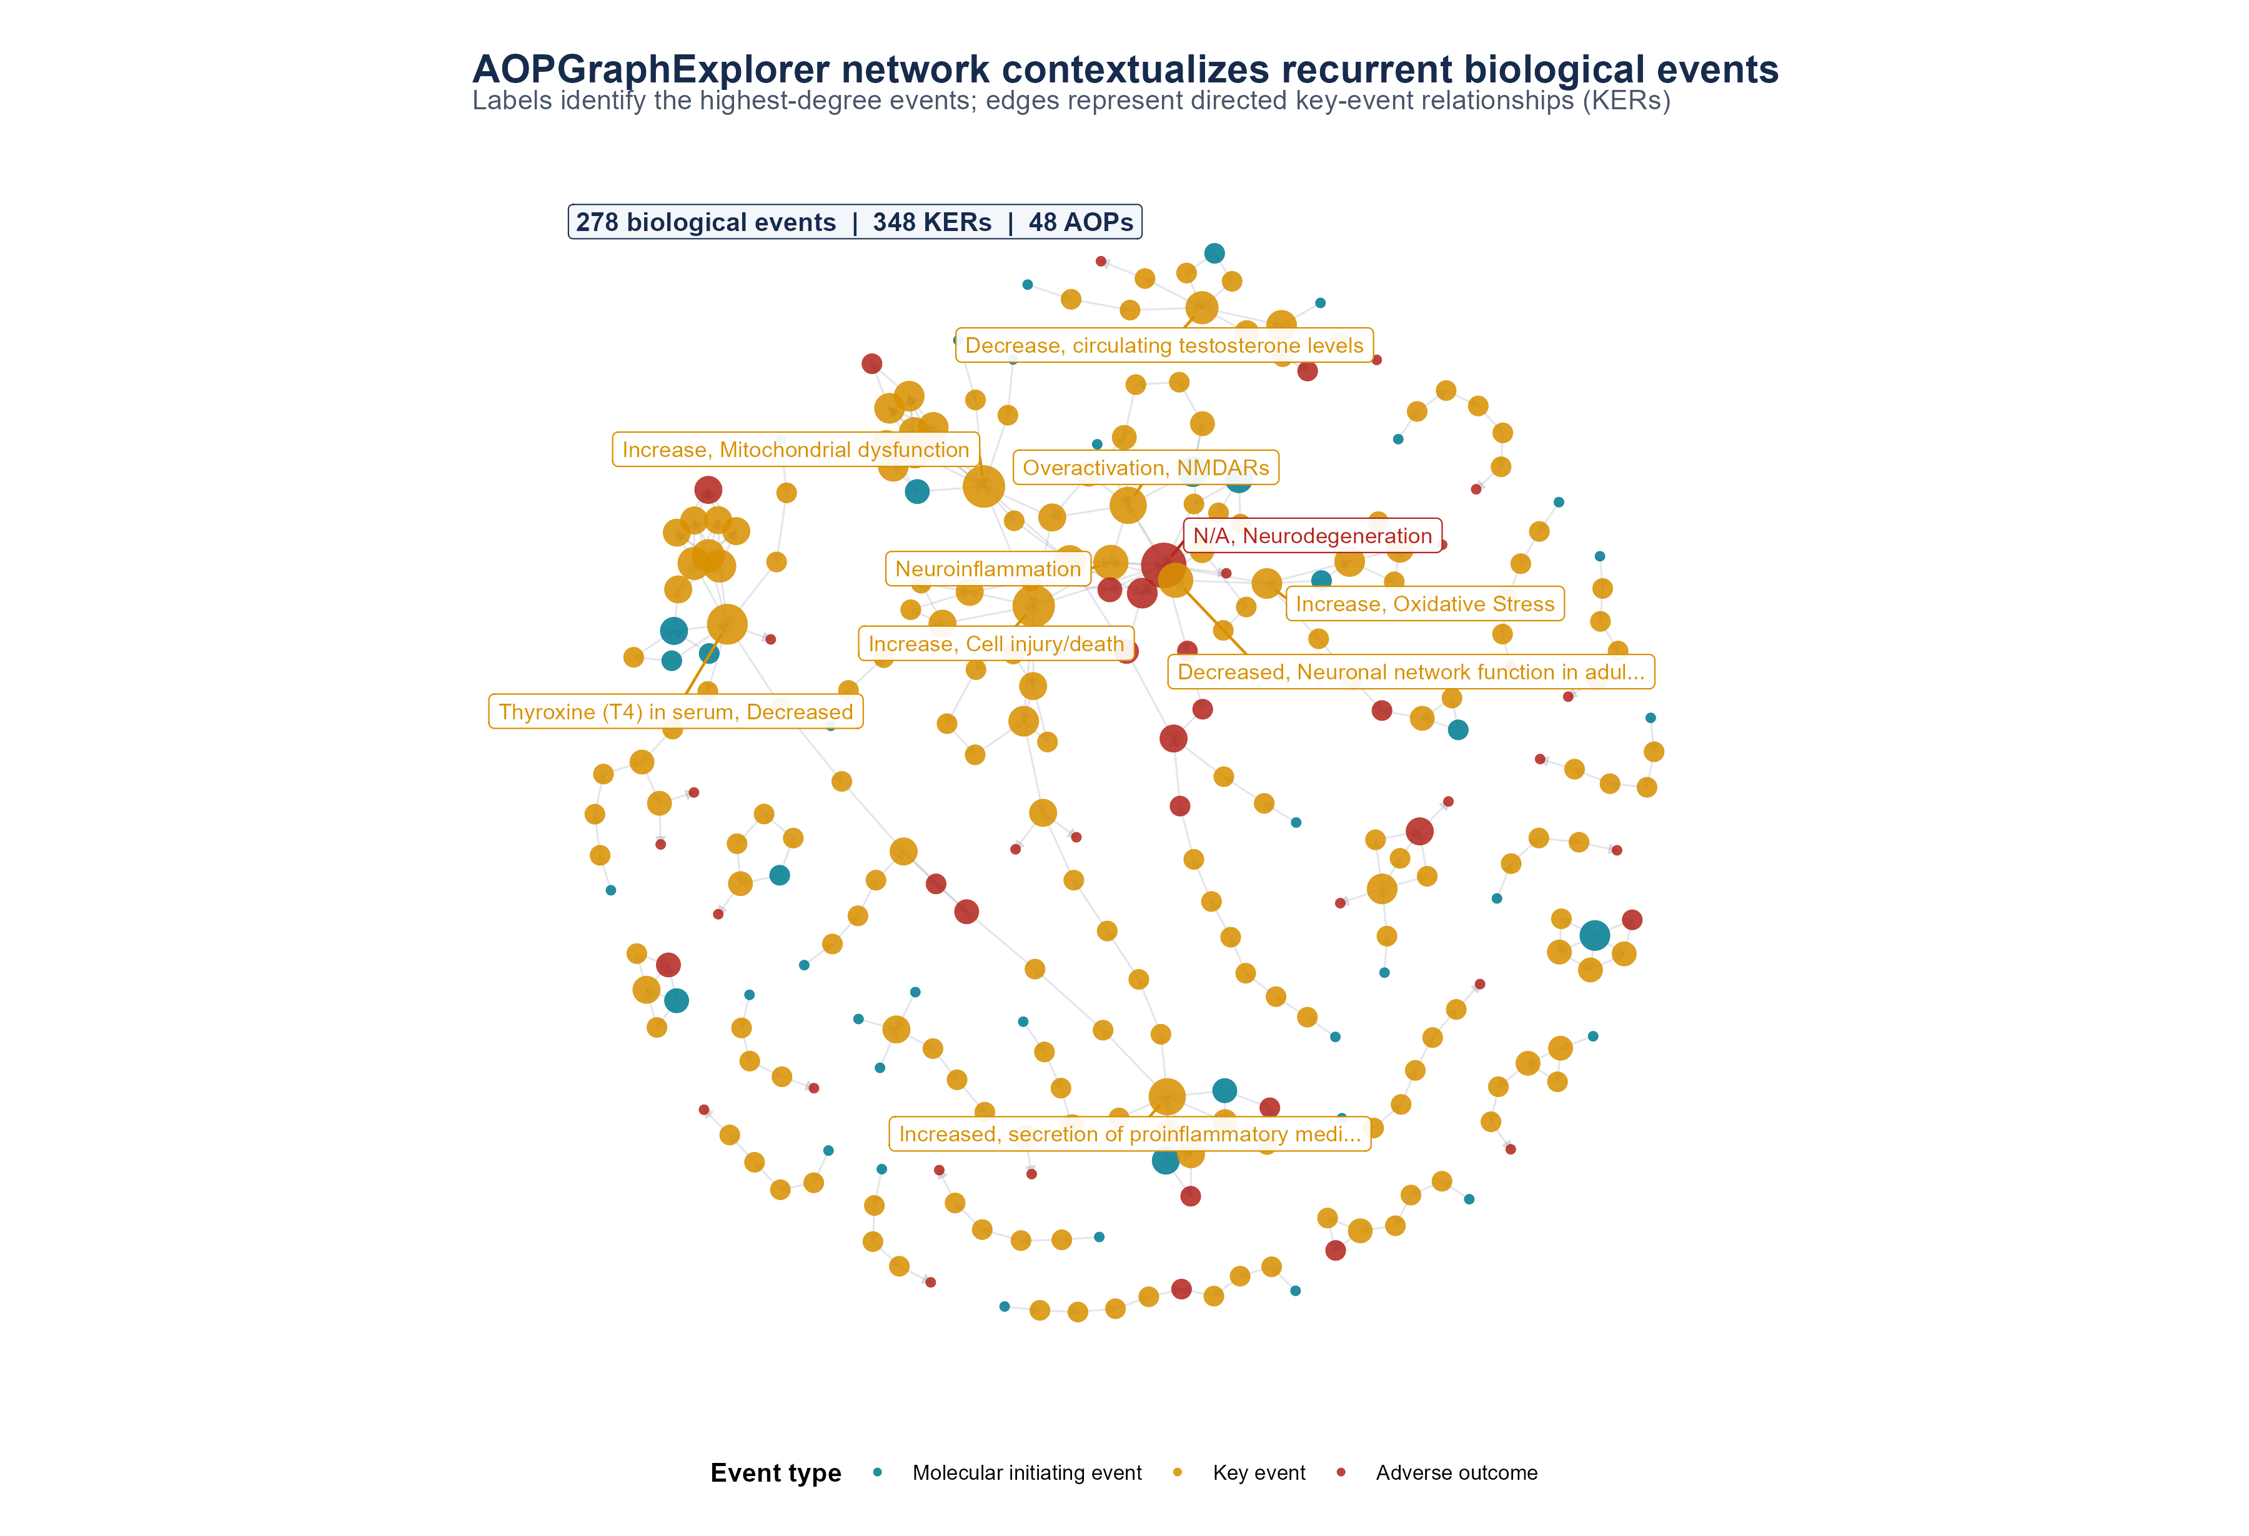
Figure 6. AOPGraphExplorer network supplied with the analysis. Nodes are coloured by event type and scaled by total degree; arrows are directed KERs. Labels identify selected high-degree or mechanistically relevant events. The network spans 48 AOP identifiers and is used for contextualization rather than as evidence that labelled AOs occurred.

Exploratory coexpression and AOPxLINK integration
AOPxGeneNet retained 17,660 expressed genes across 18 samples and applied an IQR filter to 4415 genes for WGCNA. A signed-hybrid network used an automatically selected soft-threshold power of 19 and yielded five assigned modules: coral (2592 genes), red (824), dimgrey (691), lightcoral (242), and snow (66). ConA dominated four module-trait patterns: lightcoral correlated positively (r = 0.974, nominal p = 8.86 x 10^-12), whereas coral, red, and dimgrey correlated negatively (r = -0.852, -0.847, and -0.727). The snow module was negatively associated with Ta4C3 (r = -0.708, nominal p = 0.0010) and included TM4SF19, RSAD2, EMP1, FAIM, TMEM158, CMPK2, GSTO1, and IL3RA among its strongest combined membership/trait candidates. With only three replicates per condition, all module-trait correlations remain exploratory.
For the Ta4C3-versus-control AOPxLINK contrast, 793 genes mapped to 65 KEs and 57 AOPs. Of 300 module-AOP pairs tested, four passed FDR < 0.05 (Table 3). AOP106 was enriched in dimgrey and lightcoral modules, while coral was enriched for AOP130 and AOP144. AOP106 contains tubulin and meiotic gene annotations; its enrichment in PBMC data should not be interpreted as evidence of reproductive toxicity. Rather, these results identify modules and genes for targeted follow-up. Step 3 selected 31 genes linked to 25 AOPs, including inflammatory sensing (NLRP3, CLEC7A), mitochondrial/oxidative metabolism (ALDH2, CYP27A1, HSD3B7), lysosomal processing (ACP5, GM2A, FUCA1, CTSD), and immune regulation (IRF5, FCGR2B).

Table 3. FDR-significant WGCNA module-AOP associations from the Ta4C3 AOPxLINK analysis. Enrichment ratios are relative to the mapped analysis universe.
Module | AOP | Abbreviated AOP title | Overlap genes | Enrichment ratio | FDR
dimgrey | 106 | Tubulin binding to aneuploid offspring | 35 | 2.54 | 6.51 x 10^-7
coral | 130 | LPLA2 inhibition to hepatotoxicity | 130 | 1.30 | 9.38 x 10^-6
coral | 144 | Endocytic-lysosomal uptake to liver fibrosis | 80 | 1.33 | 7.76 x 10^-4
lightcoral | 106 | Tubulin binding to aneuploid offspring | 11 | 3.34 | 0.0126
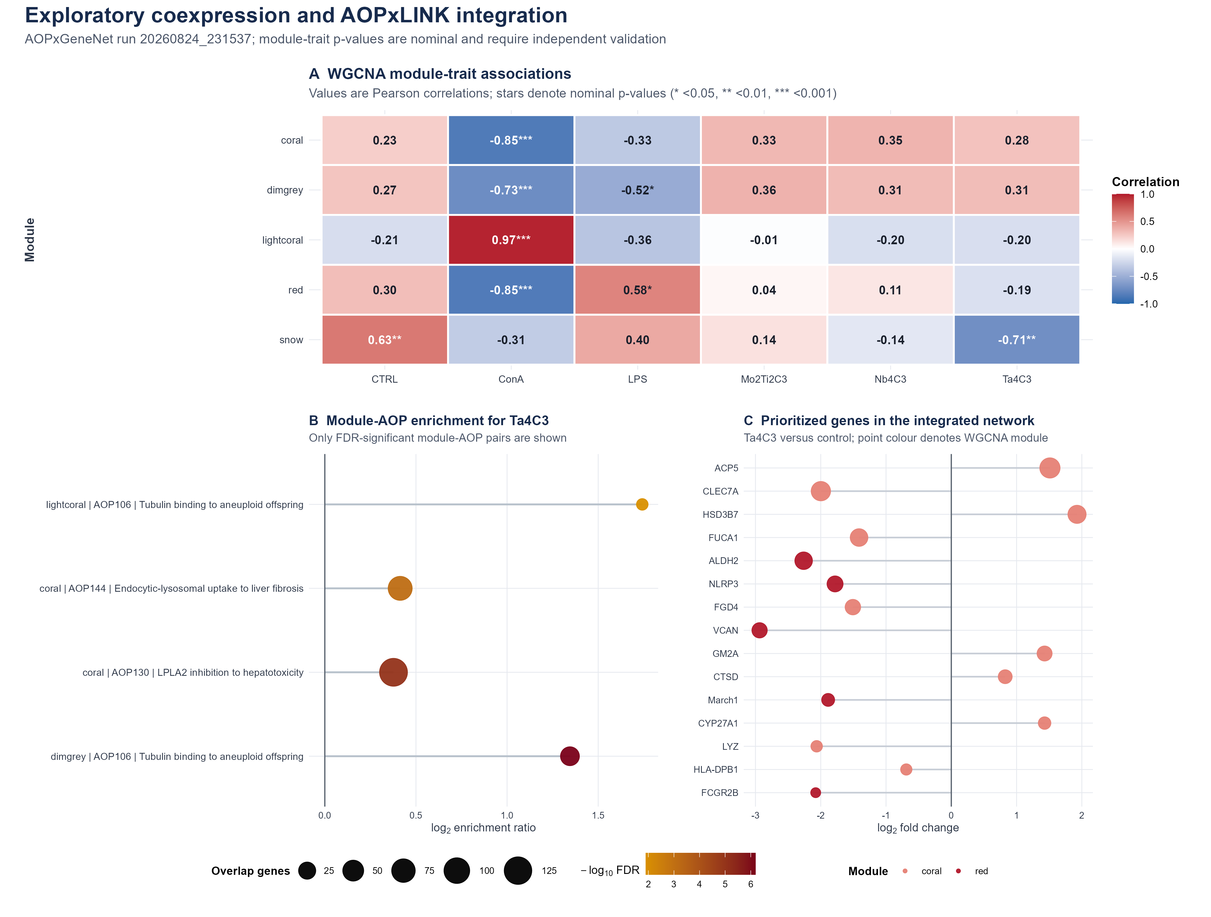
Figure 7. Exploratory coexpression and AOPxLINK integration. (A) Module-trait Pearson correlations; stars represent nominal p-values and are not multiplicity-adjusted. (B) Four FDR-significant module-AOP pairs for Ta4C3. (C) Top prioritized genes in the integrated graph, shown by Ta4C3 log2 fold change and module. These results nominate hypotheses for validation and are not causal estimates.

Evidence-based mode-of-action hypothesis and scope of inference
The convergent evidence supports a working, not definitive, mode-of-action hypothesis. The experimentally measured layer consists of balanced transcriptional induction and repression, recurrent immune-trafficking and cytokine annotations, and a larger response to Ta4C3 than to Mo2Ti2C3 or Nb4C3 under one dose and time point. Prior-knowledge layers place these genes near oxidative stress, mitochondrial dysfunction, inflammatory mediator release, lysosomal processing, and cell injury/death. Coexpression integration nominates genes connecting those themes but does not resolve their temporal order.
- Immune signalling and trafficking: chemotaxis, cytokine-receptor activity, Toll-like receptor pathways, and neutrophil degranulation were recurrent across gene sets.
- Cellular stress and processing: mitochondrial, oxidative, extracellular-matrix, vesicular, and lysosomal annotations connect the measured response to broader stress-response KEs.
- Material-dependent magnitude: Ta4C3 produced the largest DEG, KE, and AOP footprint among the three MXenes in this PBMC experiment; composition-specific causation cannot be inferred without matched physicochemical and dose-response data.
Several limitations constrain inference. The study is a secondary analysis of one dataset with three replicates per group, a single 24 h exposure, and one nominal mass concentration. PBMCs are a mixed-cell population, so apparent expression changes may partly reflect cell-state or cell-composition shifts. Over-representation results depend on gene thresholds and background definitions. TF expansion introduces prior-knowledge bias, while shared genes and KEs inflate AOP overlap. AOP annotations span tissues, species, doses, and exposure routes; organ-labelled AOs are contextual hypotheses rather than observed outcomes. WGCNA module-trait p-values were nominal, and the small sample size limits network stability. The SEMgraph result included in the application run was excluded from interpretation because the six-sample contrast was not adequate for a model with 71 estimated parameters. Independent dose-response, time-course, cell-resolved, and functional assays are required to test the proposed sequence.

Conclusions
An integrated pipeline combining validation, differential expression, functional enrichment, TF-regulon expansion, AOP fingerprinting, knowledge-graph context, and exploratory coexpression analysis produced a reproducible mechanistic summary of MXene responses in human PBMCs. Ta4C3 generated the largest response among the three tested materials, while recurrent functional evidence emphasized immune trafficking, cytokine communication, extracellular and vesicular compartments, and cellular-stress processes. Broad AOP convergence with expanded literature signatures demonstrates the reach of prior-knowledge integration but should not be interpreted as identical toxicity. AOPGraphExplorer and AOPxGeneNet analyses nominate mitochondrial dysfunction, oxidative stress, inflammatory signalling, lysosomal processing, and genes such as NLRP3, CLEC7A, and ALDH2 for targeted validation. The principal contribution is therefore a transparent hypothesis-generation framework that separates measured transcriptional evidence from inferred AOP context and can be reapplied to other case studies.

Experimental Section

Data sources and study design
Raw gene-level counts and metadata were obtained from GEO accession GSE200036 and the associated study by Fusco et al.[3] The matrix contained 58,735 Ensembl-feature rows and 18 samples: untreated control, LPS, ConA, Ta4C3, Mo2Ti2C3, and Nb4C3, with three biological replicates per condition. According to the source study, PBMCs were exposed for 24 h at 50 micrograms per millilitre. All contrasts used the untreated control as reference. No new human participants or specimens were enrolled in this secondary analysis.

Pipeline validation and differential expression
The repository-level workflow was executed from run_pipeline.R. Step 00 (00_data_validation.R) validated the input schema, matched count columns to metadata, normalized control aliases, stripped Ensembl version suffixes, mapped human gene symbols, summarized library depth and mitochondrial/ribosomal fractions, and generated variance-stabilized PCA, clustering, and sample-correlation diagnostics. Its independent QC filter retained genes with counts per million > 1 in at least three samples.
Differential expression was then performed in DESeq2 1.46.0 under R 4.4.3 with design ~ condition.[6] The model input retained genes with at least five counts in at least three samples. Size factors and dispersions were estimated by DESeq2, and pairwise contrasts were extracted against untreated control. Significant genes required Benjamini-Hochberg FDR < 0.05 and absolute log2 fold change >= 1.[17] ALL, UP, and DOWN sets were exported separately. Variance-stabilized values were used only for visualization and network analyses, not for count-model fitting.

Literature signatures and TF-regulon expansion
Two human literature signatures were curated with direction, dose, biological system, and identifier provenance. The Ti3C2Tx signature originated from lymphocytes co-cultured with HUVECs exposed to 2 micrograms per millilitre Ti3C2Tx in an allograft-vasculopathy model (125 valid unique genes).[10] The HN-Ti3C2 signature originated from 30 micrograms per millilitre exposure of human bone-marrow mesenchymal stem cells in an osteogenesis/osteomyelitis study (24 valid unique genes).[11] These signatures were not treated as matched replicates of the PBMC experiment.
TFs present in each signature were identified, and associated targets were added from DoRothEA 1.18.0.[9] Two sensitivity tiers were generated: high-confidence regulons (A/B) and broader regulons (A/B/C). Original genes were retained, targets were deduplicated, and identifiers were mapped to human Ensembl genes. Expansion represents regulatory prior knowledge and does not by itself establish TF activity or the direction of target regulation.

Functional enrichment and signature projection
Over-representation analysis was performed with clusterProfiler 4.14.6 and ReactomePA 1.50.0 for Gene Ontology biological process, molecular function, and cellular component; KEGG; and Reactome.[7,8,18,19] Transcriptomic and literature branches used their respective detectable-gene backgrounds. Multiple testing was controlled by the Benjamini-Hochberg method; FDR < 0.05 defined significant terms. Recurrence summaries counted unique gene sets with significant enrichment and retained the most significant adjusted p-value per term and gene set.
For threshold-independent comparison, each DESeq2 contrast was ranked by the Wald statistic, with sign(log2 fold change) x -log10(p-value) as fallback. Directional literature sets were projected using fgseaMultilevel (fgsea 1.32.4), with gene-set size constrained to 10-1000 and exact tail calculation requested (eps = 0).[12] Projection results were adjusted across tests, and FDR < 0.05 was used for reporting.

KE enrichment and AOP fingerprinting
AOPfingerprintR 0.0.1 was applied to the ALL, UP, DOWN, and literature-derived gene sets using the package's human Ensembl KE clusters and KE-to-AOP mappings.[5] Enrichment used branch-specific backgrounds, false-discovery-rate adjustment, and p-value threshold 0.05. Significant KEs were mapped to parent AOPs, and an AOP was represented when it contained significant KE evidence under the package workflow. Counts reported here are unique KEs or AOPs, not summed rows across directional sets.

AOPGraphExplorer network
The supplied AOPGraphExplorer NetworkX node-link JSON export was analyzed without changing its event or relationship membership.[14] Nodes were summarized by event type and total degree; directed edges were treated as KERs, and unique AOP identifiers were counted from edge memberships. A deterministic force-directed layout (seed 20260825) was used for the static figure. The export identifies AOP-Wiki event and relationship URLs and is distributed with a CC BY-SA 4.0 data notice; AOP-Wiki content was accessed through the supplied export.[13,14]

AOPxGeneNet coexpression and AOPxLINK integration
The archived AOPxGeneNet/AOPxLINK run (run ID 20260824_231537; development build; code fingerprint SHA-256 de47c12822864dfd8e9130e3c616dff3e44d6605014653fe2ffdba1ac81c874c) was evaluated from its evidence report and exported tables. The application used Python 3.10.21, PyWGCNA 2.2.1, pandas 2.3.3, NumPy 2.2.6, SciPy 1.15.3, NetworkX 3.4.2, and statsmodels 0.14.6.[15,16] It retained genes with CPM >= 1 in at least 20% of samples and non-zero counts in at least one-third of samples, variance-stabilized the counts, and applied an automatic IQR filter (4415 genes retained). A signed-hybrid WGCNA selected soft-threshold power 19. Module eigengenes were correlated with one-hot condition traits by Pearson correlation; reported p-values are nominal.
AOPxLINK Step 2 used the Ta4C3-versus-control contrast, mapped genes to KE/AOP annotations, and tested module-AOP overlap by over-representation with FDR adjustment. Step 3 combined selected genes with the uploaded AOP network and ranked genes using differential-expression, gene-significance, module-membership, intramodular-connectivity, and AOP-proximity components recorded by the application. The integrated graph contained 222 nodes and 364 edges. Because the application was a development build and the sample size was small, these analyses were classified as exploratory.

Statistical interpretation and reproducibility
Unless stated otherwise, significance was defined as Benjamini-Hochberg FDR < 0.05. Nominal module-trait p-values were displayed only to characterize the archived WGCNA run and were not treated as confirmatory. Figures were regenerated from exported CSV/JSON evidence with deterministic seeds. The pipeline uses a renv lockfile, versioned scripts, configurable input paths and case-study output directories, and machine-readable provenance files.

Data and Code Availability
The source transcriptomic dataset is available from NCBI GEO under accession GSE200036. The analysis repository contains the numbered pipeline, configuration, locked R environment, data-input specification, and derived outputs used in this manuscript. The AOPGraphExplorer export and AOPxGeneNet run evidence are stored with the analysis outputs. [AUTHOR: insert the public GitHub URL, release tag/commit, archived DOI, and any restrictions on redistribution of source or third-party data before submission.]

Supporting Information
The repository outputs include validation reports; normalized and variance-stabilized matrices; DE tables and volcano plots; functional-enrichment tables and heatmaps; KE/AOP fingerprints; DEG concordance and recurrence summaries; TF-expansion and signature-projection tables; AOP network files; and the complete AOPxGeneNet/AOPxLINK evidence report, parameters, tables, and interactive visualizations. A journal-specific Supporting Information PDF and data manifest should be assembled from these artifacts after the target journal is selected.

Author Contributions
[AUTHOR: insert CRediT contributor roles and confirm responsibility for data curation, software, formal analysis, visualization, supervision, and writing.]

Acknowledgments
This work was supported by the European Union Horizon 2020 programme under grant agreement No. 101008099 (CompSafeNano). [AUTHOR: confirm the funder wording and add institutional or technical acknowledgments required by the grant.]

Competing Interests
[AUTHOR: insert the approved competing-interest statement; if none, state that the authors declare no competing financial interests.]

References
1. Naguib, M.; Kurtoglu, M.; Presser, V.; Lu, J.; Niu, J.; Heon, M.; Hultman, L.; Gogotsi, Y.; Barsoum, M. W. Two-Dimensional Nanocrystals Produced by Exfoliation of Ti3AlC2. Adv. Mater. 2011, 23, 4248-4253. DOI
2. Anasori, B.; Lukatskaya, M. R.; Gogotsi, Y. 2D Metal Carbides and Nitrides (MXenes) for Energy Storage. Nat. Rev. Mater. 2017, 2, 16098. DOI
3. Fusco, L.; et al. Immune Profiling and Multiplexed Label-Free Detection of 2D MXenes by Mass Cytometry and High-Dimensional Imaging. Adv. Mater. 2022, 34, e2205154. DOI
4. Villeneuve, D. L.; et al. Adverse Outcome Pathway (AOP) Development I: Strategies and Principles. Toxicol. Sci. 2014, 142, 312-320. DOI
5. Saarimaki, L. A.; Morikka, J.; Pavel, A.; Korpilahde, S.; del Giudice, G.; Federico, A.; Fratello, M.; Serra, A.; Greco, D. Toxicogenomics Data for Chemical Safety Assessment and Development of New Approach Methodologies: An Adverse Outcome Pathway-Based Approach. Adv. Sci. 2023, 10, 2203984. DOI
6. Love, M. I.; Huber, W.; Anders, S. Moderated Estimation of Fold Change and Dispersion for RNA-seq Data with DESeq2. Genome Biol. 2014, 15, 550. DOI
7. Wu, T.; Hu, E.; Xu, S.; et al. clusterProfiler 4.0: A Universal Enrichment Tool for Interpreting Omics Data. Innovation 2021, 2, 100141. DOI
8. Milacic, M.; et al. The Reactome Pathway Knowledgebase 2024. Nucleic Acids Res. 2024, 52, D672-D678. DOI
9. Garcia-Alonso, L.; Holland, C. H.; Ibrahim, M. M.; Turei, D.; Saez-Rodriguez, J. Benchmark and Integration of Resources for the Estimation of Human Transcription Factor Activities. Genome Res. 2019, 29, 1363-1375. DOI
10. Yan, W.; Rafieerad, A.; Alagarsamy, K. N.; Saleth, L. R.; Arora, R. C.; Dhingra, S. Immunoengineered MXene Nanosystem for Mitigation of Alloantigen Presentation and Prevention of Transplant Vasculopathy. Nano Today 2023, 48, 101706. DOI
11. Wang, H.; Mu, N.; He, Y.; Zhang, X.; Lei, J.; Yang, C.; Ma, L.; Gao, Y. Ultrasound-Controlled MXene-Based Schottky Heterojunction Improves Anti-Infection and Osteogenesis Properties. Theranostics 2023, 13, 1669-1683. DOI
12. Korotkevich, G.; Sukhov, V.; Budin, N.; Shpak, B.; Artyomov, M. N.; Sergushichev, A. Fast Gene Set Enrichment Analysis. bioRxiv 2021. DOI
13. Martens, M.; Evelo, C. T.; Willighagen, E. L. Providing Adverse Outcome Pathways from the AOP-Wiki in a Semantic Web Format to Increase Usability and Accessibility of the Content. Appl. In Vitro Toxicol. 2022. DOI
14. Abdelwahab, A. A. AOPGraphExplorer; Zenodo, 2025. DOI
15. Langfelder, P.; Horvath, S. WGCNA: An R Package for Weighted Correlation Network Analysis. BMC Bioinformatics 2008, 9, 559. DOI
16. Rezaie, N.; Reese, F.; Mortazavi, A. PyWGCNA: A Python Package for Weighted Gene Co-Expression Network Analysis. Bioinformatics 2023, 39, btad415. DOI
17. Benjamini, Y.; Hochberg, Y. Controlling the False Discovery Rate: A Practical and Powerful Approach to Multiple Testing. J. R. Stat. Soc. B 1995, 57, 289-300. DOI
18. Gene Ontology Consortium. The Gene Ontology Resource: Enriching a GOld Mine. Nucleic Acids Res. 2021, 49, D325-D334. DOI
19. Kanehisa, M.; Goto, S. KEGG: Kyoto Encyclopedia of Genes and Genomes. Nucleic Acids Res. 2000, 28, 27-30. DOI

For Table of Contents Use Only
AOP-Guided Toxicogenomics of MXene Responses


