An AOP-Guided Toxicogenomics Framework for Mechanistic Interpretation of MXene Responses in Human Peripheral Blood Mononuclear Cells
Asmaa A. Abdelwahab¹, Angela Serra², Dario Greco^{2*}, Barry Hardy^{1*}
¹Edelweiss Connect GmbH, Technology Park Basel, Hochbergerstrasse 60C, 4057 Basel, Switzerland
2 Finnish Hub for Development and Validation of Integrated Approaches (FHAIVE), Faculty of Medicine and Health Technology, Tampere University, Arvo Ylpön katu 34, 33520 Tampere, Finland

*Correspondence: barry.hardy@edelweissconnect.com & dario.greco@tuni.fi

Abstract
Transcriptomic evidence for MXene bioactivity is distributed across materials, exposure systems, and analytical conventions, limiting mechanistic comparison. We developed a validation-first, adverse outcome pathway (AOP)-guided workflow that integrates reanalysis of human peripheral blood mononuclear cell RNA-seq data (GSE200036), two curated human literature signatures, transcription-factor regulon expansion, functional and key-event (KE) enrichment, AOP fingerprinting, and provenance-preserving network exports. At BH-adjusted P < 0.05 and |log2 fold change| >= 1, Ta4C3 produced 470 differentially expressed genes, compared with 320 for Mo2Ti2C3 and 262 for Nb4C3. The responses converged on immune trafficking, cytokine signaling, cellular stress, and lysosomal/vesicular processes, while AOP annotations were interpreted as mechanistic hypotheses rather than evidence of adverse outcomes. In a parallel direct gene-to-annotation sensitivity analysis, all 22 transcriptomic or literature set-by-family combinations exceeded 1,000 size-matched random gene sets (empirical BH-adjusted P = 0.000999). Ta4C3 was taken forward to the archived AOPxGeneNet/AOPxLINK run because it had the largest primary-response burden; this secondary coexpression analysis remained explicitly exploratory. The framework contributes (i) a reusable separation of measured and literature-inferred evidence, (ii) a gene-set-size-controlled specificity test with explicit multiple-testing families, and (iii) end-to-end provenance from curated inputs to publication-ready figures and interoperable AOP network outputs.
Keywords: MXenes; toxicogenomics; adverse outcome pathways; peripheral blood mononuclear cells; transcription-factor regulons; coexpression networks; nanosafety

Introduction
MXenes are two-dimensional transition-metal carbides, nitrides, and carbonitrides derived from layered precursors and commonly represented as Mn+1XnTx, where Tx denotes surface terminations.[1,2] Their aqueous processability, large surface area, and tunable chemistry have motivated applications in energy storage, sensing, environmental technologies, and biomedicine. The same physicochemical diversity complicates safety assessment: composition, flake dimensions, surface oxidation, terminal groups, dose, protein corona, and biological model may each change the observed response.
Human peripheral blood mononuclear cells (PBMCs) provide a relevant system for detecting immune perturbation. Fusco et al. profiled PBMC responses to Ta4C3, Mo2Ti2C3, and Nb4C3 and reported comparatively modest transcriptomic effects, with Ta4C3 producing the clearest response among the three materials.[3] Transcript-level changes alone, however, do not establish a mode of action: gene lists depend on statistical thresholds and may combine causal signals, compensatory responses, cell-composition effects, and nonspecific stress.
The AOP framework organizes evidence from molecular initiating events through measurable key events (KEs) to adverse outcomes (AOs), while explicitly separating mechanistic plausibility from hazard prediction.[4] AOP-aligned toxicogenomics can therefore provide a structured interpretation layer for transcriptomic data.[5] Transcription-factor (TF) regulons and coexpression networks add complementary prior knowledge, but they also expand the search space and can amplify shared annotations. Their outputs require transparent backgrounds, multiple-testing control, and cautious interpretation.
Here, we reanalyzed GSE200036, projected two independently curated human MXene signatures onto every transcriptomic contrast, and integrated functional, KE, AOP, and network evidence. The study makes three specific contributions. First, it provides a reusable validation-first workflow that keeps measured differential expression, literature-derived signatures, and TF-expanded inference as traceable evidence layers. Second, it adds a branch-specific, size-matched random-background analysis that tests whether KE/AOP coverage exceeds that expected from gene-set size alone and states every multiple-testing family. Third, it connects reproducible R outputs with AOPGraphExplorer and the archived AOPxGeneNet/AOPxLINK run while generating journal-ready figures directly from the pipeline. These contributions are intended for mechanistic prioritization and hypothesis generation, not diagnosis or causal proof of adverse outcomes.

Results and Discussion

Study design, data validation, and transcriptional response
The analysis comprised 18 human PBMC samples with three biological replicates per condition: medium-only control, lipopolysaccharide (LPS), concanavalin A (ConA), and the MXenes Ta4C3, Mo2Ti2C3, and Nb4C3. All exposures lasted 24 h. The deposited study used 50 micrograms mL-1 for each MXene, 2 micrograms mL-1 LPS, and 10 micrograms mL-1 ConA (Table 1). The pipeline first validates identifiers, sample matching, library sizes, replicate counts, and count-matrix structure before differential expression (Figure 1).
Table 1. Material and exposure characterization for the GSE200036/source-study mRNA-seq experiment. Lateral sizes are the original material dispersions reported by Fusco et al.; all conditions were run in triplicate.
Condition | Role | Nominal exposure | Time | Lateral size | Biological n
Ta4C3Tx | MXene | 50 micrograms mL-1 | 24 h | ~810 nm | 3
Mo2Ti2C3Tx | MXene | 50 micrograms mL-1 | 24 h | ~370 nm | 3
Nb4C3Tx | MXene | 50 micrograms mL-1 | 24 h | ~150 nm | 3
LPS | Positive control | 2 micrograms mL-1 | 24 h | n/a | 3
ConA | Positive control | 10 micrograms mL-1 | 24 h | n/a | 3
Medium | Negative control | Medium only | 24 h | n/a | 3
Note: the source study produced delaminated MXenes by HF/HCl etching and TMAOH treatment, characterized the materials by XRD, SEM, and DLS, and screened for contamination. Tx denotes mixed surface terminations, including O, OH, and F. These physicochemical descriptors do not substitute for delivered-dose measurements.
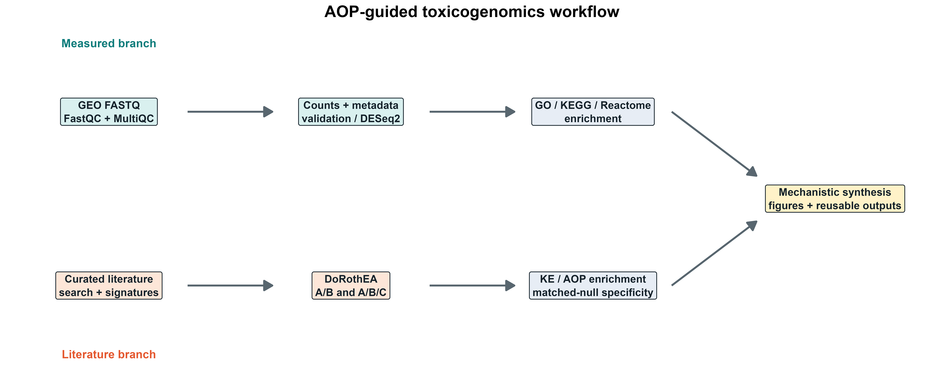
Figure 1. Reproducible AOP-guided toxicogenomics workflow. The optional FASTQ-QC stage precedes count-level validation. Measured transcriptomic and curated literature evidence remain separate through enrichment, specificity testing, and network interpretation; step 12 generates the publication figures directly from pipeline outputs.
Using a per-contrast DESeq2 BH-adjusted P-value threshold of 0.05 and |log2 fold change| >= 1, Ta4C3 produced 470 significant genes (243 up, 227 down), followed by Mo2Ti2C3 (320; 160 up, 160 down) and Nb4C3 (262; 151 up, 111 down). LPS and ConA produced 967 and 4,731 DEGs, respectively (Table 2; Figure 2). The larger control responses support assay responsiveness but do not provide a potency scale for the MXenes.

Table 2. Differential-expression, key-event, and AOP coverage by condition. DEG thresholds were per-contrast DESeq2 BH-adjusted P < 0.05 and |log2 fold change| >= 1. KE/AOP counts are primary AOPfingerprintR results and are not the direct matched-null counts.
Condition | Role | UP | DOWN | Total DEGs | Distinct KEs | Distinct AOPs
ConA | Positive control | 2183 | 2548 | 4731 | 702 | 221
LPS | Positive control | 462 | 505 | 967 | 566 | 198
Ta4C3 | MXene | 243 | 227 | 470 | 411 | 152
Mo2Ti2C3 | MXene | 160 | 160 | 320 | 289 | 107
Nb4C3 | MXene | 151 | 111 | 262 | 244 | 90
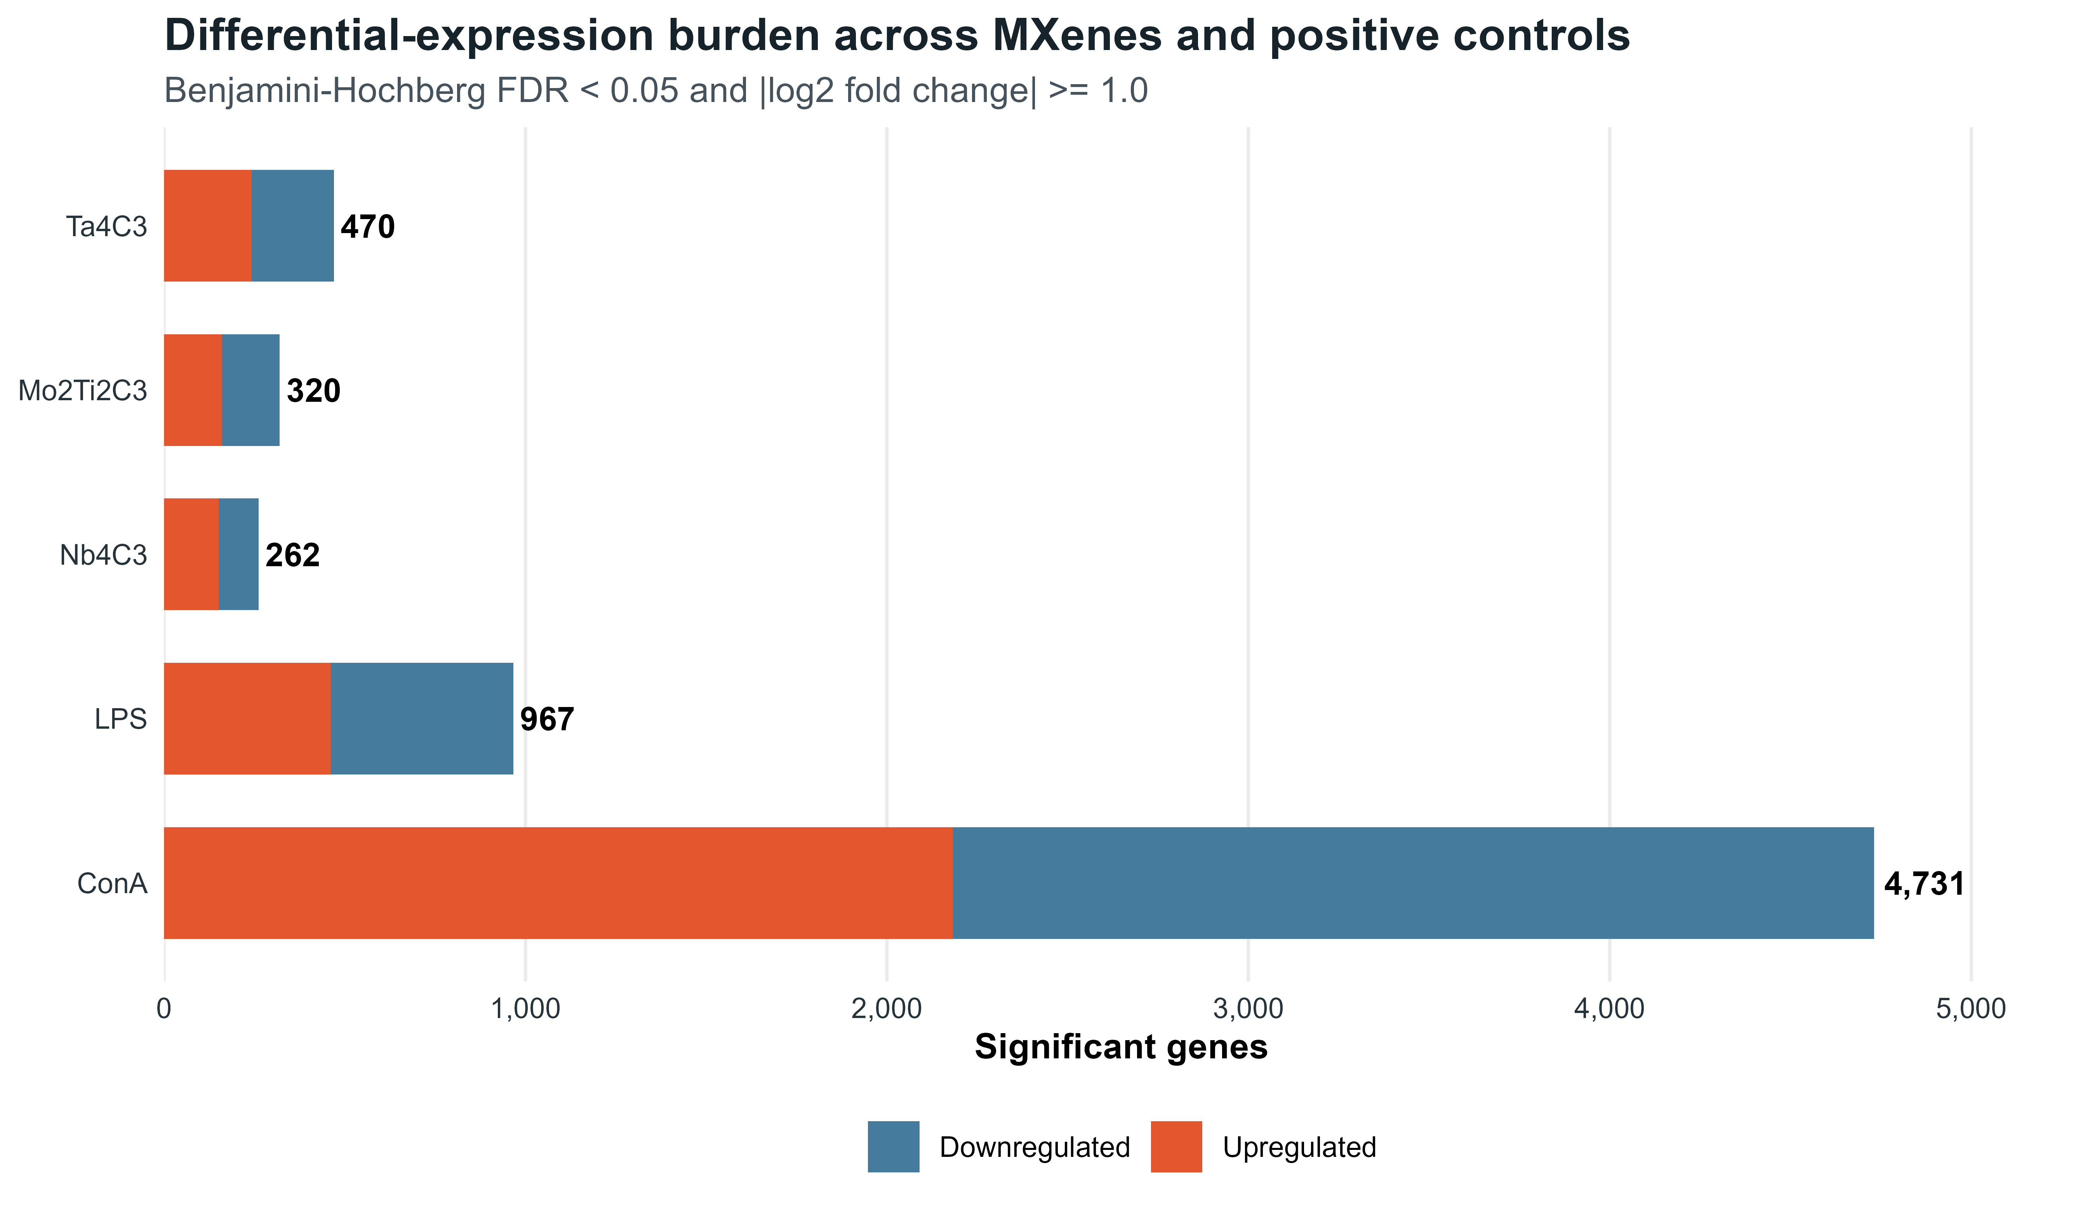
Figure 2. Differential-expression burden by contrast. Bars show genes meeting per-contrast DESeq2 BH-adjusted P < 0.05 and |log2 fold change| >= 1; labels report totals. Positive controls demonstrate assay responsiveness and are not a potency reference for the MXenes.
Pairwise overlap was substantially greater among MXene gene sets than between MXenes and the positive controls. Jaccard indices for ALL significant genes ranged from 0.36 to 0.47 among the three MXenes, compared with 0.04-0.18 for most MXene-control pairs. Direction-specific overlap was similar (UP, 0.33-0.52; DOWN, 0.35-0.42). Genome-wide log2 fold changes were most concordant between Ta4C3 and Nb4C3 (Spearman rho = 0.563), and 69 genes met the DEG threshold in all five contrasts. These results support a shared component of the PBMC response but also retain material- and stimulus-specific effects.
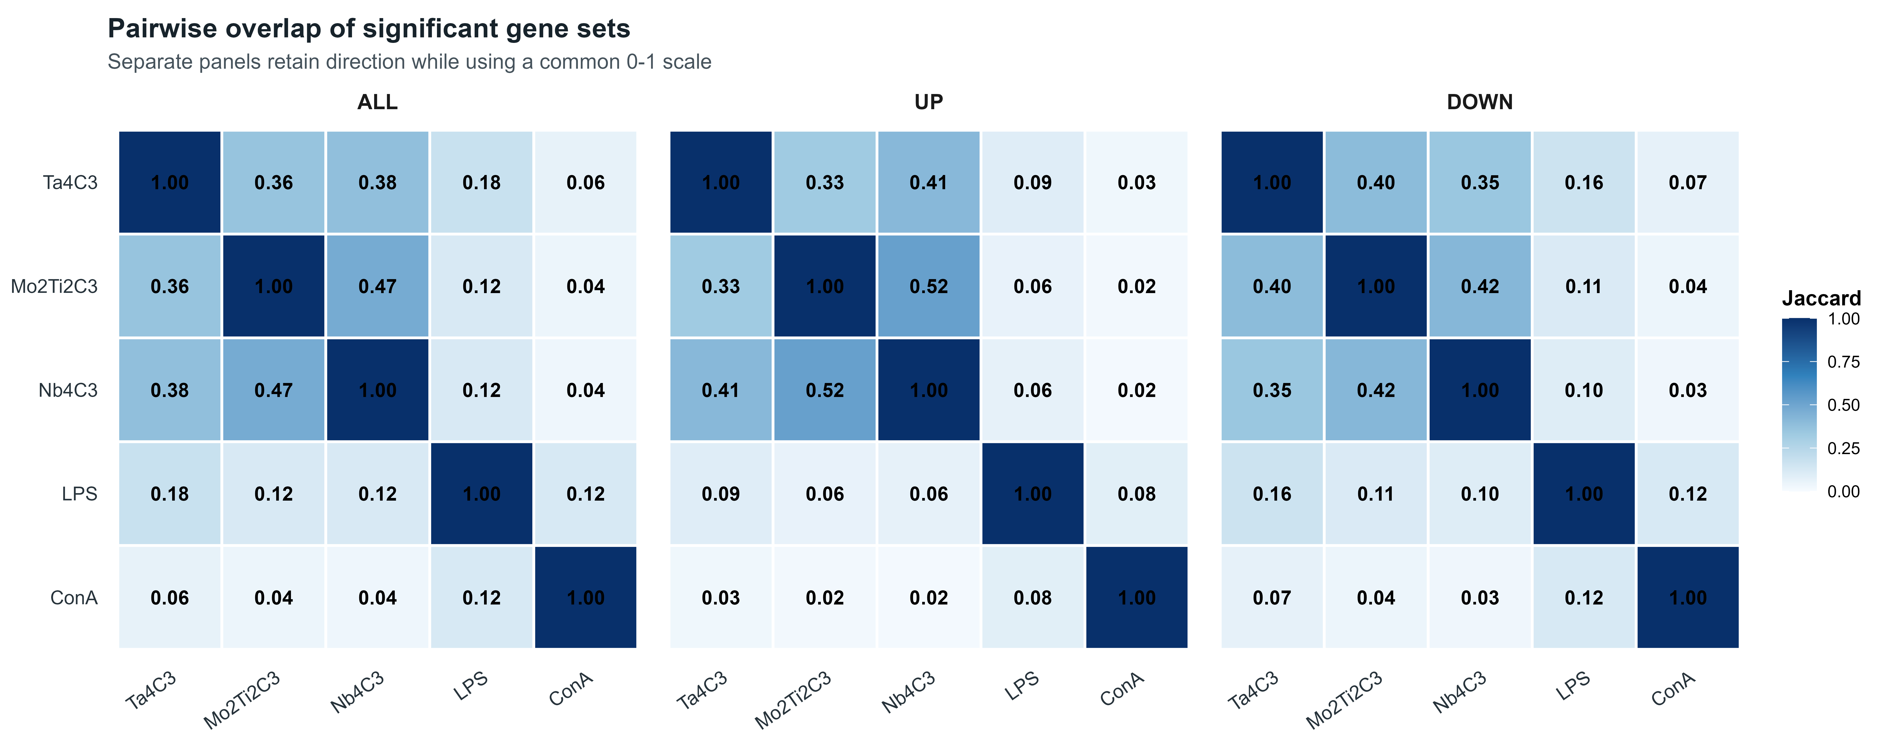
Figure 3. Pairwise overlap of significant gene sets. Jaccard indices are shown separately for ALL, UP, and DOWN sets. The enlarged three-panel design is intended to preserve labels and cell values at journal column width.

Recurrent functional programs and literature-signature projection
Across transcriptomic and literature-derived gene sets, recurrent Gene Ontology, KEGG, and Reactome terms emphasized leukocyte trafficking, cytokine and Toll-like receptor signaling, extracellular-matrix organization, vesicular processing, and lysosomal biology (Figure 4). Disease-labelled database terms indicate overlap with curated gene annotations; they are not diagnoses, organism-level outcomes, or evidence that a disease process occurred in the exposed PBMC cultures.
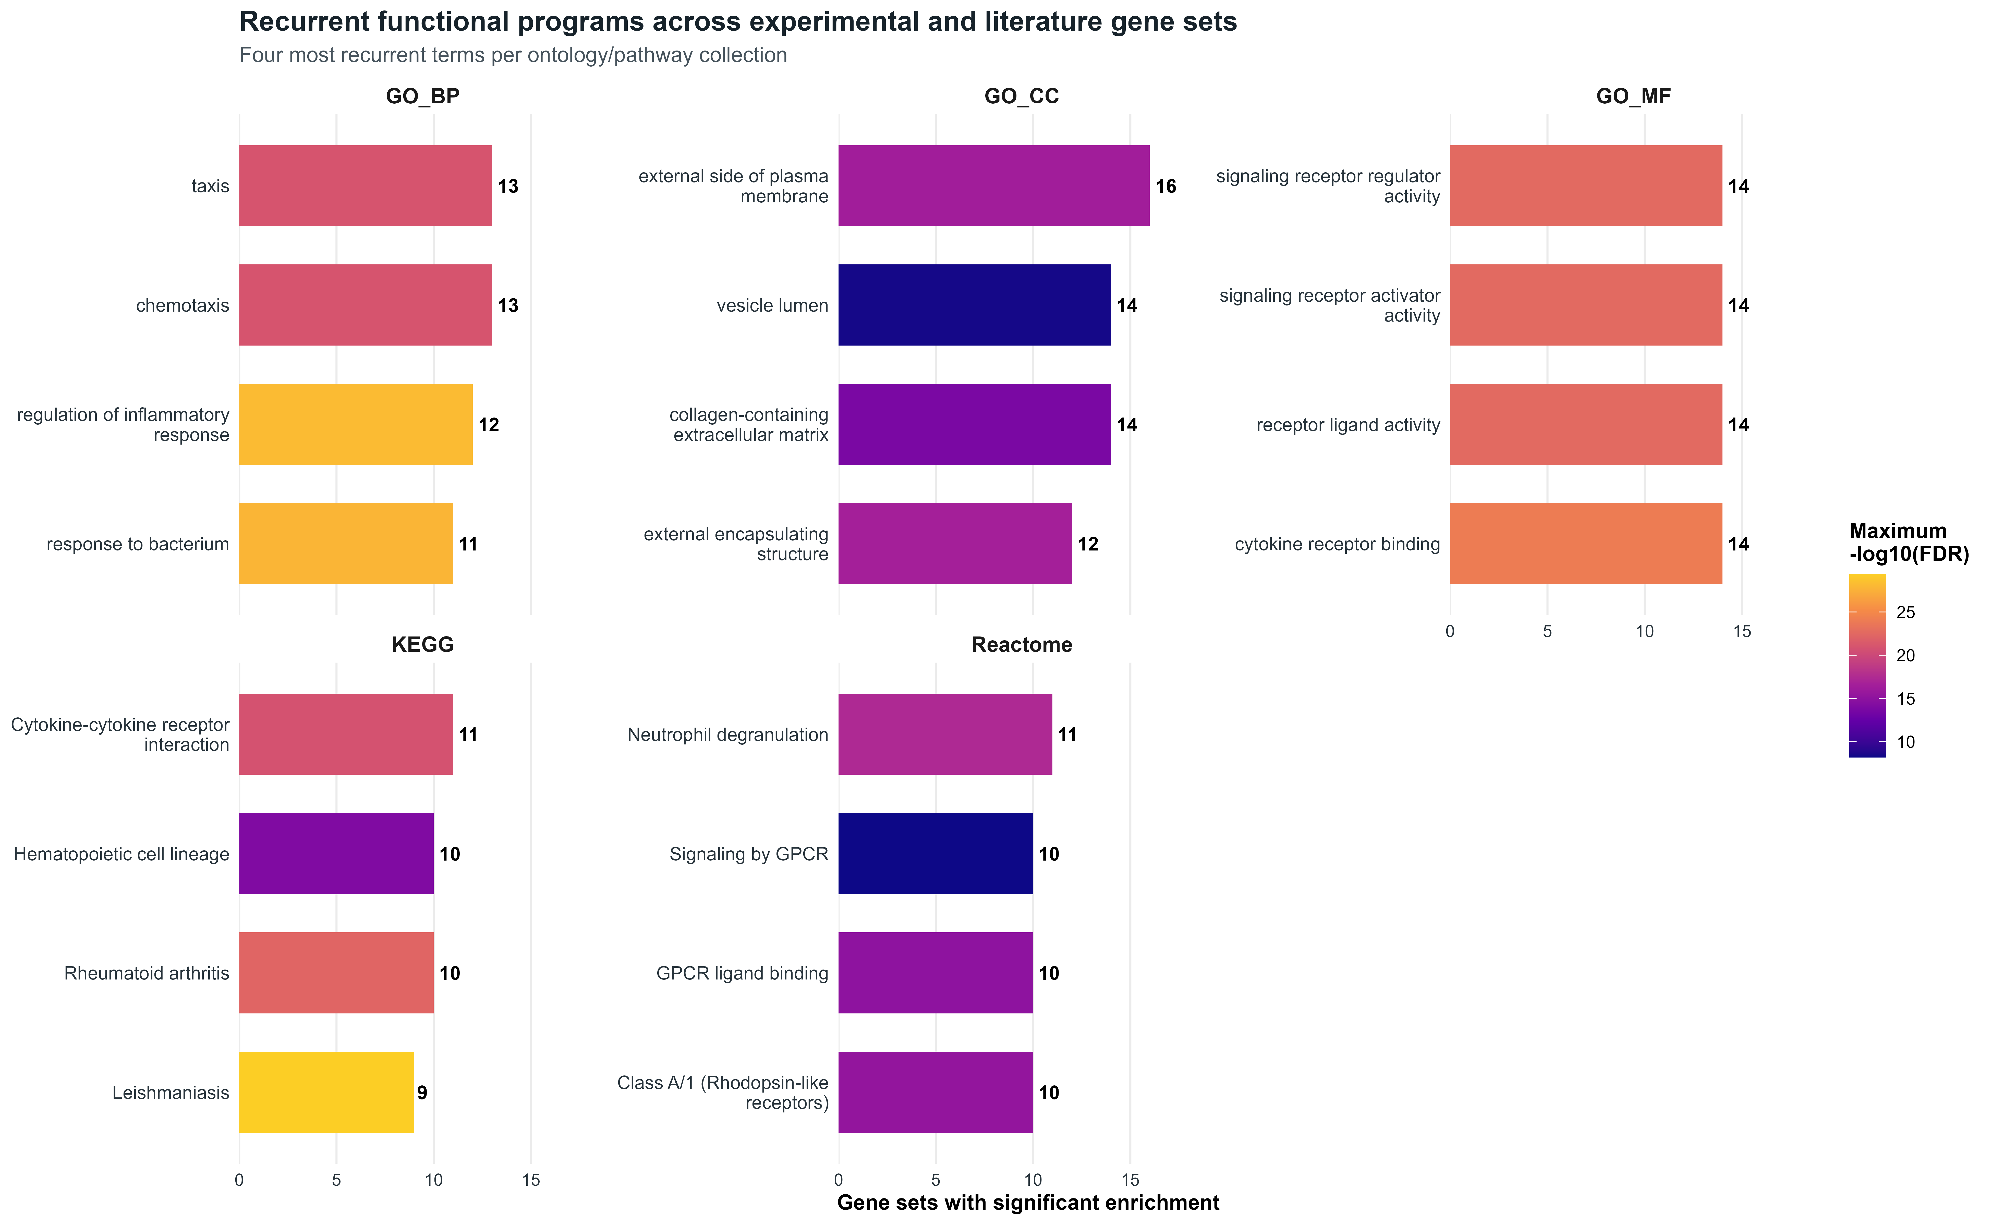
Figure 4. Recurrent functional programs across experimental and literature-derived gene sets. Point size represents overlap and colour represents BH-adjusted significance within the stated gene-set-by-database family. Disease-labelled terms are database annotations, not diagnoses or observed adverse outcomes.
Rank-based projection offered a threshold-independent comparison with the literature signatures. The HN-Ti3C2 up-regulated signature was enriched in ConA (normalized enrichment score [NES] = 2.46; BH-adjusted P = 4.65 x 10^-9), whereas the Ti3C2Tx down-regulated signature showed negative enrichment in LPS (NES = -2.21; BH-adjusted P = 1.31 x 10^-8), ConA (NES = -1.85; BH-adjusted P = 5.56 x 10^-5), and Mo2Ti2C3 (NES = -1.77; BH-adjusted P = 6.15 x 10^-4). The dominance of positive-control matches and the different source systems argue for context-dependent biological similarity rather than direct replication of the literature exposures.
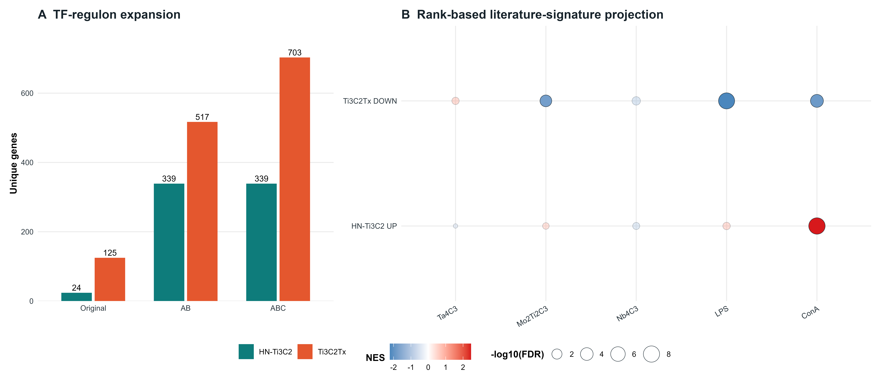
Figure 5. TF-regulon expansion and literature-signature projection. (A) Original and DoRothEA A/B and A/B/C expanded set sizes; expansion is an inference layer, not additional measured differential expression. (B) FGSEA normalized enrichment scores for original directional literature signatures projected onto transcriptomic contrasts.

Key-event and AOP fingerprints reveal broad but non-causal convergence
KE enrichment followed the overall response gradient: ConA (702 distinct KEs) and LPS (566) exceeded Ta4C3 (411), Mo2Ti2C3 (289), and Nb4C3 (244). Corresponding AOP coverage was 221, 198, 152, 107, and 90, respectively (Table 2). These values describe database coverage at the configured significance threshold; they are not measures of toxicity severity and do not imply that downstream AOs occurred in the PBMC culture.
TF-regulon expansion greatly increased the size and AOP coverage of both literature signatures (Table 3). These expanded sets are sensitivity analyses: added targets are regulatory predictions rather than genes measured as differentially expressed in the source studies, so original and expanded evidence is reported separately.
Table 3. Effect of DoRothEA regulon expansion on literature-derived gene-set and AOP coverage. Counts are unique valid genes/AOPs. Expanded sets represent inferred TF targets and are reported separately from source-study DEGs.
Signature | Original genes | A/B genes | A/B/C genes | Original AOPs | A/B AOPs | A/B/C AOPs
Ti3C2Tx | 125 | 517 | 703 | 105 | 218 | 218
HN-Ti3C2 | 24 | 339 | 339 | 28 | 186 | 186
The A/B-expanded Ti3C2Tx profile contained 150 of 152 Ta4C3 AOPs (98.7%), all 107 Mo2Ti2C3 AOPs, and all 90 Nb4C3 AOPs. The A/B/C profile contained 149 of 152, 107 of 107, and 89 of 90, respectively. These high overlaps show that the expanded reference spans most AOP annotations reached by the PBMC datasets. They do not demonstrate identical mechanisms: the expanded reference itself is broad, AOPs share KEs and genes, and the source studies used different cell systems, doses, and intended applications.

Size-matched analysis supports KE/AOP specificity
Because larger gene sets can enrich more annotations by construction, we repeated KE and AOP over-representation directly against the AOPfingerprintR human gene-to-term resources and compared each observed set with 1,000 random gene sets of identical size drawn without replacement from its branch-specific background. All 22 evaluated gene-set-by-family combinations exceeded their null distributions (empirical P = 1/1,001; BH-adjusted empirical P = 0.000999 within both the KE and AOP families; Figure S1). Null medians were zero significant terms. This parallel sensitivity analysis supports gene-set-size specificity but does not replace the primary AOPfingerprintR fingerprints, whose package workflow and term universe differ from the direct null implementation.

AOPGraphExplorer identifies recurrent network hubs
The supplied AOPGraphExplorer export comprised 278 biological-event nodes (45 molecular initiating events, 188 KEs, and 45 AOs) and 348 directed key-event relationships representing 48 AOP identifiers. Degree-based context highlighted mitochondrial dysfunction, cell injury/death, oxidative stress, secretion of proinflammatory mediators, and neuroinflammation, alongside broad AOs such as neurodegeneration (Figure 6). The network also contained endocrine and organ-specific branches. Because it combines curated relationships across biological contexts, node centrality indicates reuse within the selected knowledge graph, not causal importance in MXene-exposed PBMCs.
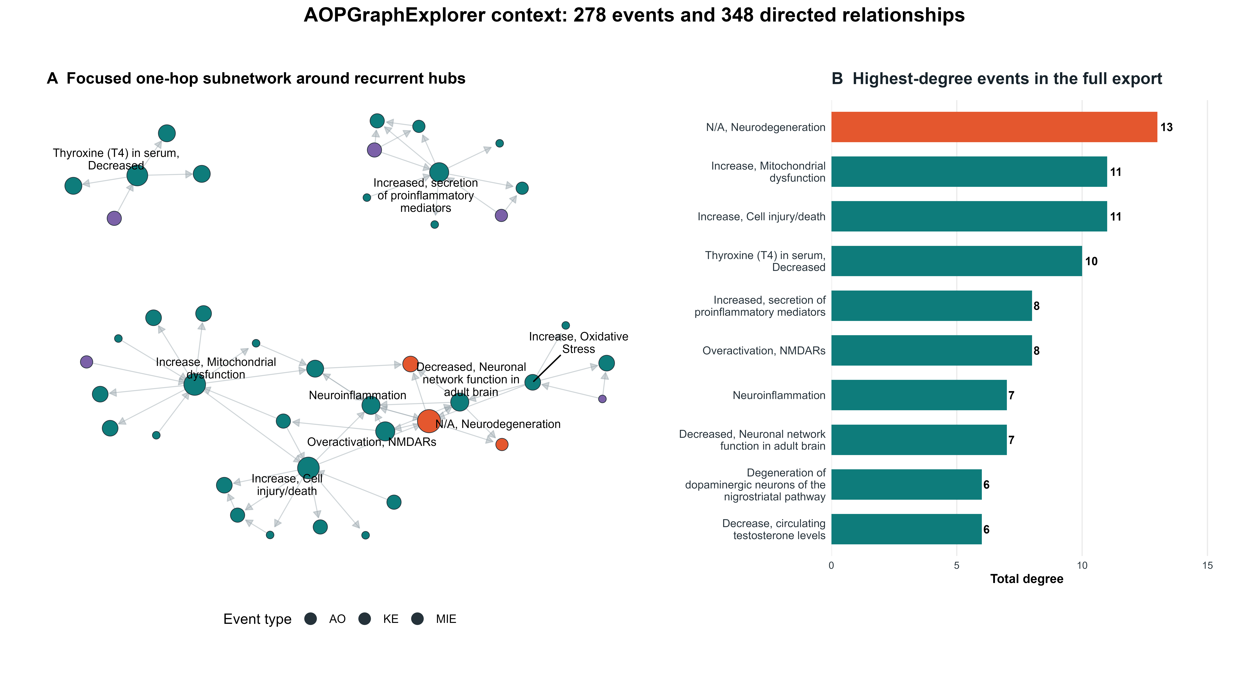
Figure 6. AOPGraphExplorer network interpretation. The left panel shows a focused event neighbourhood and the right panel ranks hubs in the full supplied export. Event labels and types come from the archived application JSON; connectivity indicates knowledge-base structure, not exposure-specific causality.

Exploratory coexpression and AOPxLINK integration
Exploratory AOPxGeneNet analysis retained 17,660 expressed genes across 18 samples and applied an IQR filter to 4,415 genes for WGCNA. Module-trait correlations were calculated across the same small experiment and their P values are nominal; they therefore serve only as secondary hypothesis-generation results and do not supersede the primary DE, functional-enrichment, or AOP-fingerprint evidence.
Ta4C3 alone was taken forward to the archived AOPxGeneNet/AOPxLINK application run because it had the largest MXene primary-response burden (470 DEGs, 411 KEs, and 152 AOPs) and thus offered the strongest signal for an already underpowered 18-sample exploratory analysis. Restricting this layer to one prespecified contrast also avoided multiplying WGCNA/AOPxLINK tests across three MXenes. For Ta4C3 versus control, 793 mapped genes covered 65 KEs and 57 AOPs; four of 300 module-AOP pairs met BH-adjusted P < 0.05 within that archived test family (Table 4; Figure 7). This choice does not establish Ta4C3 as intrinsically more hazardous than the other materials.

Table 4. Exploratory Ta4C3 WGCNA module-AOP associations meeting BH-adjusted P < 0.05 across the 300 archived AOPxLINK Step-2 tests. WGCNA module-trait P values are nominal and are not part of this table's correction family.
Module | AOP | Abbreviated AOP title | Overlap genes | Enrichment ratio | FDR
dimgrey | 106 | Tubulin binding to aneuploid offspring | 35 | 2.54 | 6.51 x 10^-7
coral | 130 | LPLA2 inhibition to hepatotoxicity | 130 | 1.30 | 9.38 x 10^-6
coral | 144 | Endocytic-lysosomal uptake to liver fibrosis | 80 | 1.33 | 7.76 x 10^-4
lightcoral | 106 | Tubulin binding to aneuploid offspring | 11 | 3.34 | 0.0126
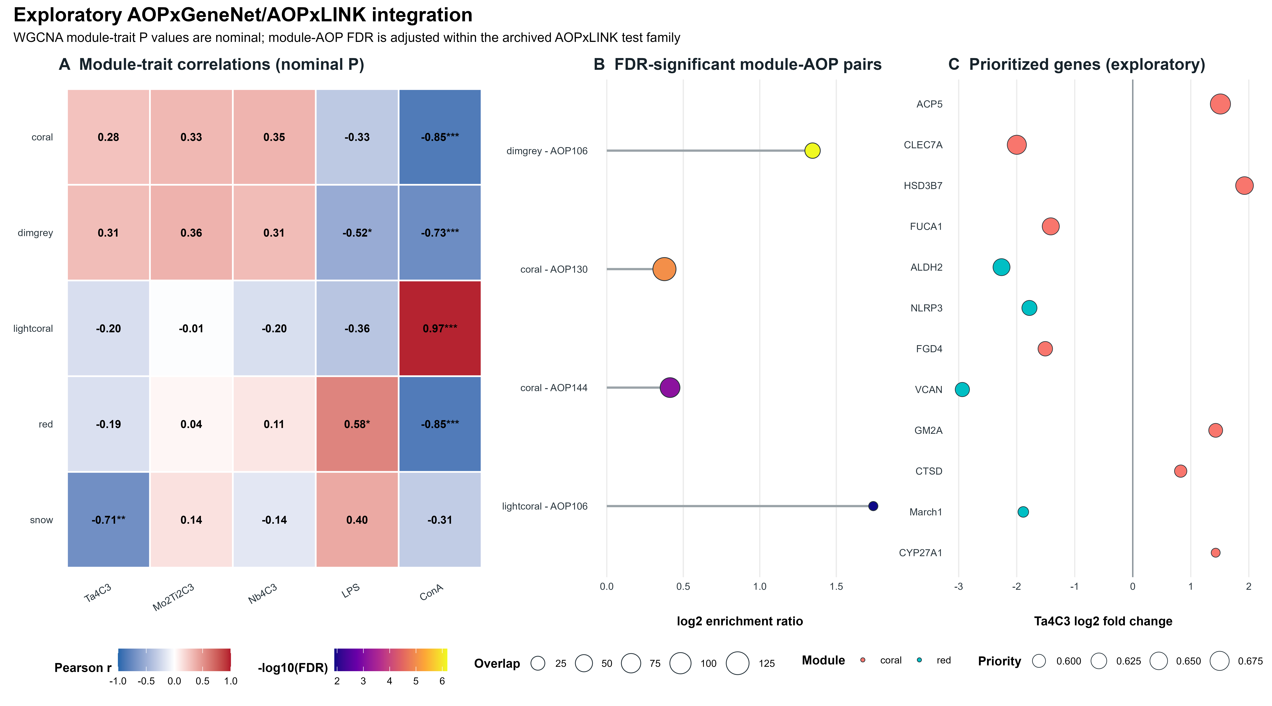
Figure 7. Exploratory AOPxGeneNet/AOPxLINK integration. (A) WGCNA module-trait Pearson correlations with nominal P-value stars. (B) Ta4C3 module-AOP pairs meeting BH-adjusted P < 0.05 across the 300 archived AOPxLINK tests. (C) prioritized genes shown only for hypothesis generation. This layer does not override the primary DE/AOP evidence.

Evidence-based mode-of-action hypothesis and scope of inference
The convergent evidence supports a working, not definitive, mode-of-action hypothesis. The experimentally measured layer consists of balanced transcriptional induction and repression, recurrent immune-trafficking and cytokine annotations, and a larger response to Ta4C3 than to Mo2Ti2C3 or Nb4C3 under one dose and time point. Prior-knowledge layers place these genes near oxidative stress, mitochondrial dysfunction, inflammatory mediator release, lysosomal processing, and cell injury/death. Coexpression integration nominates genes connecting those themes but does not resolve their temporal order.
- Immune signalling and trafficking: chemotaxis, cytokine-receptor activity, Toll-like receptor pathways, and neutrophil degranulation were recurrent across gene sets.
- Cellular stress and processing: mitochondrial, oxidative, extracellular-matrix, vesicular, and lysosomal annotations connect the measured response to broader stress-response KEs.
- Material-dependent magnitude: Ta4C3 produced the largest DEG, KE, and AOP footprint among the three MXenes in this PBMC experiment; composition-specific causation cannot be inferred without matched physicochemical and dose-response data.
Several limitations constrain inference. The study is a secondary analysis of one experiment with three replicates per group, one 24-h time point, and one nominal MXene concentration. The source dispersions differed in lateral size (approximately 810 nm for Ta4C3, 370 nm for Mo2Ti2C3, and 150 nm for Nb4C3). A nominal 50 micrograms mL-1 culture concentration is not a delivered or cellular dose: sedimentation, agglomeration, protein-corona formation, oxidation/dissolution, and material-specific uptake can alter what reaches each PBMC subtype. No in vitro dosimetry model, mass-per-cell estimate, or matched-size RNA-seq comparison was available, so transcriptomic differences cannot be attributed to elemental composition alone. Literature signatures were heterogeneous and TF expansion added predicted targets. AOP membership indicates annotation overlap rather than causal progression, and disease-labelled terms are not diagnoses. The WGCNA/AOPxLINK layer is explicitly exploratory because the sample size is inadequate for stable coexpression-network inference. Additional donors, doses, times, size-matched materials, delivered-dose measurements, and orthogonal KE assays are required for causal validation.

Conclusions
An integrated pipeline combining validation, differential expression, functional enrichment, TF-regulon expansion, AOP fingerprinting, knowledge-graph context, and exploratory coexpression analysis produced a reproducible mechanistic summary of MXene responses in human PBMCs. Ta4C3 generated the largest response among the three tested materials, while recurrent functional evidence emphasized immune trafficking, cytokine communication, extracellular and vesicular compartments, and cellular-stress processes. Broad AOP convergence with expanded literature signatures demonstrates the reach of prior-knowledge integration but should not be interpreted as identical toxicity. AOPGraphExplorer and AOPxGeneNet analyses nominate mitochondrial dysfunction, oxidative stress, inflammatory signalling, lysosomal processing, and genes such as NLRP3, CLEC7A, and ALDH2 for targeted validation. The principal contribution is therefore a transparent hypothesis-generation framework that separates measured transcriptional evidence from inferred AOP context and can be reapplied to other case studies.

Experimental Section

Data sources and study design
Raw gene-level counts and metadata were obtained from GEO accession GSE200036 and the associated study by Fusco et al.[3] Human PBMCs were exposed for 24 h in triplicate to Ta4C3Tx, Mo2Ti2C3Tx, or Nb4C3Tx (50 micrograms mL-1), LPS (2 micrograms mL-1), ConA (10 micrograms mL-1), or medium. Source-study synthesis, lateral-size, and characterization information was transcribed into the curated evidence workbook and summarized in Table 1. The analysis used the deposited gene-count matrix; it did not re-quantify reads.

FASTQ quality control, pipeline validation, and differential expression
The repository-level workflow was executed from run_pipeline.R. A portable optional stage executes notebooks/Fastq_QC.ipynb when local FASTQ files are supplied. It runs FastQC, optionally aggregates reports with MultiQC, and writes an executed notebook, module summary, and machine-readable run manifest.[20,21] Because the present statistical analysis begins from the public count matrix, this notebook documents the reproducible upstream sequence-QC route and is not claimed to have regenerated the deposited counts. Step 00 (00_data_validation.R) then validates the count schema, nonnegative integer counts, gene identifiers, sample matching, replicate counts, library sizes, identifier mapping, PCA, and contrast availability before downstream analysis.
Differential expression was performed with DESeq2 1.46.0 under R 4.4.3 using design ~ condition.[6] Each exposure was contrasted with medium control. Wald-test P values were BH-adjusted across genes separately within each contrast. DEGs required BH-adjusted P < 0.05 and |log2 fold change| >= 1; ALL, UP, and DOWN sets retained direction and contrast provenance.

Literature signatures and TF-regulon expansion
The literature search was exported from PubMed ChemInsight on 6 September 2025 using the MXene compound list and organism/omics terms preserved in the original workbook.[22] Twenty-seven article records were screened. Four publication-based omics candidates and GSE200036 were entered in the curation template. The primary quantitative literature branch retained Ti3C2Tx (Yan et al., DOI 10.1016/j.nantod.2022.101706) and HN-Ti3C2 (Wang et al., DOI 10.7150/thno.81511) because they used human systems and directional gene-level signatures could be obtained from source-provided DEG tables following author contact. A mouse liver-injury study and a mouse spatial-transcriptomics study were documented but excluded from the cross-case human signature analysis because their species/assay and accessible result format were not comparable. Gene symbols were normalized, deduplicated within source and direction, mapped to human Ensembl identifiers, and retained with DOI, material, model, dose, duration, extraction route, and mapping provenance in MXene_data_template.xlsx. The unmodified PubMed ChemInsight export is retained alongside the template.
TFs present in each signature were identified, and associated targets were added from DoRothEA 1.18.0.[9] Two sensitivity tiers were generated: high-confidence regulons (A/B) and broader regulons (A/B/C). Original genes were retained, targets were deduplicated, and identifiers were mapped to human Ensembl genes. Expansion represents regulatory prior knowledge and does not by itself establish TF activity or the direction of target regulation.

Functional enrichment and signature projection
Over-representation analysis used clusterProfiler 4.14.6 and ReactomePA 1.50.0 for GO Biological Process, Molecular Function, and Cellular Component, KEGG, and Reactome.[7,8,18,19] One-sided hypergeometric tests used branch-appropriate detectable-gene backgrounds. BH adjustment was applied separately within every gene-set-by-ontology/database collection; BH-adjusted P < 0.05 defined a significant term. Database disease labels were treated as annotation names, not phenotypic diagnoses.
For threshold-independent comparison, each DESeq2 contrast was ranked by the signed Wald statistic and tested against original directional literature signatures using fgseaMultilevel.[12] Reported normalized enrichment scores retain direction. FGSEA BH-adjusted P values are interpreted within each contrast's tested literature-signature collection and are not pooled with over-representation or AOP tests.

KE enrichment and AOP fingerprinting
AOPfingerprintR 0.0.1 was applied to ALL, UP, DOWN, and literature-derived gene sets using human Ensembl KE/AOP resources and branch-specific analysis backgrounds.[5] KE and AOP collections were treated as distinct test families within each gene set. As a specificity sensitivity analysis, the same human gene-to-KE/AOP resources were evaluated by one-sided hypergeometric tests, with BH adjustment within each gene set x annotation family. For each set and family, 1,000 same-size gene sets were drawn without replacement from the corresponding transcriptomic or literature background. The empirical P value was (1 + number of null statistics at least as large as observed)/(1,001), where the statistic was the number of BH-significant terms; empirical P values were BH-adjusted across evaluated sets separately within KE and AOP. The seed was 20260825.

AOPGraphExplorer network
The supplied AOPGraphExplorer NetworkX node-link JSON export was analyzed without changing its event or relationship membership.[14] Nodes were summarized by event type and total degree; directed edges were treated as KERs, and unique AOP identifiers were counted from edge memberships. A deterministic force-directed layout (seed 20260825) was used for the static figure. The export identifies AOP-Wiki event and relationship URLs and is distributed with a CC BY-SA 4.0 data notice; AOP-Wiki content was accessed through the supplied export.[13,14]

AOPxGeneNet coexpression and AOPxLINK integration
The archived AOPxGeneNet/AOPxLINK run (run ID 20260824_231537; development build; code fingerprint SHA-256 de47c12822864) was imported as an external, provenance-preserved analysis artifact. AOPxGeneNet filtered expressed genes by IQR and performed WGCNA across all 18 samples. Module eigengenes were correlated with binary condition traits using Pearson correlation. These module-trait P values were retained as nominal and exploratory because three replicates per condition do not support stable network inference.
AOPxLINK Step 2 used only Ta4C3 versus control. This contrast was selected after the primary DE/AOP analysis because it had the largest MXene DEG, KE, and AOP burden, providing the most information-rich single contrast while avoiding three parallel underpowered network analyses. Genes were mapped to KE/AOP annotations and module-AOP overlap was tested for 300 pairs. BH correction was applied across those 300 archived Step-2 tests. This selection was pragmatic and does not support a causal material-hazard ranking.

Statistical interpretation and reproducibility
Statistical decision rules were attached to explicit families. DESeq2 Wald P values were BH-adjusted across genes per contrast. Functional-enrichment P values were BH-adjusted per gene set and ontology/database collection. KE and AOP terms were corrected separately within each gene set. FGSEA adjusted P values belong to the signature collection tested within each contrast. Matched-null empirical P values were corrected across evaluated sets separately within KE and AOP. WGCNA module-trait P values are nominal and exploratory; AOPxLINK module-AOP P values were BH-adjusted across the 300 Ta4C3 Step-2 tests. In this manuscript, 'BH-adjusted P' names the reported quantity and 'FDR < 0.05' only names the decision threshold for its stated family. No adjusted P value is pooled across these distinct analyses.

Data and Code Availability
The source transcriptomic dataset is available from NCBI GEO under accession GSE200036. Analysis code, the portable FastQC notebook, configuration, curation templates, citation metadata, and release instructions are available at https://github.com/asmaa-a-abdelwahab/aop-guided-toxicogenomics (analysis snapshot 1cf3682b75af94a675494f49edf4e749e689729d). The original PubMed ChemInsight export and curated evidence workbook are included under manuscript/. Generated data, external application exports, and checksums are enumerated in manuscript/SUPPORTING_INFORMATION_MANIFEST.md. A Zenodo archive DOI has not yet been minted; the repository contains release-ready .zenodo.json metadata, and the DOI must be inserted after an authorized tagged GitHub release is archived.

Supporting Information
Supporting Information includes the curated study/evidence workbook; the unmodified PubMed ChemInsight export and search settings; FastQC notebook; validation, DE, enrichment, KE/AOP, TF-expansion, signature-projection, overlap, and network outputs; the AOPGraphExplorer JSON export; the archived Ta4C3 AOPxGeneNet/AOPxLINK run; the size-matched specificity summary and provenance; publication figure source tables; and the artifact/checksum manifest. Figure S1 reports the matched-null KE/AOP sensitivity analysis.
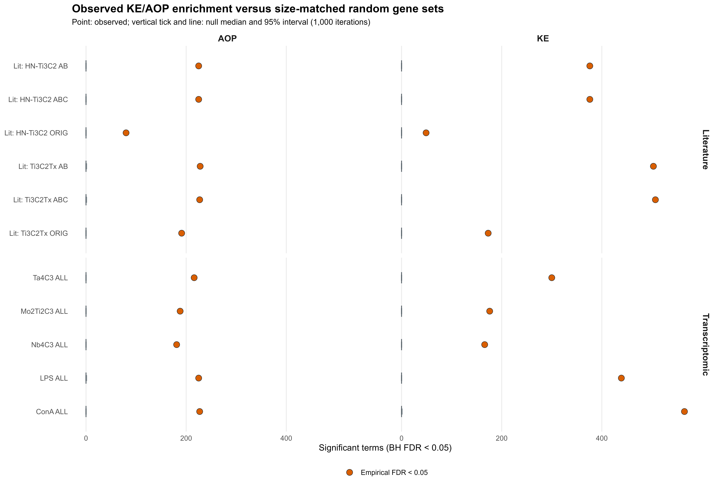
Figure S1. KE/AOP specificity sensitivity analysis. Orange points show observed numbers of BH-significant terms in the direct gene-to-annotation analysis; grey ticks and intervals show the null median and 95% interval from 1,000 same-size random gene sets drawn from the corresponding branch background. All 22 set-by-family comparisons had empirical BH-adjusted P = 0.000999.

Author Contributions
CRediT author statement (provisional pending written approval by all authors): Asmaa A. Abdelwahab—Conceptualization, Data curation, Formal analysis, Investigation, Methodology, Software, Validation, Visualization, Writing—original draft, Writing—review and editing; Angela Serra—Methodology, Resources, Supervision, Validation, Writing—review and editing; Dario Greco—Conceptualization, Methodology, Resources, Supervision, Writing—review and editing; Barry Hardy—Conceptualization, Funding acquisition, Project administration, Resources, Supervision, Writing—review and editing.

Acknowledgments
This project received funding from the European Union's Horizon 2020 research and innovation programme under grant agreement No. 101008099 (CompSafeNano). The authors acknowledge the investigators who generated and deposited GSE200036 and the corresponding authors who supplied literature DEG tables. The contents reflect the authors' views; the European Commission is not responsible for any use that may be made of the information contained herein.

Competing Interests
Competing-interest declaration: written confirmation from all authors is required before submission; no approved declaration was present in the supplied project files. This sentence must be replaced with the journal-approved statement after author confirmation.

References
1. Naguib, M.; Kurtoglu, M.; Presser, V.; et al. Two-Dimensional Nanocrystals Produced by Exfoliation of Ti3AlC2. Adv. Mater. 2011, 23, 4248-4253. https://doi.org/10.1002/adma.201102306.
2. Anasori, B.; Lukatskaya, M. R.; Gogotsi, Y. 2D Metal Carbides and Nitrides (MXenes) for Energy Storage. Nat. Rev. Mater. 2017, 2, 16098. https://doi.org/10.1038/natrevmats.2016.98.
3. Fusco, L.; et al. Immune Profiling and Multiplexed Label-Free Detection of 2D MXenes by Mass Cytometry and High-Dimensional Imaging. Adv. Mater. 2023, 35, 2205154. https://doi.org/10.1002/adma.202205154.
4. Villeneuve, D. L.; et al. Adverse Outcome Pathway (AOP) Development I: Strategies and Principles. Toxicol. Sci. 2014, 142, 312-320. https://doi.org/10.1093/toxsci/kfu199.
5. Saarimaki, L. A.; et al. Toxicogenomics Data for Chemical Safety Assessment and Development of New Approach Methodologies: An Adverse Outcome Pathway-Based Approach. Adv. Sci. 2023, 10, 2203984. https://doi.org/10.1002/advs.202203984.
6. Love, M. I.; Huber, W.; Anders, S. Moderated Estimation of Fold Change and Dispersion for RNA-seq Data with DESeq2. Genome Biol. 2014, 15, 550. https://doi.org/10.1186/s13059-014-0550-8.
7. Wu, T.; Hu, E.; Xu, S.; et al. clusterProfiler 4.0: A Universal Enrichment Tool for Interpreting Omics Data. Innovation 2021, 2, 100141. https://doi.org/10.1016/j.xinn.2021.100141.
8. Milacic, M.; et al. The Reactome Pathway Knowledgebase 2024. Nucleic Acids Res. 2024, 52, D672-D678. https://doi.org/10.1093/nar/gkad1025.
9. Garcia-Alonso, L.; Holland, C. H.; Ibrahim, M. M.; Turei, D.; Saez-Rodriguez, J. Benchmark and Integration of Resources for the Estimation of Human Transcription Factor Activities. Genome Res. 2019, 29, 1363-1375. https://doi.org/10.1101/gr.240663.118.
10. Yan, W.; et al. Immunoengineered MXene Nanosystem for Combinatorial Therapy. Nano Today 2023, 49, 101706. https://doi.org/10.1016/j.nantod.2022.101706.
11. Wang, H.; et al. Ultrasound-Controlled MXene-Based Schottky Heterojunction for Bone Regeneration. Theranostics 2023, 13, 1758-1775. https://doi.org/10.7150/thno.81511.
12. Korotkevich, G.; Sukhov, V.; Budin, N.; et al. Fast Gene Set Enrichment Analysis. bioRxiv 2021. https://doi.org/10.1101/060012.
13. Martens, M.; Evelo, C. T.; Willighagen, E. L. Providing Adverse Outcome Pathways from the AOP-Wiki in a Semantic Web Format to Increase Usability and Accessibility of the Content. Appl. In Vitro Toxicol. 2022, 8, 2-13. https://doi.org/10.1089/aivt.2021.0010.
14. Abdelwahab, A. A. AOPGraphExplorer, version 1; Zenodo, 2025. https://doi.org/10.5281/zenodo.15323478.
15. Langfelder, P.; Horvath, S. WGCNA: An R Package for Weighted Correlation Network Analysis. BMC Bioinformatics 2008, 9, 559. https://doi.org/10.1186/1471-2105-9-559.
16. Rezaie, N.; Reese, F.; Mortazavi, A. PyWGCNA: A Python Package for Weighted Gene Co-Expression Network Analysis. Bioinformatics 2023, 39, btad415. https://doi.org/10.1093/bioinformatics/btad415.
17. Benjamini, Y.; Hochberg, Y. Controlling the False Discovery Rate: A Practical and Powerful Approach to Multiple Testing. J. R. Stat. Soc. B 1995, 57, 289-300. https://doi.org/10.1111/j.2517-6161.1995.tb02031.x.
18. Gene Ontology Consortium. The Gene Ontology Resource: Enriching a GOld Mine. Nucleic Acids Res. 2021, 49, D325-D334. https://doi.org/10.1093/nar/gkaa1113.
19. Kanehisa, M.; Goto, S. KEGG: Kyoto Encyclopedia of Genes and Genomes. Nucleic Acids Res. 2000, 28, 27-30. https://doi.org/10.1093/nar/28.1.27.

20. Andrews, S. FastQC: A Quality Control Tool for High Throughput Sequence Data; Babraham Bioinformatics, 2010. https://www.bioinformatics.babraham.ac.uk/projects/fastqc/ (accessed 25 August 2026).
21. Ewels, P.; Magnusson, M.; Lundin, S.; Kaller, M. MultiQC: Summarize Analysis Results for Multiple Tools and Samples in a Single Report. Bioinformatics 2016, 32, 3047-3048. https://doi.org/10.1093/bioinformatics/btw354.
22. Edelweiss Connect GmbH. PubMed ChemInsight. https://pubmed-cheminsight.edelweissconnect.com/ (search exported 6 September 2025; accessed 25 August 2026).

For Table of Contents Use Only
AOP-Guided Toxicogenomics of MXene Responses


