Define and research the problem you want to solve

Nowadays people all over the world have their own phones. While some people play too much that they overlook taking care of themselves. therefore, causing problems later It is a disease caused by a single phone

Identify and explore the data

The Behavioral Risk Factor Surveillance System (BRFSS) is the nation’s premier system of health-related telephone surveys that collect state data about U.S. residents regarding their health-related risk behaviors, chronic health conditions, and use of preventive services. Established in 1984 with 15 states, BRFSS now collects data in all 50 states as well as the District of Columbia and three U.S. territories. BRFSS completes more than 400,000 adult interviews each year, making it the largest continuously conducted health survey system in the world.

Perform your analyses

Because most humans are in poor health because they do not take care of themselves. So I want to create ML that can improve human behavior

Design solution

: 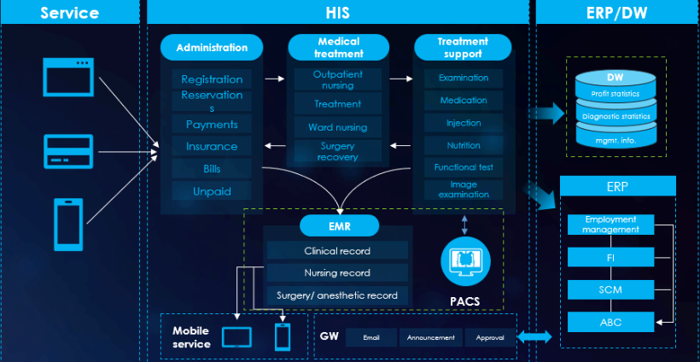

Develop a set of conclusions.

: 7 ways to take care of your physical and mental health for a bright life

1. Eat all 5 food groups and eat on time

2. Drink enough water

3. Exercise regularly

4. Get enough sleep and rest

5. Avoid behaviors that negatively affect health

6. Maintain good mental health

7. Give time to family members.

Present your analysis and conclusions.

Because most humans are in poor health because they do not take care of themselves. especially playing too much on the phone causing each part of the body to break up Be it internal or external systems, they all decay. In this regard, I want to create ML with proper self-care methods for human beings to fix and get it