 

**Control Assignment**

| Name | Sec | BN | ID |
| --- | --- | --- | --- |
| Asmaa Adel Abdelhamed | 1 | 14 | 9202285 |
| Samaa Hazem Mohamed | 1 | 32 | 9202660 |

**Requirement 1:**

Write the dynamic equations of the system and use it to build the block diagram of the system (hand analysis). Don’t perform any reduction to the block diagram.

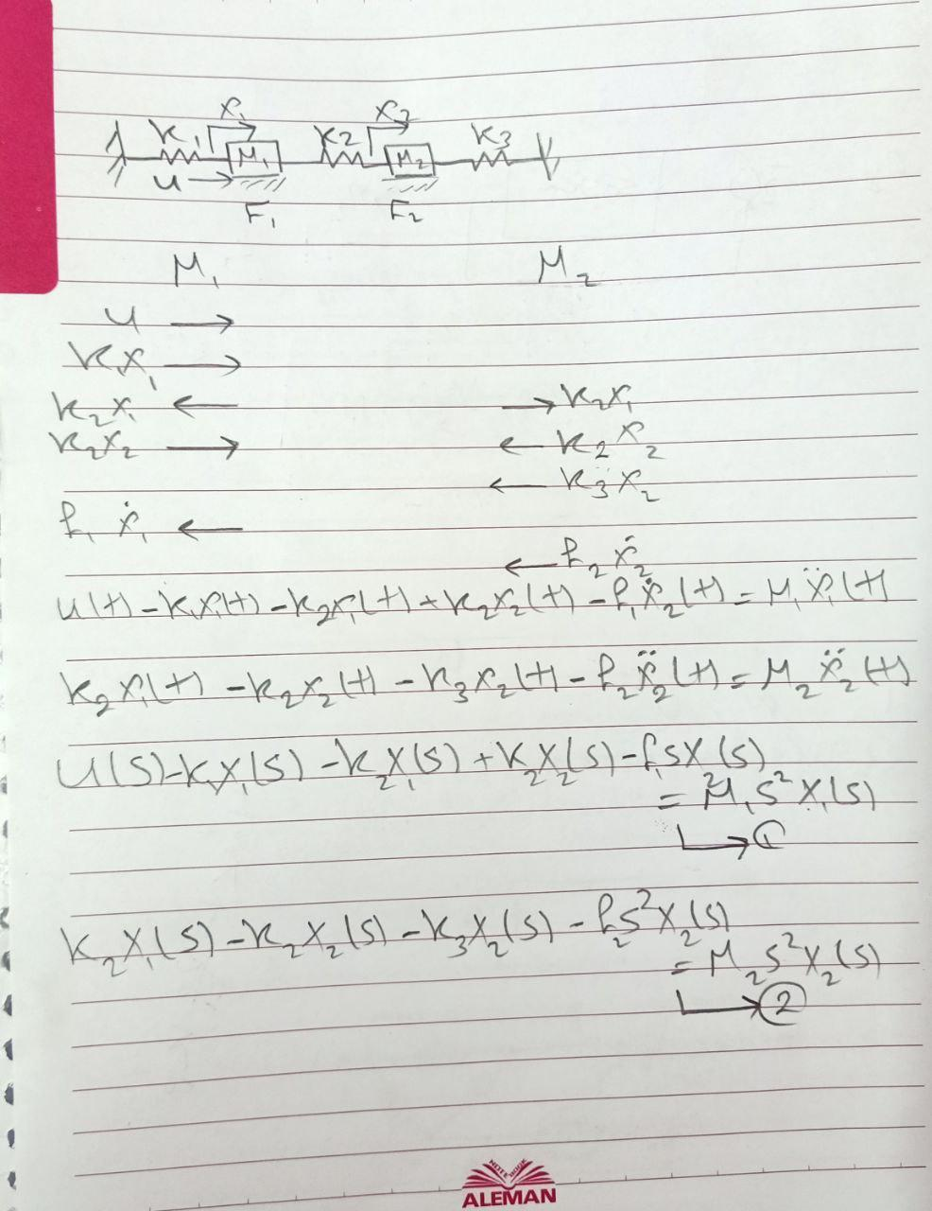

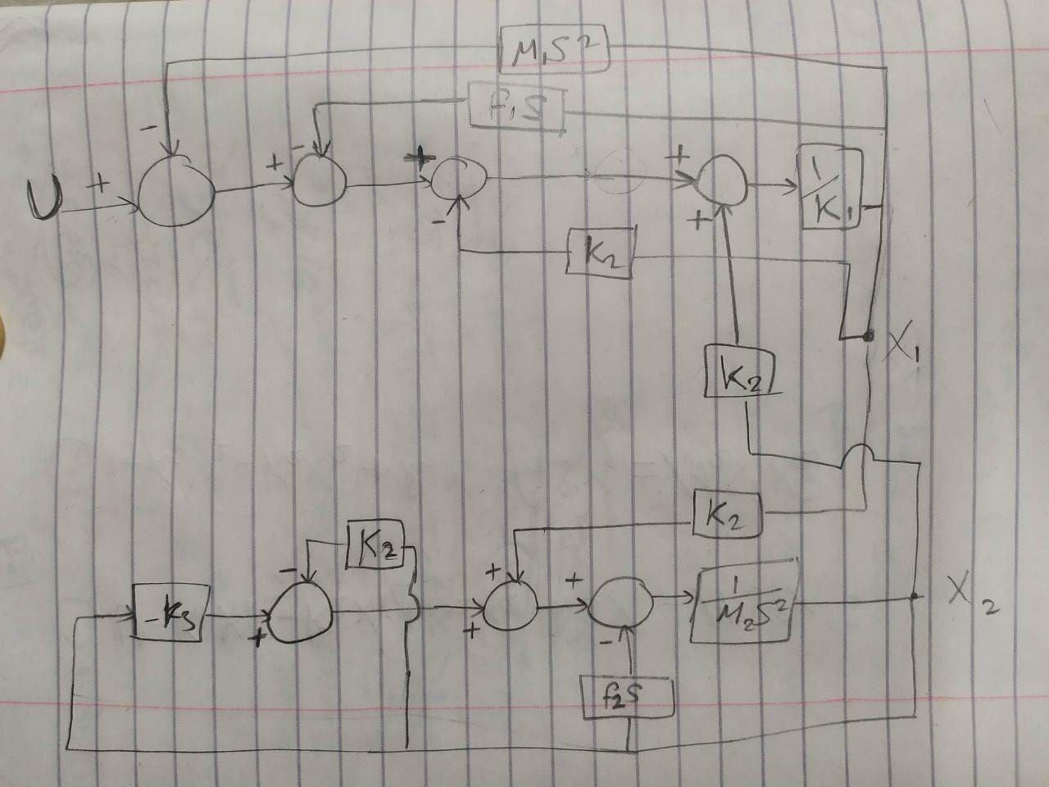

**Requirement 2:**

Use MATLAB to enter your detailed block diagram and then use MATLAB commands to obtain the following transfer functions: - X1/U, X2/U.

After building the block diagram of the system by hand analysis, we create a connect map, and block matrix, and then we plot the system, and two transfer functions for each output.

The output Transfer functions are:

0.01 s^2 + 0.01 s + 0.0055

TF(1): --------------------------------------

s^4 + 2 s^3 + 2.1 s^2 + 1.1 s + 0.0525

0.005

TF(2): --------------------------------------

s^4 + 2 s^3 + 2.1 s^2 + 1.1 s + 0.0525

**Requirement 3:**

For any of the two transfer functions (i.e. X1/U) study the stability of the system.

Poles and zeros for two Transfer functions:

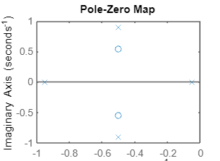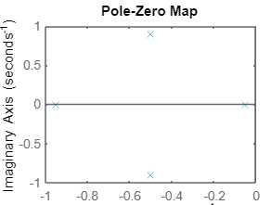

To study the stability of the system we see the poles of the two transfer functions, we found that all poles are in -ve quarter and there are any poles in +ve quarter for both transfer functions, so the system is stable.

**Requirement 4:**

If a fixed input force of 1N is applied to the system. Simulate the system under this value of input force showing the response of X1, X2 also from the resulting responses calculate the steady state values of these signals.

We plot step responses for two transfer functions and then we calculate the steady state values of these signals.

Step responses for two Transfer functions:

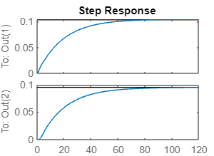

Steady state values of these signals:

|  | X1 | X2 |
| --- | --- | --- |
| Steady State | 0.105 | 0.0952 |
| Rise time | 41.5076 | 41.5076 |
| Peak time | 138.7141 | 138.7141 |
| Max peak | 0.1047 | 0.0952 |
| Settling time | 74.3184 | 76.1248 |
| ess | 0.8956 | 0.9051 |

**Requirement 5:**

Suggest a modification to the system such that: the system input is a certain desired displacement Xd (reference input) and displacements X2 is required to follow this desired displacement (Hint: Use Feedback concept).

The modification to the system is to make unity feedback:

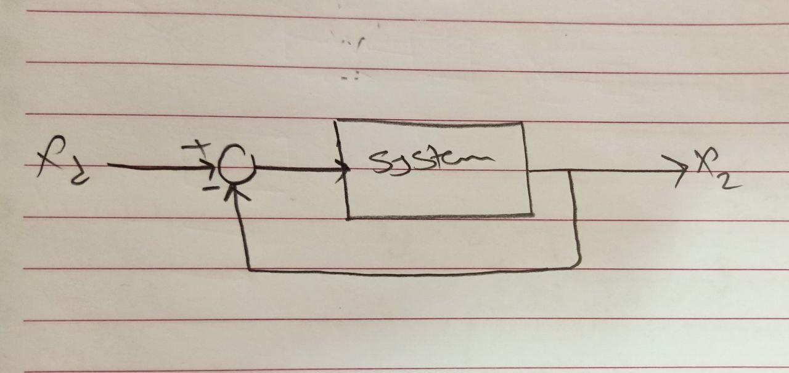

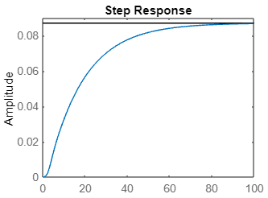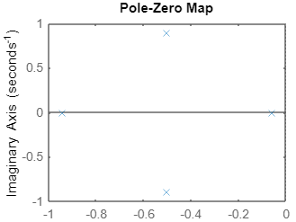

**Requirement 6:**

Simulate the system for a desired level (Xd) of 2 m. showing the response of X2.

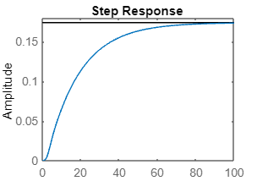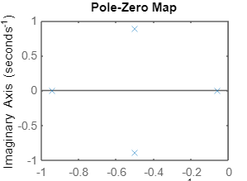**Requirement 7:**

For the response of X2 calculate the value of the rise time, peak time, max peak, and settling time. Also calculate the value of ess.

| Rise time | 37.4676 |
| --- | --- |
| Peak time | 125.2935 |
| Max peak | 0.1738 |
| Settling time | 68.9668 |
| ess | 1.8267 |
| Steady state | 0.174 |

**Requirement 8:**

As a solution to reduce the value of ess a proportional controller can be used. Study the effect of the value of proportional controller on both ess and transient response by simulating the system with the following values of P controller: 1, 10,100, and 1000. Calculate transient response parameters for each case. Comment on your results.

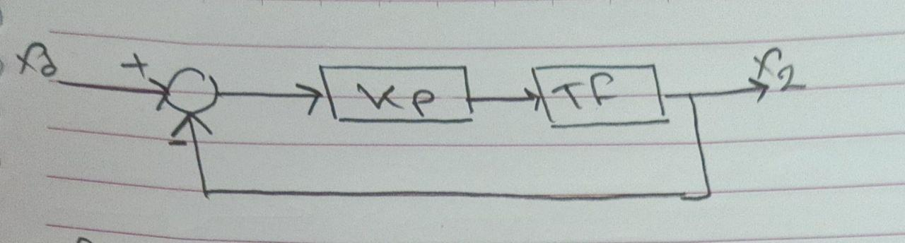

|  | K = 1 | K = 10 | K = 100 | K = 1000 |
| --- | --- | --- | --- | --- |
| Rise time | 37.4676 | 18.8465 | 2.2180 | NaN |
| Peak time | 125.2935 | 61.3895 | 6.3068 | Inf |
| Max peak | 0.1738 | 0.9746 | 2.6833 | Inf |
| Settling time | 68.9668 | 35.7815 | 31.0141 | NaN |
| ess | 1.8267 | 1.0271 | 0.1830 | 1.3619e+25(Inf) |
| Steady state | 0.174 | 0.976 | 1.81 | Inf |

|  | Step Response | Poles |
| --- | --- | --- |
| Kp = 1 |  |  |
| Kp = 10 |  |  |
| Kp = 100 |  |  |
| Kp = 1000 |  |  |

Comment on Requirement 8:

* The system is stable for all cases except when Kp = 1000, the system will be unstable.
* when Kp increases:

1. **Rise time**: The rise time decreases when Kp increases, so the system reacts faster to changes in the input signal, but when Kp = 1000 it becomes NaN, so it decreases until a certain point.
2. **Peak time**: The peak time decreases when Kp increases, A high Kp value causes the system to oscillate more and have more overshoot, which may result in instability, but when Kp = 1000, peak time becomes Inf, so it decreases until a certain point and then starts to increase.
3. **Settling time:** The settling time decreases when Kp increases, but when Kp = 1000 it becomes NaN. This is because high gains can introduce oscillations and instability.
4. **Steady state error (ess):** ess decreases when Kp increases, so the system becomes more accurate in reaching the desired output value, but when Kp = 1000 it starts to increase again, so it decreases until a certain point.

**Requirement 9:**

If the desired displacement of the second mass is to be 4 m, is it possible to obtain a steady state error less than 0.01 m using a proportional-only controller? Why?

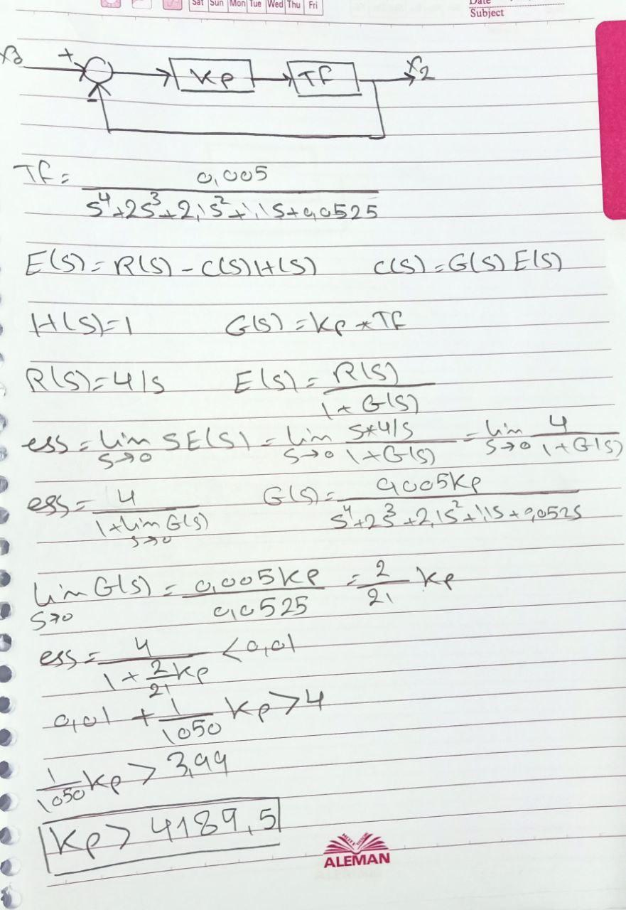

By hand calculations, when Kp > 4189.5, then we can get ess < 0.01, but when we try it in Matlab, we see that the system becomes unstable, so for k > 4189.5 , the system becomes unstable and then the ess is infinity, and it will be greater than 0.01 so we can’t do that with only a proportional controller.

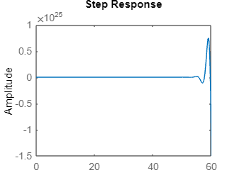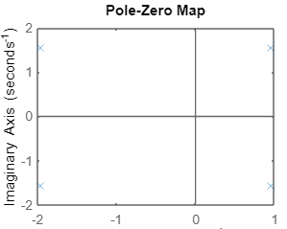

**Requirement 10:**

Suggest a suitable controller to eliminate ess. Then, simulate the system using your proposed controller.

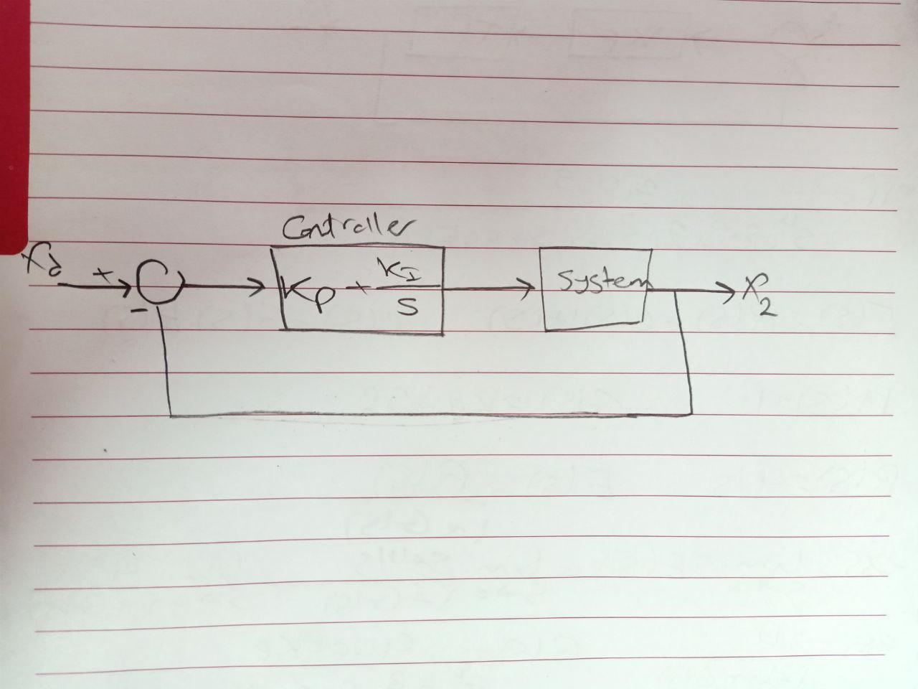

The suitable controller to eliminate ess is PI, (Kp + Ki/S)

By trying values we found that it’s the best values is Kp = 100, Ki = 5

| Rise time | 2.2676 |
| --- | --- |
| Peak time | 6.5247 |
| Max peak | 5.9835 |
| Settling time | 32.4758 |
| ess | 0.0049 |
| Steady state | 4 |

