**Travel Advisor Web Application**

Author: Maysonn Magdy

Creation Date: 28-4-2019

Version: 1.1

**Revision History**

|  |  |  |  |  |  |
| --- | --- | --- | --- | --- | --- |
| Version | Author | Date | Reviewed by | Revision Date | Comments |
| 1.0 | Maysoon Magdy | 28/04/2019 | Esraa Salah | 02/05/2019 | 1- Review the start dates and finish dates with team members.  2- Rename the section of work to work hours.  3- Complete percentage is incorrect.  4- Move the question marks from the duration section.  5- The extension of SIQ is xlsx not word.  6- Add TAWA_SystemRequirements.xlsx and TAWA_CustomerRequirements.xlsx  7- The PDF version is not clear. |
| 1.1 | Maysoon Magdy | 02/05/2019 | Esraa Salah | 02/05/2019 |  |
|  |  |  |  |  |  |

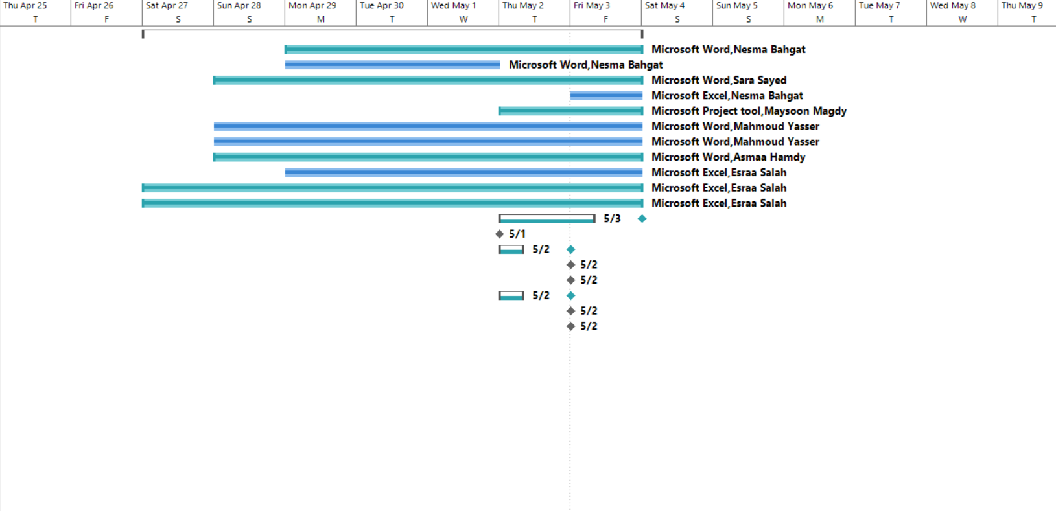**Gannt Chart**

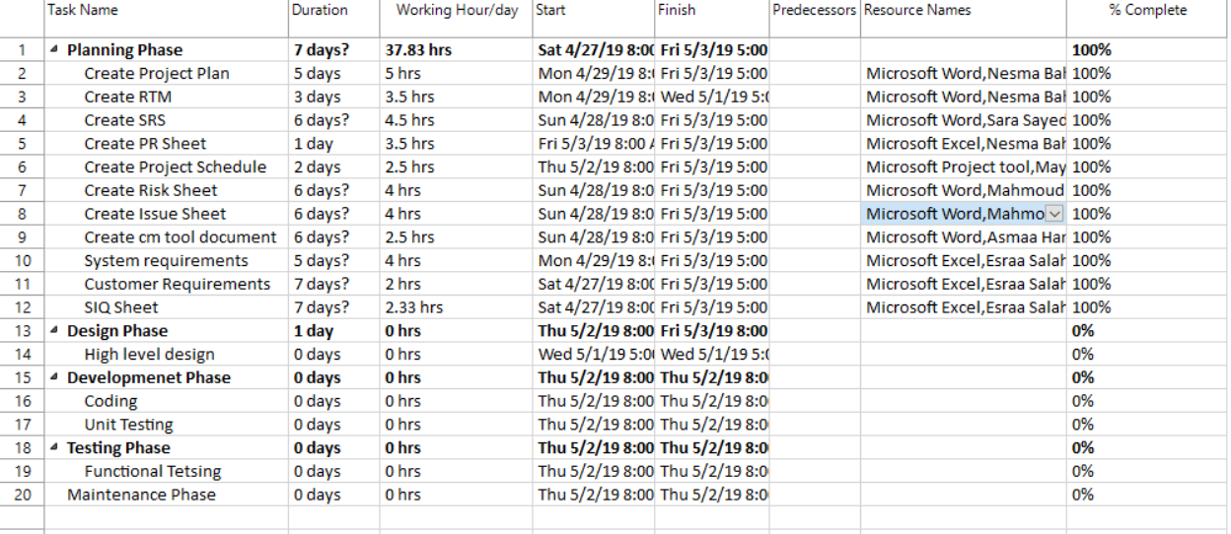**Project Schedule**