Python Multiple Inheritance
Super( )
Essentially, the super function can be used to gain access to inherited methods – from a parent or sibling class – that has been overwritten in a class object. Or, as the official Python documentation says: “[Super is used to] return a proxy object that delegates method calls to a parent or sibling class of type.

Multiple Inheritance in Python

Like C++, a class can be derived from more than one base classes in Python. This is called multiple inheritance.

In multiple inheritance, the features of all the base classes are inherited into the derived class. The syntax for multiple inheritance is similar to single inheritance.
Example

class Base1:
pass

class Base2:
pass

class MultiDerived(Base1, Base2):
pass

Here, MultiDerived is derived from classes Base1 and Base2.

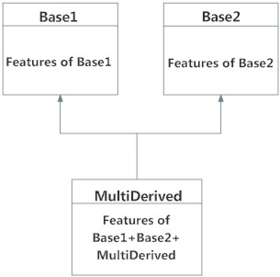

Multiple Inheritance in Python

The class MultiDerived inherits from both Base1 and Base2.
Multilevel Inheritance in Python

On the other hand, we can also inherit form a derived class. This is called multilevel inheritance. It can be of any depth in Python.

In multilevel inheritance, features of the base class and the derived class is inherited into the new derived class.

An example with corresponding visualization is given below.

class Base:
pass

class Derived1(Base):
pass

class Derived2(Derived1):
pass

Here, Derived1 is derived from Base, and Derived2 is derived from Derived1

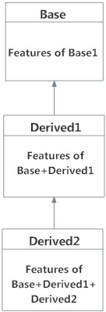

Here is a little more complex multiple inheritance example and its visualization along with the Method Resolution Order (MRO).
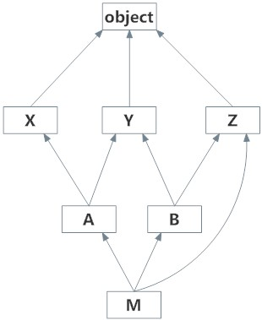

class X: pass
class Y: pass
class Z: pass

class A(X,Y): pass
class B(Y,Z): pass

class M(B,A,Z): pass

# Output:
# [<class '__main__.M'>, <class '__main__.B'>,
# <class '__main__.A'>, <class '__main__.X'>,
# <class '__main__.Y'>, <class '__main__.Z'>,
# <class 'object'>]

print(M.mro())
prepared by:

Name:Asmaa El-Sayed Ismail Mohamed Ali
Open Source track
Python

