Method overloading
In Python you can define a method in such a way that there are multiple ways to call it.
Given a single method or function, we can specify the number of parameters ourself.
Depending on the function definition, it can be called with zero, one, two or more parameters.
This is known as method overloading. Not all programming languages support method overloading, but Python does in a pythonic way.
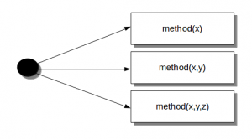

Method overloading example
We create a class with one method sayHello(). The first parameter of this method is set to None, this gives us the option to call it with or without a parameter.
An object is created based on the class, and we call its method using zero and one parameter.

#!/usr/bin/env python

class Human:

def sayHello(self, name=None):

if name is not None:
print 'Hello ' + name
else:
print 'Hello '

# Create instance
obj = Human()

# Call the method
obj.sayHello()

# Call the method with a parameter
obj.sayHello('Guido')

Output:
Hello
Hello Guido

To clarify method overloading, we can now call the method sayHello() in two ways:
obj.sayHello()
obj.sayHello('Guido')

Prepared by:

Name:Asmaa El-Sayed Ismail Mohamed Ali
Open Source track
Python

