Name: Asmaa Kreker
StudentID: 23412033
Section: 1102

Question 1:
The 300 words summary:
The dataset is about electric vehicle charging station usage and it includes 500 records with 9 variables. Station_ID is for identifying each charging station. To know where the charging session took place, look for the City variable. Vehicle_Type tells what type of vehicle was charged. Charging_Start_Time and Charging_End_Time tells when the session started and ended. Energy_Consumed_kWh tells how much energy was consumed during the session, while Cost_INR shows how much the session cost. Payment_Method indicates how the user paid. Every row in the dataset shows one full charging session. info() shows that there are 500 non-null values in each column. Also, head() and tail() make sure that the data is well organized. The nunique() output shows how well the data is varied, such as unique station IDs and many cities.
The dataset is valid because all variables have correct formats which is based on the info() output. Also, the data is accurate because the describe() output shows reasonable prices and costs for energy use. The data is complete because isnull().sum() tells us that there are no missing values. Also, the data is consistent and uniform because the categorical values like Payment_Method contain only the expected values, and there are no wrong or mixed formats.
After using isnull().sum(), we found out that the dataset has no missing values. This means the percentage of missing data is very low (essentially 0%) and it does not negatively affect the analysis. The categorical fields issues are fixed in the code by using the replace() function. There is little to no impact on the overall analysis because these issues are minimal.

Code of Question 1 and its output:

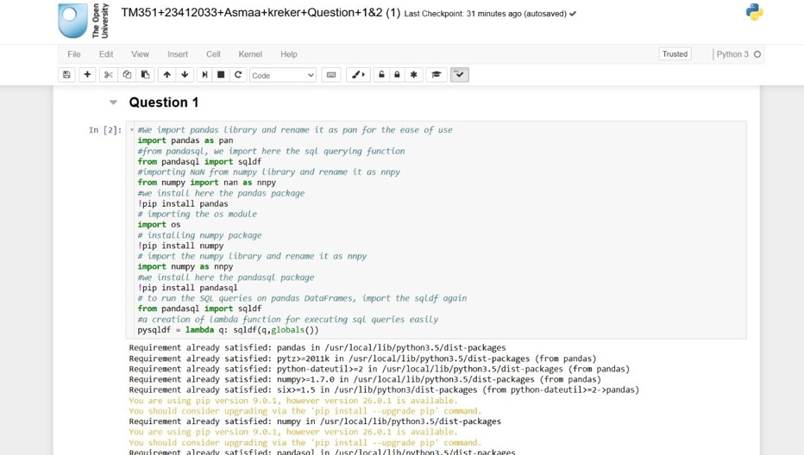
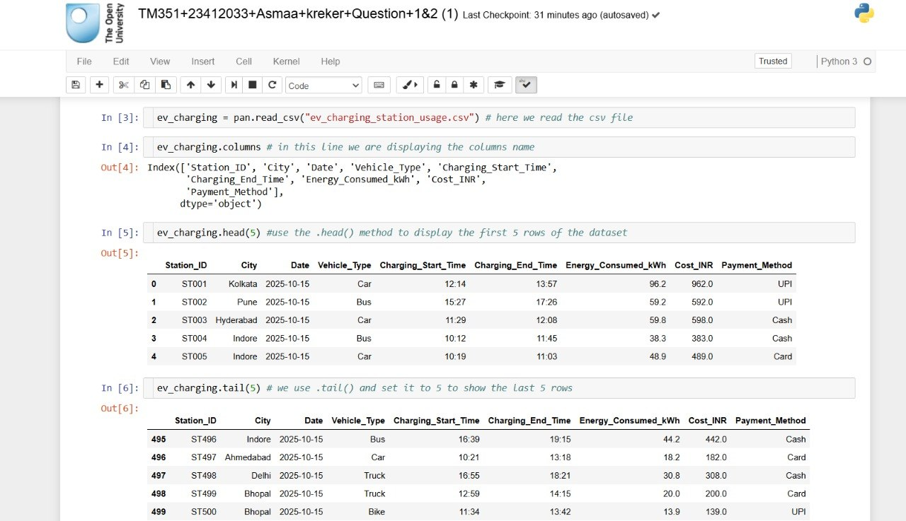
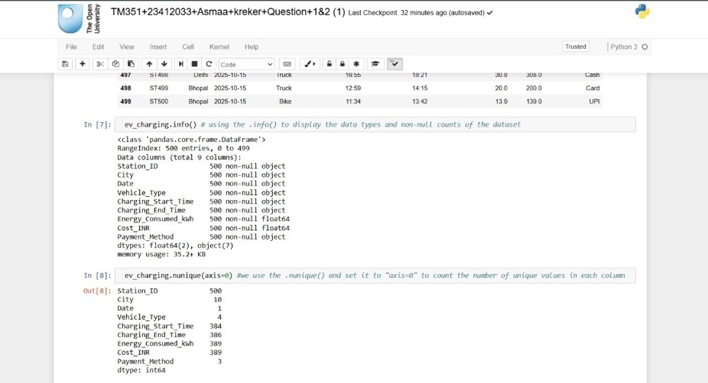
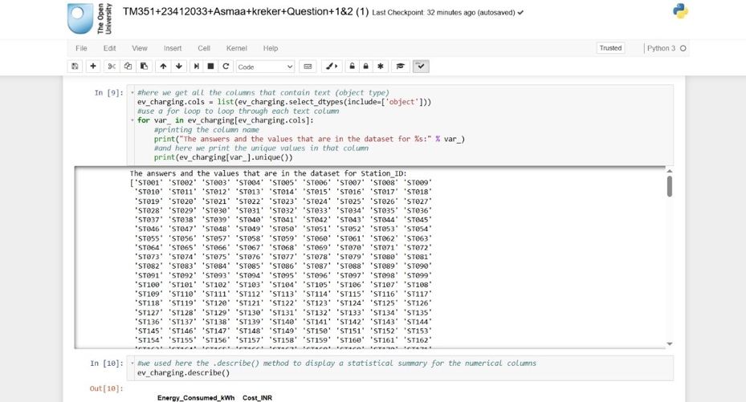
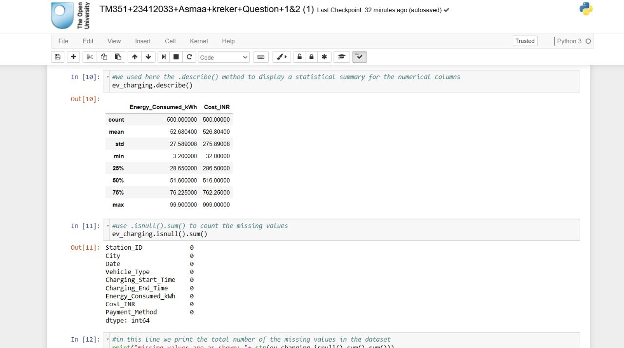
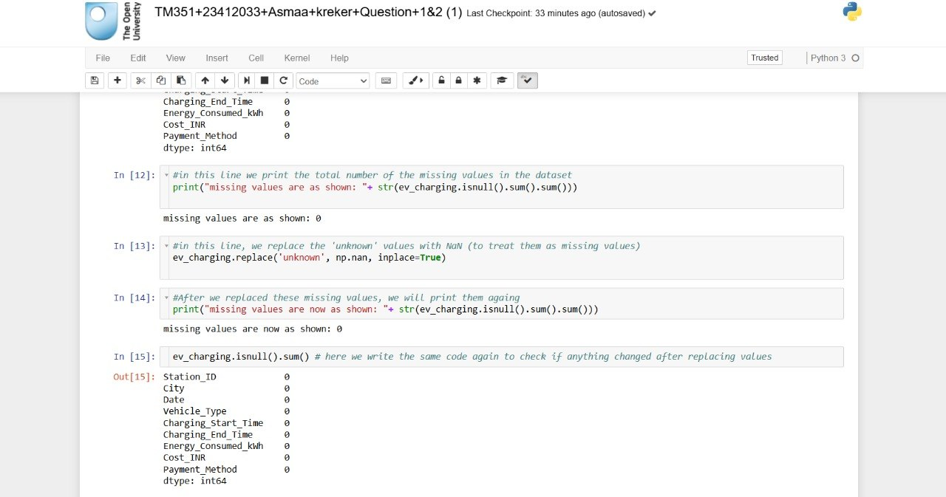

Question 2:
- Executive Summary
This analysis project studies how the cost of charging electrical vehicles varies depending on the type of car. The analysis focuses on deciding if the type of car affects the cost of charging using a dataset of 500 entries. Several types of statistical methods, such as pivot tables, correlation analysis, and visualizations including boxplots and bar charts were performed (Wang, 2008) ; (Hunter, 2003). The results reveal that are small variations in cost between vehicle types, but the overall relationship is weak. Although vehicle types affect cost to some extent, it is not an important variable compared to other variables like energy consumption. This study shows how to compare groups and analyze relationships between variables (Waskom, 2012).
- Aims and Objectives
- The main goal of the project is to study whether the type of vehicle affects the charging cost.
- The objectives are:
- Analyzing the dataset and understanding the key variables (Anon., 2023)
- Identifying Vehicle_Type as the independent variable and Cost_INR as the dependent variable of the project.
- Using statistical methods such as correlation analysis and hypothesis testding (Nelson, 2008).
- For summarizing costs between vehicle types, use pivot tables (Wang, 2008).
- Creating visualizations to compare the cost differences (Hunter, 2003).
- Analyzing the results and evaluating the srength of the relationship.
- Research Question / Hypthesis
- Research Question: Does Vehicle_Type significantly affect Cost_INR during elctrical vehicle charging sessions?
- Independent Variable: Vehicle_Type
Dependent Variable: Cost_INR
- Hypothesis: The cost of charging varies significantly depending on the type of car.

- Analysis and Findings
- The Correlation Analysis
The pandas corr() method was used to perform correlation analysis (Wang, 2008). Vehicle_Type and Cost_INR have a very weak positive relationship, with a correlation value of around 0.027. Also, the Spearman correlation test produced a correlation value close to zero with a high p-value (greater than 0.05), showing that the relationship is not statistically significant (Nelson, 2008). This tells that the cost of charging is not much affected by changes in vehicle type.
- The Pivot Table Analysis
Using the pivot tables, cost values are summarized among various vehicle types (Wang, 2008). The average cost varies slightly between vehicle types according to the results. These differences are insignificant, and the overall range of costs is similar among all groups. This implies that the type of vehicle has little impact on the cost of charge.
- Visualization 1: Boxplot
When the boxplot is used, all vehicles have a very similar value distribution, and the medians are close to each other. The boxplot is used to compare Vehicle_Type and Cost_INR by displaying the cost distribution for each vehicle category (Waskom, 2012). This shows that there is no strong difference in costs between the groups.
- Visualization 2: Bar Chart
Small variations between categories are highlighted in the bar chart presenting the average cost for each type of vehicle (Hunter, 2003). The differences are insignificant, even if some vehicle types seem to have somewhat higher average costs.
- The Final Answer to Research Question
The hypothesis is rejected because the analysis shows that Vehicle_Type does not significantly affect Cost_INR. Although there are slight variations in cost between vehicle types, the relationship is weak and not statistically significant.
- Critical Comment
The weak relationship implies that variables other than vehicle type, such as consumption of energy, have a greater effect on charging costs. Also, conversion of categorical data into numerical values might affect the correlation results. To improve the analysis, future research could involve relevant variables (Berg, 2005).

- Reflection
This project gave me great experience with data analysis methods, such as pivot tables, correlation analysis, and visualization. It helped me improve my analytical thinking and programming skills. This experience taught me to analyze statistical results and also to compare various categories. Using several visualizations was one part that worked well, which made the results clear. A challenging part could be choosing the suitable variables and statistical methods. Finally, and for future projects, I will try exploring more variables and using advanced methods. Future data analysis and research projects will benefit from this experience.
- References
(Anon., 2023) https://kaggle.com
(Hunter, 2003) https://matplotlib.org
(Berg, 2005) https://numpy.org
(Wang, 2008) https://pandas.pydata.org
(Nelson, 2008) https://scipy.org
(Waskom, 2012) https://seaborn.pydata.org

Code of Question 2 and its output:

Code of Question 2 and its output: 