- Logistic regression
  - 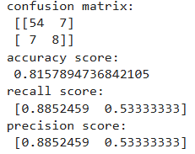

- KNN
  - 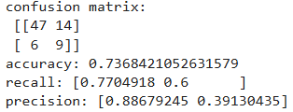

- Naïve Bayes
  - 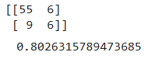

- Decision Tree
  - 

