Circuit project
Analog and Digital Electronics
SPC 227

Iman Mosaad | 202200527
Asmaa Sabry | 202201338
Omar Ahmed | 2022000527
Abdelrahman Mohamed | 202200281
Raed Asham | 202200272

Simulation
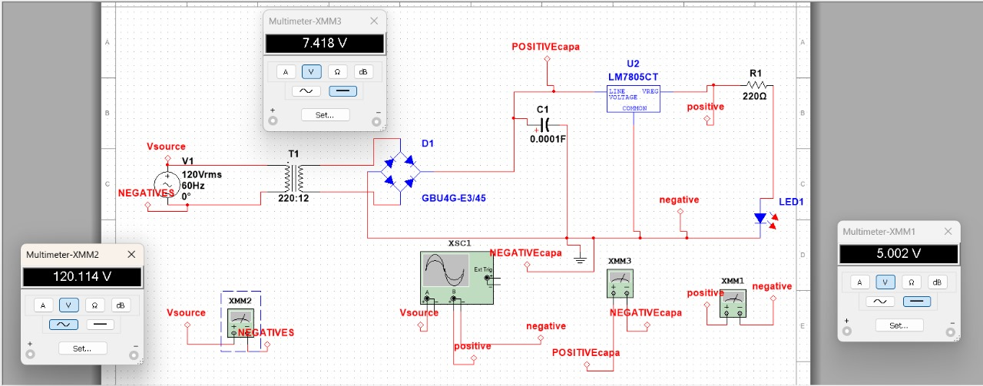

Circuit
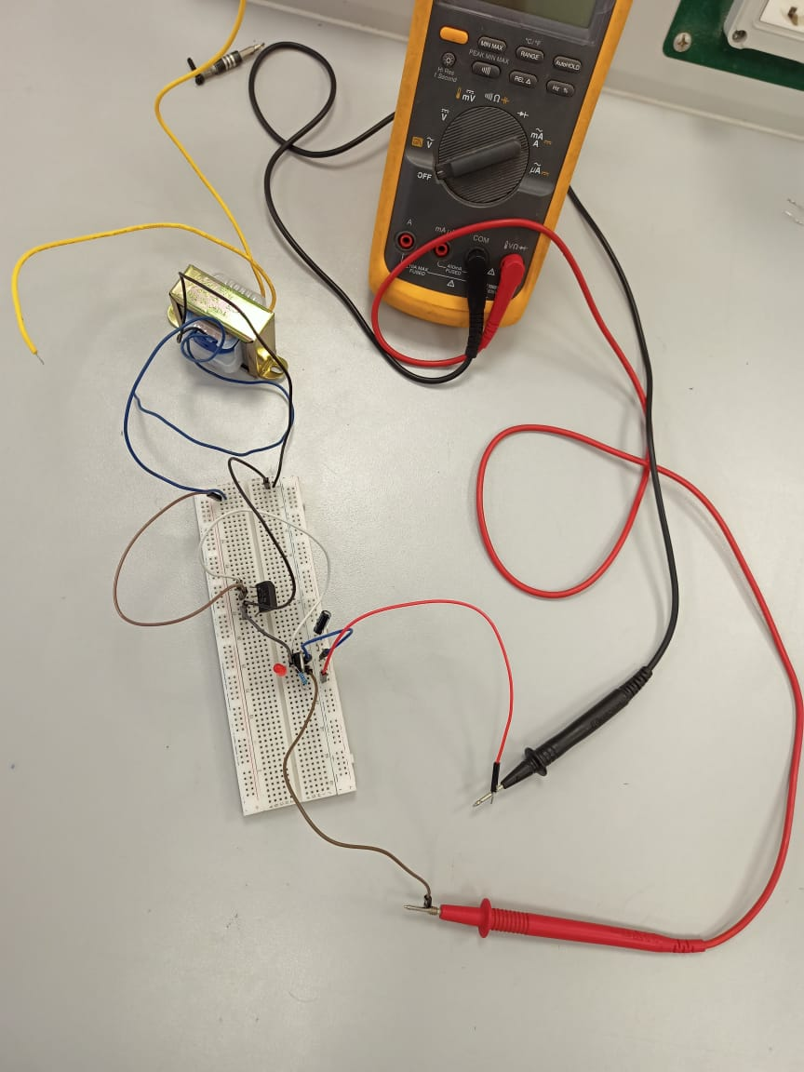

Result
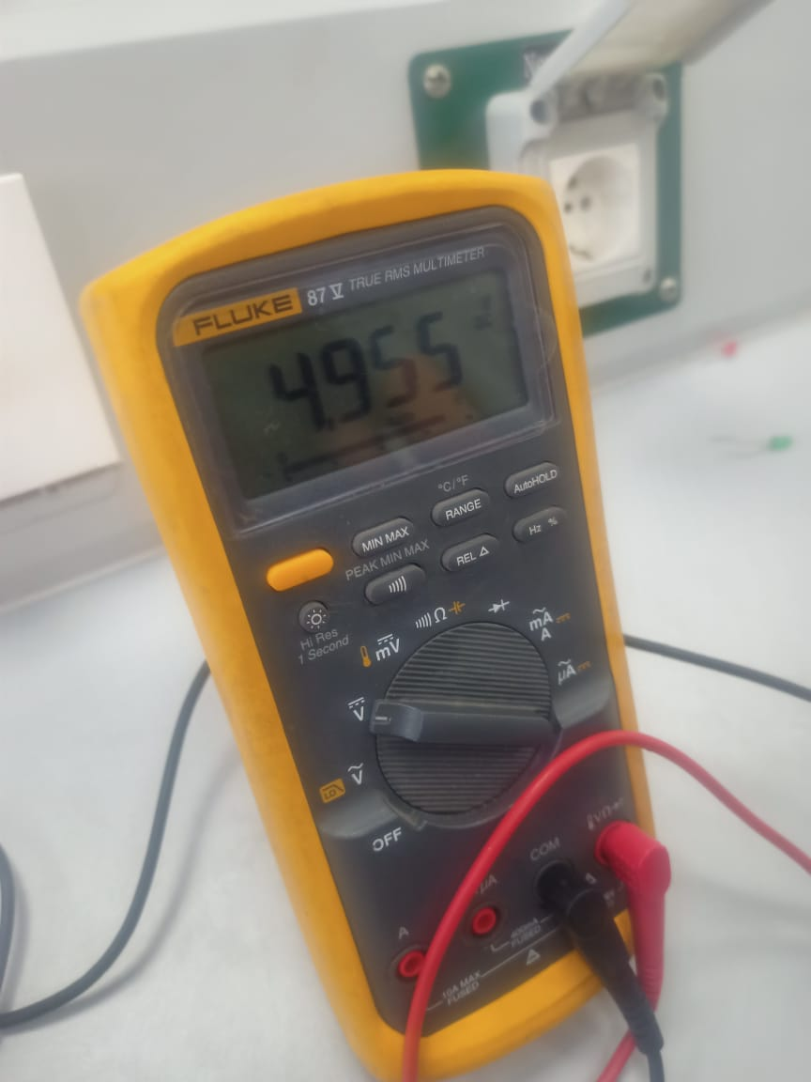

Components
- Test board: It provides a platform to test multiple electrical components like resistors, capacitors, inductors, transistors, and integrated circuits.
- Transformer: it transfers electrical energy between two or more circuits through electromagnetic induction. It is used to step up or down the levels of voltage in alternating currents electrical circuits. Moreover, it provides isolation between circuits to assure safety and prevents ground loops and interference between circuits.
- Capacitor: its main function is storing and releasing electrical energy in a circuit. Thet are also used in power supply circuits for filtering and signal filtering.
- Regulator: it is used to maintain a constant output voltage or current level. It also ensures stable operation of electronic devices and systems. It plays main role in voltage regulation, current regulation, and protection.
- Resistor: it is an electric component that regulates and limits the flow of electrical current in circuits. They play fundamental role in current limiting, voltage division, signal conditioning, biasing, and pull up and down resistors.
- Plug: it is like a connection between electrical device and power supply. It provides electrical connection, contact points, mechanical support, polarization, safety features, and compatibility.

