

Control Systems Experiment


Team’s names:
- Asmaa Sapry 202201338
- Raed Asham 202200272

Reported to:
- Dr. Mohamed L. Shaltout
- Eng. Somaia Talaat

Course Code:
- SPC 318

Table of Contents
- Abstract .………………………………………….…………..……….…..3

- Introduction …………………………………………………..…………..3
- Aim …………..…………………………………………………………………3
- Main Components …………………………………………………………4
- Wiring Diagram ………….……….…………………………………………5
- Experimental Setup ..……………………………………….…………….6
- Simulink Setup ……………………………………………….…………….7

- DC Motor Position Control ………………………………..............9
- Steps ……………………….…………………………………………………..9
- Experiment Trials & Results ..…….………………..…………………10
- Plots …………………………………..……………………….……………..16
- Comments …………………………………………………………………..18

- DC Motor Speed Control …………………………………............19
- Steps ……………………….…………………………………………………19
- Experiment Trials & Results ..…….………………..…………………20
- Plots …..…………………………………..……………………….…………24
- Comments …………………………………………………………………..26

- Conclusion ……………………………………………………………….27

- References ……………………………………………………………….27

Abstract
To make control systems useful, monitoring systems is necessary to achieve a desired performance. In this experiment, a DC motor is controlled using PLD and PL controls to regulate the angular position and speed, respectively. The main objective of this experiment is to identify and understand how controller gains affect both the transient and steady state responses of this system. This is done by adjusting the proportional, derivative, and integral gains. Also, the settling time, peak time, overshoot, rise time, and steady state error are identified. This experiment provided insight into how fine-tuning these parameters can optimize performance, achieving minimal overshoot, fast response, and high accuracy. The required results were verified using MATLAB Simulink. providing valuable data on how to balance system stability and response time in real-world applications such as robotic arms, CNC machines, and other automated systems.

Introduction
- Aim:
Many criteria have been used to describe a system’s stability, accuracy, and reliability. While defining these helps perceiving how the system performs, there is an urge to utilize the system and its characteristics in a way to have more desirable response to any stimulator.
One of the important applications of control systems is the control of motion. Motion control is crucial in robotic arms, CNC machines, drones and UAVs, elevators, exoskeletons, and others. The high-level desire of controlling these systems may be achieving human comfort (elevators), accurate cut and high surface finish (CNC machines), handling tasks at exact locations (robotic arms), or mimicking human motion (exoskeleton). Nevertheless, the low-level desire of motion control is to control the position and speed of the moving object. The degree of accomplishing these desires is interpreted from different characteristics of the response plot (e.g., percent overshoot, peak time, steady-state error, settling time, and others).
This experiment applies the fundamental concepts of systems control on a geared DC motor using MATLAB/SIMULINK. Moreover, the aim is to understand the control methods and reach precise position and speed responses. The experiment focuses on:
- Position Control: Implementing a PID controller to regulate the motor's angular position and reach exact angular displacement. The system has three gains:
  - Proportional gain ($k_{P}$)
  - Integral gain ($k_{I}$)
  - Derivative gain ($k_{D}$)
- Speed Control: Utilizing a PI controller to maintain a constant motor's speed. The control is done by two gains:
  - Proportional gain ($k_{P}$)
  - Integral gain ($k_{I}$)
For both systems, the goal is to investigate how the gains influence the system's transient and steady-state response by changing the system's overshoot, settling time, and steady-state error. Ultimately, it is desired to find the optimal tuning parameters that achieve desired performance metrics, such as minimal overshoot, fast response, and accuracy

- Main Components:
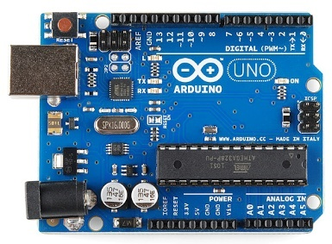
- Arduino Uno Microcontroller
- With an 8-bit built-in microcontroller, this component acts as the brain and signals manager of the setup. It creates a cycle of data reading from the encoder signals of the motor, processes control algorithms from Simulink, then sends PWM signals to the motor driver.
Figure 1: Arduino Uno Microcontroller
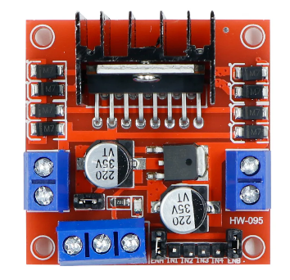
- L298N Red Dual H-Bridge Motor Driver
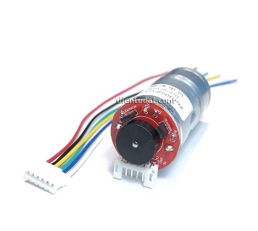
- Enables the DC motor to move with variable speed and in both directions by controlling the value and polarity of the applied voltage based on the given signals from the microcontroller. It also helps avoiding the electrical overload on the microcontroller by connecting the motor with another power source.
Figure 2: L298N H-Bridge Motor Driver

- DC Motor with Encoder (JGA25-370)
- Motor Terminals (Red/White):
  - These two wires are the terminals for the motor power supply.
Figure 3: JGA25-370 DC Motor
  - The direction of the motion can be reversed by reversing the terminals or the voltage given to them.
- Encoder Terminals (Black/Blue, Green/Yellow):
  - The Black and Blue wires are the terminals for the encoder power supply. The typical volt value is 3.3V or 5V.
  - The Green and Yellow wires are designated for the motion signals. Collaboratively, with further analysis , they define the position, velocity, and direction of the motion using the Hall Effect.
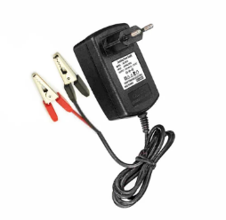
- DC Power Supply (12V, 2A)
- Delivers consistent and reliable power to the motor and driver circuit.
Figure 4: Power Supply

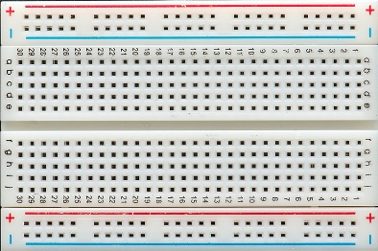
- Jumper Wires and Breadboard
- Used for combing the hardware components and building the electrical connections in the system.

Figure 5: Breadboard
- MATLAB/SIMULINK Software
- Used to design, test, and analyse control algorithms, such as:
  - PID for Position Control: Ensures the motor reaches and holds a target position accurately.
  - PI for Speed Control: Maintains desired motor velocity.

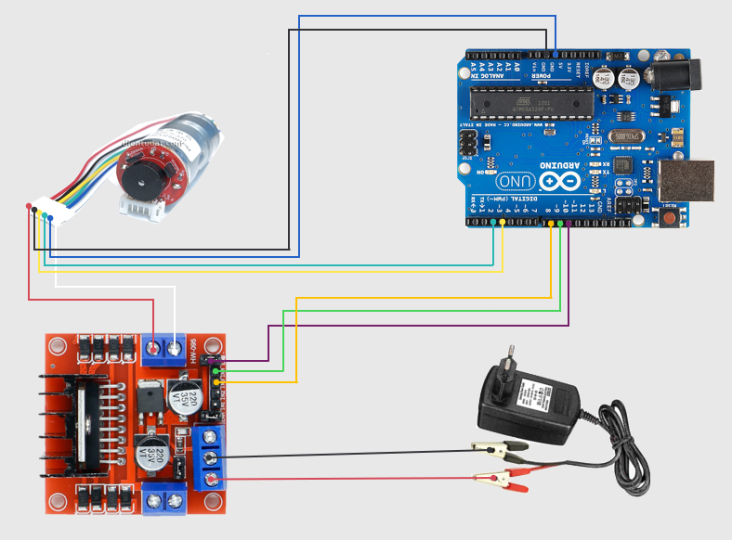
- Wiring Diagram:
Figure 6: The Wiring Diagram
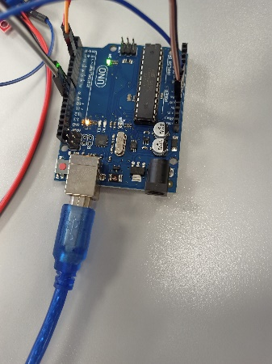
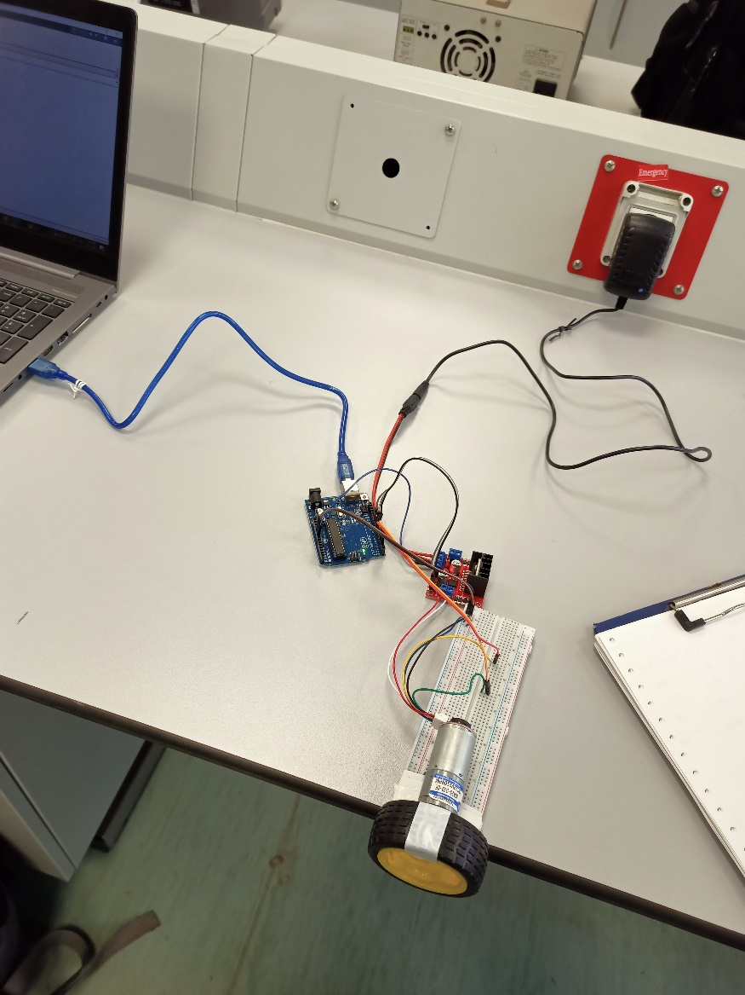
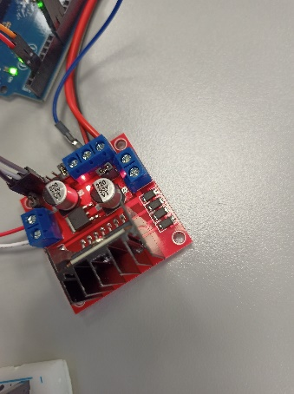
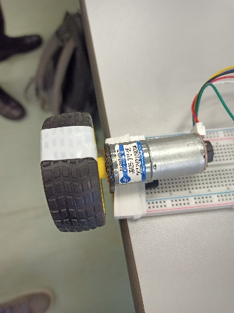
- Experimental Setup:
Figures 7,8,9,10: The Experimental Setup

- Simulink Setup:
Block Diagram:
The block diagram shows the overall control loop of DC motor speed regulation. For the position control, the reference desired position is compared with the actual position to find the error, then the PlD controller process the error to generate a control signal to apply in the DC motor. On the other hand, for the speed control, the comparison is made between the reference speed and the actual speed to determine the error, which the PI controller processes to generate the control signal.
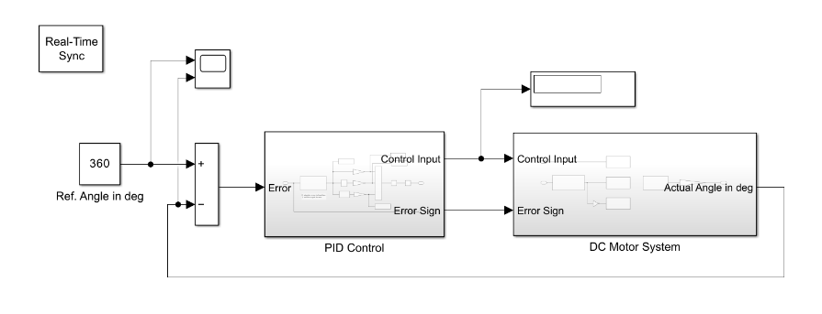

Figure 11: Position Control Block Diagram

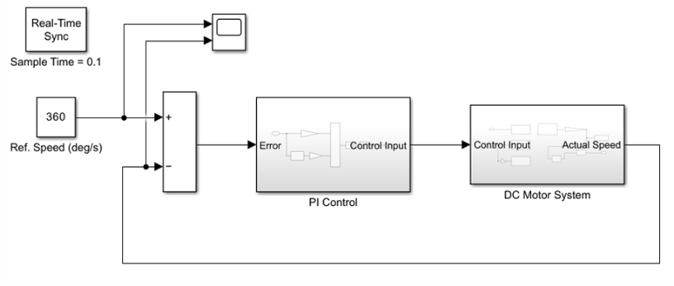

Figure 12: Speed Control Block Diagram

PID/PI Controller:
This block is designated for manipulating the error signal using PID or PI control. The resulted signal (Control Signal) is then sent to the motor driver.
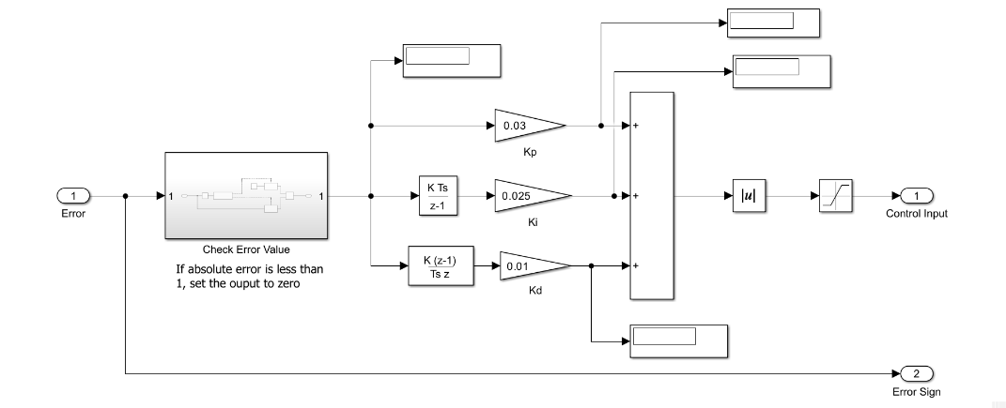
Figure 13: Position Control PID Controller

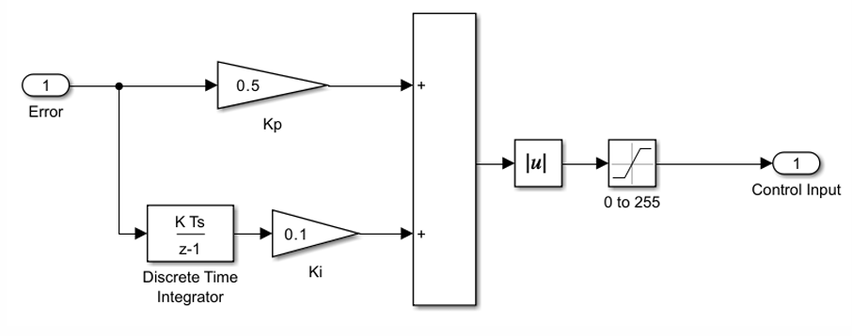
Figure 14: Speed Control PI Controller

DC Motor System:
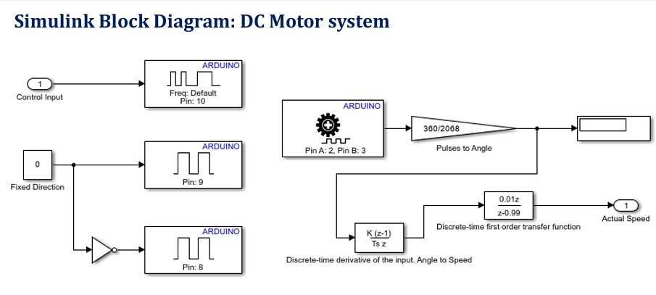
This block is dedicated to the hardware dynamics of the DC motor system. The control input signal is sent to the L298N driver via Arduino PWM pins. Encoder feedback (using Pins A and B) is processed to compute angular velocity.
Figure 15: Simulink DC Motor System Diagram

DC Motor Position Control
- Steps:
- Connecting the components using the jumpers and closing the circuit.
- Launch the Simulink file for position control using PID controller.
- Set the desired final displacement to $360 deg$ and set initial number for $k_{p}$, $k_{i}$, and $k_{d}$.
- Keep two of the three factors constant and change the third. Repeat this step till reaching an optimum value of the changing factor.
- Repeat the previous step two times to determine the optimum values for the other two constants.
- Raise the desired displacement to $720 deg$ and repeat steps (4) and (5) to find the factors optimum values.
- For each trial, open the “Scope” to observe the system response and export the plot.
- Extract and compare between the Percent Overshoot, peak time, steady-state error, and settling time of the trials.

- Experiment Trials & Results:
- $Displacement =360 deg$
- Variable $K_{p}$ at $K_{i}=0.025$ and $K_{d}=0.01$:
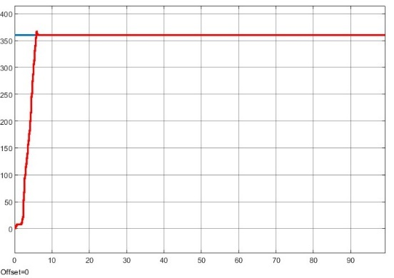
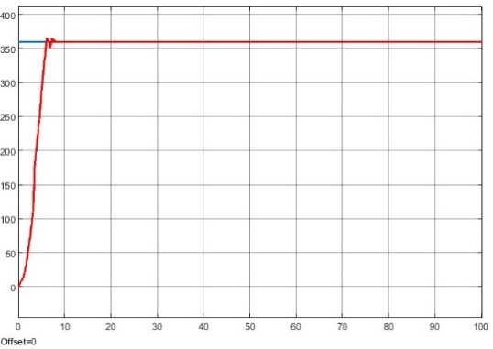

Figure 17: System Response at
k_p = 0.032 k_i=0.025 k_d=0.01
Figure 16: System Response at
k_p = 0.03 k_i=0.025 k_d=0.01

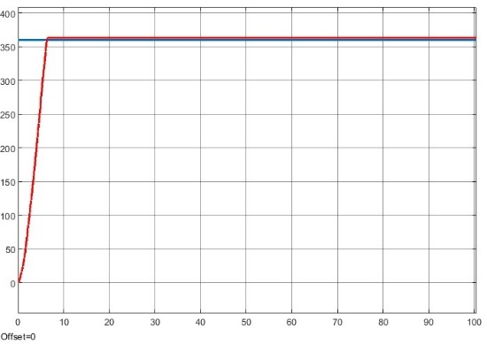
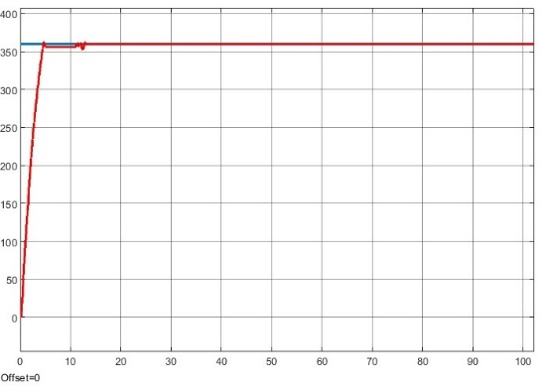

Figure 19: System Response at
k_p = 0.2 k_i=0.025 k_d=0.01
Figure 18: System Response at
k_p = 0.05 k_i=0.025 k_d=0.01

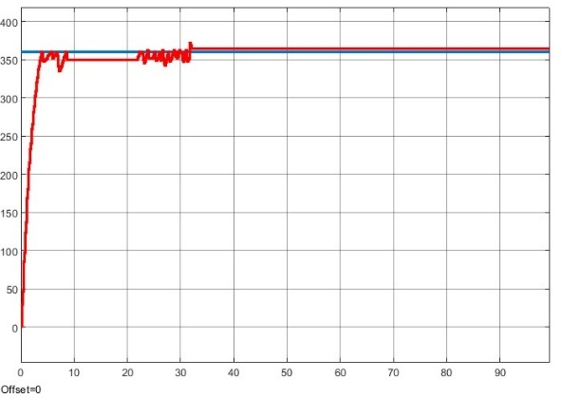

Figure 20: System Response at
k_p = 0.3 k_i=0.025 k_d=0.01

Table 1: Response Characteristics at
variable k_p k_i=0.025 k_d=0.01
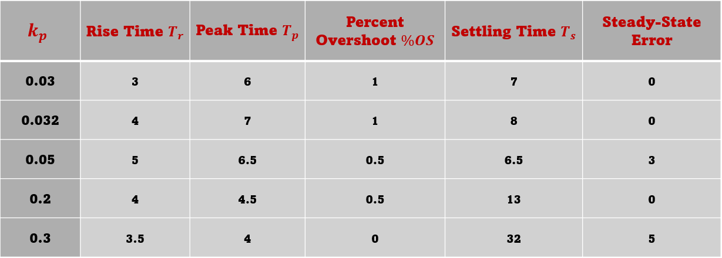
- Variable $K_{i}$ at $K_{p}=0.13$ and $K_{d}=0.01$:
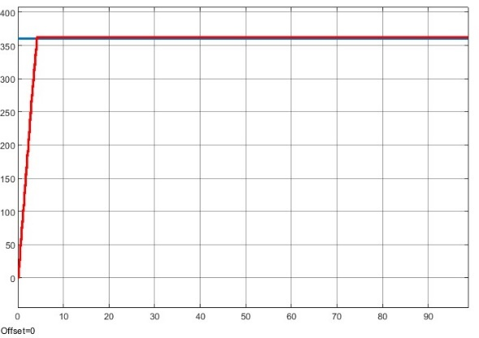
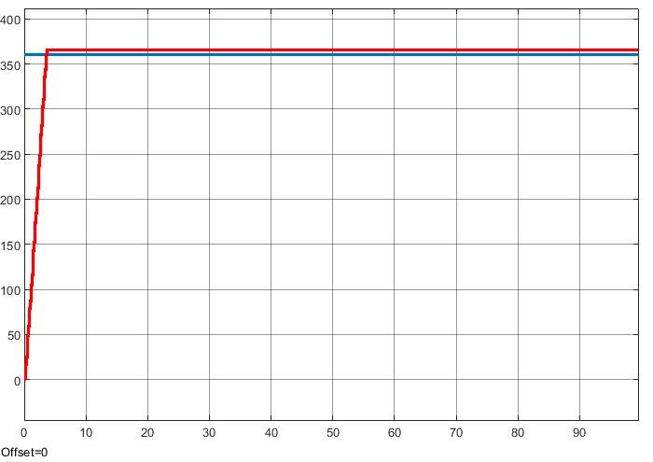

Figure 21:System Response at
k_p = 0.13 k_i=0.05 k_d=0.01
Figure 22: System Response at
k_p = 0.13 k_i=0.075 k_d=0.01

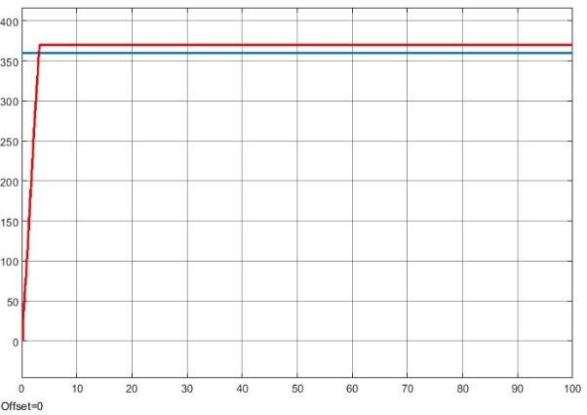

Figure 23: System Response at
k_p = 0.13 k_i=0.1 k_d=0.01

Table 2: Response Characteristics at
k_p=0.13 variable k_i k_d=0.01
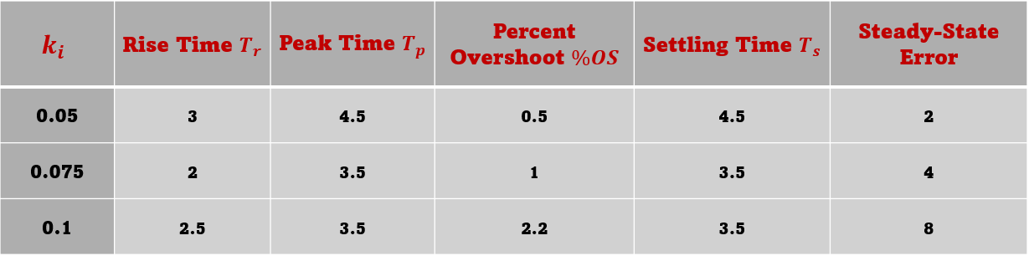

- Variable $K_{d}$ at $K_{p}=0.13$ and $K_{i}=0.025$:
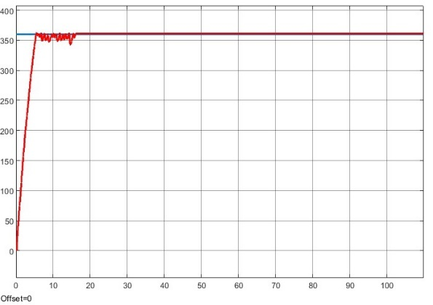
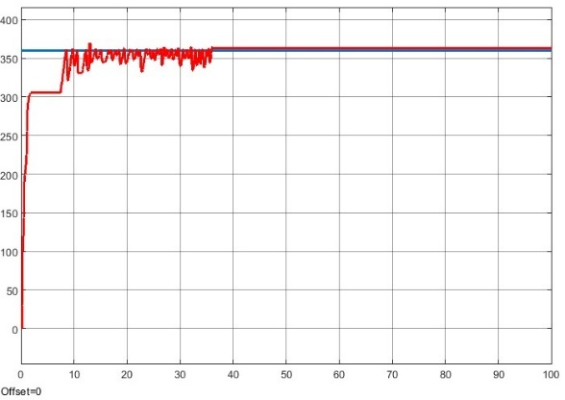
Figure 25: System Response at
k_p = 0.13 k_i=0.025 k_d=0.04
Figure 24: System Response at
k_p = 0.13 k_i=0.025 k_d=0.005

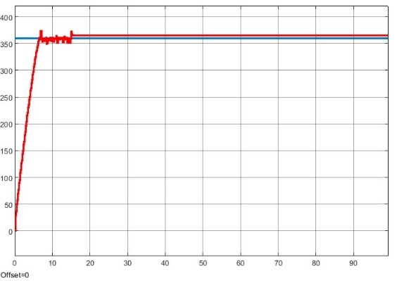
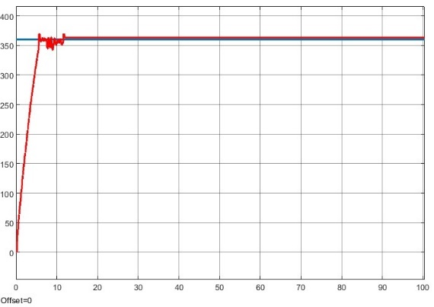

Figure 27: System Response at
k_p = 0.13 k_i=0.025 k_d=0.2
Figure 26: System Response at
k_p = 0.13 k_i=0.025 k_d=0.1

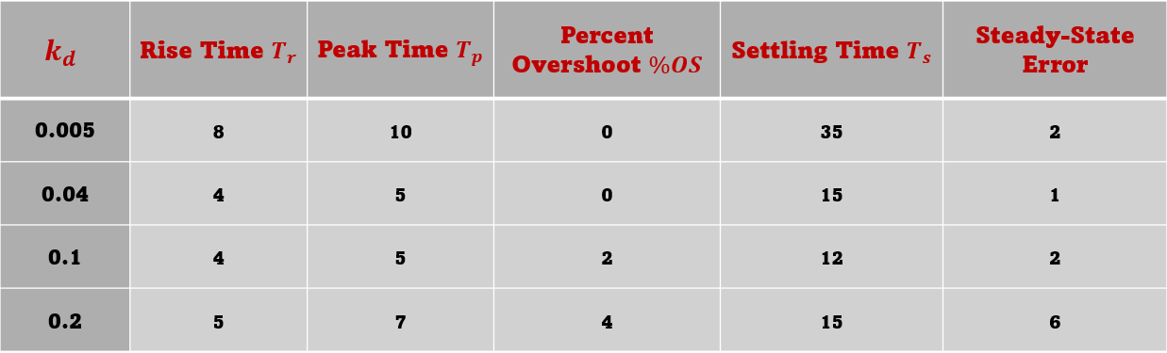
Table 3: Response Characteristics at
k_p=0.13 k_i=0.025 variable k_d

- $Displacement =720 deg$
- Variable $K_{p}$ at $K_{i}=0.025$ and $K_{d}=0.01$:
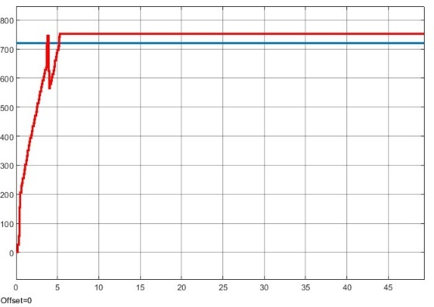
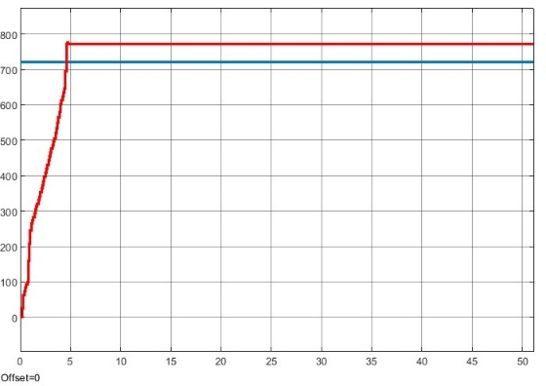

Figure 29: System Response at
k_p = 0.07 k_i=0.025 k_d=0.01
Figure 28: System Response at
k_p = 0.05 k_i=0.025 k_d=0.01

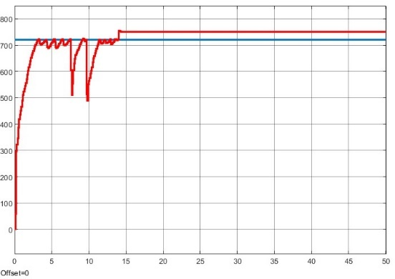

Figure 30: System Response at
k_p = 0.2 k_i=0.025 k_d=0.01

Table 4: Response Characteristics at
variable k_p k_i=0.025 k_d=0.01
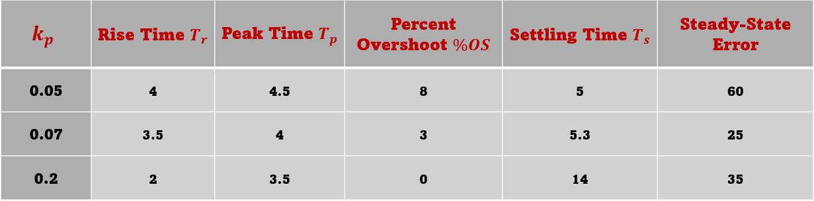

- Variable $K_{i}$ at $K_{p}=0.13$ and $K_{d}=0.01$:
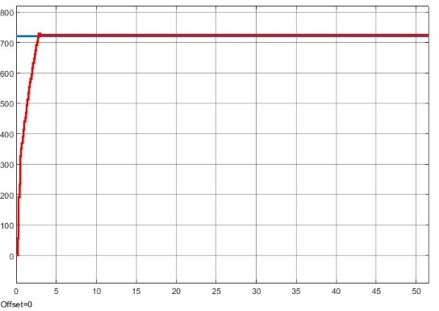
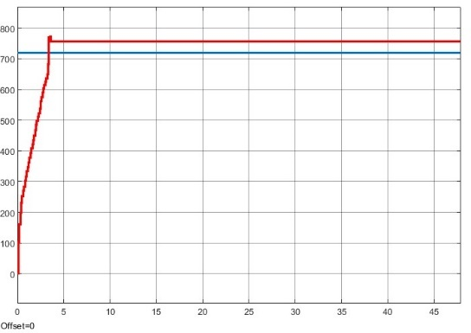
Figure 32: System Response at
k_p = 0.13 k_i=0.05 k_d=0.01
Figure 31: System Response at
k_p = 0.13 k_i=0.04 k_d=0.01

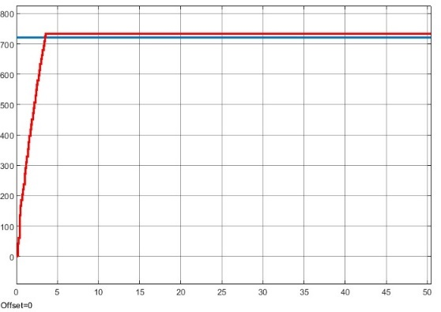

Figure 33: System Response at
k_p = 0.13 k_i=0.06 k_d=0.01

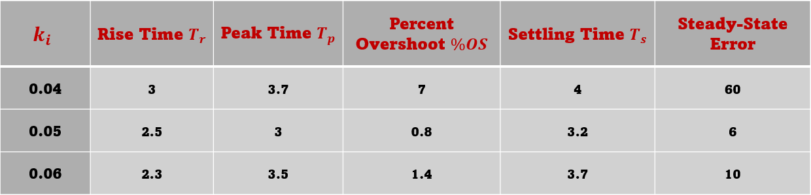
Table 5: Response Characteristics at
k_p=0.13 variable k_i k_d=0.01

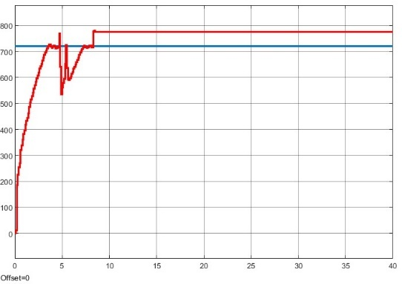
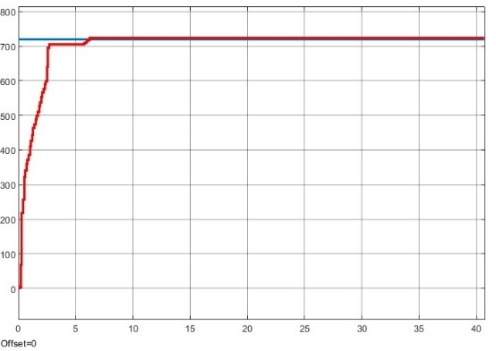
- Variable $K_{d}$ at $K_{p}=0.13$ and $K_{i}=0.025$:

Figure 35: System Response at
k_p = 0.13 k_i=0.025 k_d=0.03
Figure 34: System Response at
k_p = 0.13 k_i=0.025 k_d=0.02

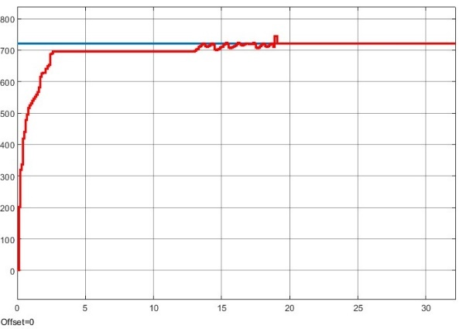

Figure 36: System Response at
k_p = 0.13 k_i=0.025 k_d=0.05

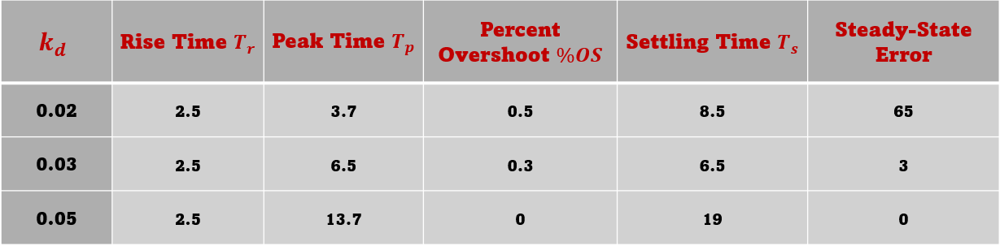
Table 6: Response Characteristics at
k_p=0.13 k_i=0.025 variable k_d

- Plots:
- $Displacement =360 deg$

- $Displacement =720 deg$

- Comments:
- $Displacement =360 deg$
- Proportional Gain ($K_{p}$​). Increasing $K_{p}$:
  - reduced both the rising time and the peak time.
  - had no effect on the overshooting.
  - increased the settling time and the steady-state error at high values. This result could be explained by the absence of damping system which induced instability. the steady-state error and improved the system's responsiveness.
- Integral Gain ($K_{i}$): Increasing $K_{i}$:
  - reduced both the rising time and the peak time.
  - increases overshoot and SS error.
- Derivative Gain ($K_{d}$​): Increasing $K_{d}$:
  - reduced the settling time.
  - Increases the overshoot.
- $Displacement =720 deg$:
- Proportional Gain ($K_{p}$​). Increasing $K_{p}$:
  - Increased the steady state error after some value.
- Integral Gain ($K_{i}$): Increasing $K_{i}$:
  - sharply decreased the steady state error
  - lowered the overshooting
- Derivative Gain ($K_{d}$​): Increasing $K_{d}$:
  - reduced the steady state error

DC Motor Speed Control
- Steps:
- Connecting the components using the jumpers and closing the circuit.
- Launch the Simulink file for speed control using PI controller.
- Set the desired speed to $180 deg/sec$ and set initial number for $k_{p}$ and $k_{i}$.
- Keep one of the two factors constant and change the second. Repeat this step till reaching an optimum value of the changing factor.
- Repeat the previous step to determine the optimum value for the other factor.
- Raise the desired speed to $360 deg/sec$ and repeat steps (4) and (5) to find the factors optimum values.
- For each trial, open the “Scope” to observe the system response and export the plot.
- Extract and compare between the Percent Overshoot, peak time, steady-state error, and settling time of the trials.

- Experiment Trials & Results:
- $Speed=180 deg/s$
- Variable $K_{p}$ at $K_{i}=0.1$:
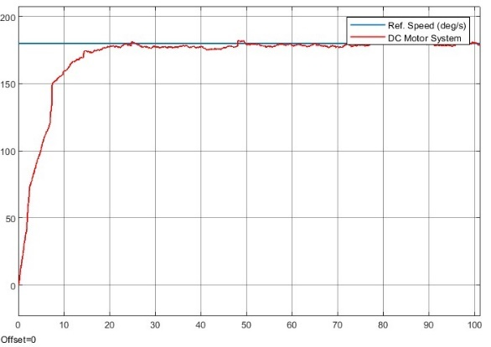
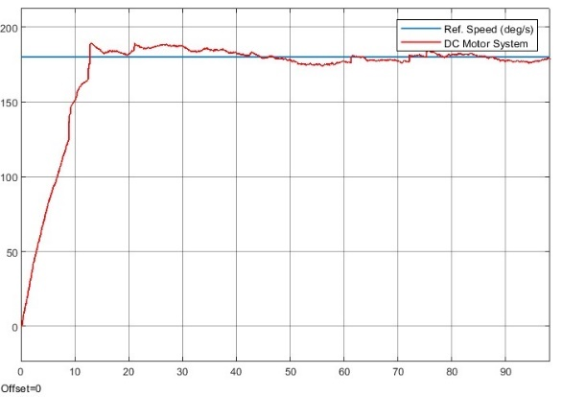

Figure 38: System Response at
k_p = 0.85 k_i=0.1
Figure 37: System Response at
k_p = 0.7 k_i=0.1

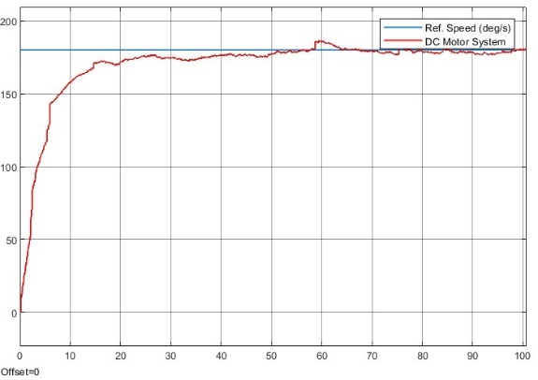

Figure 39: System Response at
k_p = 1 k_i=0.1
Table 7: Response Characteristics at
Variable k_p k_i=0.1

Table 7: Response Characteristics at
Variable k_p=0.3 k_i=0.1

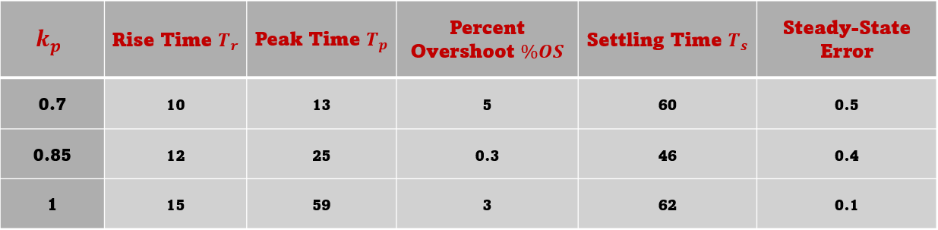

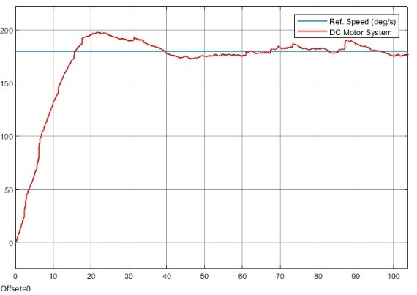
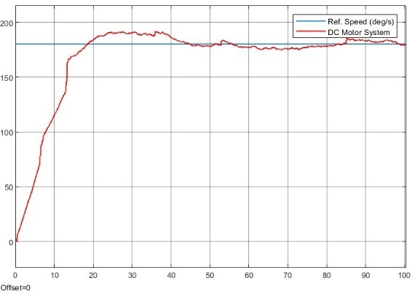
- Variable $K_{i}$ at $K_{p}=0.3$:

Figure 41: System Response at
k_p = 0.3 k_i=0.09
Figure 40: System Response at
k_p = 0.3 k_i=0.08

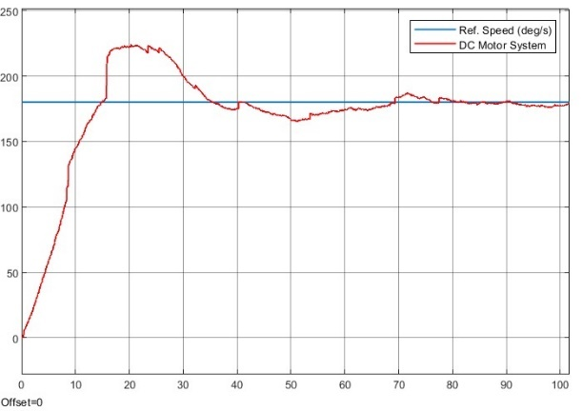

Figure 42: System Response at
k_p = 0.3 k_i=0.12

Table 8: Response Characteristics at
k_p=0.3 Variable k_i

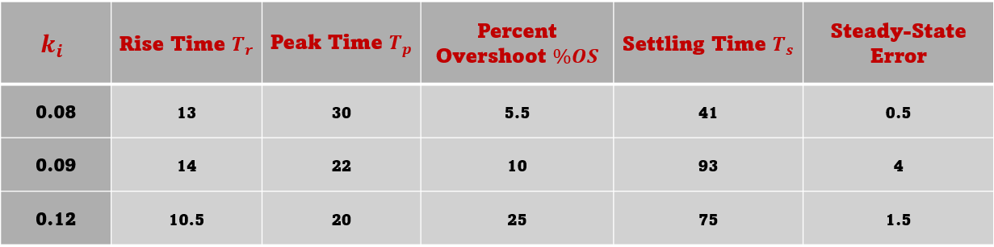

- $Speed=3$60 $deg/s$
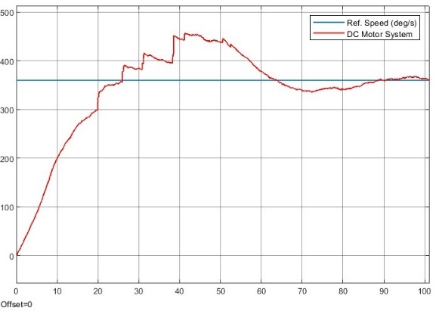
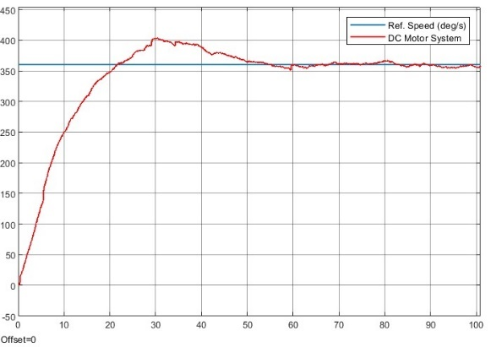
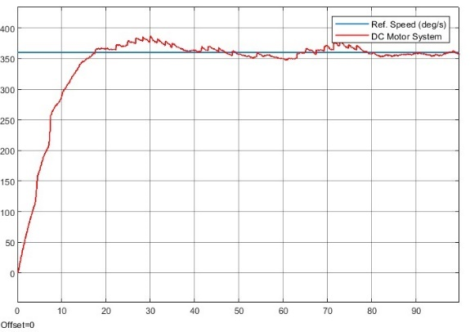
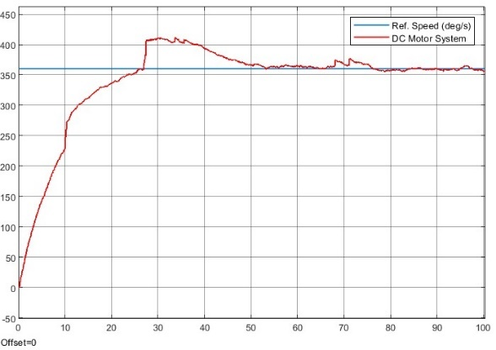
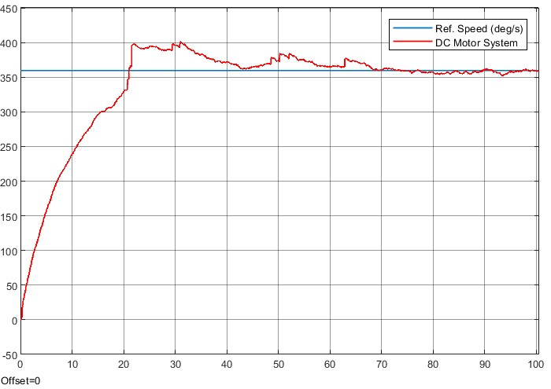
  - Variable $K_{p}$ at $K_{i}=0.1$:
Figure 43: System Response at
k_p = 0.2 k_i=0.1
Figure 44: System Response at
k_p = 0.4 k_i=0.1
Figure 46: System Response at
k_p = 1 k_i=0.1
Figure 45: System Response at
k_p = 0.8 k_i=0.1
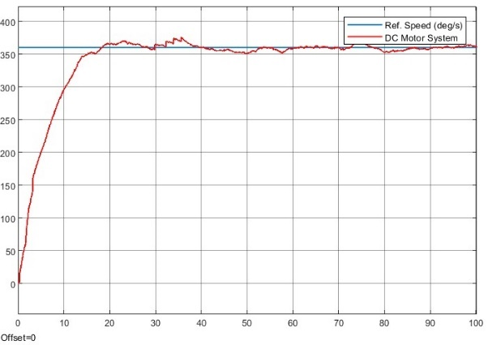
Figure 48: System Response at
k_p = 1.5 k_i=0.1
Figure 47: System Response at
k_p = 1.1 k_i=0.1
Table 9: Response Characteristics at
Variable k_p k_i=0.1

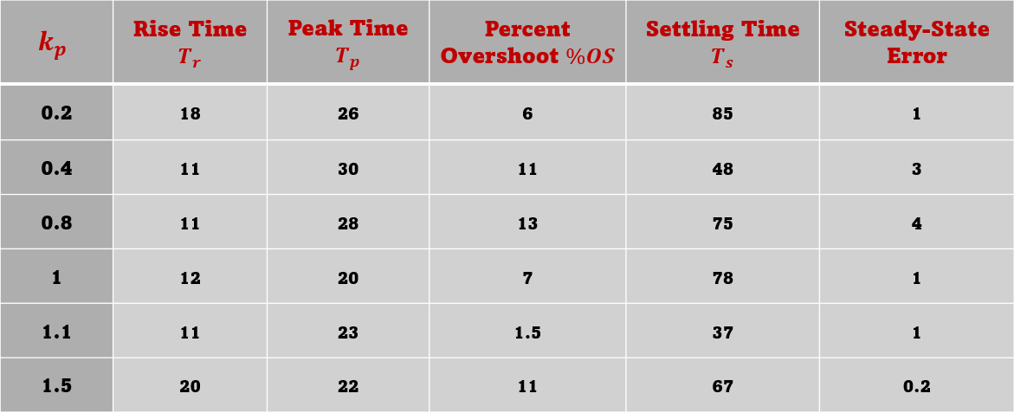

  - Variable $K_{i}$ at $K_{p}=0.3$:
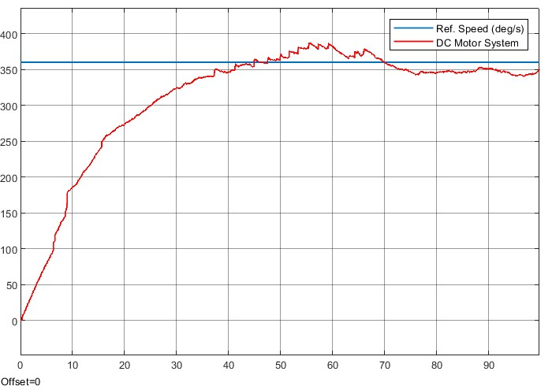
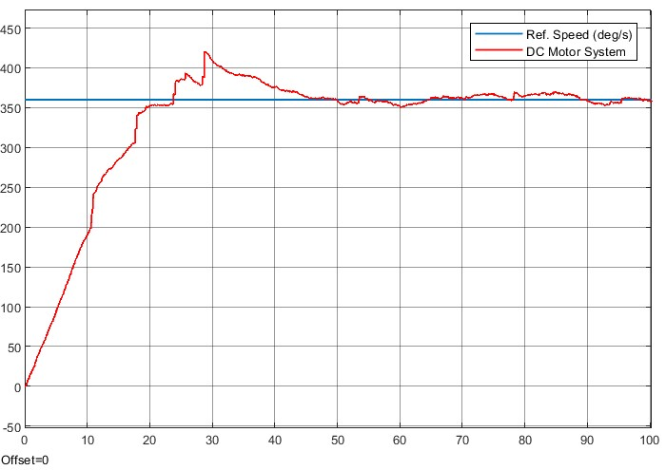

Figure 50: System Response at
k_p = 0.3 k_i=0.07
Figure 49: System Response at
k_p = 0.3 k_i=0.04
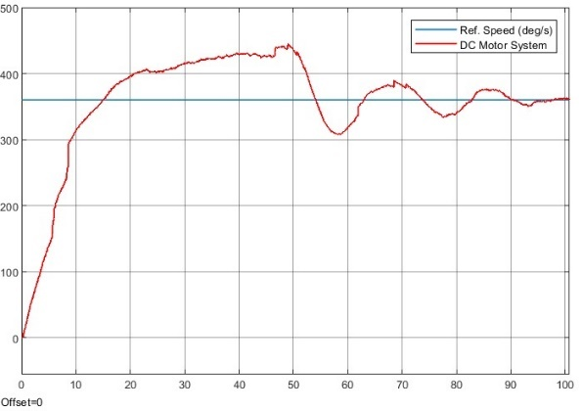
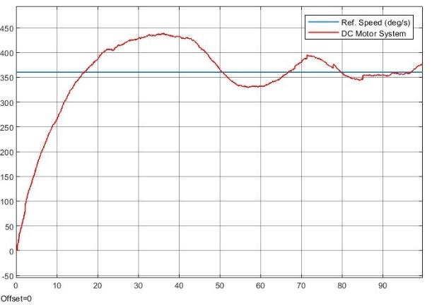

Figure 52: System Response at
k_p = 0.3 k_i=0.65
Figure 51: System Response at
k_p = 0.3 k_i=0.3
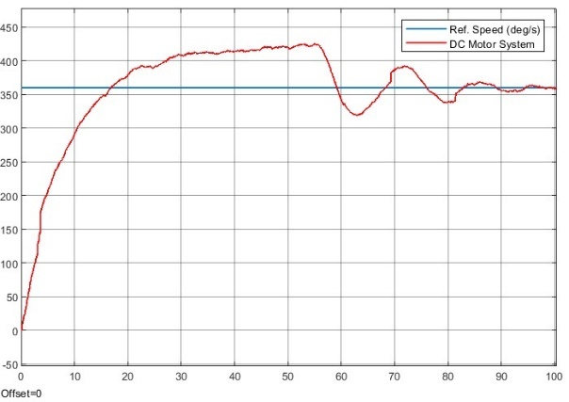

Figure 53: System Response at
k_p = 0.3 k_i=1

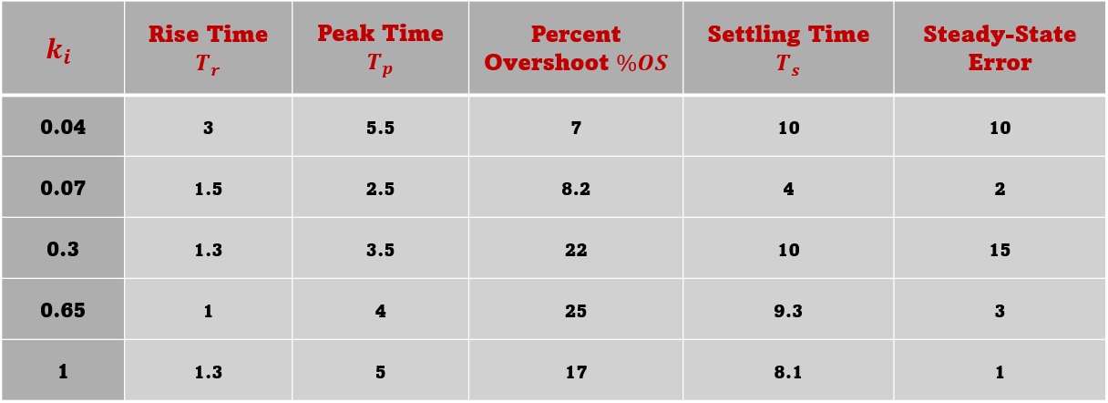
Table 10: Response Characteristics at
k_p=0.3 Variable k_i
- Plots:
- $Speed=180 deg/s$

- $Speed=360 deg/s$

- Comments:
- $Speed =180 deg/sec$
- Proportional Gain ($K_{p}$​):
  - The behaviour of the rising time and the peak time doesn’t achieve the anticipated, as they increased with the increased $K_{p}$. This could be reasoned by the high values of $K_{p}$​.

- Integral Gain ($K_{i}$):
  - The Settling time decreased with the increasing $K_{i}$.
  - increases overshoot and SS error.
- $Speed=360 deg/sec$:
- Proportional Gain ($K_{p}$​).
  - Increasing $K_{p}$, reduced the peak time.
  - The fluctuation in the settling time shows instability which was induced by the high value of $K_{p}$
- Integral Gain ($K_{i}$):
  - Increasing $K_{i}$, sharply decreased the steady state error

Conclusion
Control systems must be tuned precisely, as demonstrated by the experiment especially in the context of DC motor control for both position and speed regulation. By adjusting the PID and PI gains, significant changes were observed. For position control, the proportional gain ($k_{p}$) reduced both rise and peak times, though excessive values led to increased settling times and steady-state errors. Integral gain ($k_{i}$) was found to reduce rise and peak times but had an adverse effect on overshoot and steady-state error. Derivative gain ($k_{d}$) improved settling time and reduced overshoot. Also, for speed control, increasing the integral gain reduced steady-state error and overshoot but resulted in unstable behaviour at higher values of the proportional gain. Systems that are responsive and stable must strike a delicate balance, according to these findings.
The response of the systems didn’t always follow the expected behaviour. The sources of errors include the back-draw of changing only one gain at a time, which could stimulate instability and fluctuations in the results. Other source of errors is the USB wired connection between the Arduino and Simulink which drops some data due to its relatively slow data transmission. Moreover, a rare, yet possible, backlash between motor gears can introduce inaccuracy in position or speed measurements.
This experiment highlights the significance of gain adjustments to optimize performance in practical systems. Therefore, well-designed control systems can significantly improve real-world performance in automation, robotics, and other precision-driven industries.

References

- Ogata, K. (2010). Modern control engineering (5th ed.). Prentice Hall. ISBN 978-0-13-615673-4

- Emeasoba, N. C. (2015). The role of philosophy in the development of nations: The African case (Unpublished manuscript). Nnamdi Azikiwe University.

