IRIS ENERGY
Website Content & Asset Guide
Contact-free developer handoff for website design and implementation
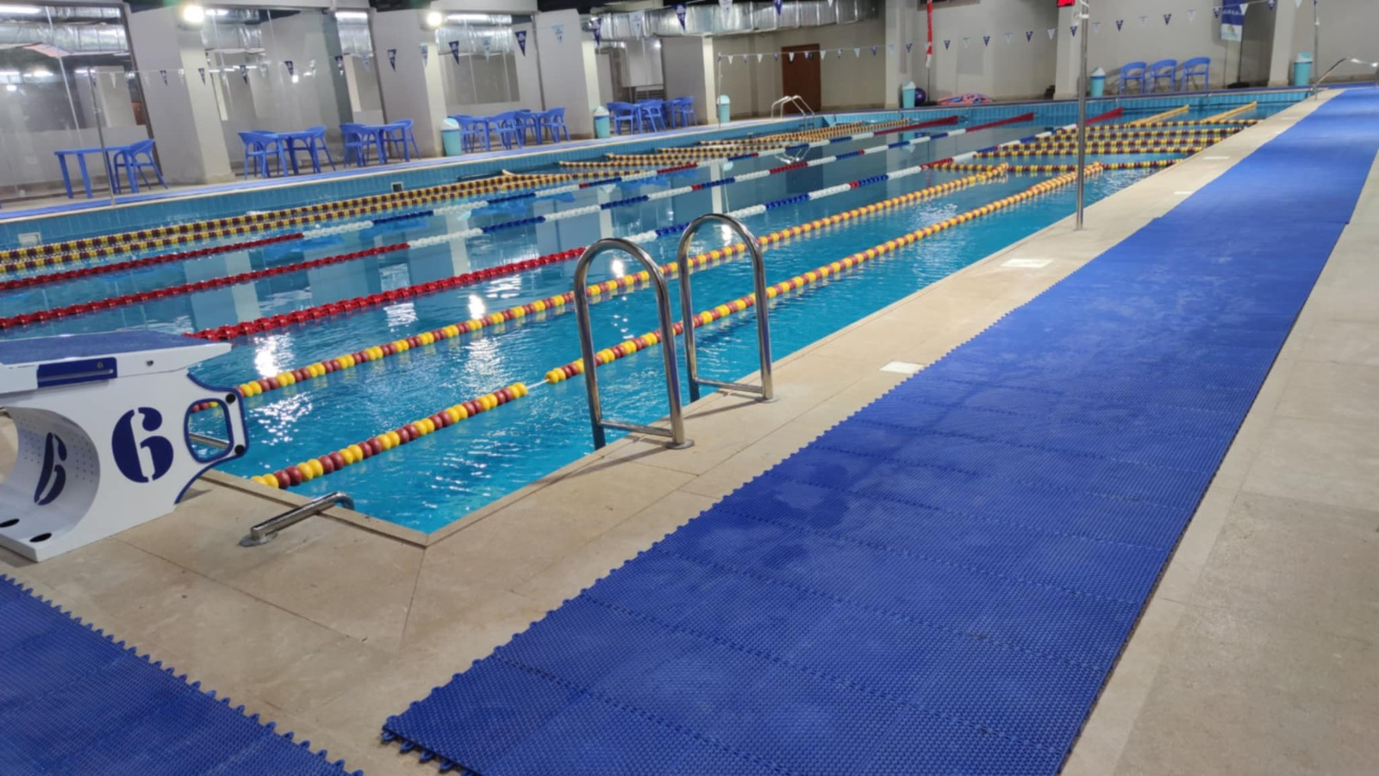
Commercial swimming-pool project image proposed for the homepage.
PACKAGE STATUS
Ready for design and development. Phone numbers, email addresses, physical addresses and legacy website links have been intentionally excluded. Claims marked for confirmation must remain unpublished until approved.

Prepared for | Primary use | Language | Source basis
Website development team | IRIS Energy website | English master copy | Three supplied company documents and project photos

1. Quick Start
This guide gives the website developer a publish-ready page structure, approved working copy, technical product data, project references, image mapping, search metadata and a final approval checklist.
NON-NEGOTIABLE PUBLISHING RULE
Do not insert any contact detail from the supplied source documents. The enquiry form may be built, but its private routing destination must be configured separately by the site owner.

Recommended Site Map
Page | Purpose
Home | Brand promise, applications, advantages, project proof and enquiry CTA
About | Company background, Egypt presence and engineering approach
Solutions | Pools and basins, domestic hot water, buildings and pool covers
Products | Residential, commercial and industrial heat-pump ranges
Projects | Approved references, sectors, geographic coverage and gallery
Services | Studies, sizing, installation, commissioning, maintenance and support
Request a Study | Website form only; no public contact details in this package

Recommended Navigation
Home | About | Solutions | Products | Projects | Services | Request a Study
- Use a sticky header on desktop and a compact menu on mobile.
- Prepare the architecture for English and Arabic, including right-to-left layout for Arabic.
- Use the Request a Study button as the primary call to action across the website.

2. Brand and Message Framework

Brand Positioning
IRIS Energy provides air-to-water heat-pump solutions designed around energy efficiency, technical reliability and project-specific engineering. Its applications cover swimming pools, industrial basins, domestic hot water and building heating and cooling.

Core Message
RECOMMENDED STATEMENT
Efficient heating and cooling, engineered for every project.

Supporting Messages
- French registered brand with regional market experience.
- Engineering support from early-stage study through installation and after-sales service.
- Residential, commercial and industrial solutions.
- High-efficiency operation with intelligent controls and application-specific system sizing.
- A growing portfolio of projects across Egypt.

Visual Direction
Element | Direction
Primary colours | IRIS blue, deep navy and white
Accent | Restrained warm gold inspired by the existing brand materials
Photography | Real installations, finished pools, equipment close-ups and engineering work
Tone | Technical, credible, clean and premium; avoid exaggerated sales language
Typography | Modern sans serif with clear numeric and technical-data rendering

3. Home Page - Ready-to-Use Copy

Hero
Component | Recommended copy
Eyebrow | AIR-TO-WATER HEAT PUMP SOLUTIONS
Headline | Efficient Heating and Cooling, Engineered for Every Project
Subheadline | Reliable heat-pump solutions for swimming pools, industrial basins, domestic hot water and residential buildings.
Primary CTA | Request a Project Study
Secondary CTA | Explore Our Solutions

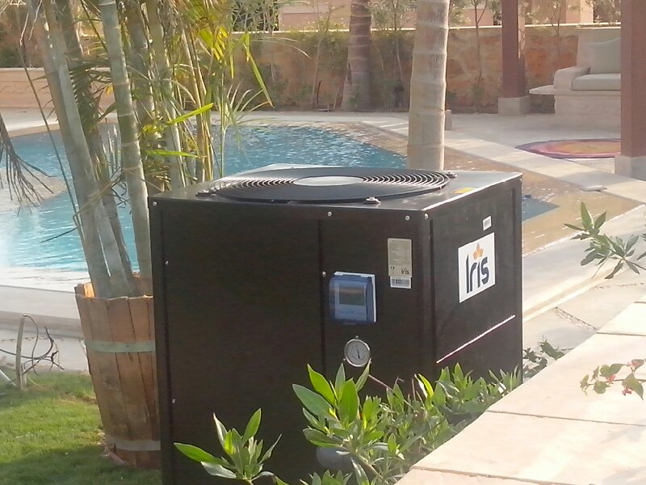
IRIS heat pump installed beside a residential swimming pool.

Homepage Introduction
IRIS Energy specializes in air-to-water heat-pump technology for projects that require dependable heating, cooling and efficient energy use. From private pools to hotels, schools, clubs and industrial applications, each system is selected around the project's operating conditions and performance requirements.

Application Cards
Application | Card copy
Swimming Pools & Spas | Efficient year-round temperature control for private and shared pools.
Commercial Facilities | Scalable systems for hotels, resorts, clubs and schools.
Industrial Basins | Engineered heating and cooling for large-volume water applications.
Domestic Hot Water | Air-to-water technology for reliable hot-water generation.
Buildings | Heating and cooling solutions tailored to residential applications.
Pool Covers | Thermal covers and roller systems that support heat retention and cleanliness.

Why IRIS Preview
- Efficient heat-pump technology
- Heating and cooling capability
- Project-specific engineering support
- Smart control options
- Installation and after-sales support
- Residential through industrial capacities

Homepage Project Proof
IRIS Energy systems support residential and commercial projects across Egypt, including villas, hotels, resorts, schools and sporting facilities. Use approved project photographs and client references to show real-world installation experience.
CTA BLOCK
Planning a pool, hot-water or building project? Share the project details to receive an initial technical assessment.

4. About Page - Ready-to-Use Copy

Page Introduction
IRIS Energy is a French company and registered brand established in 2011. Its target markets cover Europe and Mediterranean countries, with products serving customers across Europe, Africa and the Middle East.
IRIS Energy has operated in the Egyptian market since 2020 through cooperation with AOI-ABD. This local presence combines product expertise with engineering support for project studies, installation, maintenance and long-term service.
LEGAL WORDING RULE
Use the neutral wording 'cooperation with AOI-ABD' until the legal team confirms whether the approved public term is partnership, representation, cooperation protocol or joint venture.

What We Do
We accompany clients from early project stages through system selection, technical studies, installation and ongoing support. Our objective is to propose a solution that balances performance, budget, energy efficiency and service quality.

Suggested Values
Value | Meaning
Engineering First | Recommendations begin with project requirements and operating conditions.
Reliable Performance | Components and system configurations are selected for dependable operation.
Energy Responsibility | Heat-pump technology is applied to reduce unnecessary energy use.
Long-Term Support | Installation, maintenance and spare-parts follow-up are part of the project lifecycle.

5. Solutions Pages

Swimming Pools & Spas
IRIS heat-pump systems provide heating and cooling for private pools, hotel pools, schools, clubs and spa applications. System selection should consider pool volume, target temperature, ambient conditions, operating season and pool-cover use.

Commercial Pools & Industrial Basins
Large-capacity and multi-unit systems can be configured for commercial and industrial water applications. The engineering study determines capacity, hydraulic integration, controls and redundancy requirements.

Domestic Hot Water
Air-to-water heat-pump technology can support efficient domestic hot-water generation for suitable residential and commercial applications.

Building Heating & Cooling
IRIS Energy solutions can be applied to residential building heating and cooling where system design, emitters and water temperatures are compatible with heat-pump operation.

Pool Covers & Rollers
Thermal pool covers help reduce heat loss, limit contamination and reduce chemical demand. Available covers may be adapted to different pool shapes, colours and landscape requirements, with roller systems for easier handling.
POOL-COVER SPECIFICATION
The supplied material cites a cover thickness of 500 microns. Confirm the current product specification before publishing this figure.

6. Product Page

Product Introduction
The IRIS Energy portfolio includes residential, commercial and industrial heat pumps. Full-inverter and fixed-rate configurations are referenced in the supplied materials. Final model availability and technical data must be confirmed against the current product catalogue before launch.

Current Range Referenced in the Latest Supplied Document
Category | Model range | Heating capacity | Models | Technology
Residential | IRv-010 to IRv-060 | 10-65 kW | 9 | Full inverter
Commercial | IRv-075 to IRv-150 | 75-150 kW | 4 | Full inverter
Industrial | IRv-160 to IRv-500 | 160-475 kW | 5 | Full inverter

Referenced Technical Features
Feature | Referenced specification
Coefficient of performance | COP 6.15-16.11 W/W
Compressors | Panasonic, Copeland or equivalent branded compressors
Fan | DC fan motor
Refrigerants | R410A, R32 or R290, depending on model
Efficiency class | A+++ referenced in the supplied product table
Heat exchanger | PVC/titanium heat exchanger
Controls | Colour-screen smart control panel with Wi-Fi function
Sound level | 50-58 dB(A) at one metre, depending on model
Alternative configuration | Fixed-rate heat pumps referenced as available across model ranges

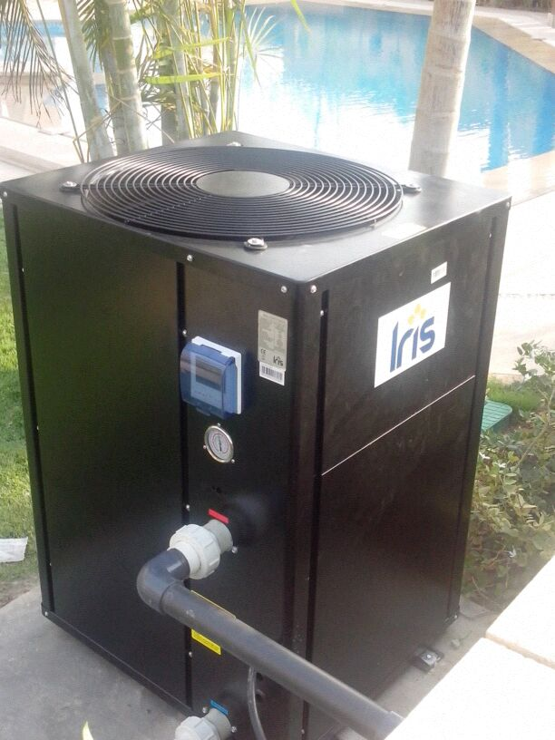
IRIS swimming-pool heat-pump unit.

Legacy Model Examples - Hold for Product Confirmation
Model | Typical pool | Heating | Input | Supply
IR-120ZB | 120 m3 | 60 kW | 10.8 kW | 380 V / 3 ph
IR-100ZB | 90 m3 | 50 kW | 9 kW | 380 V / 3 ph
IR-070ZB | 70 m3 | 35 kW | 6.3 kW | 380 V / 3 ph
IR-050ZB | 50 m3 | 25 kW | 4.5 kW | 380 V / 3 ph
IR-040ZB | 40 m3 | 20 kW | 3.6 kW | 240 V / 1 ph
IR-030ZB | Spa | 15 kW | 2.7 kW | 240 V / 1 ph

DO NOT PUBLISH YET
These model references come from the older flyer and may not match the current full-inverter range. Confirm availability, electrical data, compressor type and performance conditions first.

7. Services Page - Ready-to-Use Copy
IRIS Energy supports the full project lifecycle, from early concept and system selection to installation and continued operation.
Service | Website description
Project Study | Review application, dimensions, operating season, climate, target temperature and usage pattern.
System Sizing | Select the suitable capacity, number of units, hydraulic arrangement and supporting equipment.
Technical Advice | Coordinate integration with the pool, hot-water or building system.
Installation & Commissioning | Support equipment placement, connection, testing and operational handover.
Knowledge Transfer | Guide operators and maintenance teams on correct use and routine checks.
Maintenance | Provide planned and corrective service through qualified technical teams.
Spare-Parts Follow-Up | The supplied profile references at least five years of spare-parts follow-up; confirm the exact service commitment before publishing.

Recommended Service CTA
REQUEST A PROJECT STUDY
Provide the project type, location, water volume, target temperature and available drawings so the engineering team can review the requirement.

8. Why Choose IRIS
Reason | Supporting copy
Specialized Technology | Focus on air-to-water heat-pump applications.
Project Engineering | Solutions are selected around the project's actual operating requirements.
Scalable Portfolio | Residential, commercial and industrial configurations are referenced.
Smart Operation | Selected models include colour-screen and Wi-Fi control functionality.
Service Capability | Study, installation, maintenance and spare-parts support are part of the offering.
Local Experience | Project references span several sectors and regions across Egypt.

9. Projects Page

Publish-Ready Introduction
IRIS Energy heat-pump systems have been applied across residential and commercial projects in Egypt, including villas, hotels, resorts, schools and sporting facilities. Projects range from single-unit residential installations to multi-unit systems serving large pools.

Geographic Coverage
The supplied references include projects in Cairo, Giza, Alexandria, the Northwest Coast, Sharm El-Sheikh, Hurghada, El Gouna, Sahl Hasheesh, Soma Bay and Luxor.
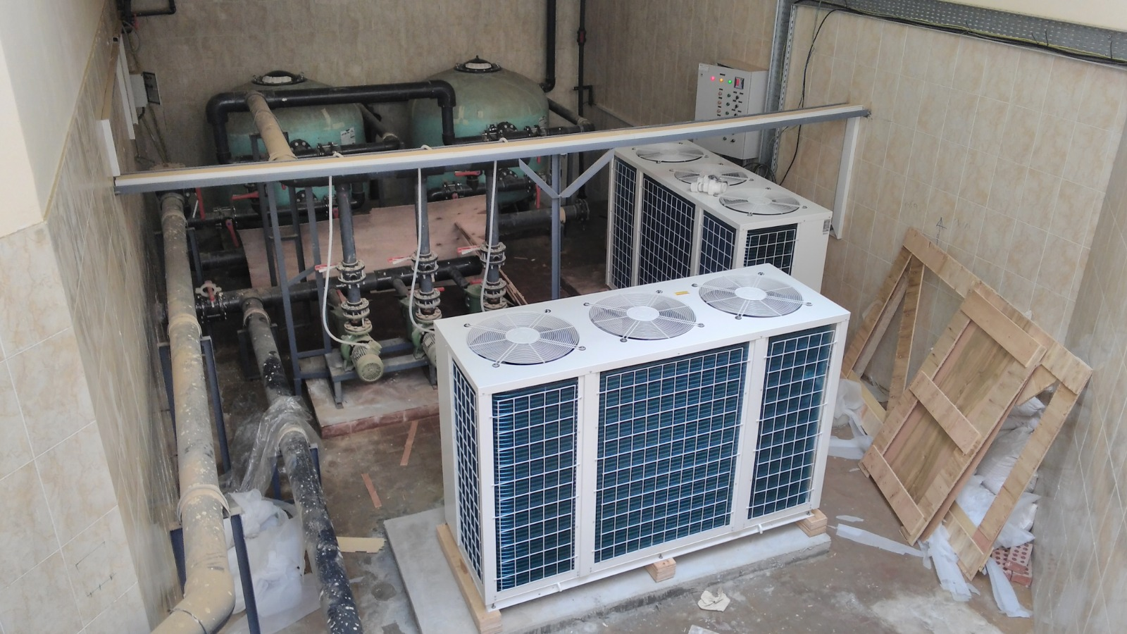
Multi-unit heat-pump installation serving a large water-heating application.

Named References - Publish Only After Permission
Reference | Sector | Supplied project data
British School of Egypt - Sheikh Zayed | School | 2 x 100 kW
American School of Egypt - 6 October | School | 3 x 125 kW
British School of Egypt - Banha | School | 2 x 55 kW
Safir Hotel - Dahab | Hotel | 2 x 200 kW and 1 x 25 kW
Al Moudira Hotel - Luxor | Hotel | 8 x 35 kW and 1 x 250 kW
Cairo Country Seasons | Sporting facility | 4 x 60 kW
El Gouna hotel group references | Hotels and resorts | Three main pools; capacity not supplied
Hurghada villa portfolio | Residential | Approximately 30 pools; mainly 30 and 35 kW

WITHHELD REFERENCES
Do not publish private-home owner names, military-facility references or identifiable customer details without explicit written approval.

Recommended Project Card Structure
- Project title or approved anonymous label
- Sector and region
- Application and pool or basin type
- Installed capacity and number of units
- Engineering challenge
- IRIS solution
- Result or operating benefit
- Approved project photographs

10. Photo Asset Map
The website-ready files are renamed, converted to WebP and stripped of embedded metadata. Images involving identifiable people or uncertain suitability are separated into the Pending Approval folder.
Source | Packaged file | Suggested use | Status
WA0022 | homepage-commercial-pool.webp | Home / Projects | Ready
WA0009 | homepage-residential-pool-heat-pump.webp | Home / Products | Ready
WA0008 | product-iris-pool-heat-pump.webp | Products | Ready
WA0030 | product-showroom-unit.webp | Products | Ready; supporting image
WA0004 | project-multi-unit-heat-pump-system.webp | Projects | Ready
WA0024 | project-protected-outdoor-installation.webp | Projects | Ready
WA0029 | project-protected-equipment-bank.webp | Projects | Ready
WA0025 | project-louvered-enclosure-side-a.webp | Projects | Ready
WA0026 | project-louvered-enclosure-side-b.webp | Projects | Ready
WA0027 | project-louvered-enclosure-front.webp | Projects | Ready
WA0023 | technical-control-panel-wiring.webp | Technical | Ready
WA0005 | pending-onsite-personnel.webp | Projects | Permission needed
WA0006 | pending-equipment-delivery.webp | Projects | Permission needed
WA0011 | pending-crane-installation.webp | Projects | Permission needed
WA0031 | pending-service-technicians.webp | Services | Permission needed
WA0032 | pending-controller-low-resolution.webp | Technical | Replace if possible
WA0007 | Not packaged | Duplicate of WA0004 | Excluded
WA0010 | Not packaged | Near-duplicate of WA0008 | Excluded
WA0012 | Not packaged | Very narrow composite image | Excluded

Image Publishing Rules
- Use real project images wherever possible; avoid generic stock photography.
- Do not publish identifiable people without permission.
- Do not state a project name or location unless it is confirmed for public use.
- Serve responsive image sizes and lazy-load images below the first screen.
- Write accurate alt text that describes the equipment or project, not promotional claims.

11. Request-a-Study Form
Build an enquiry form without displaying any public phone number, email address or physical address. Configure the private recipient only in the website backend.
Field | Implementation note
Full name | Required
Organization | Optional
Project type | Pool / spa / industrial basin / domestic hot water / building
Project location | City and country only
Pool or basin volume | Cubic metres, if applicable
Required operation | Heating / cooling / both
Target temperature | Numeric value and unit
Expected operating season | Months or year-round
Existing system | Short description
Attachments | Plans, photographs or specifications
Project notes | Free-text field
Consent | Privacy acknowledgement before submission

12. Search and Page Metadata
Page | Meta title | Meta description
Home | IRIS Energy | Air-to-Water Heat Pump Solutions | Efficient heat-pump solutions for pools, industrial basins, hot water and buildings.
About | About IRIS Energy | Engineering Efficient Heating | Learn about IRIS Energy, its heat-pump expertise and project-focused engineering approach.
Solutions | Heat Pump Applications | IRIS Energy | Explore heating and cooling solutions for pools, basins, domestic hot water and buildings.
Products | Residential, Commercial & Industrial Heat Pumps | Explore IRIS heat-pump ranges, technology and referenced performance features.
Projects | Heat Pump Projects in Egypt | IRIS Energy | View approved IRIS Energy installations across residential and commercial applications.
Services | Heat Pump Engineering, Installation & Support | Project studies, system sizing, installation, commissioning and maintenance support.
Request a Study | Request a Heat Pump Project Study | IRIS Energy | Share project requirements for an initial heat-pump system assessment.

Suggested Search Topics
- swimming pool heat pump
- commercial pool heating
- industrial basin heating and cooling
- air-to-water heat pump
- pool heating solutions in Egypt
- heat pump installation and maintenance
- thermal pool cover and roller

13. Website Build Requirements
Requirement | Acceptance expectation
Responsive design | Prioritize mobile readability, CTA visibility and technical-table usability.
Bilingual readiness | Structure content and components for English and Arabic, including RTL support.
Performance | Use WebP, responsive image sizes, compression, caching and lazy loading.
Accessibility | Keyboard navigation, visible focus states, semantic headings, labels and useful alt text.
Content management | Allow authorized staff to update models, projects, photos and technical data.
Forms | Use validation, anti-spam protection, consent text and a private backend routing destination.
Search fundamentals | Unique page titles, descriptions, canonical tags, sitemap and structured data.
Measurement | Add approved analytics and conversion events for study requests.
Security | HTTPS, dependency updates, access control, backups and secure form handling.
Quality assurance | Test current mobile and desktop browsers before launch.

14. Confirmation Required Before Publishing
LAUNCH GATE
The website may be designed now, but the following points must be confirmed before the affected claims, names or specifications go live.

Topic | Issue | Required decision
Installation count | Sources state both more than 80 and more than 100 installations. | Select one evidenced figure or publish no number.
Capacity range | Older material states 5-250 kW; newer material states 10-475 kW. | Use the current catalogue as authority.
Legal relationship | Partnership, cooperation protocol, representation and joint venture are used. | Approve one legally accurate public phrase.
Energy-saving claim | Older material claims more than 75% reduction. | Define comparison baseline and operating conditions.
Customer satisfaction | A 99% satisfaction claim is included in one source. | Publish only with supporting evidence.
Certifications | CE compliance and safety/performance certification are referenced. | Collect current certificates for applicable models.
Product data | Full-inverter and legacy fixed-rate data are both present. | Confirm active models and final datasheets.
Customer references | Named schools, hotels, clubs and private projects are listed. | Obtain permission or anonymize.
Photographs | Some images show personnel or identifiable sites. | Confirm usage rights and consent.
Service commitment | At least five years of spare-parts follow-up is referenced. | Confirm exact commercial commitment.

Final Pre-Launch Checklist
- Approved legal description of IRIS Energy and AOI-ABD relationship
- Current model catalogue and technical datasheets
- Validated performance and efficiency claims
- Approved project names, capacities and photographs
- Image-consent confirmation for visible people
- Arabic translation reviewed by a technical Arabic speaker
- Private form-routing destination configured by the owner
- Privacy notice and form consent published
- Mobile, performance, accessibility and form testing completed
- No source contact details copied into the live website
END OF GUIDE
This package intentionally contains no phone numbers, email addresses, physical addresses or legacy website URLs.

