Course Two

Go Beyond the Numbers: Translate Data into Insights


Instructions
Use this PACE strategy document to record decisions and reflections as you work through this end-of-course project. You can use this document as a guide to consider your responses and reflections at different stages of the data analytical process. Additionally, the PACE strategy documents can be used as a resource when working on future projects.

Course Project Recap
Regardless of which track you have chosen to complete, your goals for this project are:
- Complete the questions in the Course 2 PACE strategy document
- Answer the questions in the Jupyter notebook project file
- Clean your data, perform exploratory data analysis (EDA)
- Create data visualizations
- Create an executive summary to share your results

Relevant Interview Questions
Completing the end-of-course project will help you respond to these types of questions that are often asked during the interview process:
- How would you explain the difference between qualitative and quantitative data sources?
- Describe the difference between structured and unstructured data.
- Why is it important to do exploratory data analysis?
- How would you perform EDA on a given dataset?
- How do you create or alter a visualization based on different audiences?
- How do you avoid bias and ensure accessibility in a data visualization?
- How does data visualization inform your EDA?
Reference Guide
This project has six tasks; the visual below identifies how the stages of PACE are incorporated across those tasks.
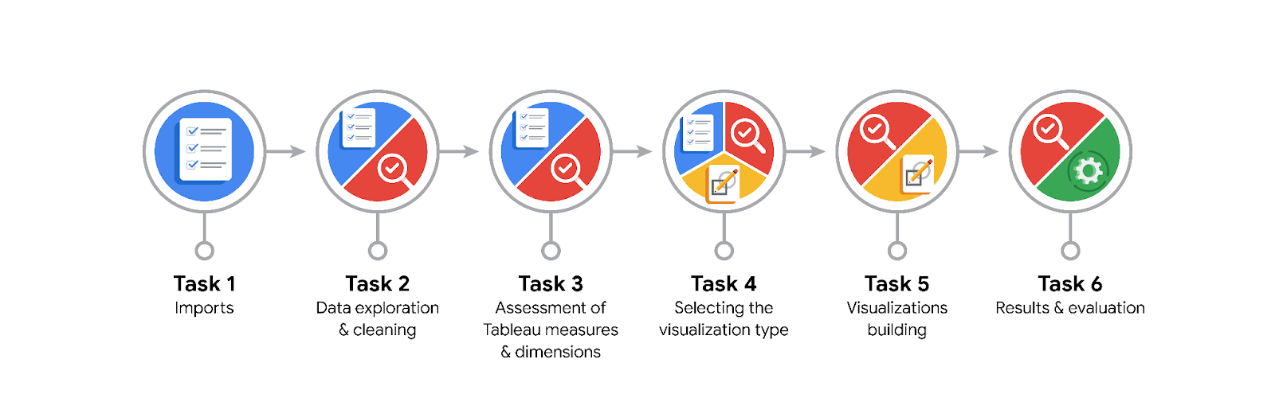
Data Project Questions & Considerations

PACE: Plan Stage
- What are the data columns and variables and which ones are most relevant to your deliverable?

- What units are your variables in?

- What are your initial presumptions about the data that can inform your EDA, knowing you will need to confirm or deny with your future findings?

- Is there any missing or incomplete data?

- Are all pieces of this dataset in the same format?

- Which EDA practices will be required to begin this project?

PACE: Analyze Stage
- What steps need to be taken to perform EDA in the most effective way to achieve the project goal?

- Do you need to add more data using the EDA practice of joining? What type of structuring needs to be done to this dataset, such as filtering, sorting, etc.?

- What initial assumptions do you have about the types of visualizations that might best be suited for the intended audience?

PACE: Construct Stage
- What data visualizations, machine learning algorithms, or other data outputs will need to be built in order to complete the project goals?

- What processes need to be performed in order to build the necessary data visualizations?

- Which variables are most applicable for the visualizations in this data project?

- Going back to the Plan stage, how do you plan to deal with the missing data (if any)?

PACE: Execute Stage
- What key insights emerged from your EDA and visualizations(s)?

- What business and/or organizational recommendations do you propose based on the visualization(s) built?

- Given what you know about the data and the visualizations you were using, what other questions could you research for the team?

- How might you share these visualizations with different audiences?

