Course Four

Regression Analysis: Simplifying Complex Data Relationships
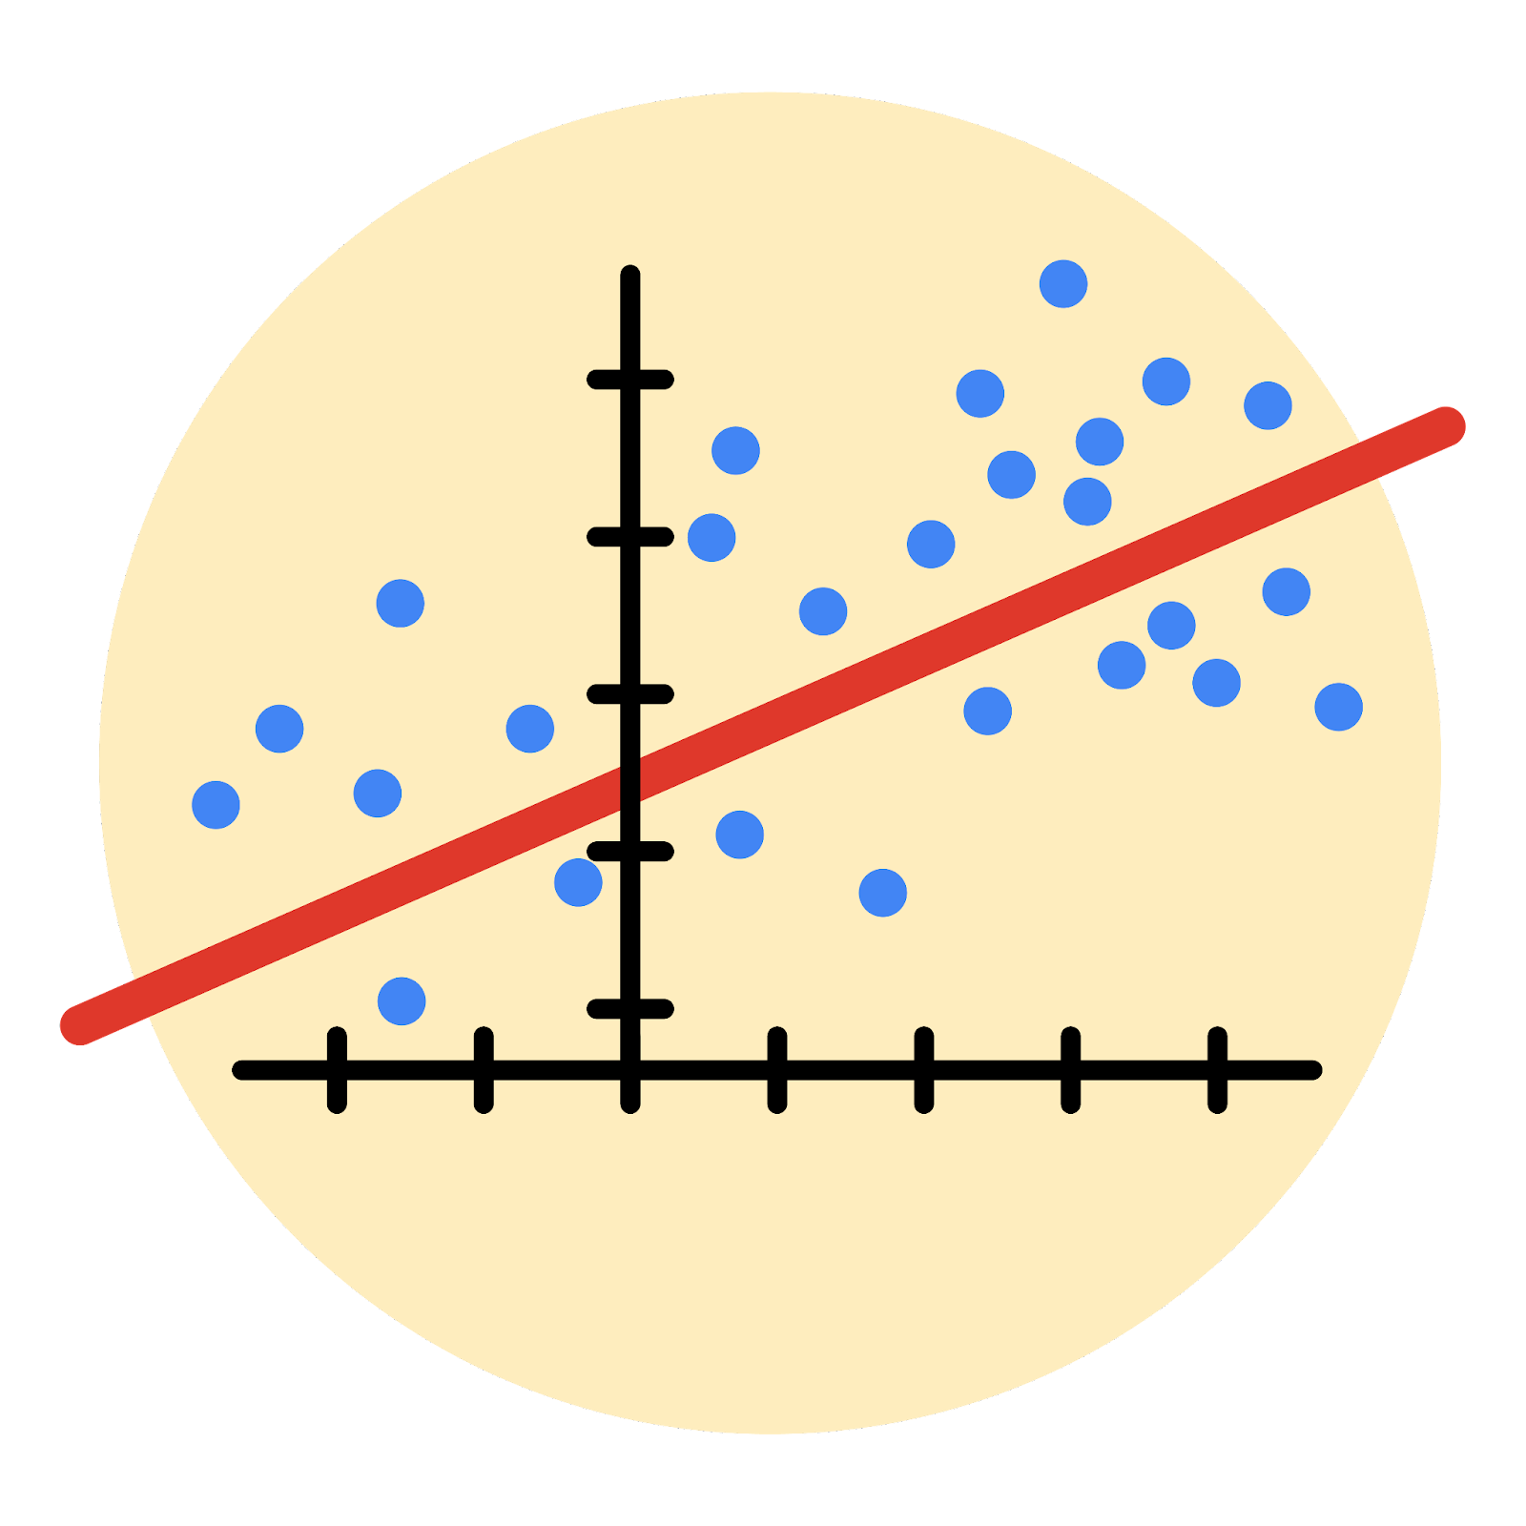

Instructions
Use this PACE strategy document to record decisions and reflections as you work through this end-of-course project. As a reminder, this document is a resource that you can reference in the future, and a guide to help you consider responses and reflections posed at various points throughout projects.

Course Project Recap
Regardless of which track you have chosen to complete, your goals for this project are:
- Complete the questions in the Course 4 PACE strategy document
- Answer the questions in the Jupyter notebook project file
- Build a multiple linear regression model
- Evaluate the model
- Create an executive summary for team members

Relevant Interview Questions
Completing the end-of-course project will empower you to respond to the following interview topics:
- Describe the steps you would take to run a regression-based analysis
- List and describe the critical assumptions of linear regression
- What is the primary difference between R² and adjusted R²?
- How do you interpret a Q-Q plot in a linear regression model?
- What is the bias-variance tradeoff? How does it relate to building a multiple linear regression model? Consider variable selection and adjusted R².
Reference Guide
This project has seven tasks; the visual below identifies how the stages of PACE are incorporated across those tasks.
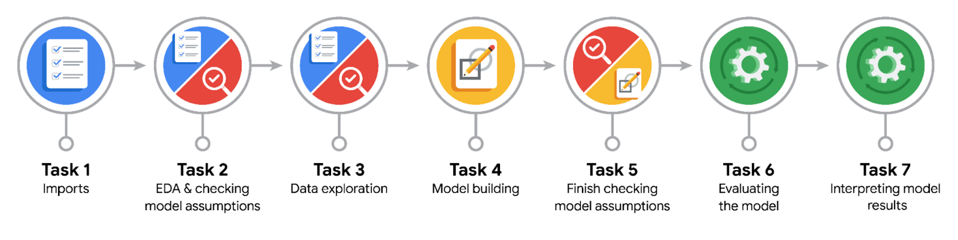

Data Project Questions & Considerations
PACE: Plan Stage
- Who are your external stakeholders for this project?
The external stakeholders for this project are the TikTok users both those who create and view TikTok videos, advertisers, who are interested in the platform’s safety, regulatory bodies who are responsible for overseeing the standards and data privacy

- What are you trying to solve or accomplish?
My team and I aim at building models that determine whether a video contains a claim or just offers an opinion.

- What are your initial observations when you explore the data?
I observed that the dataset is composed of 19382 rows and 12 columns. Five of these 12 columns are the characteristics of the videos (such as view count, like count, share count, download count, and comment count, which are all continuous values). These serve as the independent variables that we aim to analyze for their effect on the dependent variable (the verified status). I also noticed that the number of missing values (298) is the same for the independent variables and the dependent variable, which indicates that these values follow a similar data collection pattern. After reaching out to the Data Science Manager, we decided to drop them to reach an accurate conclusion.
- What resources do you find yourself using as you complete this stage?
To complete the EDA stage, I used various methods from the pandas python library. This includes read_csv to read the dataset, .head() to familarize myself with the data, dtype() to check the data type of each column, .info() to get basic summary about the dataset structure, .describe() to provide descriptive statistic, .isna().sum() to calculate how many many values are missed and dropna() to drop them.

PACE: Analyze Stage
- What are some purposes of EDA before constructing a multiple linear regression model?
The purpose of performing EDA before constructing a multiple linear regression is for data professionals to familiarize themselves with the data, conduct a thorough analysis of the relationships between variabales, and assess variable assumptions such as linearity and independent observation before the model is built.

- Do you have any ethical considerations at this stage?
The main ethical consideration at this stage is making sure that the data is not biased or imbalanced as it can lead to inaccurate results. The data is highly skewed with 94.3% of the accounts are unverified and only 5.8% are verified. The model might become much better at predicting the majority, but performing poorly for the minority. If those predictions are used in ways that disadvantage the minority, that would lead to bias. That explains the reason behind resampling the data to create class balance in the outcome variable.

PACE: Construct Stage
- Do you notice anything odd?
I noticed some variables, such as view count, share count, download count, and comment count, are highly correlated with one another, which indicates high multicollinearity that will affect the model’s prediction of how an individual independent variable affects the dependent variable.

- Can you improve it? Is there anything you would change about the model?
To improve the model, we can identify independent variables that are highly correlated with one another to address multicollinearity. We can either remove the redundant variables or combine them into a single composite variable. For this analysis, I will drop the 'like count' column, as it exhibits the highest correlation with other variables.

- What resources do you find yourself using as you complete this stage?
The resources are python libraries, such as pandas to organize the data and scikit-learn for encoding categorical variables, and training machine learning.

PACE: Execute Stage
- What key insights emerged from your model(s)?
The key insights are the following:
- For every second increase in the length of the video, the log odds of the account being verified increase by 0.009.
- Other variables have a small coefficient, which means they have a small association with the verified status. This indicates that video duration has the highest impact on determining whether an account is verified or not.

- What business recommendations do you propose based on the models built?
Based on the model’s insight, a business recommendation would be to further analyze the relationship between video duration and account status by gathering more data to make sure that the findings are robust. Also, tailor the content strategies to focus on producing longer videos, as it seems to be a strong indicator of a verified account.

- To interpret model results, why is it important to interpret the beta coefficients?
The beta coefficient shows the effect of a one-unit increase in the independent variable on the dependent variable. In this case, the effect of video features i.e., the effect of a one-second increase in video duration on account status.

- What potential recommendations would you make?
My main recommendation is to explore more analysis strategies to improve the overall accuracy score of the model. Additionally, other factors that are suspected to help in predicting the account status should be collected and used in model training.
- Do you think your model could be improved? Why or why not? How?
Yes, the model could be improved as the current precision of 61% and accuracy of 65%, indicates that the model is making significant false positive errors.

To improve the model, we could try hyperparameter tuning,use more advanced techniques, and even explore different algorithms like Random Forest or Gradient Descent.

- What business/organizational recommendations would you propose based on the models built?
For business recommendations, TikTok should prioritize the review of videos from unverified accounts since this model is better at predicting verified accounts. Additionally, since longer videos are associated with verified accounts, TikTok could consider using video duration as a key feature in verification reviews.

- Given what you know about the data and the models you were using, what other questions could you address for the team?
Building on what we know from the model, we could also explore how content
type, claim or opinion, interact with engagement metrics like views, shares, and comments.

- Do you have any ethical considerations at this stage?
The main ethical consideration at this stage is algorithmic bias. Because the model relies on features like video duration to predict verified status, it risks marginalizing creators who produce shorter videos. The model must evaluate multiple features to ensure fair treatment across all content types.

