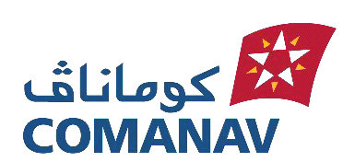P

Agence DE LAAYOUNE Avenue DE LA MEQUE LAAYOUNE
Tel.05 28 89 41 06 EMAIL :eun.aasmahri@cma-cgm.com 0666244317/0666624649
S.O.F {{vessel_name}}

FLAG : {{flag}} GRT : {{gross_tonnage}}TX DWT : {{deadweight}} TX LOA : {{loa}} Mtrs CARGO: {{cargo}} OWNERS: {{owner}}

 | DATE | TIME
ARRIVED ON ROAD / Arrivé en rade
DROP ANCHORAGE / Mouiller ancre
N.O.R TENDRED / N.O.R remise
WEIGHED ANCHOR / Levé ancre
PILOT ON BOARD / Pilote à bord
FIRST LINE / Premiére amarre
ALL FAST /Accostage
HOSE. CONNECTION . Flexible
START LOADING/DISCHARGING
Chargement/Déchargement commencé
COMPLETED LOADING / DISCHARGING
Fin Chargement / Déchargement
CARGO DCTS ON BOARDS / Dcts a bord
VESSEL SAILED / Départ navire
NUMBER OF TUGS USED FOR BERTHING
NUMBER OF TUGS USED FOR SAILING

BUNKERS ON ARRIVAL. BUNKERS ON SAILING
FRESH WATER : ……. MTS FRESH WATER : ……. MTS
FUEL OIL : ……. MTS FUEL OIL : ……. MTS
GASOIL : ……. MTS GASOIL : ……. MTS
DRAFT ON ARRIVAL DRAFT ON SAILING
FORE : .......... MTS FORE : ….. MTS
AFT : .......... MTS AFT : …… MTS

MASTER AGENT

