Pre-Dojo Setup

Thank you for joining the “ESP8266: IOT as a hobby” dojo.
Because of the limited time during the session, we need to prepare your notebook for the Dojo by installing some software and creating some account to streamline the intended exercises.

Installing the Arduino IDE:
Go to “https://www.arduino.cc/en/Main/Software” and download the install the Arduino IDE per your system (Windows, Linux or Mac O/S).

ESP8266 repository
Source: https://github.com/esp8266/Arduino
Follow the instructions below :

Installing with Boards Manager
Starting with 1.6.4, Arduino allows installation of third-party platform packages using Boards Manager. We have packages available for Windows, Mac OS, and Linux (32 and 64 bit).
- Install the current upstream Arduino IDE at the 1.8.7 level or later. The current version is at the Arduino website.
- Start Arduino and open Preferences window.
- Enter http://arduino.esp8266.com/stable/package_esp8266com_index.json into Additional Board Manager URLs field. You can add multiple URLs, separating them with commas.
- Open Boards Manager from Tools > Board menu and install esp8266 platform (and don't forget to select your ESP8266 board from Tools > Board menu after installation).

Install the CP201X Serial Driver
The board we have chosen has a Serial to USB chip that requires special drivers, please follow these instructions to install them:
Download and extract the CP2102 driver (zip file) from:
https://www.silabs.com/products/development-tools/software/usb-to-uart-bridge-vcp-drivers

Testing the installation:
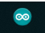
To check if the ArduinoID was installed properly :
- Start the Arduino IDE
- Go to menu «Tools → Board « and scroll all the way to «ESP8266 Boards … « section and chose «NodeMCU 1.0 (ESP-12E Module)»
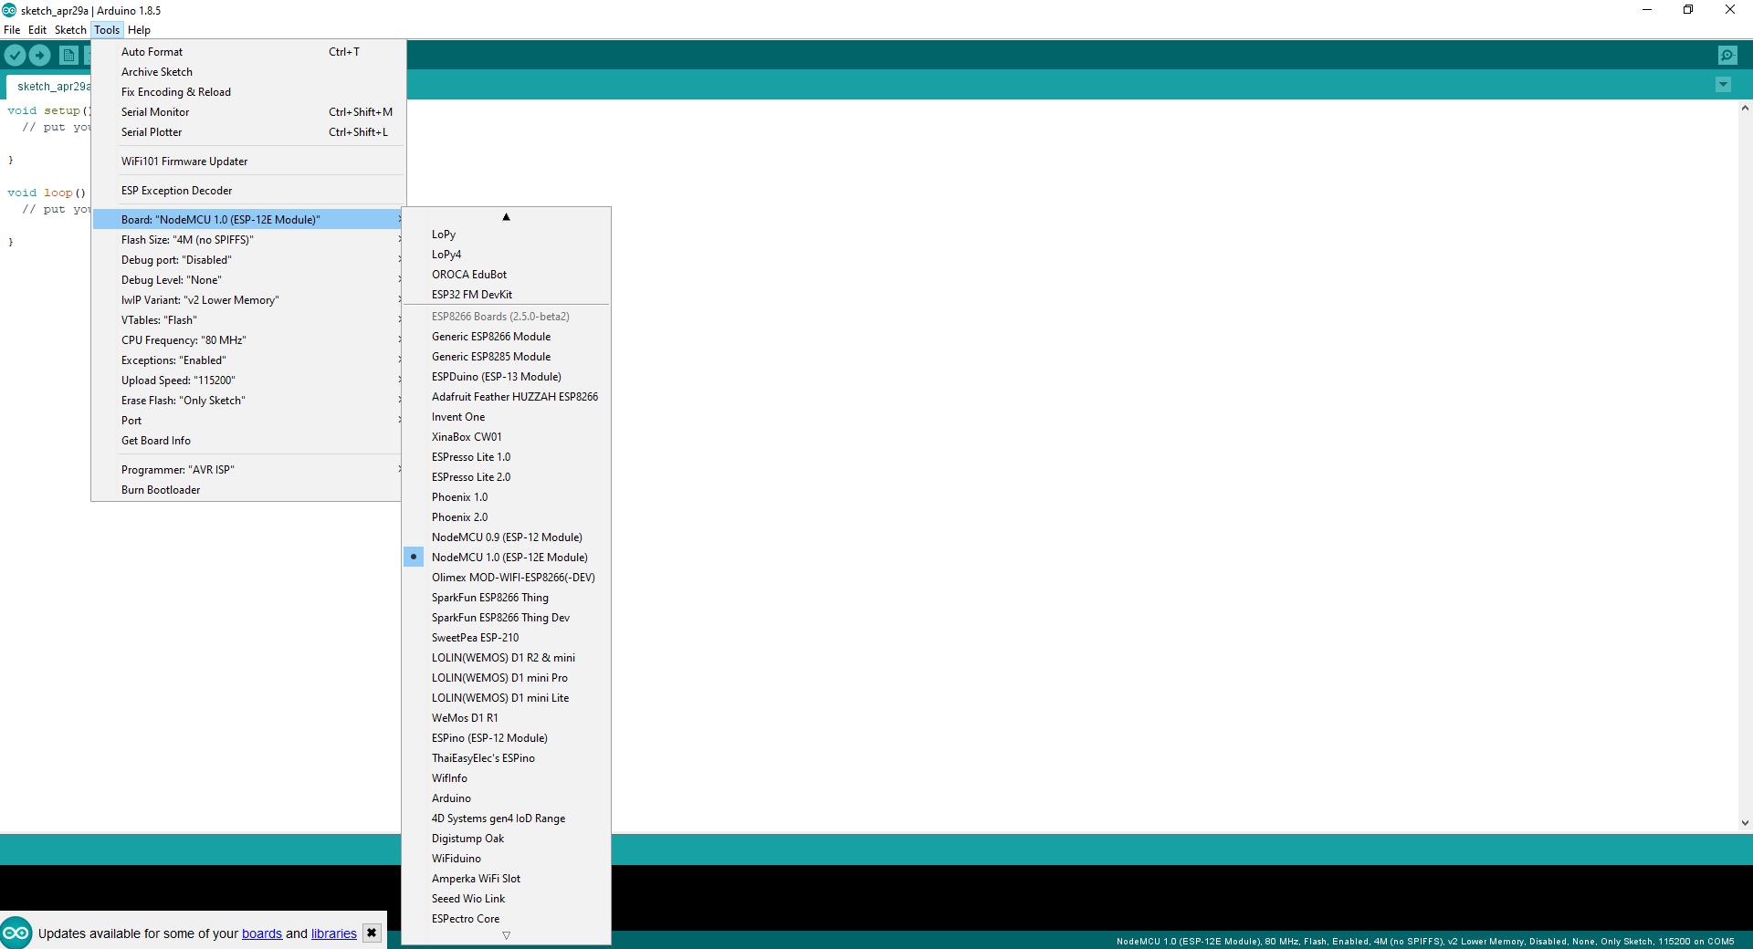
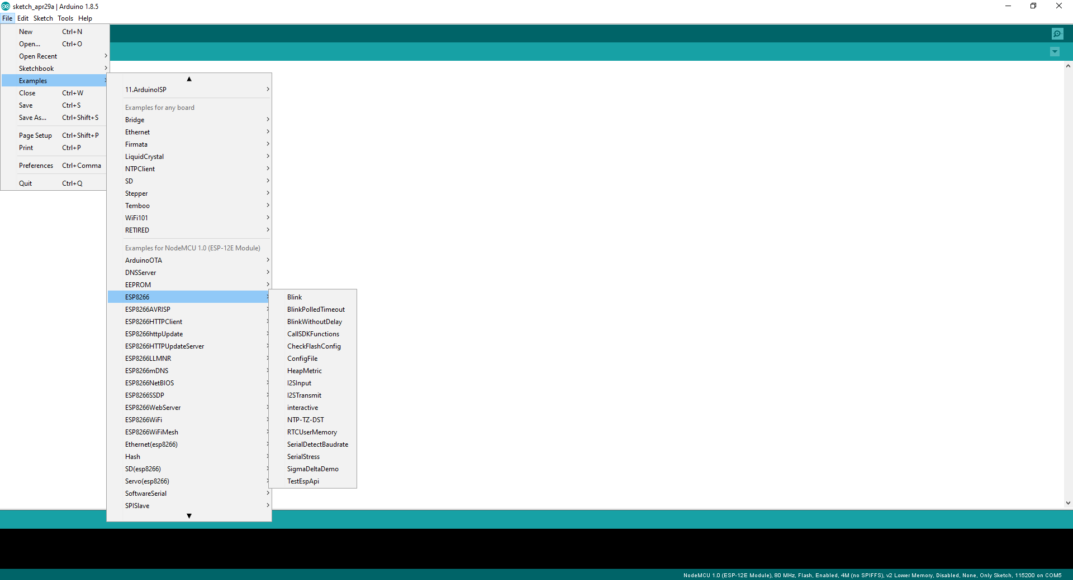
Then go to the menu: «File → Examples» scroll all the way to the «NodeMCU 1.0 (ESP-12E Module) → ESP8266 → Blink »
Then click the compile button:
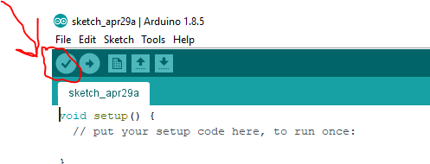

You should get something like this after a while in the lower section of the IDE:
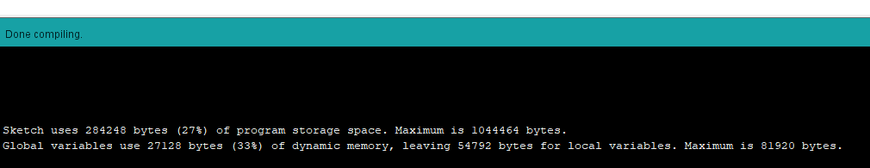

Accounts
Create these accounts and keep your passwords or API Keys ready during the session for the following Web Services:

https://blynk.io/ : you need to install Blynk Smartphone app on your phone and create an account.

https://telegram.org/ messaging smart phone App: An app Like WhatsApp, but a bit more open where you can build and program your own Bots. Install it, and look for “Botfather” . Also try to setup the web interface at “https://web.telegram.org“.

