

**NAME:**

ASMALIA FILZATI REDZUAN

**CLASS:**

DALLAS

**STUDENT ID:**

1711171509

**REPORT TITLE:**

JOLIBEE RESTAURANT MENU PROGRAM

**PREPARED FOR:**

MADAM SHAHRIZAT ISMAIL

**DEADLINE:**

JUNE 29TH, 2018

1. INTRODUCTION

Technology now has become such an important tool and necessary component in our daily lives to accomplish our tasks. Majority of business organizations specifically in food industry nowadays depends on their networking reliable to achieve their desired goals especially in Japan and United States. The reliability of the network has become the key factors among other success and failure factors of organization. By using technology, such organization can make more profit rather by saving the money from paying the salary for the worker.

A fast food restaurant called ‘Jolibee’ is needing a program for its customers to fill in their menu by themselves instead of hiring waiters for the job. In the program, it is also need to display the total cost including the 6% of government taxes that the customers have to pay for their meals. By doing this, they can save a lot money from hiring for the human services. This paper will discuss about how the program was build from the beginning.

1. PROBLEM ANALISIS
2. To save a menu in a file, to keep on using it for the same menu for every customers
3. Display the menu to customers for them to make their choices
4. The inputs from customers such as the type of menu, the item and the number of order from them have to be taken
5. At the end, it has to output the total price for the customers to pay for their meals
6. STEPS SOLUTION
7. Build the menu for the restaurant and save it to a file
8. Display out the menu to the screen for the customers to see and make their choices
9. Asking from the customer about their choices such as the type of menu they want, the item and their choices of the number of order by using loop structure
10. From the information the customer gives, calculate the total cost of each item inside the loop body
11. Calculate the total price for all items and charge of 6% that the customer has to pay
12. Display receipt and total prices include the charge to the customer

1. The Source Code

#include <iostream>

#include <fstream>

#include <iomanip>

#include <windows.h>

void write_to_file();

void menu_display();

double find_total_cost (double PRICES[5][3]);

void display_receipt(double TOTALCOST);

using namespace std;

int main()

{

double prices[5][3]= { {6.50,2.49,1.99},

{5.50,2.00,1.99},

{6.50,1.49,2.49},

{7.00,2.00,2.49},

{3.49,1.49,1.99}

};

double totalCost;

Beep(1568,400);

write_to_file();

menu_display();

totalCost = find_total_cost(prices);

display_receipt (totalCost);

return 0;

}

//write to file

void write_to_file()

{

ofstream outFile;

outFile.open("Menu.txt");

outFile << setprecision (2)

<< setiosflags(ios::showpoint)

<< setiosflags (ios::fixed);

outFile << "(a)Chicken Special $" << 6.50 << " (a)Apple Pie $" << 2.49 << " (a)Café Mocha $" << 1.49 << endl

<< "(b)Chicken Nuggets $" << 5.50 << " (b)Butter Bread $" << 2.00 << " (b)Café Late $" << 1.99 << endl

<< "(c)Rainbow Fillet $" << 6.50 << " (c)No-salt Fries $" << 1.49 << " (c)Orange juice $" << 2.49 << endl

<< "(d)Double Cheeseburger $" << 7.00 << " (d)Fun ice Cream $" << 2.00 << " (d)Ice Lemon Tea $" << 2.49 << endl

<< "(e)Tofu Burger $" << 3.49 << " (e)Rice Cracker $" << 1.49 << " (e)Pepsi $" << 1.99 << endl;

outFile.close();

}

//display menu to customer

void menu_display()

{

cout << " WELCOME TO JOLIBEE! " << endl

<< endl;

cout << " Type of Menu " << endl

<< "--------------------------------------------------------------------------------" << endl

<< "1- Entree 2- Side Dish 3- Drink " << endl

<< endl;

cout << setprecision (2)

<< setiosflags(ios::showpoint)

<< setiosflags (ios::fixed);

cout << "(1)Chicken Special $" << 6.50 << " (1)Apple Pie $" << 2.49 << " (1)Cafe Mocha $" << 1.49 << endl

<< "(2)Chicken Nuggets $" << 5.50 << " (2)Butter Bread $" << 2.00 << " (2)Cafe Late $" << 1.99 << endl

<< "(3)Rainbow Fillet $" << 6.50 << " (3)No-salt Fries $" << 1.49 << " (3)Orange juice $" << 2.49 << endl

<< "(4)Double Cheeseburger $" << 7.00 << " (4)Fun ice Cream $" << 2.00 << " (4)Ice Lemon Tea $" << 2.49 << endl

<< "(5)Tofu Burger $" << 3.49 << " (5)Rice Cracker $" << 1.49 << " (5)Pepsi $" << 1.99 << endl

<< "-------------------------------------------------------------------------------" << endl;

system("COLOR 5f");

}

/*//declaring prices in an array

double array_prices(double PRICES[5][3])

{

PRICES [5][3]= { {6.50,2.49,1.99},

{5.50,2.00,1.99},

{6.50,1.49,2.49},

{7.00,2.00,2.49},

{3.49,1.49,1.99}

};

return;

}*/

//calculating total cost

double find_total_cost (double PRICES[5][3])

{

int menu, item, numOrder;

double totalPrice=0.0;

double totalCost=0.0;

char moreItem, otherMenu;

do

{

cout << "\nChoose the type of menu you want to eat(1-3): ";

cin >> menu;

if (menu != 0 && menu <=3)

{

do

{

cout << "\nChoose the item(1-5): ";

cin >> item;

if (item != 0 && item <=5)

{

cout << "Number of order: ";

cin >>numOrder;

}

else

cout << "You've entered the wrong number! Please try again!" << endl;

totalPrice= numOrder*(PRICES[item-1][menu-1]);

totalCost += totalPrice;

cout << "Total Price: " << totalPrice << endl;

cout << "More item from the same menu? (Y-Yes,N-No): ";

cin >> moreItem;

if (moreItem != 'N' && moreItem != 'Y')

cout << "You've the wrong the letter! Please try again!" << endl;

}

while (moreItem=='Y');

}

else

cout << "You've entered the wrong number! Please try again!" << endl;

cout << "\nOther menu? (Y-Yes,N-No): ";

cin >> otherMenu;

if (otherMenu != 'N' && otherMenu != 'Y')

cout << "You've entered the wrong letter! Please try again!" << endl;

}

while (otherMenu=='Y');

return totalCost;

}

//display the receipt and total cost with gst

void display_receipt(double TOTALCOST)

{

double totalCharge;

totalCharge= TOTALCOST + (TOTALCOST*0.06);

cout << setprecision (2)

<< setiosflags(ios::showpoint)

<< setiosflags (ios::fixed);

cout << "\nHere's your receipt: " << endl;

cout << "Your total charge (plus 6% GST) is $" << totalCharge <<endl;

}

1. USER MANUAL

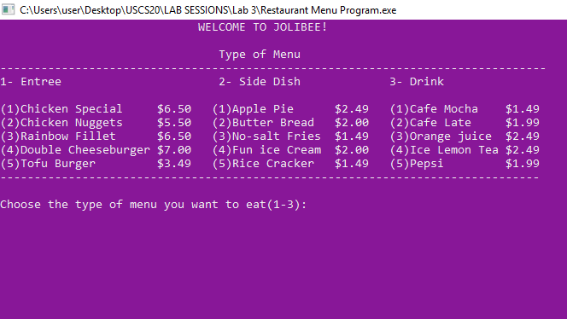

1. Choose the type of menu. Number 1 for Entrée, number 2 for Side Dish, and number 3 for Drink

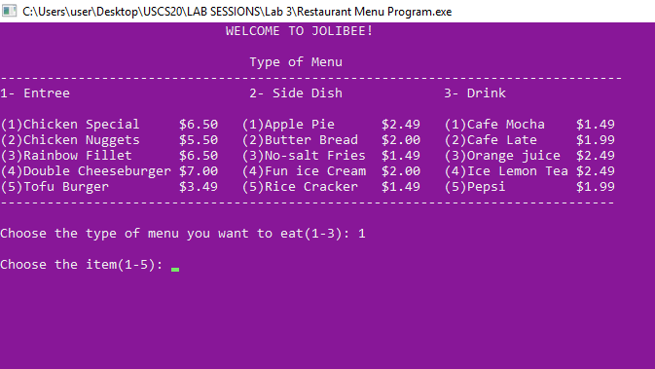

1. Now you’re asked to enter the menu from the type of menu have entered

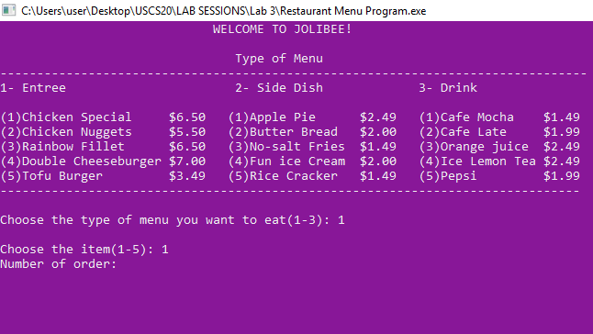

1. Enter the number of order wants

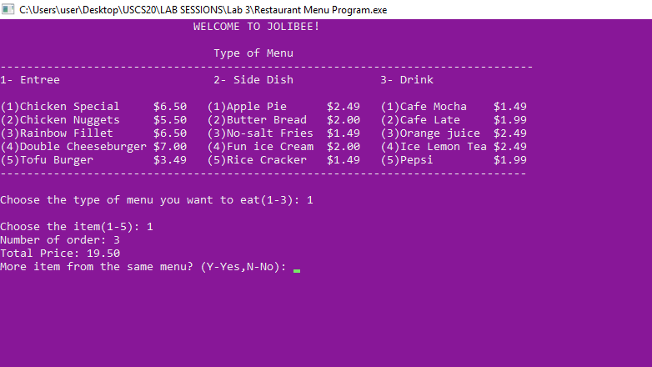

1. Total price will come out. Now you need to enter ‘Y’ if you want to continue in the same type of menu and ‘N’ if not

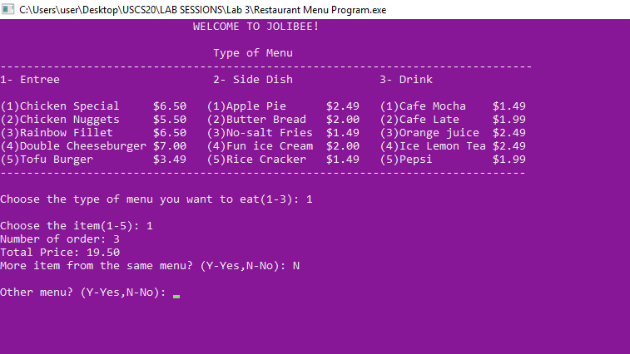

1. If you want to continue with other menu, enter ‘Y’, if you are finished with your order enter ‘N’

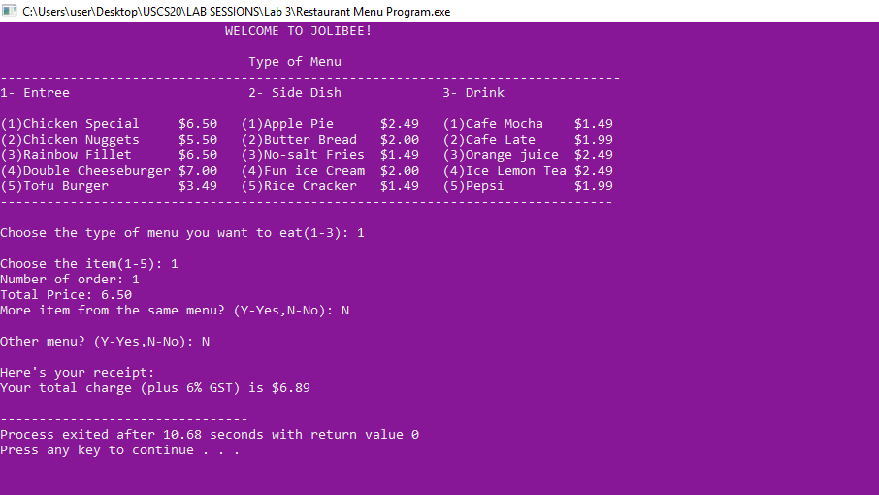

1. Your total charge including 6% gst will printed on the receipt