BUas Research Ethics Review Application Form
v1.1

N.B. The assessment by the BUas Research Ethics Review Board will be conducted in compliance with the Standards for Good Research Practices, from: Netherlands Code of Conduct for Research Integrity (2018). An overview of these standards is included to this form as an appendix, for the applicant’s convenient reference.

A - GENERAL INFORMATION
REVIEW APPLICATION FORM – registration code: | N.B. WILL BE ENTERED BY REVIEW BOARD  REGISTRATION CODE: < Project # (YY/MM + order of receipt)-REV (review application form)-serial# in document sequence-IP (in progress) or CC (case closed) e.g. 2101-01-REV-01-IP>
REQUEST FOR: | (NON-BINDING) ADVICE  <mark bold / underlined if selected> | CRITICAL REVIEW / ASSESSMENT  <mark bold / underlined if selected>
Date of Review Application Submission: | 08 June 2026

B – APPLICATION PACKAGE
List of documents included with the application (i.e. the input for the committee’s advice / assessment) | Proposal_Asmamoghimi.pdf, EDA_Asmamoghimi.ipynb, Asmamoghimi_research_notebook.ipynb, Data Management Plan

C - PERSONAL INFORMATION APPLICANT
Name of applicant (lead researcher): | Moghimi, Asma
e-Mail address: | 240791@buas.nl
BUas Department (Research Group): | Academy for Artificial Intelligence and Data Science (Applied Data Science and AI)
External parties involved (individuals or groups from other universities, organizations): | Netherlands Plant Eco-phenotyping Centre (NPEC) — dataset provider via the Hades in-vitro phenotyping system. No direct collaboration; data was provided to BUas for educational use.
Application approved by professor or research group leader (if applicant does not have this role him-/herself): | Frank Peters, June 2026

D - RESEARCH PROJECT DESCRIPTION
Name of Research Project: | Beyond Random Sampling: Improving U-Net Performance on Noisy Plant Root Images
Projected Project Duration: | April 16, 2026 – June 8, 2026 (8 weeks, Block D Year 2)
Research Project Rationale  (i.e. what is the intended goal, the ‘point’ of the research project? This brief description helps to establish the interpretation frame for the review board) | This study investigates whether patch sampling strategy affects U-Net segmentation performance on plant root images under condensation and background noise. Standard random patch sampling creates severe class imbalance: 85.5% of randomly sampled patches contain zero root pixels, meaning the model trains mostly on uninformative background. The goal is to compare three strategies — random (baseline), weighted, and hard-example sampling — to determine which produces the best segmentation performance, without changing the model architecture. The dataset consists of 492 annotated Arabidopsis thaliana root images collected by the Hades phenotyping system at NPEC.
Brief Overview of Methods  (i.e. what will be done with/to research project participants / respondents / informants): | This research does not involve human participants, respondents, or informants at any stage. The study uses exclusively a pre-existing dataset of greyscale plant root images. Three U-Net models are trained — one per sampling strategy — and evaluated using Dice score, IoU, and statistical hypothesis testing (Wilcoxon signed-rank test, Cohen's d, bootstrap confidence intervals). No data is collected from or about human subjects.

E - ADVICE AND ASSESSMENT ELEMENTS
(Approval by the Research Ethics Review Board is conditional on the accuracy of the information presented below. The overarching assessment framework of values and standards is in compliance with the 2018 Netherlands Code of Conduct for Research Integrity – see appendix for the core standards)

E0 – Preliminary Risk Assessment
(this preliminary check of elements E0.1, E0.2a and E0.2b. matches the questions (1), (2a) and (2b) of the RESEARCH ETHICS SELF-ASSESSMENT FORM. These elements E0.1, E0.2a and E0.2b establish a first risk assessment of the proposed research project, to help classify the application in a LOW, MEDIUM or HIGH risk category. After the Preliminary Risk Assessment, assessment elements E1-E4 below will address the four main research ethics assessment criteria)

E0.1 – Preliminary Risk Assessment: Special Rules Regarding Medical Research
E0.1a - Does your research involve medical scientific research? | ☐ YES ☒ NO | If E0.1a = YES, explain: How?
E0.1b - Does your research involve medicinal products? | ☐ YES ☒ NO | If E0.1b = YES, explain: How?
E0.1c - Does your research involve collecting tissue samples, blood, etc.? | ☐ YES ☒ NO | If E0.1c = YES, explain: How?
E0.1d - Does your research involve situations in which participants are subject to specific procedures or are required to follow rules of behaviour? | ☐ YES ☒ NO | If E0.1d = YES, explain: How?
 | ☐ YES at least once in E0.1 Research proposals subject to the WMO (Dutch Medical Research Involving Human Subjects Act) require assessment by a specially accredited medical ethics review board. If you wish to conduct this kind of research and seek medical ethics approval, please contact the BUas Research Ethics Review Board via <...@...>.
 | ☒ NO on all questions in E0.1 continue with E0.2
E0.2 – Preliminary Risk Assessment: Participants
E0.2a – Participant Consent Capacity
E0.2a1 - Does your research involve individuals lacking capacity or agency to consent, namely children under 12? | ☐ YES ☒ NO |  | If E0.2a1 = YES, explain: How? And: Why?
E0.2a2 - Does your research involve individuals lacking capacity or agency to consent, namely children aged 12-16? | ☐ YES ☒ NO |  | If E0.2a2 = YES, explain: How? And: Why?
E0.2a3 - Does your research involve individuals lacking capacity or agency to consent, namely participants unable to give consent, e.g. in case of mental or legal incapacity? | ☐ YES ☒ NO |  | If E0.2a3 = YES, explain: How? And: Why?
E0.2b – Treatment of Participants
E0.2b1 - Does your research involve situations in which participants might experience physical or psychological stress? Physical stress might include, but is not limited to, pain or discomfort. Psychological stress might include, but is not limited to, interview or survey questions about painful or traumatic experiences. | ☐ YES ☒ NO |  | If E0.2b1 = YES, explain: How? And: Why?
E0.2b2 - Does your research involve the collection of sensitive data which can endanger the participant’s privacy? This might include but is not limited to data about the participant’s religion, political affiliation, criminal history or sex life. | ☐ YES ☒ NO |  | If E0.2b2 = YES, explain: How? And: Why?
E0.2b3 - Does your research involve procedures or situations which might raise doubt in any other way whether proper rules of research conduct are followed? Answer ‘YES’ if any of the following are in doubt: implementation of a secure research protocol detailing who / what / when / where / why; only necessary data is collected in a legal/rightful way; a careful informed consent procedure; proper safeguards against illegitimate access to and/or modification of the data, defined in a secure data management policy. | ☐ YES ☒ NO |  | If E0.2b3 = YES, explain: How? And: Why?
☐ YES at least once in E0.2a,b your research probably requires approval from the BUas Research Ethics Review Board. Please do the following two things:
first, under ‘E0 – Preliminary Risk Assessment - OUTCOME’, indicate which category you believe your research project to belong. N.B. based on the information provided in this review application form, the research ethics review board will also categorize the project; this categorization might be different from yours. In the follow-up process, addressing this assessment and any potential divergent analyses can be part of a constructive, solution-focused dialogue.
second, continue with assessment elements E1-4 below, to add more detailed information for the formal research ethics approval process.
 | ☒ NO on all questions your research probably does not require approval from the BUas Research Ethics Review Board. If you are still in doubt and/or wish to request advice from the BUas Research Ethics Review Board, please contact the board via <...@...>.

E0 – Preliminary Risk Assessment - OUTCOME
Risk Assessment:  (based primarily on the following risk categories, as specified in the Review Application Form: involvement of vulnerable and/or underage participants; presence of privacy safeguards; negative effects of test design on participants, environment and/or property) | LOW  <mark bold / underlined if selected> | MEDIUM  <mark bold / underlined if selected> | HIGH  <mark bold / underlined if selected>

E1 - Informed Consent of Participants
(e.g. does this study involve minors or other vulnerable groups? Are participants instructed properly?)

E1.1 – Will the participants, or (in case of one or more times YES on questions E0.2a1,2,3) their legal parents / guardians / representatives, be informed about the reason for and nature of the research and the manner in which their data is used, in advance and in full? | ☐ YES ☒ NO | If E1.1 = NO, explain: Why not? And: What information will be presented, and at what time during the research? If E1.1 = YES, explain: How?
E1.2 – Will the participants give actively informed / explicit consent to their participation in the research, and the manner in which their data is used? E.g. by signing a clear, truthful and complete consent form, without being placed under duress to comply.  N.B. this applies if participant is over 16 and able to give legal consent. If between 12 and 16: consent by participants PLUS their legal parents / guardians / representatives. If under 12 or unable to give consent due to mental or legal incapacity: consent by their legal parents / guardians / representatives. | ☐ YES ☒ NO | If E1.2 = NO, explain: Why not? If E1.2 = YES, explain: How?
E1.3 – Will it be clear to participants that they can terminate their participation in the research at all times? | ☐ YES ☒ NO | If E1.3 = NO, explain: Why not?
E1.4 – Outside of this research project, are the participants in a subordinate relationship to the researcher? E.g. lecturer vs. students, or manager vs. employees. | ☐ YES ☒ NO | If E1.4 = YES, explain: How?

E2 - Safeguards to Avoid Negative Consequences
(e.g. is there sufficient focus on participant wellbeing, environmental sustainability in methodological design? If there are to be negative consequences, is there a convincing reason for this?)

E2.1 – Will participants be under any risk of harm, damage, danger or stress during the research? Include your answer to question E0.2b1: Does your research involve situations in which participants might experience physical or psychological stress? | ☐ YES ☒ NO | If E2.1 = YES, explain: How? And: also answer E2.4 and E2.5.  If E2.1, E2.2 and E2.3 = NO, mark E2.4 and E2.5 as N/A (not applicable) and continue with E2.6.
 | ☐ YES ☒ NO | If E2.2 = YES, explain: How? And: also answer E2.4 and E2.5.  If E2.1, E2.2 and E2.3 = NO, mark E2.4 and E2.5 as N/A (not applicable) and continue with E2.6.
E.2.3 – Will your research create any risk of harm, damage, danger or stress for the researcher or any member of the research team, of for the reputation or property of Breda University of Applied Sciences? | ☐ YES ☒ NO | If E2.3 = YES, explain: How? And: also answer E2.4 and E2.5.  If E2.1, E2.2 and E2.3 = NO, mark E2.4 and E2.5 as N/A (not applicable) and continue with E2.6.
If E2.1, E2.2 and/or E2.3 = YES:  E2.4 – If there is any risk of harm, damage, danger or stress, is the importance of the research sufficiently great to offset that risk? (proportionality) | ☐ YES ☐ NO  ☒ N/A | If E2.4 = either YES or NO, explain: How and Why?
If E2.1, E2.2 and/or E2.3 = YES:  E2.5 – If there is any risk of harm, damage, danger or stress, can the research design be modified in such a way that said risk is lowered? (subsidiarity) | ☐ YES ☐ NO  ☒ N/A | If E2.5 = either YES or NO, explain: How and Why?
E2.6 – Will participants be rewarded for their participation? | ☐ YES ☒ NO | If E2.6 = YES, explain: How and Why?
E2.7 – Are there any other (potential) benefits to participating in this research for the participants, other than the reward as specified in E2.6? | ☐ YES ☒ NO | If E2.7 = YES, explain: How and Why?

E3 - Integrity in Research Project Management
(e.g. are there conflicts of interest involving participants, researchers and/or financiers?)

E3.1 – Who / what is the source of funding for the research? |  | Explain: This research is an individual student project conducted as part of the Applied Data Science and AI programme at Breda University of Applied Sciences (BUas). Funded entirely by BUas through the standard curriculum. No external funding.
E3.2 – Will the funding organization have any control over the methods, execution and/or reporting of the research? | ☐ YES ☒ NO | If 3.2 = YES, explain: How?
E3.3 – Are there any researchers involved with the research who have connections to any organization or company, in such a way that a conflict of interests (or the impression thereof) might arise? | ☐ YES ☒ NO | If 3.3 = YES, explain: How? And: What will be done to mitigate that risk?

E4 - Privacy and Data Management
(e.g. availability of sound data management plan)

E4.1 – Is there a Data Management Plan? | ☒ YES ☒ NO | If E4.1 = in the explanation box write: A Data Management Plan is included in the application package.
E4.2 – Will it be possible to link any data to specific participants? E.g. will any of the data NOT be anonymous? | ☐ YES ☒ NO | If E4.2 = YES, explain: Why? And: also answer E4.3. If E4.2 = NO, mark E4.3 as N/A (not applicable) and continue with E4.4.
If E4.2 = YES:  E4.3 – Will any personal information (name, address, phone number, etc.) be stored? | ☐ YES ☒ NO  ☐ N/A | If E4.3 = YES, explain: Why?
E4.4 – How will the data be stored? Who will have access to any private and/or non-anonymized data (including but not limited to the raw data)? |  | Explain: All data is stored on the BUas GPU server at /home/y2b/. No data is stored on personal devices or external cloud storage. The original raw dataset is never modified — all preprocessing produces copies only. Model checkpoints are saved on the same server. Access is restricted to the researcher (Asma Moghimi) and BUas supervisory staff. The dataset contains only plant root images with no personal data, so no anonymisation is required. Data is owned by BUas and will not be shared with third parties.

- APPENDIX: Standards for Good Research Practices, from: Netherlands Code of Conduct for Research Integrity (2018).

APPENDIX: Standards for Good Research Practices,
from: Netherlands Code of Conduct for Research Integrity (2018).

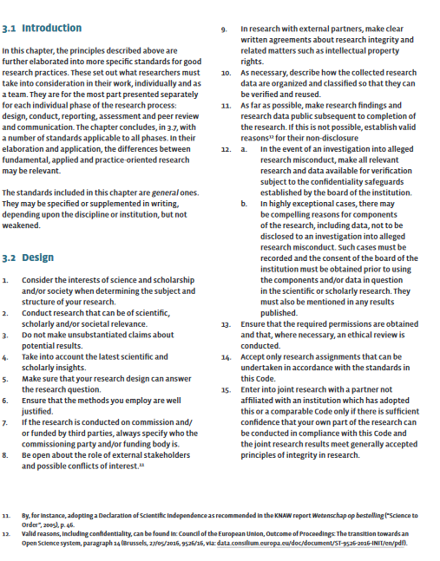

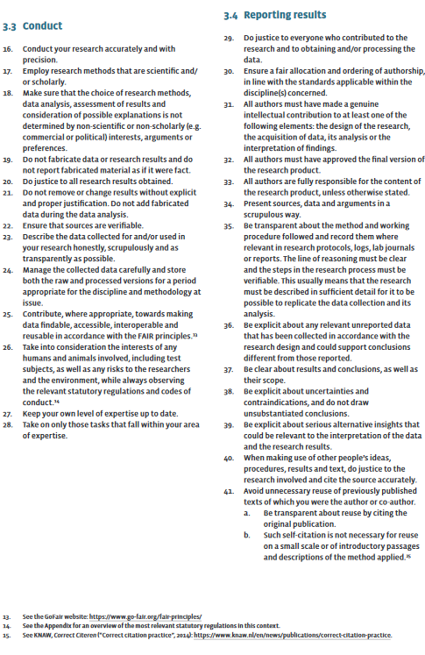

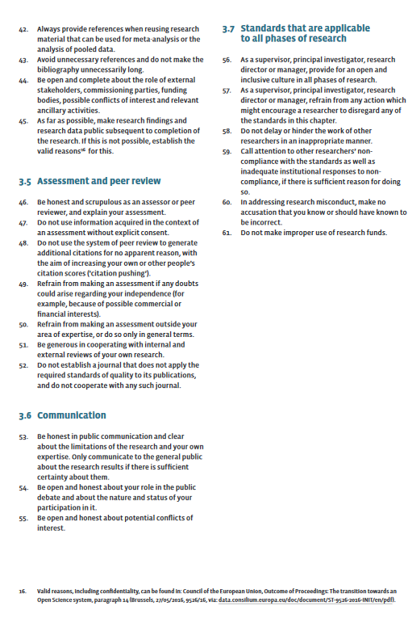

“Medical/scientific research is research which is carried out with the aim of finding answers to a question in the field of illness and health (etiology, pathogenesis, signs/symptoms, diagnosis, prevention, outcome or treatment of illness), by systematically collecting and analysing data. The research is carried out with the intention of contributing to medical knowledge which can also be applied to populations outside of the direct research population.” (from: https://english.ccmo.nl/investigators/legal-framework-for-medical-scientific-research/your-research-is-it-subject-to-the-wmo-or-not)
“In general, research with human subjects is only subject to the WMO if there is an infringement of the physical and/or psychological integrity of the subject. The subject himself/herself must be physically involved in the research for the research to be subject to the WMO. Therefore retrospective research/file research is not subject to the WMO. In that case the data are already available and not collected specifically for a medical-scientific research. The subject does not have to do or abstain from something on behalf of the research. A blood sample being taken from the participant for the purpose of scientific research: this is always subject to the WMO as the participant is subjected to a procedure. If additional blood is taken for the research as part of a planned vene puncture or from an existing line, then the research is also subject to the WMO. Research during which a participant must provide one urine sample once, generally is not subject to the WMO. However, research during which urine samples must be provided over the course of a three-week period does.” (from: https://english.ccmo.nl/investigators/legal-framework-for-medical-scientific-research/your-research-is-it-subject-to-the-wmo-or-not)
For more information on whether your research might be subject to the WMO (the Dutch Medical Research Involving Human Subjects Act), see: https://english.ccmo.nl/investigators/legal-framework-for-medical-scientific-research/your-research-is-it-subject-to-the-wmo-or-not
From 16 years of age, for all mentally and legally competent participants, consent for approved research is only obtained from the participant. For some types of research it may nevertheless be good practice to inform the parents or legal guardian/representatives. IF ANY OF THE CASES AS SPECIFIED ABOVE APPLY, make special note of the consent requirements for when you enter the formal approval process, particularly for ADVICE AND ASSESSMENT ELEMENT E1 - Informed Consent of Participants.
In case of minors under 12 years of age, informed consent is obtained from the parent(s) or legal guardian/ representative(s). It is good practice to also ask the child where possible. N.B. This is all IF the research is deemed appropriate, because in principle, scientific research for this group is severely restricted, and is generally subject to a ‘no, unless’-policy. See also https://english.ccmo.nl/investigators/additional-requirements-for-certain-types-of-research/research-with-subjects-under-the-age-of-16-years
In case of minors between 12 and 16 years of age, informed consent is obtained from both the minor and the parent(s) or legal guardian/representative(s). N.B. This is all IF the research is deemed appropriate, because in principle, scientific research for this group is severely restricted, and is generally subject to a ‘no, unless’-policy. See also https://english.ccmo.nl/investigators/additional-requirements-for-certain-types-of-research/research-with-subjects-under-the-age-of-16-years

