CW1 PDE4430
Hello all, This is the Readme file for CW1 of PDE4430. Simply put in this file you’ll find all that’s needed to launch and test my work as well as simple explanation for the thought process behind it. All tasks are implemented and sourced in launch files for your ease of use. Thanks.
Teleoperation
Starting with Teleoperation all the task needed was to capture the keyboard button pressed and then according to that execute the relative command whether increasing speed using the “+” and “-” keys or rotate and move using the arrow keys. It published the commands to cmd_vel as seen in this RQT graph:

To Launch Teleoperation use roslaunch turtlebotsub Teleop.launch
Auto Goal Navigation
Auto Goal takes the input from the user and moves the bot to that location. It achieves this by first calculating the euclidean distance to the goal and then the required rotation to the goal. It starts by rotating to the desired direction in a closed loop manner where its receiving feedback from the pose topic. Then once it is facing the goal the bot starts moving to the goal also with a feedback from the pose topic as seen in the rqt graph below until the goal is reached.
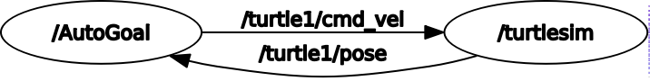
To launch AutoGoal use roslaunch turtlebotsub AutoGoal.launch
Collision Avoidance
collision avoidance is the simplest of all tasks. The node simply receives the location of the bot from the pose topic and decides if the bot is approaching to exceed the boundaries which are set at 0.5 and 10.5 of bot axes then publishes to cmd_vel all zero commands to stop the bot in its tracks.
The node is launched along side Teleop for testing purposes. To launch collision avoidance use roslaunch turtlebotsub collisionavoid.launch
Roomba Mode
The cleaning task or “Roomba Mode” as I call it spawns in 5 bots to clean the screen. The bots receive their path decided by their starting locations then they proceed to execute this path using a similar code to the autogoal task. This task uses helper nodes to move the bots and the master node deciding their paths. The launch file uses a helper node and script to spawn in the bots.

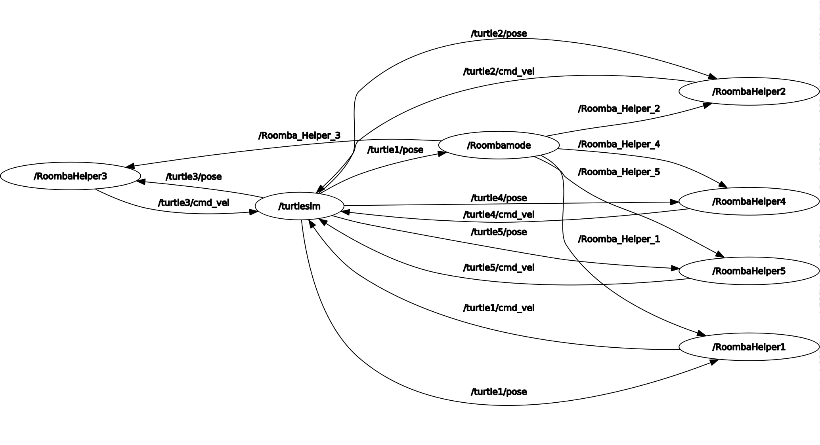
To launch roomba mode use roslaunch turtlebotsub Roomba.launch

Thank you.

