Telecom Customer Churn & Revenue Analysis
Dashboard Interpretation Report
Purpose : to Provide clear understanding of business in sights

1. Data Preparation & Analysis Approach
Data preparation: The customer churn dataset was cleaned using Python before being loaded into Power BI for analysis.
Analysis tool: Microsoft Power BI
Focus areas: Customer churn, customer lifecycle, contract/service behaviour, payment methods, customer value, and revenue at risk.
Important note: Total Charges represents cumulative billed charges available in the dataset. It should not be interpreted as a true month-by-month revenue history unless transaction-level monthly data is available.
The dashboard combines customer counts, churn rates and cumulative charges to identify where customer loss is occurring and where the business may be exposed to revenue risk.

2. Dashboard / Model Structure
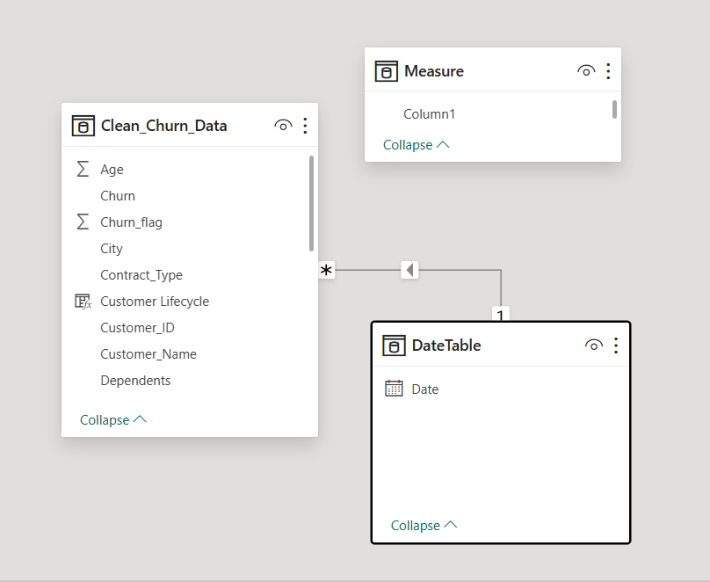
Figure 1. Power BI data model used for the churn and revenue analysis.
The model contains the cleaned customer table, a DateTable for date-based analysis, and a measure table. The customer table contains the main customer, contract, service, lifecycle and churn fields used in the dashboard.

3. Customer Retention / Churn Analysis Dashboard
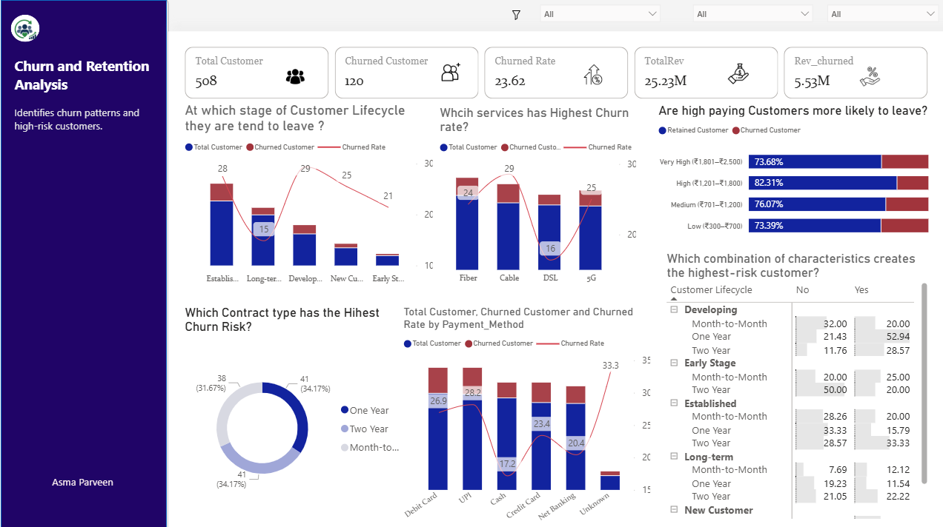
Figure 2. Customer Retention / Churn Analysis dashboard.

3.1 KPI Cards
- Total Customers: 508
- Churned Customers: 120
- Overall Churn Rate: 23.62%
- Total Revenue / Total Charges: approximately ₹25.23M
- Revenue associated with churned customers: approximately ₹5.53M
These KPIs provide the overall health of the customer base. Approximately one in four customers has churned, while the cumulative charges associated with churned customers indicate a meaningful financial impact.

3.2 Customer Churn by Lifecycle Stage
Business question: At which stage of the customer lifecycle do customers tend to leave?
Answer: Developing customers show the highest churn rate at about 29%, followed by Established customers at 28%. New Customers are around 25%, Early Stage customers around 21%, and Long-term customers have the lowest rate at about 15%.
Business insight: The Developing stage is an important retention point. The business should investigate why customers who have already stayed beyond the early period are still leaving.

3.3 Churn Rate by Internet Service
Business question: Which service has the highest churn rate?
Answer: Cable has the highest churn rate at about 29%. 5G follows at about 25%, Fiber at about 24%, and DSL has the lowest rate at about 16%.
Business insight: Cable customers should be examined for service quality, pricing, competition, support experience and other churn drivers. The chart identifies an association, not a causal relationship.

3.4 Churn by Monthly Charge Group
Business question: Are high-paying customers more likely to leave?
Answer: The answer is not simply yes. The approximate churn shares are 26.61% for Low charges, 23.93% for Medium, 17.69% for High, and 26.32% for Very High.
Business insight: Very-high-charge customers do show relatively high churn, but the Low group is slightly higher in this dashboard. Therefore, pricing level alone does not explain churn.

3.5 Contract Type and Churned Customers
Business question: Which contract type has the highest churn risk?
Answer: The visual shows 41 churned customers for One Year and 41 for Month-to-month, compared with 38 for Two Year. Therefore, One Year and Month-to-month are the highest based on churned customer count in this visual.
Business insight: A count of churned customers is different from churn rate. For a stronger risk comparison, contract type should also be evaluated using churn rate because the total number of customers in each contract group may differ.

3.6 Churn by Payment Method
Business question: Which payment method is associated with the highest churn rate?
Answer: The highest displayed churn rate is for the Unknown payment category at about 33.3%. Among known payment methods, UPI is highest at about 28.2%, followed by Debit Card at 26.9%, Credit Card at 23.4%, Net Banking at 20.4%, and Cash at 17.2%.
Business insight: The Unknown category should first be investigated as a data-quality or classification issue. Among identifiable methods, UPI has the highest observed churn rate.

3.7 Customer Profile Matrix
Business question: Which combination of customer characteristics creates the highest-risk customer profile?
Answer: The highest visible combination is Developing + One Year contract + Tech Support = Yes, with a churn rate of about 52.94%. Other high visible combinations include Early Stage + One Year + Tech Support = No at 50%, and several Established/Two Year combinations around 33.33%.
Business insight: Customer risk is better understood through combinations rather than a single variable. The matrix suggests that some Developing and Early Stage contract combinations deserve targeted retention attention. The lower part of the matrix should also be checked because the screenshot does not show every row.

4. Revenue & Customer Value Analysis Dashboard
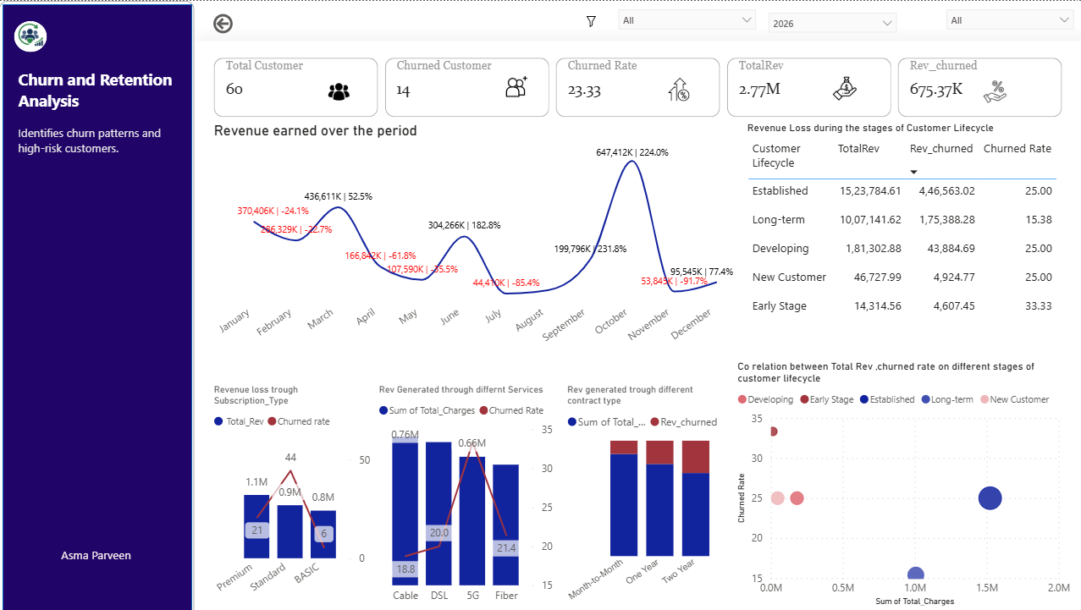
Figure 3. Revenue and customer value analysis dashboard.

4.1 KPI Cards – 2026 Filtered View
- Total Customers: 60
- Churned Customers: 14
- Churn Rate: 23.33%
- Total Revenue / Total Charges: approximately ₹2.77M
- Revenue associated with churned customers: approximately ₹675.37K
For the selected 2026 view, 14 of 60 customers are shown as churned. The churned-customer charges of approximately ₹675K show the financial value associated with those churned customers.

4.2 Revenue Earned Over the Period
Business question: How did revenue change during the selected period?
Answer: Revenue is highly uneven across the months. Major peaks occur in October (about ₹647.4K), March (about ₹436.6K) and January (about ₹370.5K). The lowest visible point is July at about ₹44.4K. The chart also shows strong month-over-month fluctuations, including a 224.0% increase in October and a 91.7% decline in November.
Business insight: Revenue is volatile rather than stable. Large monthly increases and decreases should be investigated further to determine whether they reflect customer additions, billing patterns, seasonality or the structure of the available dataset.

4.3 Revenue Loss by Customer Lifecycle
Business question: Which customer lifecycle stages contribute the most revenue and churned revenue?
Answer: Established customers contribute the largest cumulative charges at approximately ₹1.52M, with about ₹446.6K associated with churned customers and a 25% churn rate. Long-term customers contribute about ₹1.01M with a lower 15.38% churn rate. Developing contributes about ₹181.3K with a 25% churn rate. New Customers contribute about ₹46.7K at 25%, while Early Stage has the highest churn rate at 33.33% but a much smaller revenue base of about ₹14.3K.
Business insight: Established customers are the most important revenue-protection segment because they combine high customer value with meaningful churn. Early Stage customers show higher churn risk but lower cumulative revenue, making them more relevant for early retention programs.

4.4 Revenue by Subscription Type
Business question: Which subscription type generates the most revenue and where is churn highest?
Answer: Premium generates the highest cumulative charges at approximately ₹1.1M, followed by Standard at about ₹0.9M and Basic at about ₹0.8M. Standard has the highest displayed churn rate at about 44%, compared with about 21% for Premium and 6% for Basic.
Business insight: Standard customers are a particularly important segment because they combine substantial revenue with the highest observed churn rate in this visual.

4.5 Revenue Generated Through Different Services
Business question: Which services generate the most revenue and how does churn compare?
Answer: Cable generates the highest visible cumulative charges at approximately ₹0.76M. DSL is also high, while 5G and Fiber contribute smaller cumulative amounts. The churn-rate line indicates that 5G has a relatively high churn rate, at roughly the low-30% range, while Cable is around 19% and Fiber around 21%.
Business insight: Revenue contribution and churn risk are not the same. A service can generate high revenue without having the highest churn rate, so both measures should be considered when prioritising management action.

4.6 Revenue by Contract Type
Business question: How does cumulative customer value differ across contract types?
Answer: The three contract types contribute broadly similar levels of cumulative charges in the selected view, with the One Year contract appearing slightly higher than Month-to-month and Two Year in the visual. The red portions represent charges associated with churned customers.
Business insight: Contract type should be assessed together with churn rate. A segment with moderate revenue but high churn can still create a significant retention opportunity.

4.7 Customer Value vs Churn Rate by Lifecycle
Business question: Which lifecycle segments combine customer value with churn risk?
Answer: Established customers have the largest cumulative value at about ₹1.5M and a churn rate of 25%. Long-term customers contribute about ₹1.0M with the lowest churn rate at 15%. Developing customers have a much smaller cumulative value but the highest visible churn rate at about 33%, while Early Stage and New Customer are around 25%.
Business insight: Established is the clearest high-value revenue-protection segment. Developing is the stronger churn-risk segment. The business can therefore use different strategies: protect high-value Established customers while improving early-stage retention.

5. Overall Business Findings
- Overall churn is 23.62%, meaning churn is a significant customer-retention issue in the analyzed customer base.
- Developing customers have one of the highest lifecycle churn rates, making the 13–24 month period an important retention checkpoint.
- Cable has the highest churn rate among the displayed internet services.
- High charges do not automatically mean higher churn; the Low and Very High charge groups both show relatively high churn shares.
- One Year and Month-to-month contracts account for the highest number of churned customers in the displayed contract visual.
- Among known payment methods, UPI shows the highest observed churn rate; the Unknown category should be reviewed for data quality.
- The customer profile matrix shows that combinations of lifecycle, contract and Tech Support can reveal much higher-risk segments than individual variables alone.
- Established customers represent the largest cumulative customer value and therefore deserve strong revenue-protection attention.
- Standard subscription customers show a particularly high churn rate while contributing substantial cumulative charges, making them an important segment to investigate.
- Revenue varies substantially by month in the selected 2026 view. Because the source dataset is customer-level, monthly movements should be interpreted carefully unless true monthly transaction data is available.

6. Recommended Business Actions
- Create targeted retention campaigns for Developing and other high-risk lifecycle segments.
- Investigate the reasons for high churn among Cable and Standard subscription customers.
- Prioritise high-value Established customers for proactive retention because their churn represents greater revenue exposure.
- Review One Year and Month-to-month customers for pricing, contract, service and customer-experience issues.
- Investigate the Unknown payment-method category and improve data capture or classification.
- Use customer-profile combinations to create targeted rather than one-size-fits-all retention offers.
- Monitor churned revenue in addition to churned customer count so that retention efforts focus on financial impact, not only volume.

7. Final Conclusion
The analysis shows that customer churn is not driven by a single factor. Lifecycle stage, contract type, service, payment method, subscription type and customer value interact to create different levels of risk. The most important business opportunity is to identify high-risk customer segments early while protecting high-value customers from revenue loss. Power BI provides a useful way to monitor these patterns and support targeted retention decisions.

Purpose: to Provide clear understanding of business in sights

