**Sync Clouds-Landing Page**

**Unlock Your Business's Potential with the Best Software Company - Innovation at Your Fingertips (H-1 tag)**

Experience unmatched excellence in digital solutions with the best software company and transform your business with cutting-edge technology. We help global brands to design, develop, and market businesses digitally-provided with 24/7 professional support.

**Book My Call Our Services (CTA)**

**LOGO LOGO LOGO LOGO  (Brand Names)**

**Bespoke IT Services By Sync Clouds (H-2 Tag)**

Make a statement and drive revenue with our trusted IT services to deliver ultimate profitability.

1. **Web App Development (H-3 Tag)**

Secure and scalable website is the need of the hour in this digital era. So, take active steps today to get future-ready solutions with web app development services.

1. **Mobile App Development (H-3 Tag)**

Like a website, a mobile app is crucial to level up your business. Leverage your digital presence with a seamless user experience with our mobile application development services.

1. **UX/UI Design (H-3 Tag)**

Great design can speak to your users in thousands of ways that you can't. Get magnetic UX/UI design followed by a robust UX strategy to grab your user'suser's attention instantly.

1. **Digital Marketing (H-3 Tag)**

Build your online presence and enjoy market expansion at a fraction of the cost. Discover how to boost your revenue with strategic and result-driven digital marketing tidbits!

1. **Clouds (DevOps) (H-3 Tag)**

Leverage the Cloud DevOps solutions to get real-time monitoring and immediate feedback between developers and your operation team to handle complex conducts more smoothly.

1. **Cyber security (H-3 Tag)**

"No technology that's connected to the internet is invulnerable." So secure your personal or professional assets with our cyber security services and kick off the vulnerabilities immediately.

1. **Block Chain (H-3 Tag)**

We offer Blockchain development solutions to help clients grow in areas like Cryptocurrency Marketplace.

1. **AI &ML (H-3 Tag)**

We are a leading provider of AI &ML development services that assist companies in integrating intelligence into their ecosystems.

1. **WEB 3.0 (H-3 Tag)**

Revolutionize the way you interact with the Internet with Web 3.0. and unlock the power of data with the semantic web that understands your needs.

1. **META VERSE (H-3 Tag)**

Unlock infinite experiences with the power of the Metaverse, Connect, create, and experience like never before and reimagine what's possible in a virtual world.

1. **NFTs (H-3 Tag)**

Experience the value of actual digital ownership with NFTs and Experience the value of true digital ownership.

**Boost Your Business Expansion!**

Sync Clouds is committed to providing everyone with complete custom software development services. No matter what, there is always a chance to flourish, stand out, acquire, and rise.

**Future Building Using Software, Innovation, And Technology**

Today's world is dominated by technology, so businesses and people can survive. We have a global clientele because of our unmatched solutions and innovative methods.

**Add Portfolio**

**Filters: All, iOS App Development, Android app development, E-Commerce Development, Custom App Development, Custom UX/UI Design, Penetration Testing, SOC Services, Application Security, Security Consulting, SEO, PPC, Social Media Marketing, Content Marketing, Hire A Developer, Hire A Team. (Slide)**

**FAQs (Dropdown)**

1. **What is a software company?**

A software company develops software products, services, and solutions for businesses, including custom software development, web development, and mobile app development.

1. **How can I find the best software company for my business?**

To find the best software company, evaluate their experience, expertise, development methodology, team members, customer support, and pricing through their portfolio, case studies, references, and reviews.

1. **How is Sync Clouds' best software company for you?**

Sync Cloud is a top-rated software company specializing in custom software development, web development, and mobile app development. Their team of skilled developers and designers follows an agile development process and provides ongoing support and maintenance services to ensure high-quality software solutions.

1. **What kind of software does your Company offer?**

Sync Cloud offers a wide range of software solutions, including but not limited to custom software development, web development, mobile app development, and software consulting services.

1. **How can I get in touch with your Company?**

You can email us or fill out the contact form on our Website. We also have a live chat option on our Website for real-time assistance.

1. **How do you ensure that your software solution meets my business needs?**

We take the time to understand your business needs, goals, and challenges and create a comprehensive plan for your software solution. We at Sync Clouds also provide ongoing maintenance and support services to ensure that your software solution continues to meet your evolving business needs**.**

1. **How do you handle project management and communication?**

We use agile project management methodologies and tools to ensure that our projects are completed on time and within budget. We also provide regular updates and maintain open communication with our clients throughout development.

1. **What is the timeline for developing a software solution?**

The timeline for developing a software solution varies depending on the scope and complexity of the project. Therefore, we work closely with our clients to create a timeline that meets their specific requirements and deadlines.

**Team Up With Sync Clouds For (H-2 Tag)**

**100% Customer Satisfaction (Add icon) / (H-3 tag)**

We treat our valued clients withunlimited support and care with full-time availability.

**3X Guaranteed Results (Add icon) / (H-3 tag)**

Wecustomize our strategies to optimize results according to updated algorithms.

**Diligent Team Work (Add icon) / (H-3 tag)**

We highly believe in; "Teamwork makes the dream work." Let'sSo let's do it together.

**24/7 Availability (Add icon) / (H-3 tag)**

Our team will be there at your doorstep.

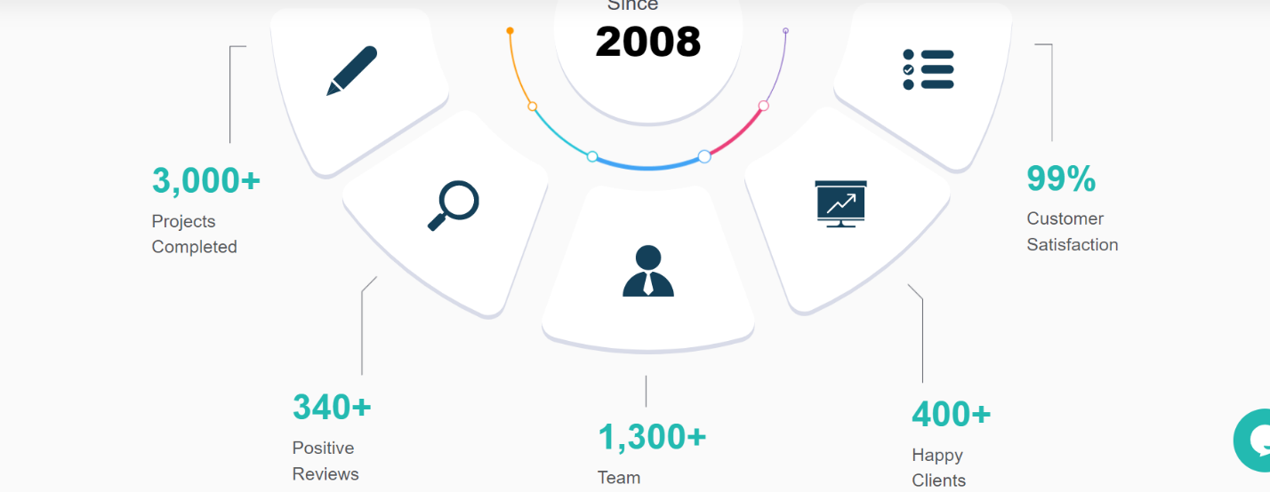

**What People Like You Are Saying About Us**

1 video testimonial

3 written testimonials.

**Black CTA BOX – E-mail Opt-in Form**

**Be Equipped With Sync Clouds Updates for Accomplishment**

**Email:_________ Subscribe**

**Footer**

**Sync Clouds**

Sync Clouds transform your digital landscape by providing comprehensive software solutions tailored to your brand.

**About Us- Page (H-1 Tag)**

Syncclouds is an industry-leading Digital Transformation and Engineering Firm offering end-to-end software development solutions to Enterprises, Digital Agencies, and Startups worldwide. Sync clouds bring together a team of brilliant minds to support you in realizing your ambitions and delivering a superior digital experience.

**Get In Touch (CTA)**

**EXPAND YOUR DIGITAL HORIZONS WITH SYNC CLOUDS (H-2 Tag)**

For our clients, the services we provide can increase productivity and speed up growth. We have vowed to raise the bar for our client’s performance continually.

**Mission: (Add Icon)/ (H-3 Tag)**

Our mission is to develop innovative services that solve complex problems, enhance productivity, and improve people's lives.

**Vision: (Add Icon)/ (H-3 Tag)**

Our vision is to empower people and businesses worldwide with transformative services that enable them to achieve their full potential.

**Goal: (Add Icon)/ (H-3 Tag)**

Empowering the Future with Cutting-Edge Services: Our Goal to Simplify Complexity and Fuel Progress

**Value: (Add Icon)/ (H-3 Tag)**

We value innovation and quality. We're dedicated to services that are efficient, reliable, and user-friendly.

**Transforming Ideas Into Reality Through Our Innovative Services (H-2 Tag)**

**You Think. We Build. (H-3 Tag**

We create cutting-edge services and implement data-driven marketing campaigns that drive customer engagement, enhance brand awareness, and deliver measurable results that help our clients achieve their business goals.

**Let’s Get Started**

**Together, Our Team Brings a Diverse Range Of Services To Our Clients.**

* **Web App Development (Dropdown)**

We use state-of-the-art technologies and development practices to create custom web applications for your business.

* **Mobile App Development (Dropdown)**

We develop mobile apps that help businesses for better operational efficiency and engagement.

* **UX/UI Design (Dropdown)**

Simple design is a complex process. We simplify it by focusing on Challenges and Solutions and building functional user interfaces.

* **Cybersecurity (Dropdown)**

We offer Cybersecurity services that defend your computers, mobile device, and data from malicious attacks.

* **Digital Marketing (Dropdown)**

The finest marketing isn't even noticeable as marketing. We boost your sales and develop the voice of your business with our innovative ideas.

**Give Your Dreams a Digital Reality with our Passionate Team**

Image Image Image Image

**Sync Clouds Blueprint for Software Success (H-2 Tag)**

Our 3-step process ensures that every task is completed efficiently, accurately, and with attention to detail.

**Step 1: Analysis (H-3 Tag)**

By investing time upfront, we can ensure that our work is aligned with your expectations and goals and save time and resources.

* Gather all necessary information
* Review project requirements
* Identifying potential challenges, risks, and constraints
* Develop a mitigation plan.

**Step 2: Execution (H-3 Tag)**

Our team of skilled professionals works collaboratively to ensure that each job is completed efficiently and accurately and that any issues are resolved promptly.

* Industry-standard tools & techniques
* Ensure project consistency
* Open communication with clients
* Regular updates & feedback

**Step 3: Quality Assurance (H-3 Tag)**

Finally, we subject our work to rigorous quality assurance checks to ensure that it meets the highest standards of quality and accuracy.

* Reviewing work for errors & inconsistencies
* Testing under different scenarios & conditions
* Review and approval.

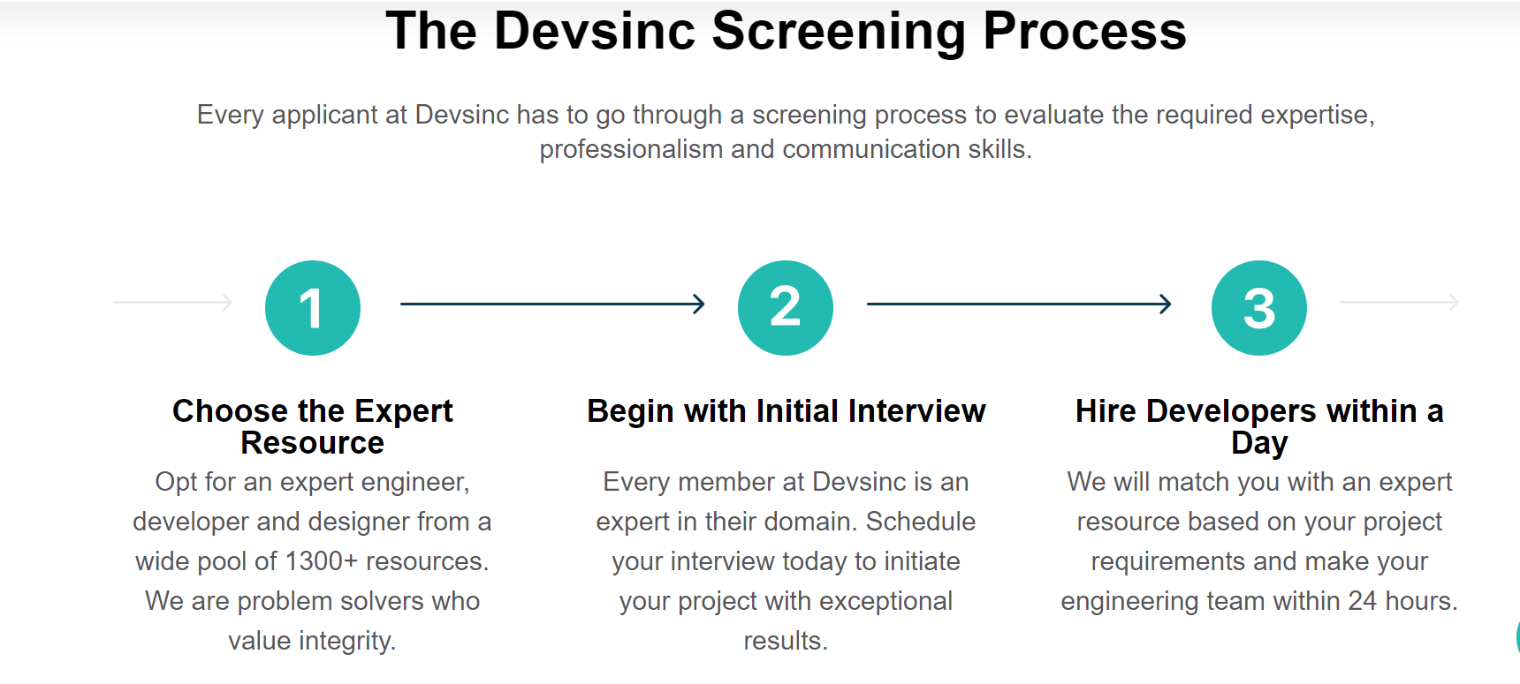

**Black CTA BOX**

**Get Synced Up With Sync Clouds**

We assist you in leading the new world by providing a comprehensive range of effective tech services. Step on it fast!

**Email: ______________ Subscribe**

**Our Services-Page**

**Elevate Your Business with Premium Software Services - Unleash Your Efficiency and Productivity (H-1 Tag)**

At Sync Clouds, we transform your business with high-end software solutions that simplify complex processes and enhance efficiency. With our expert guidance and support, you can harness the full potential of software solutions to achieve your business goals and stay ahead of the competition.

**Let's Discuss (CTA)**

**Our Experts Craft Custom Software Solutions** **(H-2 Tag)**

Skyrocket your sales by providing 24/7 access to your business with our best-in-class services for everyone.

**#01 Web App Development Services (H-3 tag)**

* Custom Web App Development
* Angular JS Web App Development
* React JS Web App Development
* Node JS Web App Development
* Laravel Web App Development
* Django Python Web App Development
* Mean Stack Web App Development
* Mern Stack Web App Development

**#02 Mobile App Development Services (H-3 tag)**

* Custom Mobile App Development
* Native Mobile App Development
* Hybrid Mobile App Development
* Cross-Platform Mobile App Development
* Android Mobile App Development
* iOS Mobile App Development
* IOT-App Development
* Wearable's App Development

**#3 User Experience & Design (H-3 tag)**

* Web App UX/UI Design
* Mobile App UX/UI Design
* SaaS UX/UI Design
* Product UX/UI Design
* 2D & 3D Designs & Animations
* Multimedia solutions

**#04 Cyber Security Services (H-3 tag)**

* Penetration Testing
* Security Operation Center (SOC) services
* Application Security
* Security & Consulting Services

**#05 Digital Marketing Services (H-3 tag)**

* Social media marketing
* Pay-per-Click (PPC)
* Search Engine Optimization (SEO)
* Email marketing
* Content writing
* Affiliate marketing

**Expert Ideation At Positions**

     9999+ 350+ 250+ 150+

Advance Process   Custom Software Solutions    Success Stories Amplified Businesses

**Why Choose Sync Clouds (H-2 Tag)**

**100+ Industry Experts** **(Add icon) / (H-3 tag)**

**Supportive Staff Augmentation (Add icon) / (H-3 tag)**

**5X Cost-Effective Solutions (Add icon) / (H-3 tag)**

**Best Offers & Discounts (Add icon) / (H-3 tag)**

**Get The Perfect Combination of Passionate Engineers, Top-Notch Skills, And Brilliant Project Ideas.**

**Contact Us (CTA)**

**Tools & Technologies Our Software Developers Use (H-2 Tag)**

With extensive knowledge in every field required for dependable software development, Sync Cloudss has developed into a competitor on a global scale in the field of software engineering.

**LANGUAGES (H-3 Tag)/ (Add Icon)**

Java, C#, C/C++, Objective C, Python, Groovy, Swift, Kotlin, PHP, Rust, Scala

**FRAMEWORKS (H-3 Tag)/ (Add Icon)**

JDBC / JPA, JMS, Hibernate, .NET, EJB, Apache Camel, Nodejs, Firebase LDAP / Active Directory, Reactive (Akka, RxJava, Reactor)

**MOBILE (H-3 Tag)/ (Add Icon)**

iOS, Android, HTML5, React, Xamarin, JavaScript

**WEB (H-3 Tag)/ (Add Icon)**

Vue, Sass, Coffee, Angular, WebGL

**DATABASE MANAGEMENT (H-3 Tag)/ (Add Icon)**

NoSQL, MySQL, Oracle SQL, PostgreSQL, Microsoft SQL

**CLOUD (H-3 Tag)/ (Add Icon)**

Amazon Web Services (AWS), Google Cloud Oracle, Cloud IBM Cloud, Microsoft Azure

**Building Your Vision, One Step at a Time**

Our 8-step development process brings your software vision to life, ensuring every step is thoughtfully crafted and executed.

**Planning (Dropdown)**

This step involves defining project goals and objectives, analyzing requirements, and creating a roadmap to guide development.

**Requirements (Dropdown)**

The team collects and documents all necessary information about the project's features, functionalities, and user experience in this step.

**Design (Dropdown)**

Here, the team visually represents the software, including wireframes, mockups, and prototypes.

**Development (Dropdown)**

This step involves writing code and developing software applications based on the design specifications.

**Testing (Dropdown)**

The software is thoroughly tested to ensure it is free of bugs, errors, and glitches.

**Deployment (Dropdown)**

In this step, the software is released into production and made available to users.

**Maintenance (Dropdown)**

After deployment, the team provides ongoing support and maintenance to ensure that the software functions properly and meets the user's needs.

**Updates and Improvements (Dropdown)**

Finally, the software is updated and improved to add new features, functionalities, and enhancements based on user feedback and evolving business needs.

**Our Clients**

**Brand Brand Brand Brand Brand**

**E-mail opt-in form**

**Contact Me**

Name

E-mail

Mobile Number:

Company:

Budget:

How we can help you? (File Attachment)

**What Comes Next?**

* Following an evaluation of your business requirements, our sales manager contacts you quickly.
* In the interim, we affix an NDA to ensure the highest level of privacy.
* Our pre-sale manager provides project budgets and a rough schedule

**Entire Catalog of Services (H-2 Tag)**

Our service offerings include system integration, complete lifecycle management of custom products, apps, and services, and strategic IT and technology consulting.

**Services (H-3 Tag)**

Sync Cloudss is equipped with the tools, technology, and domain knowledge necessary to produce various professional software development services. We assist our clients in creating and capturing value and enhancing company outcomes by eliminating the operational inefficiencies that impede growth.

**Technologies (H-3 Tag)**

We create adaptable, scalable software development solutions for our clients to help them become more creative and practical, which speeds up the description process.

**Solutions (H-3 Tag)**

We are a software development services company offering a comprehensive range of engineering services to Fortune 1000 firms and international organizations, whether a consumer-focused app or a revolutionary enterprise-class solution.

**Platforms (H-3 Tag)**

Are you prepared to prevent dangers, quicken transformation, and ignite revenue growth? Put, go digital. We utilize the most recent tools, technologies, and platforms to accelerate our transformation initiatives and enhance your business outcomes.

**Team Expansion (H-3 Tag)**

Our culture values finding software developers with the appropriate knowledge and intense levels of commitment quickly. Team extension is an improved, contemporary iteration of the committed team strategy.

**FAQs: (Dropdown)**

1. **What is Sync Clouds?**

Sync Clouds is a software development company that provides end-to-end services, including mobile app development, web development, enterprise software development, and IT consulting.

1. **What services does** **Sync Clouds provide?**

Sync Clouds provides various services, including software development, mobile app development, web development, enterprise software development, blockchain development, AI development, IoT development, cloud consulting, and more.

1. **What platforms does Sync Clouds develop for?**

Sync Clouds develops for various platforms, including iOS, Android, web, and desktop.

1. **What is Sync Clouds’ approach to software development?**

Sync Clouds follows an agile development methodology, which involves iterative and incremental development focusing on collaboration, flexibility, and customer satisfaction.

1. **How does Sync Clouds ensure quality in its software development process?**

Sync Clouds’ dedicated Quality Assurance team ensures the software meets the highest standards. The unit uses various testing methods, including manual, automated, and continuous integration and delivery.

1. **How does Sync Clouds ensure data security and privacy?**

Sync Clouds follows industry-standard security protocols and best practices to ensure the security and privacy of its client's data. This includes using encryption, access controls, and regular security audits.

1. **What is Sync Clouds’ approach to project management?**

Sync Clouds uses a project management approach that involves regular communication with clients, transparent reporting, and a focus on meeting project timelines and budgets.

1. **What is Sync Clouds’ experience with blockchain development?**

Sync Clouds has extensive experience in blockchain development and has built various blockchain-based solutions for clients in multiple industries.

**Reference:** <https://www.intellectsoft.net/services>

**Detailed Services**

**Page#01**

**Crafting Bespoke Web Apps to Redefine Your Online Success. (H-1 tag)**

Web app development Service Company is dedicated to delivering excellent web solutions for startups to entrepreneurs worldwide.

**Book My Discovery Call (CTA)**

**Sync Clouds Transformational Web App Development Services (H-2 Tag)**

Leverage the perk of creativity to a profit-generating website for ultimate conversions with all-hands-on-deck collaboration at Sync Clouds. We create distinctive and secure custom web apps that fulfill our valuable customers' expectations regarding scalability and interoperability across all devices.

**Offering Next-Level Web App Services For Various Platforms (H-2 TAG)**

Along with our expert team of web developers, Sync Cloud is providing versatile web development services to help you to fill the gap between end-user and advanced marketing approaches.

Choose your **Inclusive Platform** that fits your business model, and let us do the rest.

**WordPress Development Services (H-3 Tag)**

Sync Cloud offers traditional WordPress development for extended functionality. You can easily leverage the third-party plug-ins & themes and hand-pick customization options.

**Custom CMS Development Services (H-3 Tag)**

Get high-end content management system development from Sync Clouds for absolute high-level data security and a flexible, functional approach.

**BMS Development Services (H-3 Tag)**

Go for productive Building Management Systems with Sync Clouds, as We offer an outstanding development approach and expert supervision for larger corporations only.

**CRM Development Services (H-4 Tag)**

Customer**s**are gold for every business**.**So let us enhance your productivity, followed by absolute automation with our classic customer-relationships management deployment services.

**ERP Development Services (H-4 Tag)**

Wemake stellar Enterprise Resource Planning apps for maximum scalability and flexibility. Our promising apps will assure efficient management performance throughout your business journey.

**Single-Page App Development Services (H-3 tag)**

We at Sync Clouds offer spectacular Single-Page App development for the fast yet responsive digital solution that will only help to rank for SEO but also aids smooth processing across all devices.

**Want To Find the Best Web App Development Approach?**

**Let's Discuss (CTA)**

**Our Proficiency With Different Web App Development Technologies (H-2 Tag)**

Either desktop or laptop, let your users enjoy the seamless, highly responsive, yet HTML-optimized web app on multiple browsers. Our experts are trained with advanced technologies to deliver majestic web solutions for optimal conversions-5x more than your competitor!

**Angular JS Web App Development (H-3 Tag)**

Our web app developers can use a structural framework of Angular JS for high-end dynamic web apps.

**React JS Web App Development (H-3 Tag)**

React JS is one of the conventional technologies used by our developers to optimize the output for different business models.

**Node JS Web App Development (H-3 Tag)**

With the Angular JS web app, we can maximize the uptime and scalability of your innovative web applications.

**Laravel Web App Development (H-3 Tag)**

Our developers prefer the Laravel framework to express beautiful syntax with effective authorization systems, mainly for Enterprises.

**Django Python Web App Development (H-3 Tag)**

We use the Django Python web framework for a pragmatic development approach. It gives the privilege of fast, secure & efficient web applications.

**Mean Stack App Development (H-3 Tag)**

We create a dynamic yet custom web app using the bundle of JavaScript-based technologies-Mean Stack.

**Mern Stack App Development (H-3 Tag)**

Our experts use Mern Stack-JavaScript-based coding to operate the front, backend, and database as per your requirements.

**Robust Web App Solutions For All Businesses (H-2 Tag)**

We have extensive experience delivering engaging web solutions for a diverse clientele across various industries, from startups to large corporations.

**Fin-tech (Add Icons)**

Get the most out of fin-tech web applications as we ensure streamlined financial operations for better risk management.

[**Healthcare**](https://www.scnsoft.com/healthcare/services)**(Add Icons)**

We provide patient-centric web solutions for timely care, quick payments, and digital access to healthcare.

**Construction &**[**Manufacturing**](https://www.scnsoft.com/manufacturing)**(Add Icons)**

Strengthen your work order & management systems with construction & manufacturing web app solutions.

[**Professional Services**](https://www.scnsoft.com/professional-services)**(Add Icons)**

Boost your branding with our customized web application services to nurture your community and get maximum leads.

[**Insurance**](https://www.scnsoft.com/insurance)**(Add Icons)**

Enjoy simplicity, online support, notification, and convenience with our multiple-page web app services to enhance profitability.

**Retail & E-commerce (Add Icons)**

Hit the mark with our innovative web application that runs smoothly across all devices, ensuring a fast buying process and sustainable customer support.

[**Transportation & Logistics**](https://www.scnsoft.com/transportation-and-logistics)**(Add Icons)**

Beat the delivery time and cost by route optimization and monitoring performance with transportation web applications.

[**Telecommunications**](https://www.scnsoft.com/telecommunications)**(Add Icons)**

Telecommunication web apps improve user experience and enhance the productivity of the overall process.

**HOW DO WE MAKE FLAWLESS WEB APPS? (H-3 tag) / (Dropdown)**

* **Analysis**: Understands your idea to achieve your business goals smartly.
* **Planning & Designing**: Research and develop effective KPIs to check your success rate over time.
* **Sitemaps & Wireframing:** Creating sitemaps, wireframing, logos, and layouts for your Website.
* **Optimized Content:**Writing stellar web copies to get maximum conversions.
* **Bug-free Coding:** Crucial factor for optimizing your Website for search engines and social media sites.
* **Pre-launch Testing**: Pre-launch code testing for a smoother user experience.
* **Timely Delivery:** Make your Website live to get a full-bloom market approach.
* **Support & Maintenance:** Tracking, maintaining, and updating your Website with 24/7 support.

**FAQs (Dropdown)**

1. **What is a web app, and how does it differ from a website?**

A web app is a software application that is accessed through a web browser, while a website is primarily designed for informational purposes. Also, web apps typically have more complex functionalities and interactive features.

1. **How do you ensure the security of the web app?**

Sync Clouds use the latest security protocols and tools to ensure your web app is secure and protected against cyber threats. We also conduct regular security audits and provide ongoing maintenance and support services to secure your web app.

1. **How do you ensure the web app is responsive and works across different devices?**

Sync Clouds use responsive design techniques and conduct thorough testing. Our experts go through an in-depth trial on multiple platforms to ensure our app is fully functional and adaptable for all devices.

1. **How can I contact your team to discuss my web app development needs?**We offer various contact options on our Website, including email and a contact form. Our team is always ready to answer your questions and discuss your web app development project.
2. **What is the process for getting a quote for web app development services?**

We offer a free consultation to discuss your project requirements and provide an estimate for the cost and timeline of the project. You can also request a quote directly on our Website.

1. **What kind of consultation services do you offer for web app development?**

We offer comprehensive consulting services to help you define your web app development requirements and goals. Our team of experts can guide technical requirements, design considerations, and more.

1. **How do you ensure that your pricing is competitive and transparent?**

We provide transparent pricing and work closely with our clients to ensure our services are competitively priced. We also provide detailed breakdowns of costs and work with our clients to create a budget and payment plan that works for them.

1. **What kind of support do you offer after completing the web app development project?**

At Sync Clouds, we offer ongoing support and maintenance services to ensure that your web app performs optimally and meets your evolving business needs. In addition, our team of experts is available to provide assistance and resolve any issues that may arise.

**Testimonials**

**Black CTA BOX / E-mail Opt-in Form**

**You're just 2 minutes away from a no-strings quote**

**Name:**

**Phone:**

**Email:**

**Service Required:**

**Budget**

**Message/ Attachment**

**GET A QUOTE (CTA)**

**Page#02**

**Leverage Best Mobile Apps Development Services (H-1 tag)**

Revolutionize Your Digital Presence with Custom Mobile Apps Tailored to Your Needs. **(H-2 tag)**

**Let's Discuss My Project (CTA)**

**Get Permanent Customers With Compelling Mobile Apps (H-2 tag)**

We're a diverse group of individuals who believe in the power of incredible design to impact your business. We create engaging experiences that excite people about what you do—from attention-grabbing iPhone Apps to beautiful Android apps that people can't wait to explore.

**Custom Mobile App Development Services For All (H-2 tag)**

Our team ensures you deliver the solutions that satisfy the end-user needs and provide you with a never-ending growth expansion with a single yet mini bundle solution- the mobile app!

We are offering mobile apps that are highly functional among all smart gadgets.

* **Custom Mobile App Development (H-3 tag)**

We can build a custom mobile app to get real-time insight into your consumer data and achieve high scalability metrics in one go.

* **Progressive Mobile App Development (H-3 tag)**

Progressive mobile app solutions are best for businesses with high user engagement rates. Our developers can deliver top-notch progressive apps for smooth yet faster conversions.

* **Hybrid Mobile App Development (H-3 tag)**

Get the blend of web and native app technologies with a single codebase to build a Cross-platform or hybrid mobile app and maximize your targeted audience by 40%.

* **Native Mobile App Development (H-3 tag)**

Whether Android or iOS, our developers can build compelling native apps exclusively targeting a single platform compatible with advanced customization options.

* **Wearables & Embedded Software (H-3 tag)**

Upgrade your web progress with companion apps across several wearable devices that can integrate with all smart devices.

**Ready to Choose the Right Mobile App Development Approach For Your Business?**

**Let's Find Out! (CTA)**

**Elite Mobile App Services For Various Industries (H-2 tag)**

Finance, Medical Care, Construction & [Manufacturing](https://www.scnsoft.com/manufacturing), [Insurance](https://www.scnsoft.com/insurance), M-commerce & E-commerce, [Transportation and Logistics](https://www.scnsoft.com/transportation-and-logistics), [Telecommunications](https://www.scnsoft.com/telecommunications) **(Add Icons)**

**Advanced Frameworks For Mobile App Development (H-2 tag)**

At Sync Clouds, we have**ONLY EXPERT MOBILE APP DEVELOPERS** who consistently push their limits to bring innovation, advancement, and compliance to your app to beat your competition in the best way possible.

**Cross-Platform App Development (H-3 tag)**

If you are looking for an all-in-one app that exclusively functions on all platforms, then this cross-platform or hybrid app is your go-to alternative for a fast yet cost-effective solution.

**(Add Logos)**

Flutter, React Native, Kotlin Multiplatform**,**JavaScript, TypeScript.

**Native App Development (H-3 tag)**

Let us build native apps for fast and secure tracking and reach your business goals with instant updates from these win-win technologies;

**(Add Logos)**

 Java, Kotlin, Python, Swift, Objective-C, C++, and React

**Android App Development (H-3 tag)**

Smartphones are the most common yet effective way to reach gazillions of people. Get your top-notch Android- apps made with these latest technologies;

**(Add Logos)**

Java, Kotlin, Gradle,

**iOS App Development (H-3 tag)**

Our developers can make iOS apps that are fully functional across all iOS devices because of their stunning user interface & user support with highly-secure data protection features aligned with;

**(Add Logos)**

Swift UI, Swift

**Our Process For Flawless Mobile Apps (H-3 Tag) / (Dropdown)**

* **Discover:**

We ensure we fully understand our Client's business needs and brainstorm your concept with our ideas and hypothesis to get results correctly.

* **Define:**

We prefer to share your ideas in the SRD document, and let us set milestones to align with your concepts. Need to know how it works? No worries. We'll guide you step-by-step.

* **Design**:

Prototyping, wireframing, and UX/UI design are discussed with the Client so that your app complements your business aesthetics.

* **Develop**:

We use the right technology for your app development to code, debug, and perform API testing to ensure its error-free functionality.

* **Delivery:**

In this phase, your app is live, and we ensure it integrates with all devices and closely monitors environment deployment.

* **Maintenance & Support**:

We make sure to get regular checks on post-deployment reviews and provide post-delivery lifetime support.

**FAQs (Dropdown)**

1. **What kind of platforms do you develop mobile apps for?**

We develop mobile apps for various platforms, including iOS, Android, and hybrid platforms such as React Native and Flutter, and many more.

1. **Can you help me with publishing the mobile app to app stores?**

We can help publish the mobile app to app stores, including Apple App Store and Google Play Store. In addition, we ensure that the mobile app meets all the guidelines and requirements for submission**.**

1. **How do you ensure the security of the mobile app and user data?**

Our developers follow strict security protocols and guidelines to ensure the mobile app's and user data's security. We also use encryption techniques and conduct regular security audits to identify and address vulnerabilities.

1. **Do Sync Clouds provide post-launch marketing and promotion services for the mobile app?**

Yes, we can help with the mobile app's post-launch marketing and promotion services. We work closely with our clients to create and execute a marketing plan to reach the target audience.

1. **What is the process for testing the mobile app?**

We conduct thorough mobile app testing throughout the development process, including functional testing, usability testing, and performance testing. We also conduct beta testing to get feedback from real users before launching the mobile app.

1. **Can you provide maintenance and updates for the mobile app after launch?**

Yes, we provide ongoing maintenance and updates for the mobile app to ensure that it performs optimally and meets evolving business needs.

1. **How do you ensure the mobile app is user-friendly and easy to use?**

We follow user-centered design principles and conduct user testing to ensure that the mobile app is intuitive, easy to use, and meets the target audience's needs. We also guide best practices for mobile app design and user experience.

**Apps We Have Developed (**Testimonials)

1Video, 2written

**Black CTA BOX – E-mail Opt-in Form**

**You're just 2 minutes away from a no-strings quote**

**Name:**

**Phone:**

**Email:**

**Service Required:**

**Budget:**

**Message:**

**GET A QUOTE (CTA)**

**Page#03**

**Get Creative With Our Innovative UI/UX Services**.**(H-1 Tag)**

Unleash Your Business Potential With Our Expert Creative Services And UX/UI Design Solutions.

**Let's Discuss Your Design (CTA)**

**Choose Sync Clouds UX/ UI Team (H-2 Tag)**

With 9999 designs to choose from, there's a theme that's perfect for your business. So whether you're looking for clean and cutting-edge or fun and colorful, you can find it here.

3X                                      40%                    30%

Efficient designers Unique User Ratio Reduced Bounce Rate.

**(Add Icon) (Add Icon) (Add Icon)**

**Innovative UX/UI Design Services For Business (H-2 Tag)**

Our mission is to help your customers find what they want in the fastest, most enjoyable way possible with our legitimate services. We provide clean, minimalist designs that capture the user's attention in a blink without sacrificing the classic details that make it special.

**Web App UX/UI Design (H-3 Tag)**

Web app design is as important as its high-end development. If you want a long-term reliable relationship with your consumers, you must have a highly-responsive yet eye-catchy design to improve the retention time on your Website.

We offer web app UX/ UI design services to lock your clients permanently.

**(Add Icons)**

* Landing page designs
* Web app designs
* BMS website design
* CMS website design
* Frontend development

**Mobile App UX/UI Design (H-3 Tag)**

About 75% of businesses get more engagement via mobile applications. Having a design that offers a smoother interface to interact with your users is crucial. Ensure you provide a clean yet classic design to grab your user's attention.

Build a unique magnetic mobile design with our team of experts that know how to present your services in the best way possible.

**(Add Icons)**

* Native app designs
* Hybrid app designs
* Custom app design
* Android mobile app design
* iOS mobile app design

**SaaS UX/UI Design (H-3 Tag)**

Developing software can be challenging but selling your software as a service is way harder than you think! For this purpose, captivating SaaS UX/UI design is a great way to capture your audience's attention and show its purpose effectively.

Our graphic experts are proficient in making SaaS designs that can help you to get more converting clients with two clicks only!

**(Add Icons)**

* Custom software designs
* Digital product designs

**Product UX/UI Design (H-3 Tag)**

With booming competition in the E-commerce industry, keeping your business secure and stable is getting harder. But with the right UX/UI design, you can sell your products most innovatively.

Get your quote now to kick-start your business with our clean yet captive designs made by expert product designers.

**(Add Icons)**

* Custom product designs
* B2B product designs
* B2C product designs

**2D & 3D Designs & Animations (H-3 Tag)**

Animation is getting real and real. Consumers like to engage with content that is fictionally real. So why not leverage this opportunity to make your business a win-win go? You can use animated images or videos for an ever-lasting impact on your audience.

We offer interesting yet cost-effective 2D & 3D Designs & Animation services for all startups and enterprises.

**(Add Icons)**

* 2D animation designs
* 3D animation designs

**Multimedia Solutions (H-3 Tag)**

Sync Clouds is all about making your business a delightful experience in the best possible way. That is why we offer several other multimedia solutions to make your daily business chores a breeze.

**(Add Icons)**

* Professional presentation designs
* Custom E-newsletter designs
* Banner designs
* Designs for Brand Identity, such as logos.

**Serving UX/UI Design Services To Several Industries (H-2 Tag)**

The human eye can process an image 60,000 times faster than it can process text. With a strong visual presence in your online marketing, you'll have more opportunities to attract your ideal customer.

B2B, B2C, Logistics, Ride-Hailing, Education, Travel, Retail, Accounting, Digital portals, Chats, Startups, Enterprises, Corporates, Health Tech, Socials, Marketplaces, Fin-Tech **(Add Icons)**

**READY TO REDESIGN YOUR BUSINESS**

**Let’s Discuss (CTA)**

**Our Process (H-2 Tag)**

**UX design process**: Analysis, interaction design, sketching &wire framing, Prototyping, editing

**UI design process:**Design reference, design interface, animation prototypes, UI guideline, design review

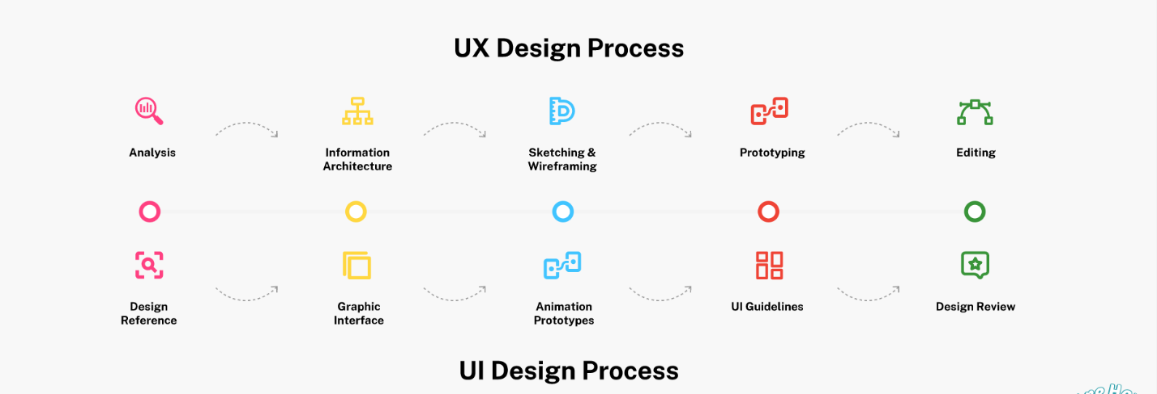

**Breakthrough To Some Of Our Tools & Frameworks (H-2 Tag)**

**Animation Editors (H-3- Tag)/ (Add icons)**

Adobe Effects, Autodesk Maya, Cinema 4D. **(Add logos)**

**Design Tools (H-3- Tag)/ (Add icons)**

Sketch, Adobe XD, InVision Studio, Proto.io, Webflow, Figma, Adobe Illustrator, Adobe Photoshop **(Add logos)**

**FAQs (Dropdown**

1. **What is UX/UI design?**

UX/UI design creates an enjoyable, seamless, and efficient experience for users when they interact with a website or application. This involves designing user interfaces that are easy to navigate and visually appealing.

1. **How can UX/UI design improve my business?**

Good UX/UI design can help increase customer satisfaction, reduce bounce rates, and improve conversion rates. By creating a positive user experience, customers are more likely to engage with your product or service and return in the future.

1. **What is the difference between UX and UI design?**

UX (user experience) design focuses on the user's overall experience, while UI (user interface) design focuses on the visual and interactive elements of a website or application.

1. **Why is it important to conduct user research during UX/UI design?**

User research is crucial in UX/UI design because it allows designers to understand the needs and preferences of the target audience. This helps create a design tailored to the user's expectations, resulting in a positive user experience.

1. **How can UX/UI design benefit my business?**

UX/UI design can benefit your business by improving user satisfaction, reducing bounce rates, and increasing conversion rates. In addition, it can create an enjoyable user experience and make it easier for customers to interact with your product or service.

1. **What should I expect when working with a UX/UI designer?**

When working with a UX/UI designer, you can expect them to conduct user research, create wireframes and prototypes, design visually appealing interfaces, and collaborate with developers to ensure a seamless implementation. They should also provide feedback and make revisions based on your input and preferences.

1. **How does user research help in creating a successful UX/UI design?**

User research is crucial in creating a successful UX/UI design because it helps understand the needs and preferences of the target audience. In addition, it provides insights into how users interact with your product or service and what improvements can be made to create a better user experience. This ultimately leads to a more effective and engaging design

**Testimonials**

**Black CTA BOX – E-mail Opt-in Form**

**You're just 2 minutes away from a no-strings quote**

**Name:**

**Phone:**

**Email:**

**Service Required:**

**Message:**

**GET A QUOTE (CTA)**

**Page#04**

**Trusted Cyber Security Services (H-1 Tag)**

Protecting Your Digital Assets with Cutting-Edge Cybersecurity Solutions and Expert Consultation.

**Get in Touch (CTA)**

**KEEP IT SECURE & UP-TO-DATE WITH SYNC CLOUDS**

We specialize in offering the best cyber security as a service and ensure that our prestigious clients can enjoy cyber immune business without worrying about any catastrophic damage to their business or organization. **(H-2 Tag)**

Together, we can avoid being the next mega-breach headline by;

* Custom cyber security services
* Robust strategy to reduce the chances of risk alleviation.
* Regulatory strategies to avoid any potential threats.
* Firmly believes in the zero-trust principle to minimize the attack chances.
* Always prepared for a quick response to emerging threats.
* Manage risks 24/7 for growing businesses
* Availability of information security consultation around the clock to enterprises.

**Revitalise With Exclusive 360 Cyber Security Services (H-2 Tag)**

To "**Keep Your Information Safe**" is our priority. The threat is real and growing, and so are we!

Our experts constantly update their cyber skills to protect your assets from malicious attacks and ensure safety, reliability, and co-dependency for ultimate security.

Select Your Vital Service to Lock Your Business Efficiently!

**Vulnerability Assessment & Penetration Testing (H-3 Tag)**

Leverage your business with high-level security with our VAPT services to identify and rectify all possible vulnerabilities in one go.

**Security Operation Center (24/7) –SOC Services (H-3 Tag)**

We provide powerful SOC services for continuous network monitoring to protect your business from any harmful entity in a cost-effective way.

**Application Security Services (H-3 Tag)**

Get our application security services to prevent the leakage of any sensitive data of your employee or customer and build your brand image with full confidence.

**Security and Consulting Services (H-3 Tag)**

Get in touch with our cyber consultants to understand your core business and identify the need for the right security approach to spot the risk entities and regulatory strategy to mitigate them.

**CYBER-ATTACKS ARE GETTING MORE SOPHISTICATED. ARE YOU?**

**Let's Protect My Business (CTA)**

**Our Competency with Cyber Security Frameworks (H-2 Tag)**

Do you want to protect your sensitive data from insider attacks or a cyber-attack from the outside? No worries! Our team of experts isis here to leverage you with the right tools and solutions to eliminate any malicious activity risk.

**PCI DSS Compliance Framework (H-3 Tag)**

Our experts are proficient with this well-known security framework to secure major card brands among different industries.

Payment Card Industry Data Security Standard (PCI DSS) helps to;

* Protect the data of all cardholders.
* Protect the data from any virus or attack.
* Protect access to cardholder data.
* Tracks the access of related network sources of cardholders.

**OWASP-Top10 Compliance Framework (H-3 Tag)**

Open Web Application Security Project (OWASP) is a standard used by our experts for all tech giants and IT communities for absolute software security.

It helps with the following;

* Code safety against any cyber threat.
* End-to-end powerful encryption.
* Minimizes the chances of bugs and errors.

**Nist 800-53 Compliance Framework (H-3 Tag)**

Allow us to play our part in protecting sensitive data by using the best standard practices of Nist 800-53.

Nist 800-53 ensures;

* For private or government agencies
* For technical and business stakeholders
* For supportive communication

**Absolute Cyber Security Solutions For All (H-2 Tag)**

We locate, identify and correct security threats before they can cause any damage to your personal or professional data

IBM, Kaspersky, Force point, Rapid, Splunk, ELK stack **(Add Icons/logos)**

**Our Top-Notch Cyber Security Services For Various Industries (H-2 Tag)**

We are a group of cybersecurity experts who know how to improve cybersecurity for everyone. Join us in the world of cyber security, and discover a world that can protect your business.

**Healthcare (Add Icons)**

Make cyber security better for your patients, your providers, and your business with our security specialists.

**Banking (Add Icons)**

Strengthen your security systems and protect your bank's critical assets and customers' data with us.

**Higher Education (Add Icons)**

We help Higher Education IT pros protect their students, faculty, and staff with the right security solutions.

**Software (Add Icons)**

We provide security solutions covering all your connected devices: servers, storage, networks, and more.

**Telecommunication(Add Icons)**

We offer cyber solutions with exceptional best-in-class capabilities and network services to safeguard your Critical Infrastructure Assets.

**FAQs (Dropdown)**

1. **How do you ensure the confidentiality of my sensitive data?**

We follow strict confidentiality protocols and guidelines to protect sensitive data. In addition, we use encryption techniques, access controls, and other security measures to prevent unauthorized access and data breaches.

1. **Can you help me with compliance with industry regulations and standards?**

Yes, we can help you comply with industry regulations and standards, including GDPR, HIPAA, PCI-DSS, and more. In addition, we ensure that our clients meet the necessary compliance requirements and standards to protect their sensitive data.

1. **What is the process for identifying vulnerabilities and threats?**

Sync Clouds conducts comprehensive risk assessments and penetration testing to identify vulnerabilities and threats. We use advanced tools and techniques to identify weaknesses in the network, applications, and other systems.

1. **How do you ensure the security of cloud-based systems and services?**

Sync Cloud uses industry-leading cloud security measures and best practices to ensure the security of cloud-based systems and services. In addition, we guide selecting secure cloud solutions and ensure that they meet the necessary security standards and requirements.

1. **Do you provide employee training and education on cybersecurity best practices?**

Yes, we provide employee training and education on cybersecurity best practices to help our clients reduce the risk of human error and prevent cyberattacks. In addition, we offer customized training programs tailored to the specific needs of our clients.

1. **Can you provide 24/7 monitoring and support for cyber security incidents?**

Yes, we provide 24/7 monitoring and support for cyber security incidents to ensure our clients can respond quickly and effectively to any security breaches or incidents. In addition, our team of experts is available around the clock to provide assistance and resolve any issues that may arise.

**Testimonials**

**Black CTA BOX – E-mail Opt-in Form**

**You're just 2 minutes away from a no-strings quote**

**Name:**

**Phone:**

**Email:**

**Service Required:**

**Budget:**

**Message:**

**GET A QUOTE (CTA)**

**Page#05**

**Comprehensive Digital Marketing Services (H-1 Tag)**

Revolutionize Your Brand's Digital Footprint with Next-Level Marketing Strategies!

**Discuss My Project (CTA)**

**Innovative Digital Marketing Services For Every Business (H-2 Tag)**

Spark your business with our innovative digital marketing services that will help you get more business fast by closing sales, increasing conversions, and solving problems WITH EXPERTS ONLY!

**Our Standard Marketing Approach For Your Dream Project (H-2 Tag)**

Our Power packed Strategy **(In center)**

In-Depth Business Understanding, Customer Identification, Customer Persona Development, Goal Setting, Resource Allocation, Action Plan, Reporting & Analysis. **(In-cycle form)**

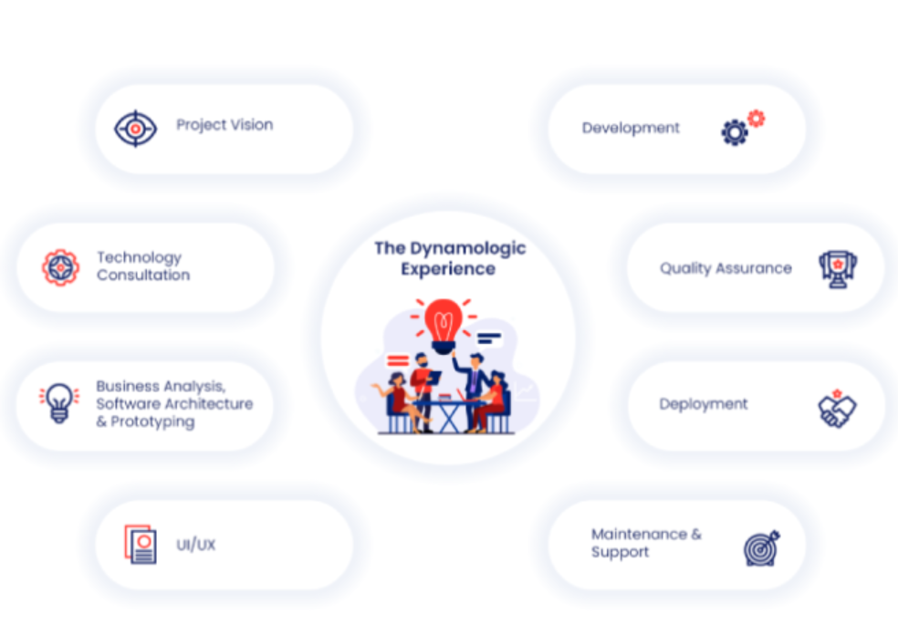

**Result-Driven Digital Marketing Services For You (H-2 Tag)**

Convert your site into an efficient sales machine!

We'll show you the best marketing strategies to grow your business right now. These tried-and-true tactics will instantly grow your business faster than speeding bullets.

**Reference**: <https://webnet.com.pk/digital-marketing-services>

**Social Media Marketing** **(H-3 Tag)**

**It gives your business a voice and a personality**

Undoubtedly, social media power is irreplaceable when it comes to branding and leads. But finding quality leads needs the right strategy that fulfills the requirement of constantly changing algorithms.

Get in touch with us and allow our social media experts to target each Platform exclusively!

Facebook, Instagram, Twitter, YouTube, Snapchat, TikTok **(Add Logos)**

**Pay-Per-Click (PPC) (H-3 Tag)**

**Get your brand in front of the right people**

Developing meaningful relationships and engaging with the right audience can be hard and time-consuming. But if you are looking forward to speedy growth for 5x sales, then paid search advertising is your way.

Our performance marketer knows the right bidding strategies to generate 3x ROI with the bare minimum investment. Get yours now!

Google Ads, Bings Ads, Facebook-Meta Ads, Instagram-Meta Ads, TikTok Ads **(Add Logos)**

**Search Engine Optimization (SEO) (H-3 Tag)**

**Get your Website on top Of Google**

Over 200 Google ranking factors need to be followed; only then can you see your Website among the top 10 SERP results.

Are you using the right keywords, providing valuable content, and simultaneously building links with high-authority domains? Let's discuss this.

Link building, White-hat SEO, ON-page SEO, Technical SEO, Keyword Research**(Add Icons/ Logos)**

**Email Marketing (H-3 Tag)**

**Touch your audience's heart with personalized emails**

Newsletters and personalized emails are the best way to nurture your leads. It also helps to retarget your audience and develops a personal connection with your brand. But are you adding that oomph factor to your emails?

Contact our certified digital marketing consultant to build an effective relationship with your desired audience.

Mail chimp, Sender, Omnisend, MailerLite, Mailjet **(Add Icons/Logos)**

**Content Writing (H-3 Tag)**

**Write in between white spaces**

Content is the King. But stuffing the pages with targeted keywords will not make it any better for you. So, you must provide valuable, unique content backed up with a robust content strategy.

Let's talk content-what it is, why it is important, and how we can get you started.

Grammarly, Hemingway, Ahref, UberSuggest, Answer the public **(Add Icons/Logos)**

**Affiliate Marketing (H-3 Tag)**

**Make money while you sleep**

Affiliate marketing is one of the most trending businesses in today's world. Promoting the product or service at the right place, at the right time, and to the right audience is crucial.

Our extensive marketing expertise and industry connections can help you to do it rightly. Let's start!

Affiliate programs, blogs, influencer marketing, customer fan—base, 100% profit **(Add Icons/Logos)**

**DID WE MENTION THAT WE'LL HELP YOU TO CHOOSE THE RIGHT WAY ONLY?**

**Let's Uncover (CTA)**

**Digital Marketing Services For Distinctive Industries (H-3 Tag)**

We will transform your business into a well-oiled digital marketing machine so you can be hands-free and watch the dollars roll in.

**B2B Digital Marketing**

Buyer-to-Buyer **(Add Icons/Logos)**

**B2C Digital Marketing**

Buyer-to-Consumer **(Add Icons/Logos)**

**Education**

Schools, Colleges, Academies, Universities **(Add Icons/Logos)**

**Healthcare**

Hospitals, Laboratories, Pharmaceuticals, related departments **(Add Icons/Logos)**

**E-commerce**

Retailer stores, Shopify stores, Amazon **(Add Icons/Logos)**

**Fin-tech**

Finance, Banks, Corporates **(Add Icons/Logos)**

**Telecommunication**

Network communities and companies **(Add Icons/Logos)**

**FAQs (Dropdown)**

1. **How do you customize your digital marketing services to meet each Client's specific needs?**

Sync Clouds offer a customized approach to digital marketing services that starts with an initial consultation to understand each Client's needs and goals. We then develop and implement a tailored strategy with ongoing adjustments and optimizations.

1. **How do you handle changes to search engine algorithms or social media platform policies that may impact our digital marketing strategy?**

We stay up-to-date with the latest changes and updates to search engine algorithms and social media platform policies and adapt our strategies accordingly. Our team of experts is well-versed in the latest digital marketing trends and best practices, making us prepared to adjust our strategies to deliver the best possible results

1. **Can you help with developing a digital marketing strategy for my business?**

Yes, our performance marketing specialist can develop a customized digital marketing strategy for your business, taking into account your target audience, goals, and budget.

1. **How do you measure the success of digital marketing campaigns?**

We use a variety of metrics to measure the success of digital marketing campaigns, including website traffic, conversion rates, click-through rates, engagement rates, and more**.**

1. **What is your approach to content marketing?**

Our data-driven approach to content marketing involves conducting thorough research and analysis to identify the most effective content strategies for our clients. We provide content creation, distribution, and promotion guidance to maximize engagement and ROI.

1. **Can you help with managing social media accounts and advertising campaigns?**

We provide social media management services, including creating content, scheduling posts, and managing ad campaigns. In addition, we use advanced targeting techniques to reach the right audience and maximize engagement.

1. **Do you provide email marketing services?**

Yes, we provide email marketing services, including creating and managing email campaigns, developing email templates, and tracking and analyzing performance metrics.

1. **How do you stay current with digital marketing trends and best practices?**

We stay up-to-date with the latest digital marketing trends and best practices through ongoing research, training, and collaboration with industry experts. This ensures that our clients benefit from the latest advancements in digital marketing and remain competitive in their markets.

**Testimonials**

**Black CTA BOX – E-mail Opt-in Form**

**You're just 2 minutes away from a no-strings quote**

**Name:**

**Phone:**

**Email:**

**Service Required:**

**Budget:**

**Message:**

**GET A QUOTE (CTA**

**Page #06**

**Scale Your Team, & Accelerate Your Success With Our Expert Team Augmentation Service (H-1 Tag)**

**Hire a Pro Hire a Team (CTA)**

**To Cover Talent Gaps, Are You Looking For Experts With A Particular Skill Set? (H-2 Tag)**

Your project's development and cost-effectiveness can be perfectly balanced with the assistance of our IT staff augmentation firm. Based on the current development demands, quickly scale your team up or down. We assist you in avoiding expensive, drawn-out hiring procedures and the associated administrative hassle.

**Ready-To-Go & Custom Developer Teams To Boost Your Project (H-2Tag)**

Team augmentation service is the perfect solution for businesses looking to quickly scale their team size, access top talent, and reduce costs.

With our team of experts, you can be confident that your project will be delivered on time and to the highest standard. We provide services like:

* Web App Development
* Mobile App Development
* UX/UI Design
* Cybersecurity
* Digital Marketing
* Block Chain
* AI &ML
* WEB 3.0
* META VERSE
* NFTs
* Cloud (DevOps)

**READY TO GET ON-BOARD WITH YOUR EXPERT?**

**Let’s talk (CTA)**

**Tackle Your Tech Skills Gap in the Shortest Time Possible (H-2- Tag)**

Get top tech talent with Syncclouds ‒ we provide team augmentation services to strengthen your project with the required skill sets ‒ fast and effortlessly.

**Add Extra Power To Existing Projects**. **(H-3- Tag)/ (Add icons)**

Add talent to your existing team to deliver quality projects on time. Leverage our IT team growth services to build custom teams with diverse skill sets to meet your business needs.

**Vendor Transition (H-3- Tag)/ (Add icons)**

Looking for a new technology provider to bring your solution to market? We can help you make a smooth, effective provider change and take over your project.

**Short-term Team Augmentation (H-3- Tag)/ (Add icons)**

Use this recruitment model for urgent hiring of technical talent. In addition to our out-of-the-box team, we have a candidate base of top talent that can fill jobs in a week.

**Long Term Team Expansion (H-3- Tag)/ (Add icons)**

For stable cooperation, we offer bespoke recruitment - you can hire a developer with the necessary hard and soft skills. So, watch, and we'll handle the rest.

**Accelerate Your Success With Our Expert Team Augmentation Service H-2 Tag)**

Team Augmentation Service is the perfect solution for companies looking to quickly scale their teams, access top talent, and reduce costs. Our team of experts ensures that your project is delivered on time and to the highest standards.

**No Recruitment Hassles (H-3- Tag)/ (Add icons)**

Our team augmentation services take the hassle out of finding and hiring vetted developer talent for your organization. We will review and send you an approved resume.

**Lower Operational Costs (H-3- Tag)/ (Add icons)**

Reduce your company spending by eliminating the costs of office space, equipment, and taxes. Instead, pay for what drives the most value for your company.

**Fewer Legal Hassles (H-3- Tag)/ (Add icons)**

Within our team augmentation services, we remain the official employers of your hires. Our company takes care of all legal responsibilities and documentation.

**Access to Vetted Talent (H-3- Tag)/ (Add icons)**

We offer you immediate access to a vast talent pool at affordable costs. Amplify your team with certified software specialists.

**Aggressive Deadlines (H-3- Tag)/ (Add icons)**

Ramp up your technical capacity when chasing a stringent deadline. Our team of developers dedicates their efforts to delivering the project on time.

**Full Control (H-3- Tag)/ (Add icons)**

We encourage you to cherry-pick your team members and participate in the screening process. Then, manage your project's success and stay updated on all changes.

**Revolutionize Industries with Digital Services! (H-2 Tag)**

Syncclouds serve every industry and provide cutting-edge services to empower industries and businesses worldwide. Our expert developers, designers, and engineers are dedicated to delivering innovative software services that enable businesses to thrive in today's dynamic and fast-paced market.

**Commercial (Add icons)**

Empower Small Businesses with The Right Technology and Customized Solutions to Keep Your Business Running Smoothly and Maximize Your Business Potential.

**Government (Add icons)**

Public sector organizations need IT that can scale to meet demand while maintaining the flexibility, manageability, and strict data security required today.

**Financial (Add icons)**

Designed, Development, Maintenance, and Updated fintech software for financial institutions and products with a financial element.

**Education (Add icons)**

Services for eLearning design and development, LMS design, online course development, educational app dev, and more!

**Retail (Add icons)**

Custom e-commerce solutions & advanced integrations. B2C, B2B, and marketplace solutions.

**HealthCare (Add icons)**

Strategy, design, and software development for healthcare (E-Health, Digital Health, Telemedicine, or Mobile Health).

**FAQs / (Dropdown)**

1. **What is team augmentation and how does it work?**

Team augmentation is a service where businesses can hire additional skilled professionals to work alongside their in-house team. The team augmentation service provider works closely with the client to understand their needs and provides additional resources on a temporary basis.

1. **Who can benefit from team augmentation services?**

Any business that needs additional resources to complete a project or manage an increase in demand can benefit from team augmentation services. This can include businesses in the software development, digital marketing, customer support, and graphic design industries.

1. **How do I choose the right team augmentation service provider?**

When choosing a team augmentation service provider, it's important to consider their expertise, experience, and track record. Look for a provider that has a strong reputation in your industry and has a proven track record of delivering high-quality work.

1. **What types of professionals can be hired through team augmentation services in your company?**

Sync Clouds can provide access to a wide range of skilled professionals, including software developers, digital marketers, customer support representatives, graphic designers, project managers, and more.

1. **What are the benefits of team augmentation services over hiring full-time employees?**

Team augmentation services can provide a more flexible and cost-effective solution compared to hiring full-time employees. They can help businesses to manage peaks in demand, reduce recruitment costs, and access a wider pool of skilled professionals.

1. **How can team augmentation services help businesses to scale?**

Team augmentation services can help businesses to scale by providing access to additional skilled resources on a temporary basis. This can help businesses to complete projects more quickly and efficiently, manage an increase in demand, and ultimately grow their business.

1. **Can I get a free consultation call with your team or experts?**

Yes, you can reach out our team augmentation service providers. During the consultation call, you can discuss your project requirements and timeline, and the provider can recommend additional resources that can help you complete your project more efficiently.

**Opt-In Form**

**Need experts in technologies that are not listed here?**

Let us know. Our extensive talent database and strong recruitment department allow us to find candidates with any skill set.

E-mail section **Let’s Discuss (CTA)**

**Career Page**

**Reference:** [**https://www.devbatch.com/careers/**](https://www.devbatch.com/careers/)

**Engage in the Sync Clouds Software Team (H-2 Tag)**

We have your dream team and job. Meet our team, view our perks and benefits, and read about our mentorship program. We are looking to hire committed, imaginative, and motivated team members eager to advance their careers by expanding their knowledge and experience in various settings.

We firmly believe that professional advancement and work-life balance are essential to our employees' well-being. Delivering cutting-edge technology solutions to our clients is one of our company objectives, which is well understood in our work approach and culture.

**Job Vacancies (H-2 Tag)**

We are seeking bright people to join our enthusiastic and diverse team of experts who can expand competitive advantage by delivering innovations and driving efficiency. Go over a position that interests you and quickly submit your application.

**Apply Now**

**Available Job List: (H-1 Tag)**

Title A

Title B

Title C

**Life At Sync Clouds (H-2 Tag)**

To achieve new heights and contribute equally to the well-being of our employees, Syncclouds, a worldwide digital transformation tech company, offers substantial salaries, rewards, and chances to support their transformation and growth.

**Medical Insurance (H-3 Tag)**

We provide for the needs of our employees in more significant ways. A high-quality medical insurance plan is part of our attractive benefits package. In the event of an emergency, you will be compensated.

**Work-Life Harmony (H-3 Tag)**

Spending quality time away from the workplace is essential for our staff to be happy at work. So we provide time off and organize outdoor activities to boost morale and keep our employees upbeat.

**Strive to learn (H-3 Tag)**

We are committed to giving every employee the knowledge required to perform their duties effectively. We frequently communicate essential business information throughout the entire firm.

**Reference**: <https://closers.io/marketing-coordinator/> **(How-To-Apply Section)**

**How We Conduct Interviews?**

The interviews aim to assess the candidate's skills, knowledge, and overall fit for the position. Here are the steps that can be taken during the initial consultation:

1. **Initial Interview: General Assessment**

This interview can help determine if the candidate has the necessary expertise, communication skills and ability to articulate complex ideas.

1. **Technical Interview 1 - Knowledge Check:**

The first technical interview questions the candidate about their technical knowledge and background.

1. **Technical Interview 2 – Skill Testing:**

This interview can help evaluate candidates' ability to apply their knowledge and skills to real-world scenarios.

1. **Non-Technical Interview - Aptitude Analysis:**

Our team typically assesses the candidate's personality, communication skills, and cultural fit.

It includes;

**Screening Interview:**   
An interview with one of our team members so that we can acquire more about each other

**Skill Test:**  
To evaluate your skills, we take a test to check your strengths and areas of interest.

**Training Period**:  
A period of training to get you warmed up to achieve career goals.

1. **Feedback & Decision:**

After all the interviews, the interviewer will provide constructive feedback to the candidate about their performance.

The interviewer will also communicate the next steps within 48 hrs. in the hiring process and when the candidate can expect to hear back.

**Click The Button Below To Get Started**

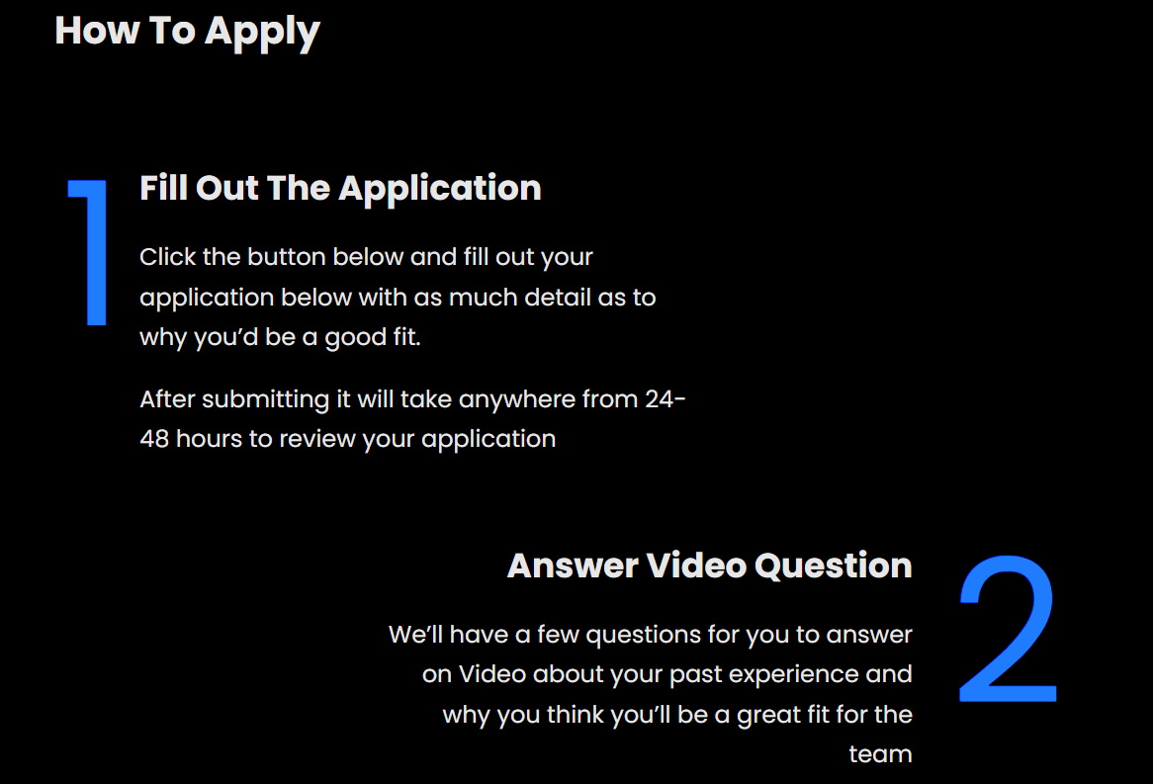

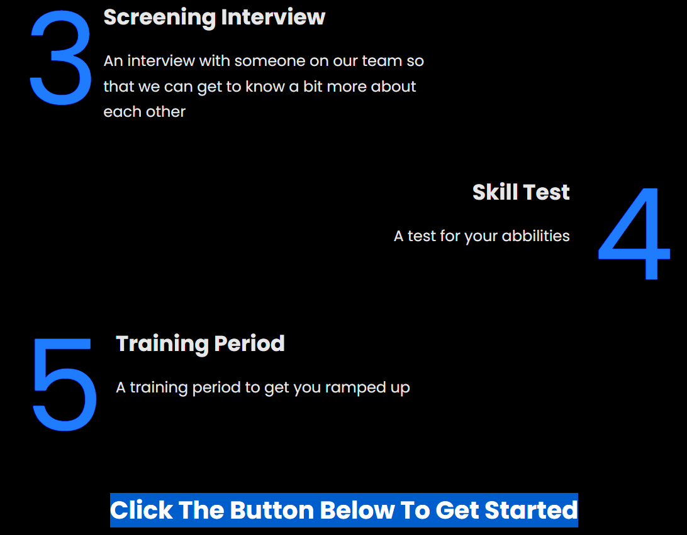

**Black CTA BOX – Contact Us- Form**

**Can’t Find Your Desired Position? Leave Us A Message Here!**

**Name:**

**Phone:**

**Email:**

**Message:**

**Contact Us Page**

**Alternatives For Custom Software That Modify Your Enterprise (H-2 Tag)**

With our proficient team, you can stop sailing through turbulence and start making an impact! Link up with Sync Clouds and begin laying the groundwork for your company right away.

**Opt-In Form**

**Let's talk about your project and make your dream a reality!**

After receiving the following information, a member of our staff will contact you to go through the specifics of your project.

**Add Form:**

**Name:**

**Phone:**

**Email:**

**Service Required:**

**Message:**

**WHY CHOOSE US (H-2 Tag)**

**Completely Accessible (H-3 Tag)**

We are available for phone calls 24 hours a day, so you will be able to resolve any problem at any time you want. Our team will be there at your doorstep.

**Qualified Agents (H-3 Tag)**

Our team members are highly skilled, trained, educated, and professional. They're all trained per the most current technology.

**Staff Augmentation (H-3 Tag)**

Outsourced developers are managed directly by you and collaborate remotely with your internal team. It works best for bridging the knowledge and resource gaps in your development team.

**Adequate Price (H-3 Tag)**

Our prices are affordable for everyone. We provide flexible discounts so you can use any service you require.

**Exceptional Offers (H-3 Tag)**

We offer discounts on the most well-known services, meaning you will surely get help without delay.

**References:** [**https://www.devbatch.com/contact-us/**](https://www.devbatch.com/contact-us/)

**https://toggle.ai/**

**Terms and Conditions (H-1Tag)**

The access, use, and browsing of this website and its contents are all governed by the legally enforceable terms of this agreement between you and Syncclouds. Additionally, it regulates how you utilize all of the written, numerical, and graphic content that we offer. Nothing in this text is meant to confer any rights or advantages upon any third party.

We advise reading these terms carefully before using this website. You affirm that you have read, comprehended, and accepted these conditions in its entirety and that you will abide by all rules, regulations, and laws by using this website. You won't be allowed to use this website if you don't accept these terms. We imply that you agree to these terms and conditions using this Website. If you disagree with all of the terms and conditions listed on this page, do not use Syncclouds further.

**Disclaimer (H-2 Tag)**

The terms "Client," "You," and "“Your" refer to the user who visits this Website and complies with the terms and conditions set forth by the Company and which are referenced in these Terms and Conditions, Privacy Statement, and Disclaimer Notice and all Agreements. Our Company is referred to as "The Company," "Ourselves," "We," "Ours," and "Us." The terms "Party," "Parties," or "Us" include both the Client and us. The provision of our support to the Client in the most suitable manner for the explicit purpose of meeting the Client's needs with the condition of the Company's specified services, in line with and subject to applicable law, is referred to in all terms.

**Cookies (H-2 Tag)**

We use cookies in our operations. You consented to the usage of cookies by Syncclouds Company's Privacy Policy by accessing Syncclouds.

**License (H-2 Tag)**

The Website and its content are the property of Syncclouds or its licensors unless otherwise specified. They all have reserved intellectual property rights.

You are not allowed to:

* Republish content from Syncclouds.
* Distribute, lease, or sublicense Syncclouds content.
* Reproduce, duplicate, or clone Syncclouds content.
* Equalize content from Syncclouds unless it was created with redistribution in mind.

**User Content (H-2 Tag)**

By submitting content to Syncclouds, you provide the Company a non-exclusive, copyright, perpetual, irrevocable, and fully sublicensable license to use, distribute, publish, edit, adapt, publish, interpret, create derivative works from, and display the content anywhere in the world in any format.

In addition, Syncclouds has the right to review any user-generated content and to delete any that it considers offensive or improper.

**Prohibition Activity (H-2 Tag)**

You acknowledge that you won't:

* Take part in any activity that might harm, impair, or overtax the Website.
* Attempt to get illegal access to user accounts, computer systems, networks, or Syncclouds.
* Use a false name or other forms of identification or otherwise misrepresent your association with a person or organization.
* Submit any content related to your usage of Syncclouds that is defamatory, offensive, or objectionable.
* Utilize Syncclouds to break any rules or laws in force.

**Other Sites Links (H-2 Tag)**

Links to third-party websites or services that are not within the ownership or control of Syncclouds Company are not permitted on the Website. The Syncclouds Corporation has no control over and accepts no liability for third-party websites or services, including their content, privacy policies, or practices. Furthermore, you understand and acknowledge that Syncclouds Company is not responsible or liable, directly or indirectly, for any loss or damage that may result from the use of or reliance on any such content, products, or services available on or through any such websites or services.

**Terms & Conditions Modifications (H-2 Tag)**

The Syncclouds Company retains the right to alter or amend these terms and conditions at any time and for any reason. Any adjustments will be considered OK as long as you use Syncclouds.

**Rule of Law (H-2 Tag)**

The laws of the country where Syncclouds Corporation is based shall govern and be applied in interpreting these terms and conditions.

**Privacy Policy (H-1 Tag)**

Synccloud is dedicated to offering services that adhere to privacy regulations. So that you are aware of how your personal information is handled and safeguarded, we work to make our Privacy Policy as simple, transparent, and understandable as possible.

At Syncclouuds, we take the privacy of our users very seriously. This Privacy Policy explains how we collect, use, and protect the information you provide through our services.

**Information We Collect (H-2 Tag)**

We may collect certain information from you when you use our services. This information may include the following:

* **Personal Information:** When you sign up for an account or contact us through one of our services, we may gather your name, email address, and other contact details.
* **Usage Information:** We may keep track of the pages you view, the features you use, and the activities you do when using our services.
* **Device Information:** We may compile data about the type of device, operating system, and browser that you use to access our services.

**How We Use Your Information (H-2 Tag)**

We use the information that we collect from you to provide and improve services. Specifically, we may use your information to:

* Personalize your experience with our services
* Communicate with you about our services
* Analyze how our services are being used
* Improve our services
* Prevent fraud and protect the security of our users

Except when it's necessary for us to deliver our services or when it's required by law, we won't disclose your personal information to third parties.

**Data Retention (H-2 Tag)**

As long as it takes us to perform our services or as long as it takes the law, we shall keep your personal information on file. Please contact us at [contact email] if you would like us to erase your personal information.

**Security (H-2 Tag)**

We take appropriate precautions to guard your information against unauthorised access, disclosure, modification, or destruction. Unfortunately, no technique of electronic storage or transmission over the Internet is 100 percent secure. As a result, we are unable to ensure that your information is completely secure.

**Do we use cookies? (H-2 Tag)**

When you visit our website, Sync Clouds may collect cookies and other analytical codes on your computer, browser, or webpage to customize your experience, track usage trends, and provide, enhance, and secure our website.

Cookies are tiny text files that websites put on your computer or device when you visit them. This way, the website's content can be altered to reflect your preferences the next time you visit.

In addition, the information obtained via cookies may be linked to personal information that we store about you, even though cookies typically do not contain any information that personally identifies a person.

**Adaptations to this Privacy Policy (H-2 Tag)**

We might occasionally change our privacy statement. Any updates will be published on this page. If there are significant changes, we will give a more obvious notice (including, for certain services, email notification of Privacy Policy changes). You accept the updated Privacy Policy by using our services after any modifications have been made to it.

**Contact Us (H-2 Tag)**

If you have any queries or worries about our privacy Policy, please get in touch with us at inquiry@synclouds.com.