**Tutorial: Learn to build UML profiles**

Jérémie Tatibouët, Shuai Li, Patrick Tessier and François Terrier

|  |  |
| --- | --- |
| **Lab 1 – A profile to express relational databases** |  |

**Objectives**:

* Build a profile
* Apply it on a model

**Exercise:**

1. Create a profile to express relational databases
   1. Identify the concepts that you want to add to UML (Table, Primary key, etc.)
   2. Identify the meta-classes that will be extended by the concepts newly introduced
   3. Implement the profile within Papyrus
      * File -> New -> Papyrus Project -> Select “SW engineering – profile” as architectural context
2. Customize the notation associated to the stereotypes
   1. Associate each of your stereotype with a dedicated icon. This icon will be displayed when you will use your stereotypes on a model. Note: icons can be found at <https://www.iconfinder.com/>.
3. Use your profile on a database model
   1. Import the model that can be found in the “**tp5/Lab1-Profile-For-RelationalDatabases**” folder
   2. Apply your profile on the imported model
      * Click on the root element of your model
      * In the property view select the “profile” tab
      * Click on the “+” button and reference the profile that is in your workspace.
   3. Complete the database model (using your stereotypes) to satisfy the following requirements
      * A customer is identified by an “ID”
      * A customer can be client in zero or many banks
      * A bank handles zero or many account
      * A Bank is identified by an “ID”
      * A customer is the owner of a specific account
      * A account has only one owner
      * A customer can realize transactions.
      * A transaction takes place at a specific date.
      * A transaction is related to a specific account.
      * **Note: If you cannot fulfill all the requirements, this probably means you need to refine your profile.**

|  |  |
| --- | --- |
| **Lab 2 – A profile to describe an hardware platform (Bonus)** |  |

**Objectives**:

* Propose a profile to describe an hardware platform

**Exercise**:

* The picture below presents the schema of a modern motherboard. A UML model of this motherboard could be realized using composite structures.
* Propose a profile that applies on composite structure based models. This profile must allow the designer of a motherboard to describe the part of the system enabling the CPU to communicate with the memory slots using the bus. Typical information that need to be captured by the profile are:
  + CPU socket type, Accepted CPUs, CPU slot power supply, etc.
  + Accepted memory modules, max memory size per slot, max transfer rate, memory slot power supply, etc.
  + Bus type, bus bandwidth, bus frequency, etc.
  + Northbridge frequency, etc.

[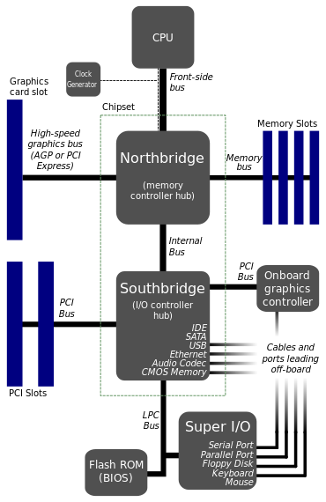](https://en.wikipedia.org/wiki/Motherboard#/media/File:Motherboard_diagram.svg)

<https://en.wikipedia.org/wiki/Motherboard#/media/File:Motherboard_diagram.svg> (cf. © on wikipedia)

* Note: all the types you use must be defined.

|  |  |
| --- | --- |
| **Expected outcome** |  |

The report (as a PDF) and the model should be send to [ansgar.radermacher@cea.fr](mailto:ansgar.radermacher@cea.fr). Please zip your report and your model in an archive “**FIRSTNAM-LASTNAME.zip**”