Tutorial: specify the lifecycle of different parts of the elevator controller
Jérémie Tatibouët, Shuai Li, Patrick Tessier and François Terrier

Preamble: current state of the model

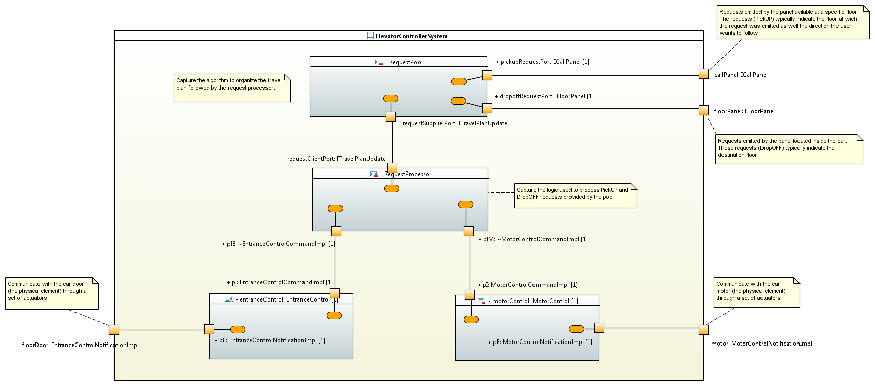

The architecture of the controller is composed of four parts:
- The “RequestPool” which basically builds the travel plan of the elevator based on requests (pick up and drop off) received from the call panel available at a floor as well as the panel placed in the elevator car.
- The “RequestProcessor” which is in charge of processing the travel plan provided by the request pool. Requests processing leads this part to interact with the motor controller to make the elevator to move. It also interacts with the entrance controller to control door opening and closing.
- The “MotorControl” which provides control over the real motor available for the elevator.
- The “EntranceControl” which provides control over the real door available for the elevator car.
Signals, which are used to communicate asynchronously between the different parts, should be defined in the package “Signals”.
Interfaces and classes used to type ports and so formalize the communication protocols existing between the different parts should be defined in the “Interfaces” package.

Lab 1: active classes

RequestProcessor, MotorControl and EntranceControl are active classes. This means their lifecycle (i.e., the way they evolve over time) needs to be defined as classifier behaviors.
- Explain why these classes need to be set as being active.
- Attach a classifier behavior being a state-machine to each of these classes.

Lab 2: state-machine of the class “MotorControl”

The state-machine of the class “MotorControl” must be defined. It must meets the following requirements:
- The elevator car is either “stopped” or “moving”.
- The action of moving the elevator car is controlled by the arrival of a request emitted by the request processor.
- The action of stopping the elevator car is controlled by the arrival of request emitted from the environment (i.e., an element that is external to the controller) to the motor control components.
- When the elevator car gets stopped it notifies the request processor.
- It is possible to update the destination at which the elevator car must stop while it is moving (typically if the travel plan was modified).

Lab 3: state-machine of the class “EntranceControl”

The state-machine of the class “EntranceControl” must be defined. It must meets the following requirements:
- While the elevator is moving the door remain closed
- The door opens upon the arrival of a request emitted from the request processor is received.
- The door remains opened 5 seconds after the last passenger gets in or leaves the elevator car.
- When the door is finally closed the request processor is notified.
- Bonus: you can integrate a control of the weight limit for the elevator car. If you do so add the required ports to get incoming values provided by the weight sensor.

Lab 4: state-machine of the class “RequestProcessor”

The state-machine of the class “RequestProcessor” must be defined. It must meets the following requirements:
- The “RequestProcessor” stays idle while its travel plan is empty.
- As soon as its travel plan is updated the “RequestProcessor” starts to process it.
- Processing a request consists in:
  - Moving the elevator at the required floor (only if current floor different from the destination floor)
  - Controlling the door opening and closing when arrived at the destination floor.
- While processing a request, the travel plan might be modified (e.g., stop required before the currently defined destination floor).

