Correction: Use-cases of an Elevator Controller

Lab 1 – Basic use-case model

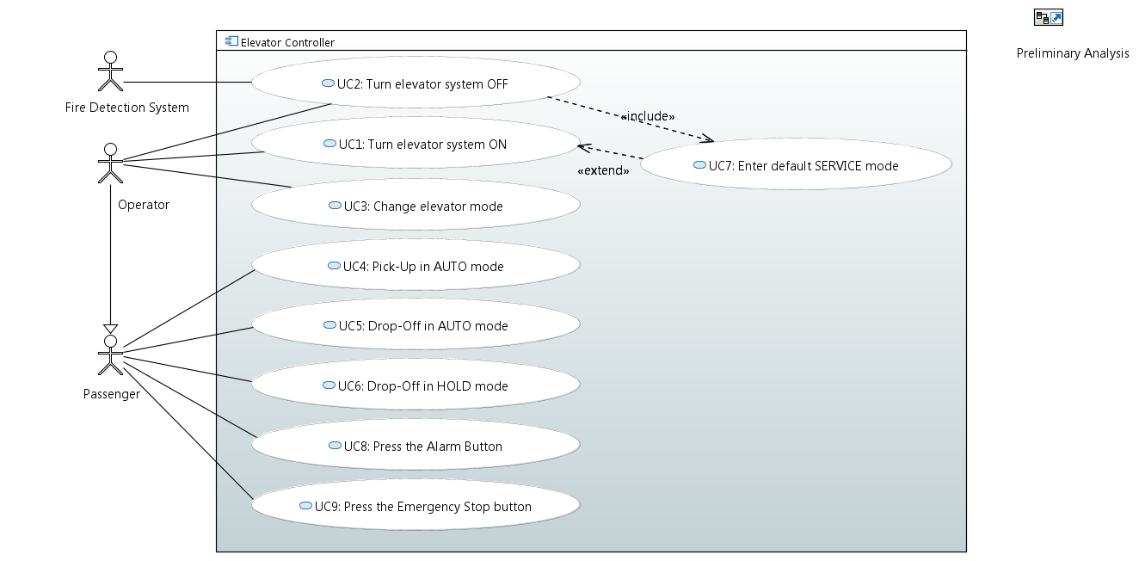

Justifications are in “024b_UC_Tutorial_Highlights”. See highlighted yellow text for justification of actors. See comments in text for justification of use-cases and relationships.

UC1: Comment SL6
UC2: Comment SL6
UC3: Comment SL1
UC4: Comment SL2
UC5: Comment SL2
UC6: Comment SL3
UC7: Comment SL10
UC8: Comment SL7
UC9: Comment SL8

Fire detection --- UC2: Comment SL9
Operator --- UC1: Comment SL6
Operator --- UC2: Comment SL6
Operator --- UC3: Comment SL5
Passenger UC4: Comment SL4
Passenger UC5: Comment SL4
Passenger UC6: Comment SL3
Passenger UC8: Comment SL7
Passenger UC9: Comment SL8
UC1 --- UC7: Comment SL11
UC2 --- UC7: Comment SL10
Operator --- Passenger: “An operator is also a passenger.”

Lab 2 – Description of use-cases

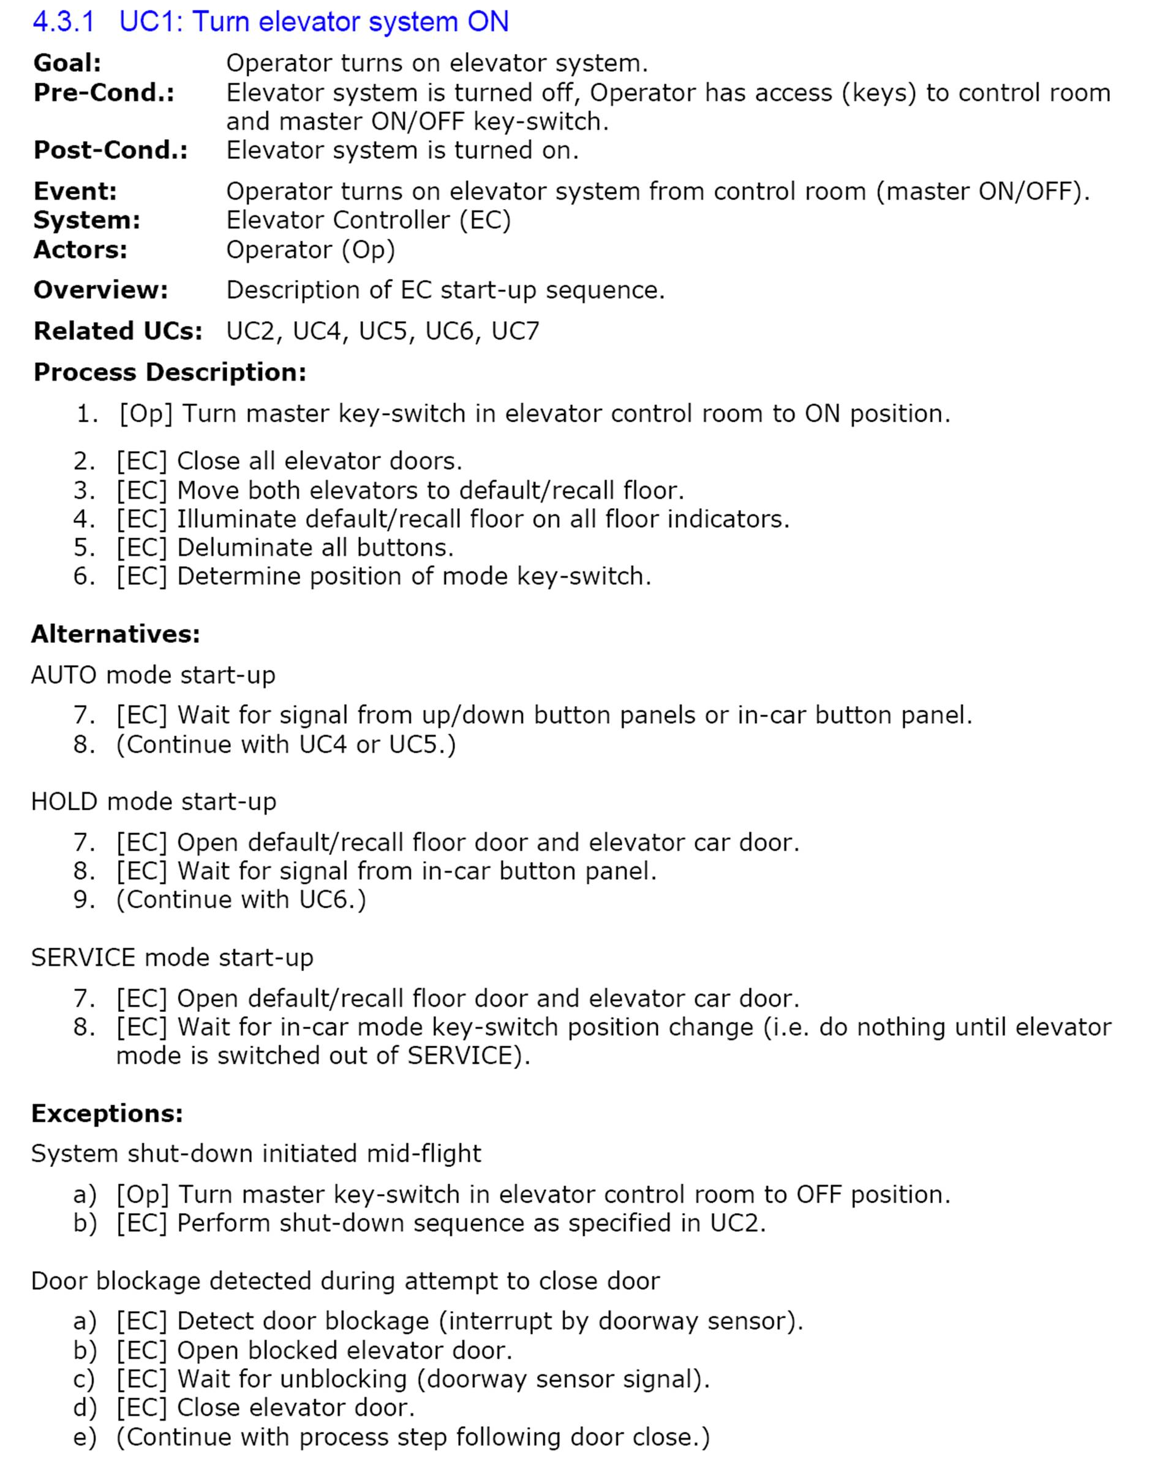
Copyright (c) 2015, CEA LIST, All rights reserved.
Redistribution and use (commercial or non-commercial), of this presentation, with or without modification, is strictly forbidden without explicit and official approval from CEA LIST

