Programming in UML using activities
Jérémie Tatibouët, Shuai Li, Patrick Tessier and François Terrier

Lab 1 – The basics of UML activities

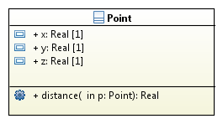

The activity below is the implementation of the “distance” operation.
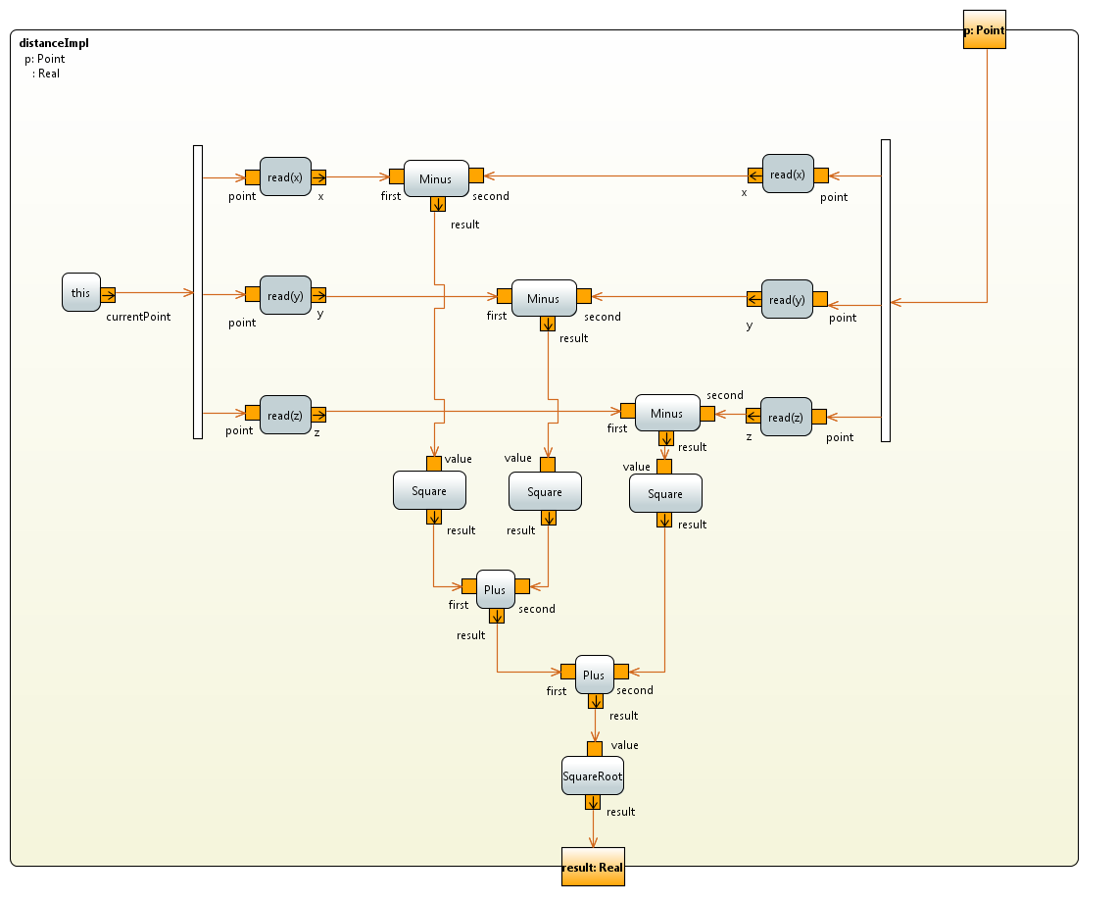

Lab 2 – Activities used in the context of communicating active objects

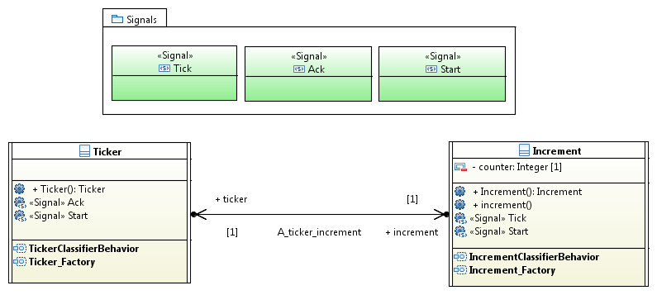
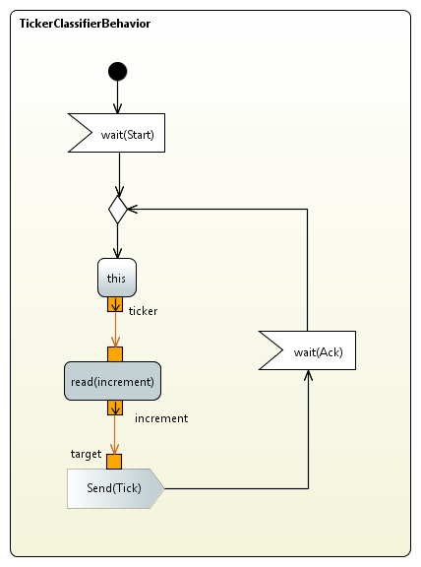 | 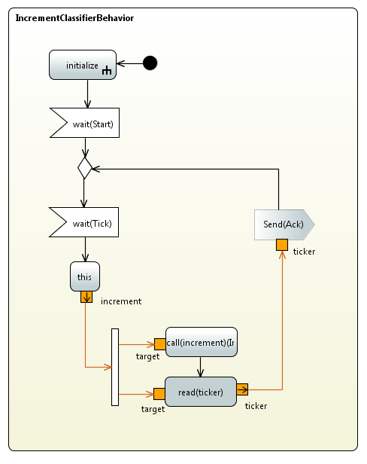

The two activities shown above respectively describes the classifier behaviors of the “Ticker” and “Incrementer” active classes.

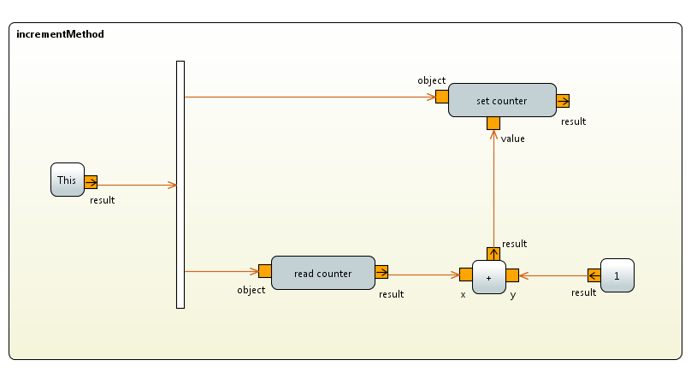
The activity shown above describes the implementation of the increment operation.

Lab 3 – Apply you knowledges about activities in the context of the elevator

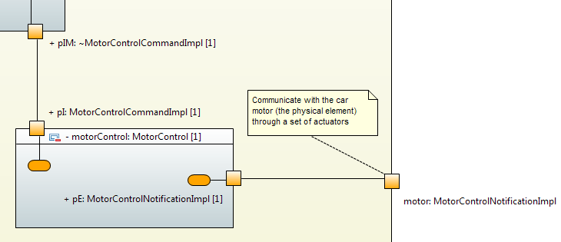

- Send a movement request from the request processor to the motor controller.
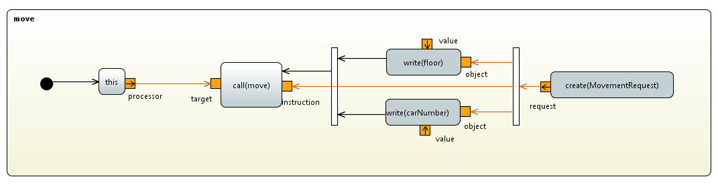

- This can be can be realized with the kind of activity presented above. An object “Movement Request” is created and its attributes are assigned. Note that this part is incomplete on the diagram. Indeed the values of write actions must be specified.

- The operation “move” is called through the call operation action “call(move)”. The “MovementRequest” is given as a parameter of the operation call. The call is realized by the processor and emitted through the port “pIM”. The specification of the transmission port can be realized through the property view via the meta-attribute “onPort”.
