Abstract

A comprehensive UI redesign of a legacy web application to align with the Theme design system, enhance usability, and enforce visual consistency.  
The transformation focused on structured layouts, theme adherence, responsive design, and intuitive navigation to improve overall user experience.

UI Case study

Web Application UI Design

# TABLE OF CONTENTS

* **Objective 3**
* **Visual Comparison 3**1. List Page - Before and After  
  2. Details Page - Before and After  
  3. Add / Edit Page - Before and After
* **Design Issues and Provided Solutions 7**1. List Page - Before and After  
  2. Details Page - Before and After
* **Problem Summary (Old UI) 13**
* **New UI Design (Velzon Theme-based) 14**UI Solutions & Improvements
* **Final Outcome 15**
* **Objective**

To revamp the existing UI of the web application to ensure consistency, theme adherence (Velzon), improved usability, and modern aesthetics.

* **Visual Comparison**

1. **A) List Page - Before**

1. **B) List Page - After**

1. **A) Details Page - Before**

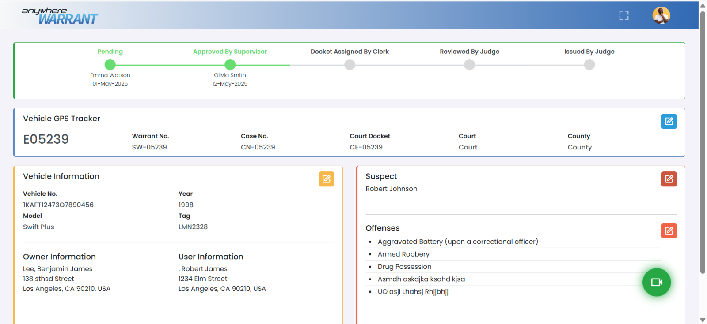

**2. B) Details Page - After**

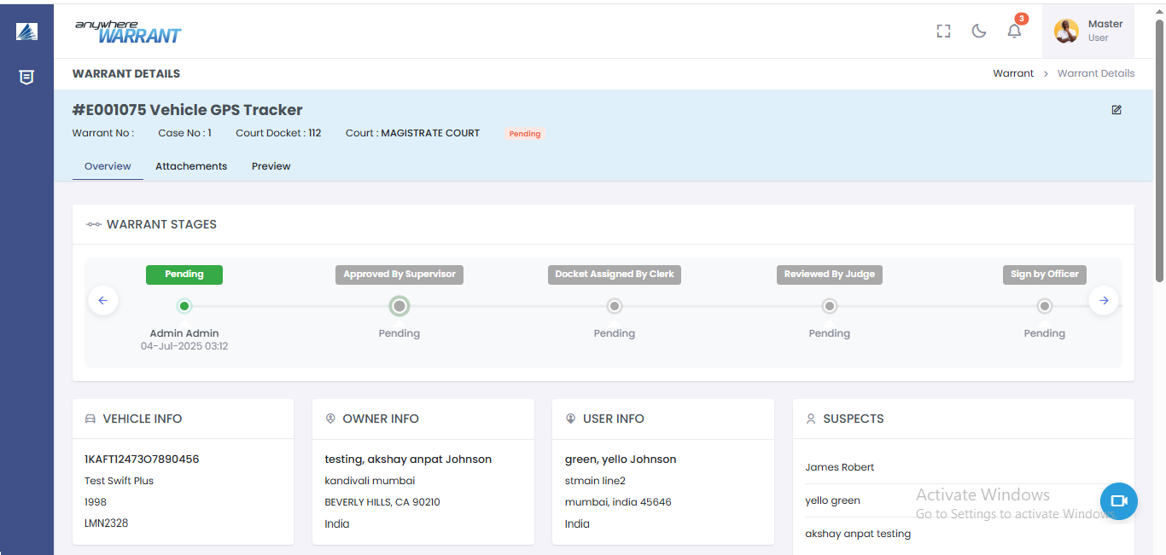

1. **A) Add /Edit Page - Before**

**3. B) Add /Edit Page - After**

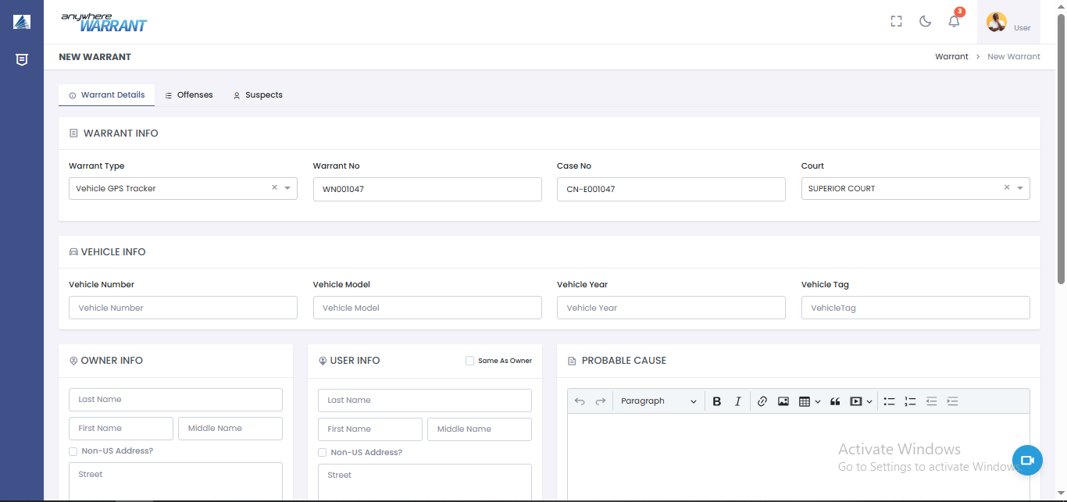

1. **A) Add / Edit Page - Before**

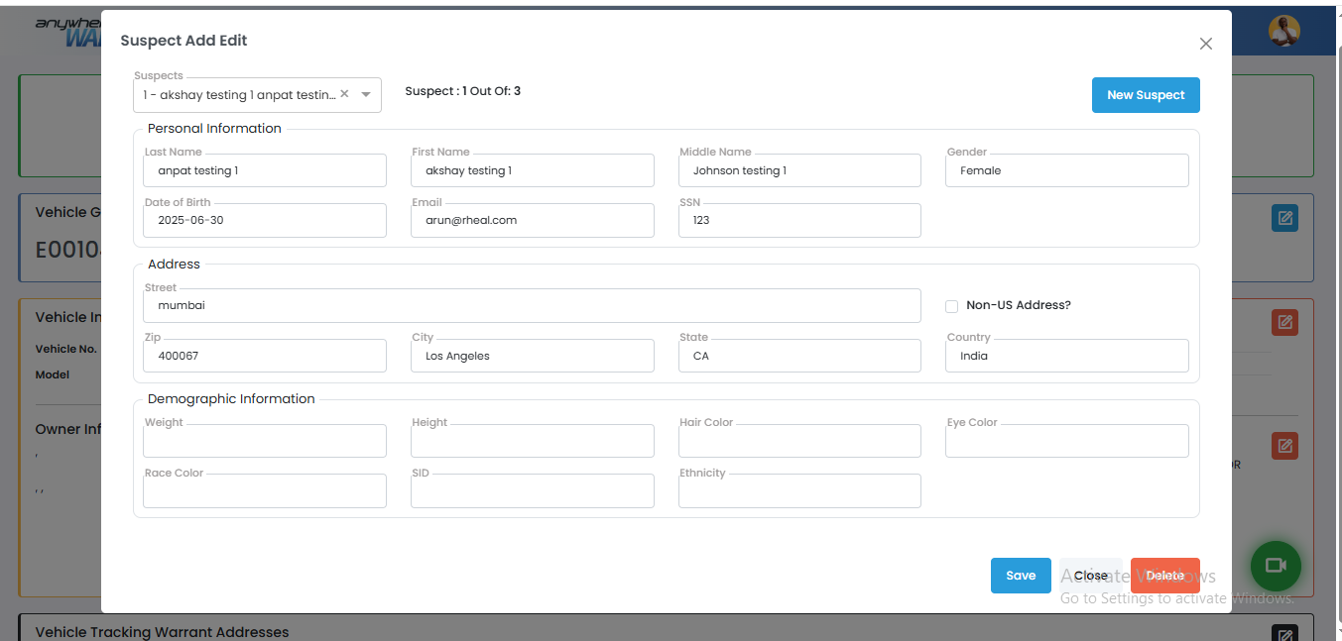

1. **B) Add /Edit Page - After**

* **Design Issues and Provided Solutions**

1. **List Page**

* **Before-**

* **Identified Issues:**

1. Design Does Not Align with the Specified Theme  
   The current design deviates from the established or selected UI theme (Velzon). Components such as fonts, colors, buttons, and layouts appear inconsistent with the theme's default styles.
2. Gradient in the Top Bar  
   The top navigation bar contains a color gradient, which is visually inconsistent with modern minimal UI practices and the selected theme. Most themes today use flat, solid colors for headers to maintain clarity and avoid distractions. Gradients can clash with other design elements and reduce readability of the top bar text and icons.
3. Buttons Are Overly Colorful and Use Custom Colors  
   Action buttons use a variety of vibrant or custom colors that do not follow the design system or theme palette.
4. Inconsistent Spacing and Gaps Between Elements  
   There is no standard and consistent margin or padding between components.
5. Uneven Padding Around Elements  
   UI components have uneven vertical and horizontal padding.
6. In Tables or Lists, Colored Icon Buttons for Single Actions  
   Single-action buttons within tables or lists are styled with vivid or non-theme icon colors
7. Alternate Colors for Rows and Columns in Tables or Grids  
   Non-standard or non-muted colors makes the UI noisy and inconsistent.
8. Top Labels for Input Fields Do Not Match Theme and Are Overridden  
   Input field labels (e.g., “Warrant Type,” “Stage”) have been manually styled with custom fonts, colors, or spacing, which do not align with the theme
9. Action Button Colors Not Part of Theme  
   The action button color do not map to the theme’s defined button color set.

* **After-**

* **Solution:**

1. Implemented a New UI Design that Adheres to the Velzon Theme  
   The user interface was completely redesigned to follow the Velzon theme, ensuring visual consistency and alignment with a professional, modular design system. All UI components—such as buttons, form fields, tables, headers, and icons—now utilize Velzon’s predefined styles and spacing guidelines.
2. Included a Left Navigation Bar for the Menu  
   A left-aligned vertical navigation bar was added as the primary method for navigating between modules.
3. Added a Page Title  
   Each page now begins with a clear and descriptive page title, placed at the top of the main content area.
4. Incorporated a Breadcrumb Navigation  
   A breadcrumb trail has been introduced just beneath the page title. It shows the user's current location within the application hierarchy (e.g., Warrants > List) and allows them to easily: Backtrack to previous sections, Understand the app structure at a glance, Navigate without relying on browser buttons.
5. Ensured Equal Spacing on All Sides of the elements  
   Consistent and even padding and margin spacing has been applied to all layout components.
6. Used Hyperlinked Primary Columns in Tables Instead of Action Buttons or (Optional Dropdown Menus can be used for additional actions for Row-Level Actions)  
   The primary column (e.g., Id, Name, or order number) is now a hyperlink, serving as the main access point to view or edit detailed information.  
   For any additional actions (such as Edit, Delete, Export), a three-dot vertical dropdown menu is provided in the last column of each row.
7. **Details/ Summary page**

* **Before-**

* **Identified Issues:**

1. Page Lacks a Header/Title and Breadcrumb  
   The current page layout does not include a clear page title or breadcrumb navigation.
2. Module Panels Are Missing Headers  
   Individual modules or content blocks on the page do not have section headers. This makes it difficult for users to distinguish one functional area from another.
3. Excessive Colors Are Used to Segregate the Page into Modules  
   Excessive or non-uniform use of color distracts the user from key actions and information. The intense or varied background colors create visual overload and make the interface look cluttered.
4. Each Module Has Differently Colored Buttons  
   Action buttons across different modules use inconsistent and non-theme-aligned colors, which breaks the UI theme consistency, and can confuse users about which actions are most important.
5. There Is No Symmetry  
   Panels section hight appear unevenly spaced or misaligned.
6. Inconsistent Spacing  
   There is irregular spacing between elements—such as inconsistent margins, paddings, and gaps between sections, inputs, or buttons.

* **After-**

* **Solutions**:

1. Theme-Based Readonly / Summary Page  
   A readonly or summary page has been designed to fully align with the application’s predefined theme (e.g., Velzon).  
   This ensures that all visual elements—such as colors, typography, icons, and layout spacing—adhere to the theme’s style guide, promoting a clean and consistent visual identity.  
   The summary view is designed to present non-editable, well-structuredinformation, making it ideal for viewing key details.
2. Added a Page Title  
   Each page now includes a clear and descriptive page title placed prominently in the header area.
3. Included Breadcrumb Navigation  
   A breadcrumb trail has been introduced below the page title to indicate the user’s position within the application hierarchy.
4. Well-Structured Primary Details in the Page Header  
   Important high-level information are now prominently displayed in the page header section.
5. An Edit Button to Navigate to Edit Details  
   The Edit button has been added, allowing users to seamlessly switch from the summary view to the edit form or page. This supports a view-first, edit-when-needed workflow.
6. Tabs View for Data Presentation  
   A tabbed interface has been implemented to organize and present data across multiple related categories within a single page view. This design Improves Content Organization, Saves Screen Space. Users only see one focused section at a time, which prevents distractions and allows for better content comprehension.
7. Cards with Headers for Each Separate Module  
   Content is organized into modular cards, each with its own header clearly labelling the content (e.g., “Vehicle Info,” “Warrant Stages,” “Owner Info”). Cards help visually separate different functional areas, making the interface easier to digest.
8. Proper and Consistent Spacing Between HTML Elements  
   The entire layout now follows a standardized spacing system for margins and padding.

* **Problem Summary (Old UI)**
* **General Design Issues:**
* Inconsistent theme usage; does not follow Theme (Velzon) standards.
* Topbar uses outdated gradient styling.
* Button styles vary across modules, lack of uniformity.
* Margins and paddings are inconsistent, creating visual clutter.
* Poor element padding affects readability and usability.
* Tables use action icons instead of intuitive hyperlinks.
* Distracting alternate row colors in grids.
* Non-standard input labels break design coherence.
* Custom-colored action buttons disrupt visual hierarchy.
* **Layout & Structural Issues:**
* Missing page titles and breadcrumbs hurt navigation clarity.
* Panels lack headers, reducing context.
* Excessive color usage for module separation is distracting.
* Layout lacks alignment and symmetry.
* Uneven spacing between UI elements affects flow and structure
* **New UI Design (Velzon Theme-based)**
* **UI Solutions & Improvements:**

| **Problem Area** | **Old UI Behavior** | **New UI Solution (Velzon Theme)** |
| --- | --- | --- |
| **Theme adherence** | No theme structure | Fully adopted Velzon theme across all components |
| **Topbar styling** | Gradient color used | Replaced with flat, theme-based solid color |
| **Buttons** | Custom colorful per module | Standardized button color palette (primary, secondary, etc.) |
| **Spacing/Padding** | Uneven/missing padding | Uniform padding/margins applied using grid system |
| **List/Table UI** | Icon button for actions | Hyperlinked primary column OR three dot dropdown menu for actions |
| **Row/Column styling** | Alternate background colors | Clean, minimal table design; alternate colors removed |
| **Input Labels** | Custom top labels | Theme-aligned floating or left-aligned labels used |
| **Page Layout** | No Page titles and breadcrumbs | Page title and Breadcrumb added |
| **Module headers** | No headers or inconsistent headers | Each section enclosed in a card with a proper header |
| **Colors per module** | Used as a visual separation | Replaced with layout-based modularity and headers |
| **Read-only views** | Editable modules or unclear UI states | Clean read-only views with “Edit” icon button |
| **Symmetry** | No alignment/symmetry | Consistent alignment and symmetry |

* **Final Outcome**
* **Consistent visual language** across all pages.
* **Improved usability** with clear navigation, action items, and better information hierarchy.
* **Cleaner tables** with link-based navigation instead of scattered action buttons.
* **Unified theme colors** improve aesthetic and accessibility.
* **Structured module view** using cards and tabs improves readability.
* **Responsive spacing and padding** make the UI feel modern and organized.