Student Marks Data Analysis using Pandas
- Objective:
This project analyzes student marks data using the Pandas library in Python and calculates average marks and top-performing student details.
- Technologies Used:
• Python
• Pandas
• CSV File Handling
- Code screenshot:
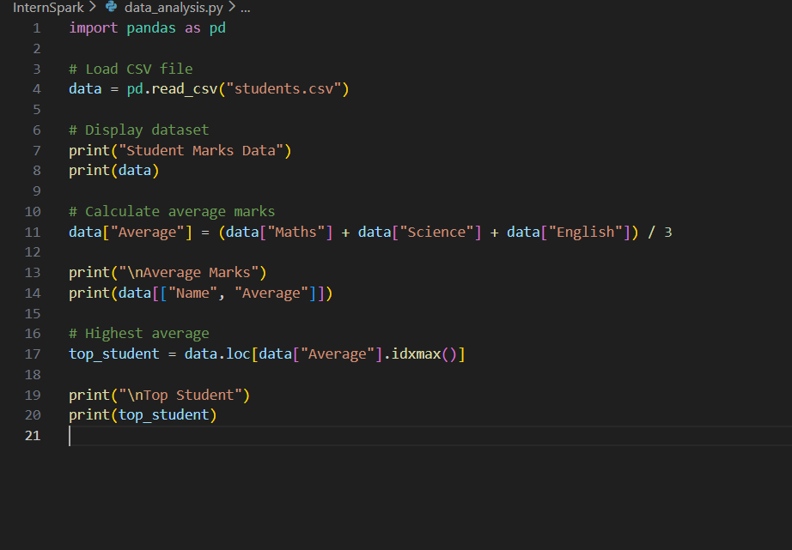

- Output screenshot :
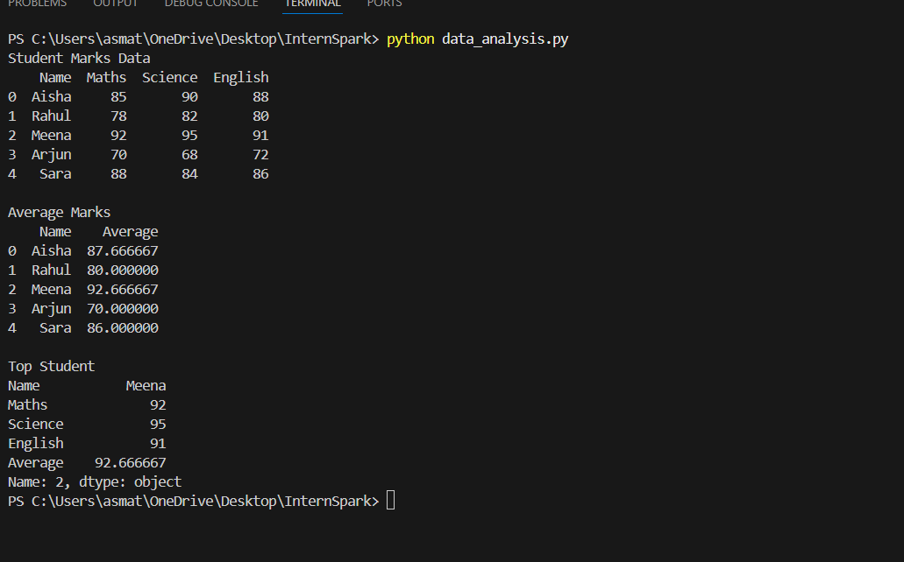

5. Result:
The project successfully analyzed student marks data and displayed average marks and top student details using Pandas.

